Tab 1

1. **Incident #22939  
   Sub: Requesting to delete PGR account.**

**Question:** Here Aashish has requested to delete the PGR account for both DQ and DC. And also assigned task for,

* Ramana to develop a script to handle deletions in the DC (Data Catalog) and DQ (Data Quality) databases and informed that the script should identify and delete records starting from the most downstream tables so it ensures that cascading effects do not cause performance issues or errors while deleting.
* Adnan to identify and manage deletion of data stored outside the database in different systems or storage locations like S3 bucket for metadata, S3 bucket for exception json, S3 bucket for logs, Elastic Search for DC and DQ.

And he has informed them to add that process in the instruction document so in future Customer Success team can refer to that document and execute that by themselves.

And informed Jawad Butt to add that ticket as Sprint action items with high priority but not critical. And informed Matt Dahlman to communicate with Ashwin and Tien to send a mail to the PGR account team saying that, the deletion process has started and ask confirmation to delete the main account and finally he has informed to send a mail to the PGR team confirming that their account has been deleted.

And he has informed Taimoor Ajmal to use the Zendesk ticket as the primary tracking and close this ticket when the 2 step activities are done.

**Solution:** Ramana has confirmed to Taimoor that he has completed the script and deleted the PGR account successfully. Then Taimoor used Zendesk to track this request and closed this ticket after completing the 2 step activities.

1. **Incident #27664**

**Sub: Request -- need the record id or url to direct rule from using the rest api**

**Question:** We have not been able to replicate fully our use of setting a link in our dashboard to display the correct rule in dvsum. It is related to the url used in DI is using a record id where in DQ it was using the rule id (DQ-000082).

If the record id is coming over and we have missed please correct us.

If that record id is not coming over, please update the API to get it coming over ASAP.

We have less functionality due to the api changes and architectural changes that in DI in terms of dashboards. Please help to rectify as soon as possible. We don't like our group seeing errors or us directing them to an overall page where they then need to manually track and search for the rule. Please advise as soon as possible when the expected change could be completed.

**Solution:** For this Hajra and Taimoor has provided an image showing a rule ID in the rest API and also mentioned that, if the selected view doesn't have the Rule ID column then in that case it won't come over in the response upon running the URL and that will also not then appear in their dashboard as well.

Below image is a reference image sent by Taimoor.

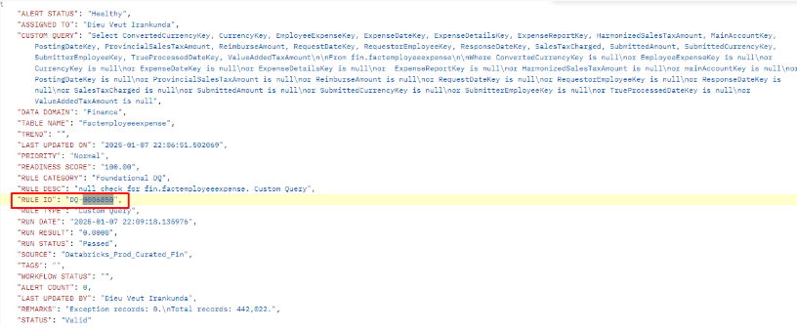

Further Debra has replied that, by referring to that image sent by Taimoor she couldn't find the record ID and the URL anywhere and she requested to add that in the rest API. Then our team discussed this internally and added the record ID and URL to the REST API. Debra has reviewed the update and she is satisfied with our response.

Below image is the reference image sent to Debra after addition of record ID and URL to the rest API.

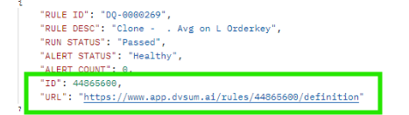

1. **Incident: #26676 for this incident follow-up ticket#27355 is created**

**Sub: Need notification of errors in catalog/profile**

**Question:** We have jobs set up to catalog/profile in DI on either Wednesday or Thursday. However, on Thursday, these jobs did not run successfully. Upon reviewing the logs, I can see that there were issues, but there were no notifications or warnings indicating any problems. In fact, the interface incorrectly shows that the job was completed.

This is not acceptable, as the incomplete execution has resulted in missing tables from the system, which are now completely inaccessible. I am attempting to rerun the job to see if this resolves the issue. This problem occurred for the HR schema, and the errors were logged on the 1st.

**Solution:** Our team has analyzed and informed them as, the logs indicate that 27 tables were successfully profiled, but only 15 of them appear in the UI. This discrepancy is due to the remaining tables being marked as hidden. This happens when certain fields within those tables are flagged as restricted, resulting in the entire table being marked as restricted and, consequently, hidden from view in the UI.

And informed them that this issue has been identified and reported internally. While a fix has not yet been scheduled, we are aware of the concern and will work on ensuring that, in the future, tables will remain visible in the UI even if some fields are marked as restricted.

As for the errors observed in the logs, the profiling process completed successfully, and all 27 tables were profiled. The visibility issue is solely due to the restricted status of certain tables, as explained. For this FR has been logged and this ticket was closed.

After the issue got addressed a follow up ticket was opened and informed the client that, the issue we discussed regarding hidden tables in the UI has been addressed. Now, even if certain fields are restricted, the tables will still appear in the UI as expected.

1. **Incident #26685**

**Sub: Catalog/Profile should NOT mark items as 'delete' not found if it does not connect**

**Question:** I’m not sure why, but it shows that I ran the job last night at 7:15 PM (possibly due to a schedule change, as the job was actually scheduled for Wednesday at 7:15 PM CST). The job ran but could not access the system (likely because the clusters were down, as there was no wake-up job).

All the tables in the schema were marked as deleted and were not found, which should never happen. If the connection cannot be made to evaluate the data, there should be no updates from that job.

This issue was for Databricks Prod Curated USAF Lauren, and I did receive a notification stating that 66 scans PASSED. However, the log button showed no connection and errors.

**Solution:** Team has analyzed the ticket and informed them that the datasets are marked as deleted when the cluster is down. Once the cluster is up and you run the scan again, these datasets are restored and scanned.

Our team informed them that they've already noted this issue internally, and our team has plans to address it. We're working on a fix that will also ensure the email notifications accurately reflect any errors, rather than being misleading as they currently are.

As of now the ticket is closed, a follow-up ticket will be created once the feature has been implemented.

1. **Incident #26691**

**Sub: Fake null values in data quality**

**Question:** While making a MDC rule for our table FactPurchases (DQ-0005021) it returns back a lot of columns as null (see spreadsheet) when they aren't actually null in our data source (see screenshot). Can you address this inequality?

Below are the Reference image and Excl sheet.

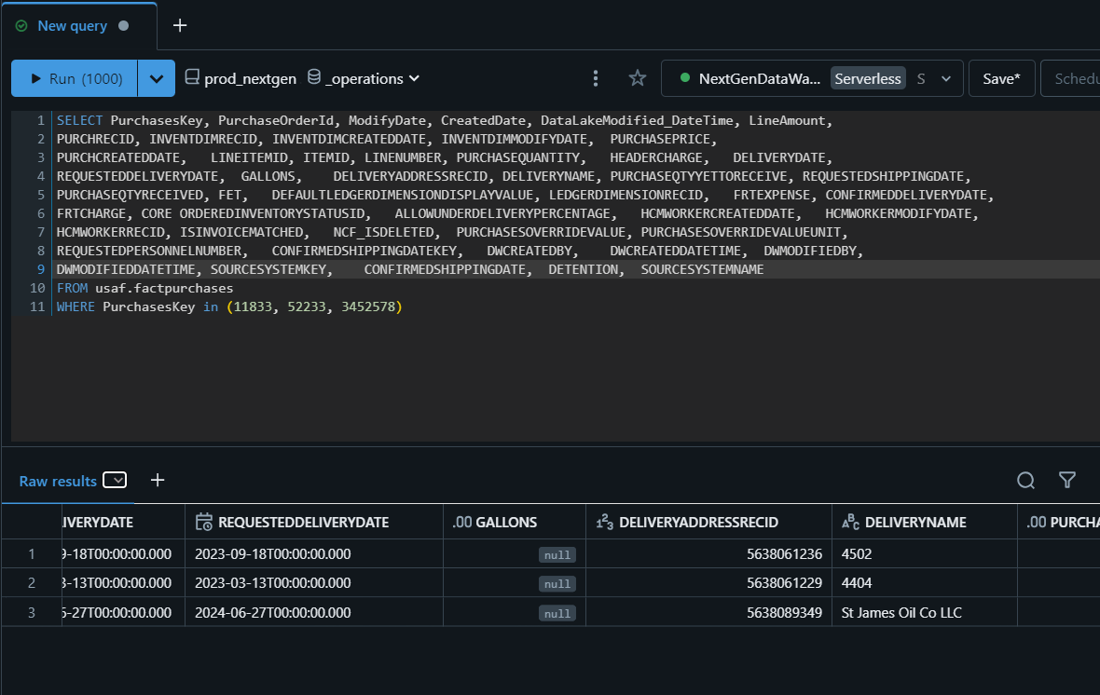

Link for ExclSheet:

<https://dvsum.zendesk.com/attachments/token/vhjujEGgGeMHyXwhSkTbOkcvo/?name=exceptions_DQ-0005021_114349900.xlsx>

**Solution:** Our team informed them that as our system is designed to retrieve the top 30 columns from the database source. When they created an MDC rule and applied a blank check to the DELIVERYADDRESSRECID column, along with several others. Since DELIVERYADDRESSRECID is not included in the top 30 columns, the actual values were not retrieved from the database so it is showing with the null values. And confirmed that, the rule is working as expected, but because the column wasn't fetched from the database, the Excel sheet displays those blanks.

And informed them, this is something that needs to be resolved, and the team has discussed it internally. Then the FR was logged, and the ticket is now closed. A follow-up ticket will be created once the feature is implemented.

1. **Incident #26700 merged with ticket#27133**

**Sub: Request to decommission TBC account on DQ Legacy**

**Question:** Aashish informed thatTBC has decided to not continue with DvSum any longer. Please work with the Product team to backup TBC assets and then proceed to purge them from application and backups.

I need a written document (which will be signed) that describes all the things we have done to purge their data from DvSum. It should include a checklist like “Rules, Sources, Users, Connections, History”. And that it is deleted from the main db, from databases, from S3. So I can certify that list and send it to TBC.

In the merged ticket the customer asked: Just checking in on how things are going with the data retention request. These old workflows are still alerting us.

**Solution:** As per the Aashish request TBC account submitted for backup and prepared for deletion, during that since it was submitted in cognito pool the scheduled jobs were running continuously. So the customer raised a ticket again about this(merged ticket#27133). After connecting with Ramana and Adnan all those scheduled jobs were deleted and the TBC account deleted permanently including “Rules, Sources, Users, Connections, History” after sending all back-up details to TBC.

1. **Incident #26967**

**Sub: Procedure to re-set user local passwords**

**Question:** I just enabled SSO live mode within the DVSUM site for our instance.

Normal Jamaica users (and a couple of Trinidad users) will test the new login tomorrow morning.

When I enabled live mode, I received a warning saying that current local passwords were going to be deleted.

I would like for you to provide instructions on steps that users (or us as admins) will need to follow for users to create their password again, in case we need to turn SSO off.

This is just a precaution, I’m not anticipating any problems, but it’s better to have this knowledge beforehand.

**Solution:** Team replied that, Since we've switched to Live Mode, users can now log in via SSO without needing their email and password.

And said that If they decide to disable SSO in the future, users will automatically receive an email containing a temporary password, allowing them to set new passwords. While this flow is rarely used in production by customers, it is the established process. We will however still run internal tests to ensure it functions smoothly and they do not face any issues. And informed them that, an update will be given within a week so that client can proceed with disabling SSO at their convenience and confident that everything will work as expected.

A week later, the team followed up to confirm that everything was in order for customer to proceed with disabling SSO at their convenience. Since no response was received from the customer, the ticket was closed.

1. **Incident #27101**

**Sub: DI down for USV - URGENT**

**Question:** DI down for USV after Gateway update today.

**Solution:** They installed the updated gateways and all the initial checks were passed. But when they tried cataloging/profiling they encountered some errors after that they connected with the customer team and later the error was fixed. Then they downgrade the previous versions of gateways for both DQ and DI.

**Note:** For high-priority tickets, we need to follow the SLA process, which requires immediate attention. First, we should try to contact Taimoor or Hajra via Skype or Teams. If there is no response on Skype or Teams, we should reach out through whatsapp. If still no response, then need to follow the same for Jawad.

1. **Incident #27132**

**Sub: Re: Unable to validate & publish the records on DVSUM tool**

**Question:** Users requested to add below new suppliers to DVSUM portal and we have done the set up for the same .After the new set up , we are facing some new issue such as below .

Please need your support to fix the issue & feel free to connect for more details .

Requested Supplier

Supplier Code : CRE019

Supplier Name : CREATIVE POINT ADVERTISING LLC

Issues-

* DQ status reading as INVALID

* Items are not getting committed on Dvsum

* Publish Failed

* Unable to validate & publish the records

**Solution:** For this Team asked the customer to share SAWS log for the further analysis about the issue to understand about how the new supplier was set up and what occurs when fetching the records in the workbench, particularly regarding the "INVALID" status and also to review about the storing procedure running in the background to see why this is happening. The team connected with the customer directly and solved the issue.

1. **Incident #27211 for this incident follow-up ticket#27212 is created**

**Sub: LLA User Nigel James (GRN) not able to login to CADDI**

**Question:** User nigel.james@cwc.com is not able to login through https://www.app.dvsum.ai/login

He is using the box at the left (SSO), but getting this error.

He tried entering nigel.james@cwc.com and also 1803002@cwc.com (oneID, which is also a valid login within LLA)

His account is created locally in CADDI, and authorized in Okta portal.

Please note this should be treated as an important matter, as this is our main test user in Grenada, therefore is delaying deployment of CADDI for that market.

**Solution:** After reviewing the login issue, the team found that the user is not currently added to the DvSum application account. And then they informed the customer to add the user in the DvSum account, because the user must be added to the application before they can log in via SSO. For reference, the team has attached screenshots.

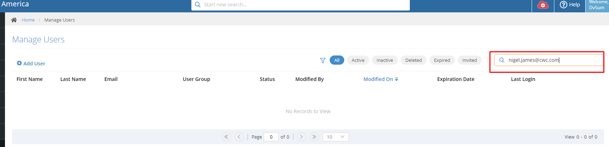

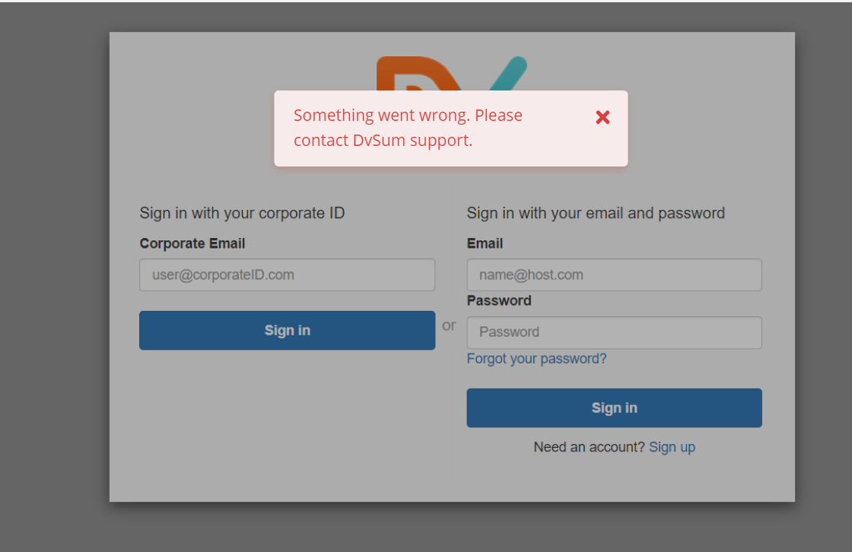

They have provided the link to the knowledge base article for a reference to add a user <<https://dvsum.zendesk.com/hc/en-us/articles/203082210-Manage-Users>>.

The follow up ticket was created by the customer,

**Question:** Team, Nigel was able to successfully access CADDI.

However, I think the invitation email is misleading, as it says there is a temporary password set. However, as we are using SSO, I believe this password will never be used/required. I suggest reviewing that workflow for SSO enabled customers.

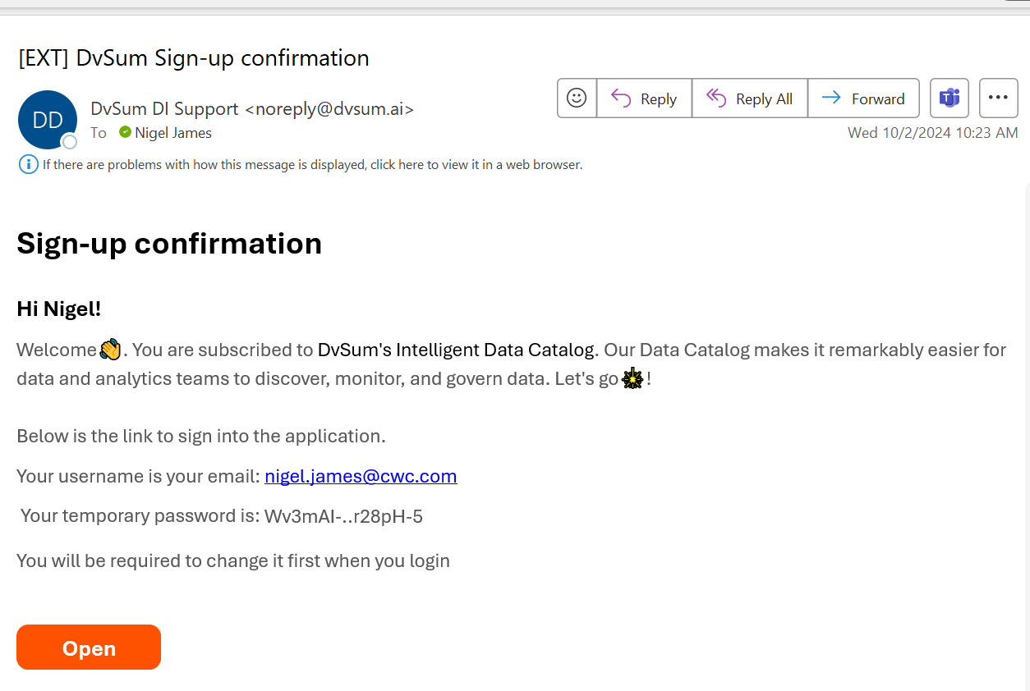

**Solution:** Matt informed the team that this should be treated as a high-priority bug.

As we didn’t face this issue during the Jamaica rollout because SSO was enabled after the initial deployment. However, with TT, SLU, and GND, all new users will encounter this message. If a large number of users receive emails with incorrect information, it will become challenging to manage.

So he informed the team to log a FR and share FR number in the group so that he can track it with the Development team. And informed Allison to put this issue into their OAI tracker so that we stay on top of it.

Then FR was logged and FR number and FR link was shared in the group by Taimoor.

Later the team implemented the requested update regarding SSO-enabled users. When SSO is enabled, the invitation email will no longer include a temporary password. This ensures that new users in TT, SLU, GND, and other regions won’t encounter any misleading information during the onboarding process.

1. **Incident #27213**

**Sub: Scheduler not working**

**Question:** Why was my recurring job with a defined number of occurrences not showing up in the list or being assigned to a rule?

Below images are the reference images.

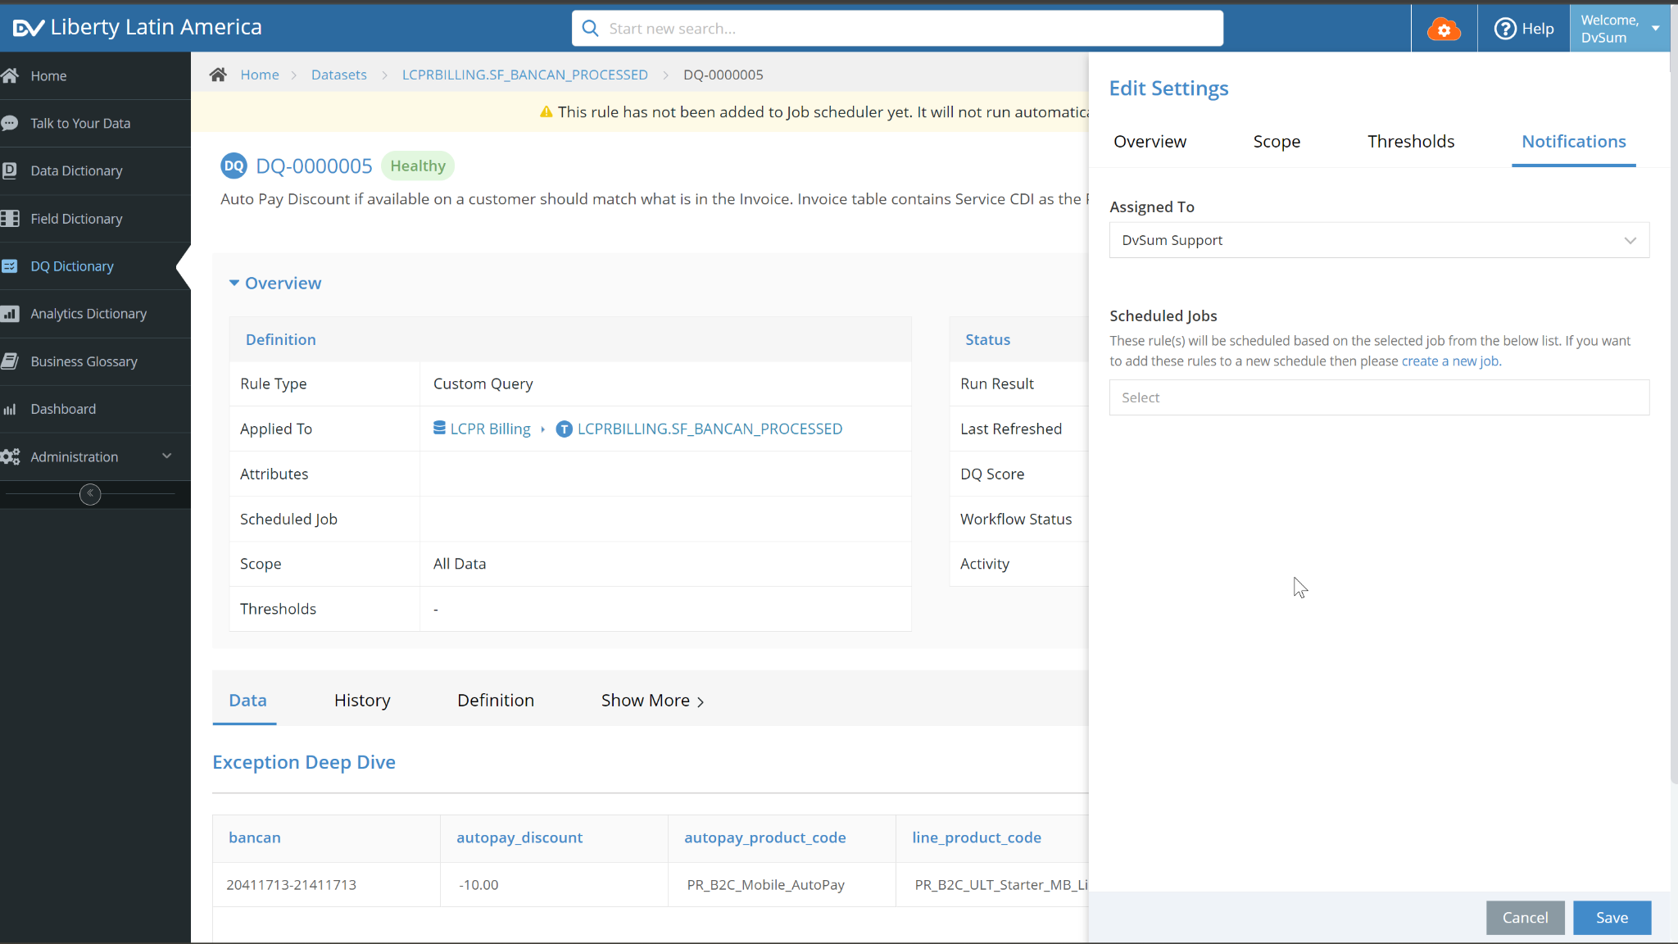

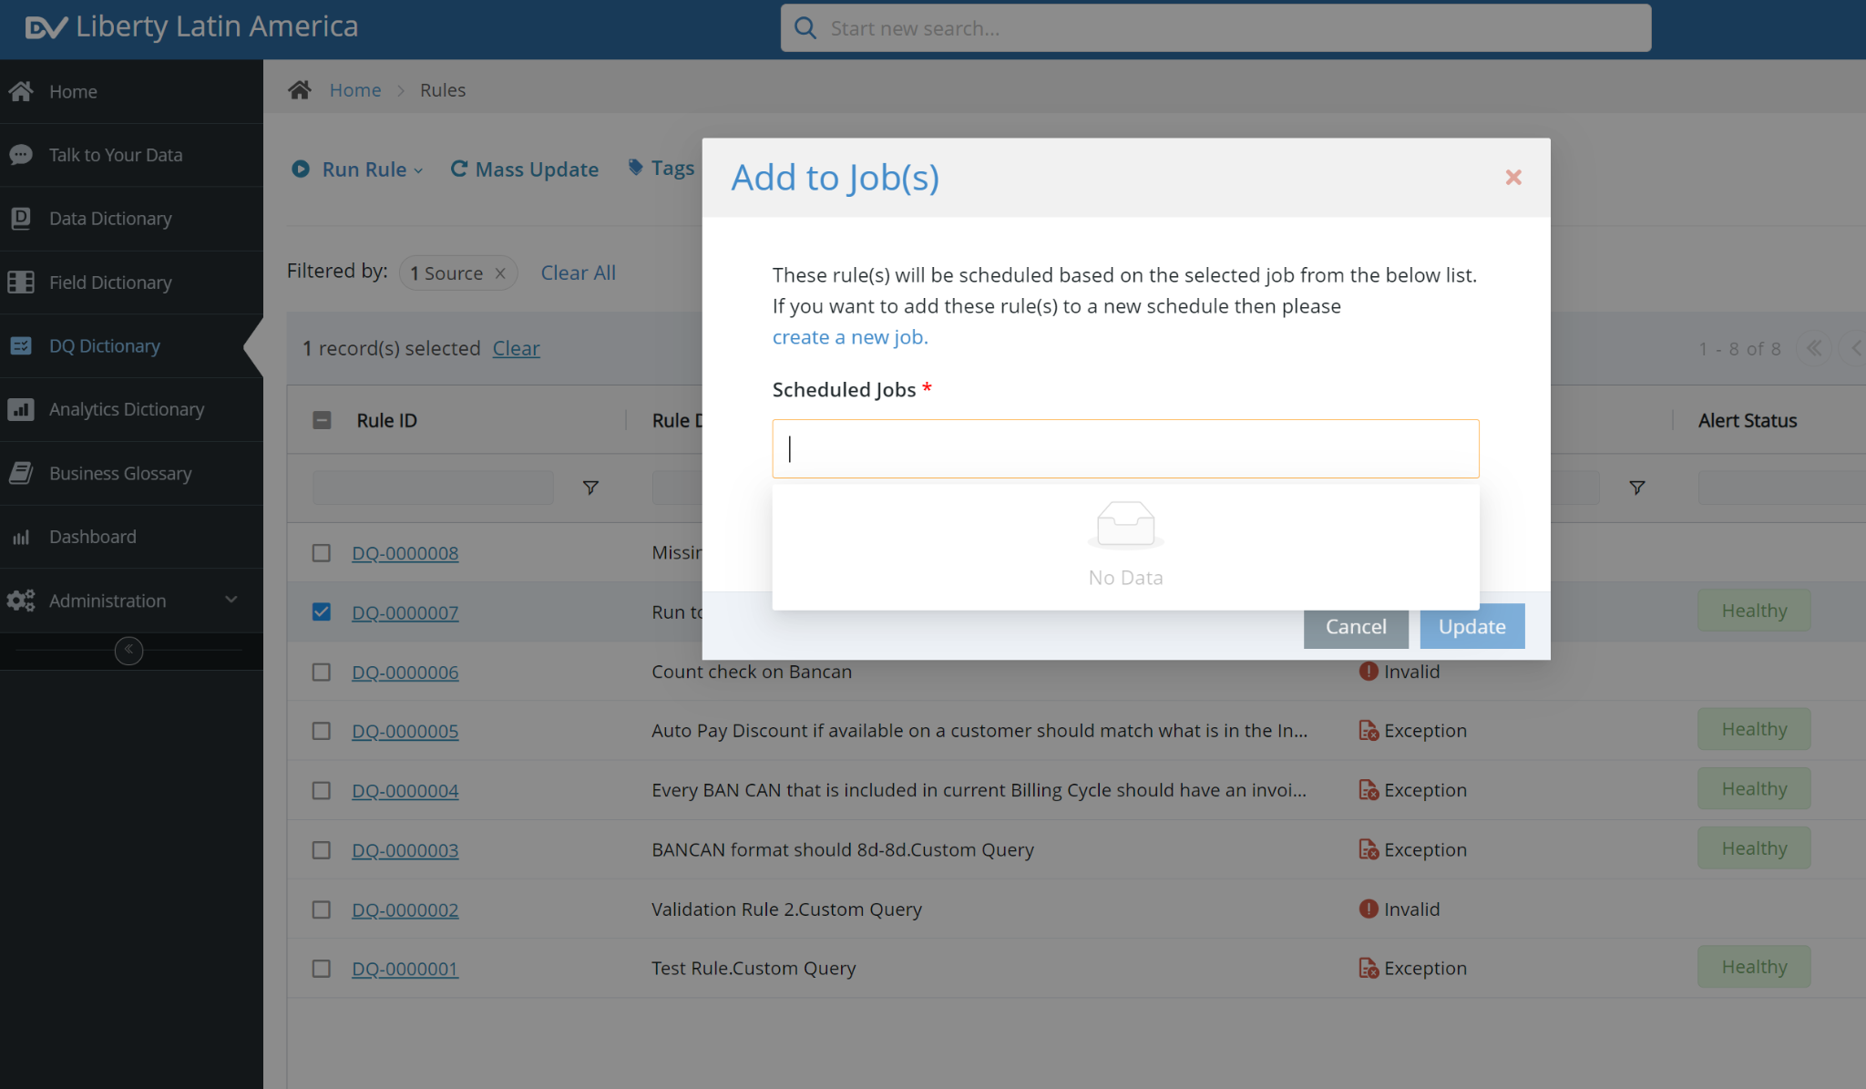

**Solution:** Initially, the system was designed to only display and allow assignment of jobs that were either never-ending or recurring with daily, weekly, or monthly frequencies. However, recurring jobs set to end after a specific number of occurrences were not being shown as assignable due to this restriction.Based on the feedback, a fix has been implemented. Now, all valid recurring jobs—except one-time jobs—will appear in the job list and can be assigned to rules as long as there are future scheduled occurrences. This adjustment ensures greater flexibility and usability when managing recurring jobs.

Knowledge base article about scheduling jobs in DI for reference to the client:

<https://dvsum.zendesk.com/hc/en-us/articles/18727787422228-How-to-Schedule-a-Job-for-Data-Sources>

1. **Incident #27214**

**Sub: Rule Privileges in DQ**

**Question:** If a user is assigned an edit role on a table, should they be allowed to create rules?

**Solution:** Team as replied as Yes.

Knowledge base article about rules in DI for reference to the client:

<https://dvsum.zendesk.com/hc/en-us/articles/17457922936468-Rules>

1. **Incident #27465**

**Sub: please check current profile job**

**Question:**  Why is this job running 2+ hours with no log?

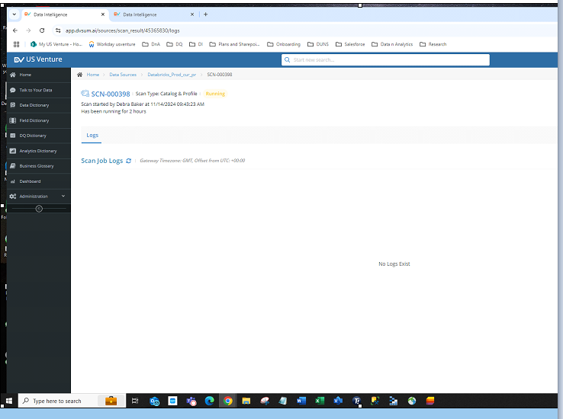

**Solution:** The team attempted to investigate the issue where the scan was stuck in the running state, but further analysis requires a live occurrence of the issue. In this instance, the job was aborted, preventing us from gathering additional details. And informed them that if the issue arises again, please let us know so we can notify the team to check while it's still in the running state.

Additionally, the internal team came up with a logic that, if any job took more than 15-20mins, it automatically terminated the job and reinitiated the job.

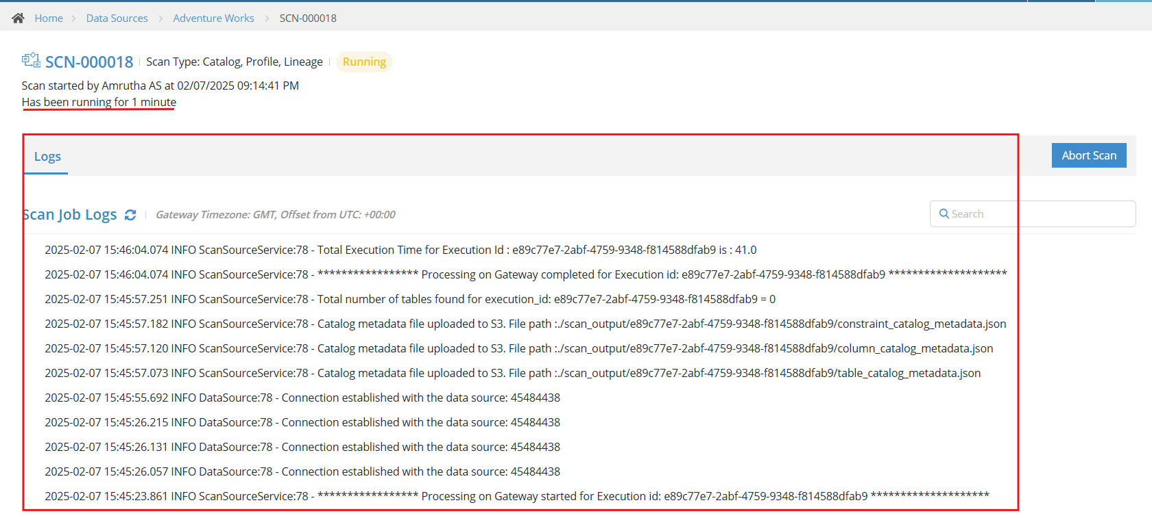

Now the jobs are running actively within 1 or 2 mins with log information.

1. **Incident #27468**

**Sub: Issue on Data Dictionary View**

**Question:** Customer tried a new Create View off of Data Dictionary mistype format for Record count filter. She is doing implementation now. Image included, and video comments, three sections to review if needed:1. Beginning to about 5 minutes. Then also at 8:30 until end. Notes: a. Cleared cached, logged in and out. Logged in with another browser with the same userID. The issue remained across browser sessions.

Reference video link:

https://dvsum.zendesk.com/attachments/token/sUg8zR2D5SC6DIylpv1C2qguU/?name=troubleshooting+Data+Dictionary+View+Recording.mp4

Reference image:

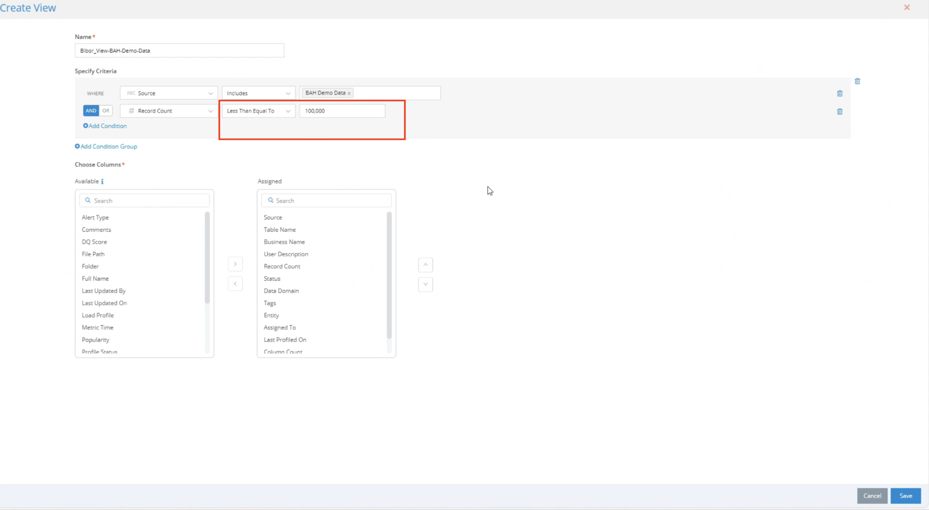

**Solution:** The team analyzed the issue and identified that it occurred due to the use of a comma (,) when entering the record count value in the specified criteria. The issue was resolved, and the user was advised to avoid using commas until the fix is permanently deployed to the product.

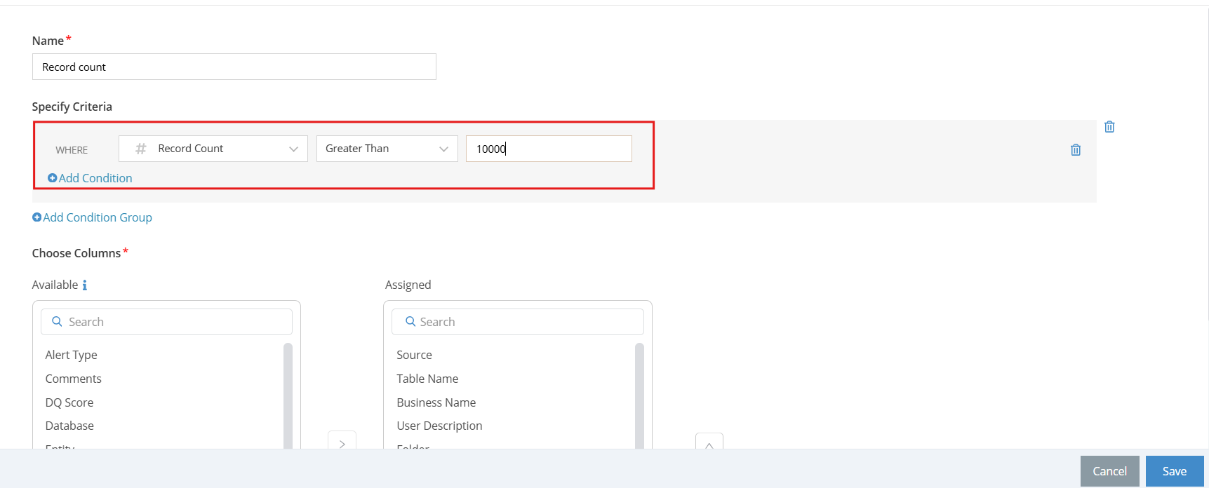

Now we cannot use the comma to specify the count number only we use dot(.) or we can enter the number without any special characters.

Knowledge base article about creating view in DI for reference to the client:

[**https://dvsum.zendesk.com/hc/en-us/articles/10027321551380-How-to-create-Governance-Views**](https://dvsum.zendesk.com/hc/en-us/articles/10027321551380-How-to-create-Governance-Views)

1. **Incident #26524 for this incident follow-up ticket#26738 is created**

**Sub: updating DVSum Mazda Catalog Admin access**

**Question 1:** Can you please help us on the below request :

Under the current setup for intelligence data catalog admin (https://www.app.dvsum.ai/) We had created Mazda Catalog Admin Group which provides access to the below groups as mentioned in the screenshot.

Tag Management was not included under Mazda Catalog Admin Group , Can you please let us know how we can add the tags under Mazda Catalog Admin Group, I know that if we provide Default Admin Group it will give access, but we don’t want to provide Default Admin Group because it provides all user related access.

Mazda Catalog Admin Groups :

Below is how it was defined for Mazda Catalog Admin Group :

Default Administrator Groups :

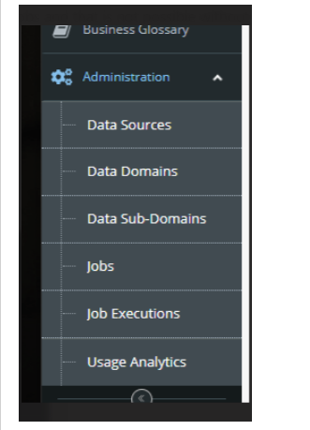 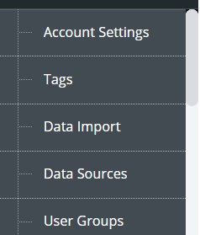 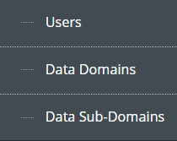 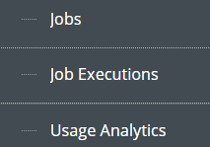

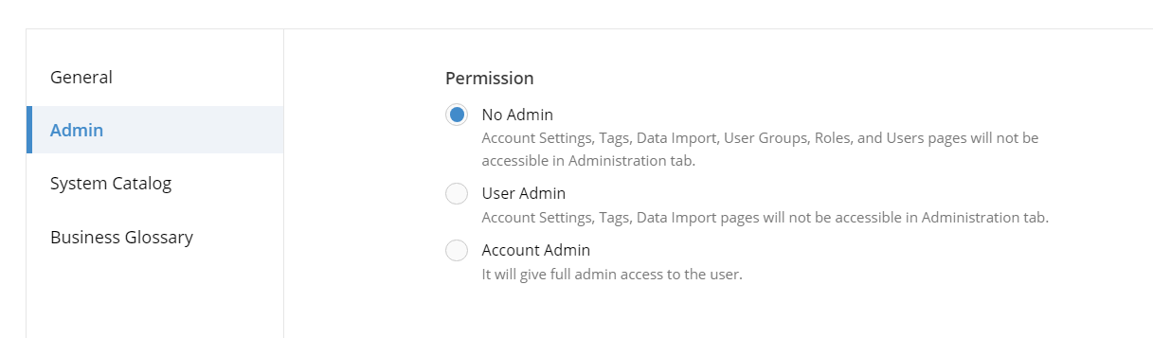

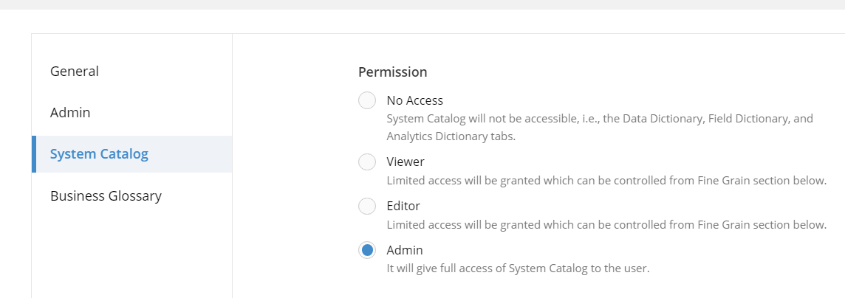

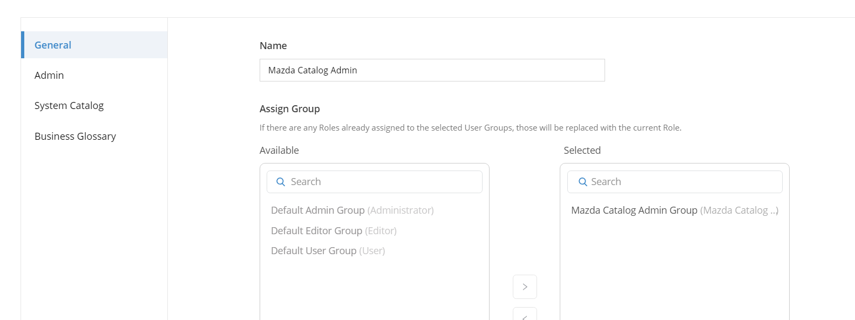

**Solution:** The team reviewed the request.And informed the customer that, the reason why the customer cannot add or see the Tags tab for this user group is that they have selected the "No Admin" permission under the Admin section. This permission level explicitly prevents users from accessing the Tags page.

To provide access to the Tags page, they need to assign "Account Admin" access to the "Mazda Catalog Admin" user role. A screenshot has been attached for reference.

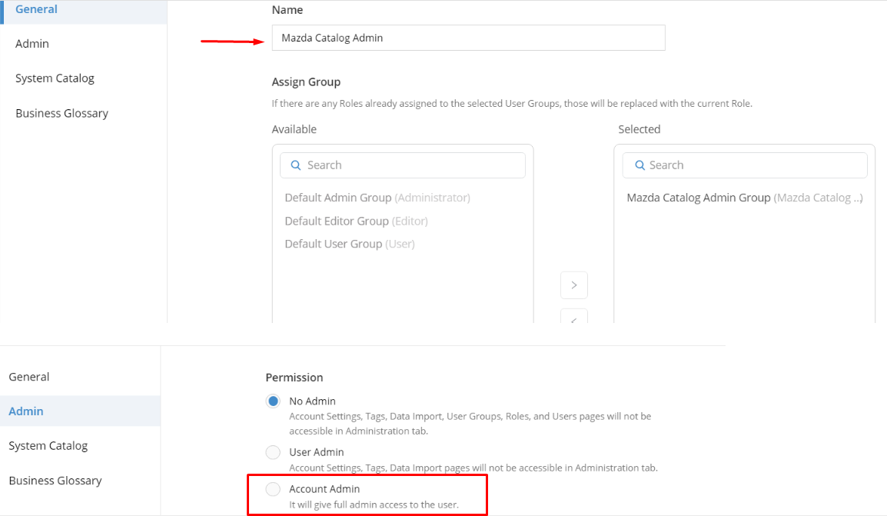

Reference article for creating user roles:

<https://dvsum.zendesk.com/hc/en-us/articles/17327470244244-User-Role-and-Module-Settings>

**Question 2:** We don’t want them to have user administration access. Can you please confirm if only tag management alone can be done.

**Solution:** For this team informed that currently, tag management cannot be done without account admin access. However, we will consider this feedback and log it as an enhancement request.

**Question 3:** Hi Billy and Dave,

We have enabled admin access as per DvSum's support guidance. Currently, Catalog admin access includes user administration privileges. Please inform your team to collaborate with RACF and adhere to the standard procedures for adding users in DvSum.

Meanwhile, we will liaise with DvSum support to explore options for creating a separate group with Tag management capabilities while excluding user management features. Thank you for understanding our security concerns.

This revision clarifies the actions taken and communicates the next steps more clearly

**Solution:** Billy informed that this will be communicated to the team. He mentioned that, even though users are added, access to roles will not be granted unless a business or use case has been provided to him. Once he receives the request, he will forward it to client’s team, and no access will be granted until then. He assumes the system will track changes, so please notify him if anyone grants access or changes any settings, so that the appropriate actions will be taken.

Then the follow up ticket is created to inform that the FR has been logged for this ticket. And informed that the changes have been deployed to the production and the demo has been presented to the client(Mazda).

1. **Incident #27099**

**Sub: Re: Siebel and SOA Database Integration**

**Question:** Hi Octopai and DVSum Teams,

We have created Siebel and SOA connections to run scan have some questions:

DVSUM:

SOA(Fusion Middleware) is Metadata DB What type of Permissions need to be Provisioned.

Siebel CRM Databases permission document.

Octopai:

I have run a scan but it's completed with errors, could you please check and let us know.

**Solution:** Team asked the customer to give me more information and clarity on their request for DvSum?

1.SOA(Fusion Middleware):

Can we schedule a call to discuss this in more detail? We’d like to understand how you're using SOA and how you'd like to proceed with its integration into DvSum.

2.Siebel CRM Databases permission document:

Since we don't have a direct Siebel connector, I assume there’s an underlying database you’re using. Could you confirm which database technology is being utilized with Siebel CRM?

After that, we will be able to provide you with the information on the database permission document.

For this customer confirmed that they are using an oracle database and connected with Taimoor directly and discussed about the issue.

Based on the discussion Taimoor provided the key takeaways:

* We reviewed your use case and confirmed that the underlying databases (Oracle) are supported by DvSum, as the Oracle cluster has already been added as a data source.
* However, due to schema permissions, the schemas are not visible after authentication. Based on our discussion, here are the next steps for you:

Action Items:

1. Verify the schema access for the SVC_DVSUM user to ensure that all required schemas and tables are accessible. (Rohini)
2. Run the provided SQL query to check schema access and confirm if the necessary schemas are available.

After receiving the confirmation from the customer we have closed this ticket.

**17. Incident #27600**

**Sub: Mass update functionality for data classification in glossary terms is not available, requiring manual updates for each term.**

**Question :**

We can update individually the items in the business glossary but we can't use a mass update which has been time consuming and unfortunate since all our recent glossary terms don't have a data classification.

Can you turn this into a request for more options/mass change to change the data classification for the glossary terms like we can with the field dictionary?

I do have a question on expected functionality.

Do we have to set the data classification on all fields that come in AND the glossary terms that we link the fields to?

Is there any relationship or check between the data classification on a field that is linked to a glossary term? It appears they are not integrated and without manually updating both. I could see the data in the linked fields from a term that is marked as confidential. Is this the design?

**Solution:**

**1. Mass Update for Data Classification in Glossary Terms**

Currently, there is no functionality to perform a mass update for data classification in glossary terms. While mass approval of terms is supported, data classification updates are not included in this feature.

Next step: We can consider this as a Feature Request (FR) to enable mass updates for data classification in glossary terms, similar to what we currently have in the field dictionary.

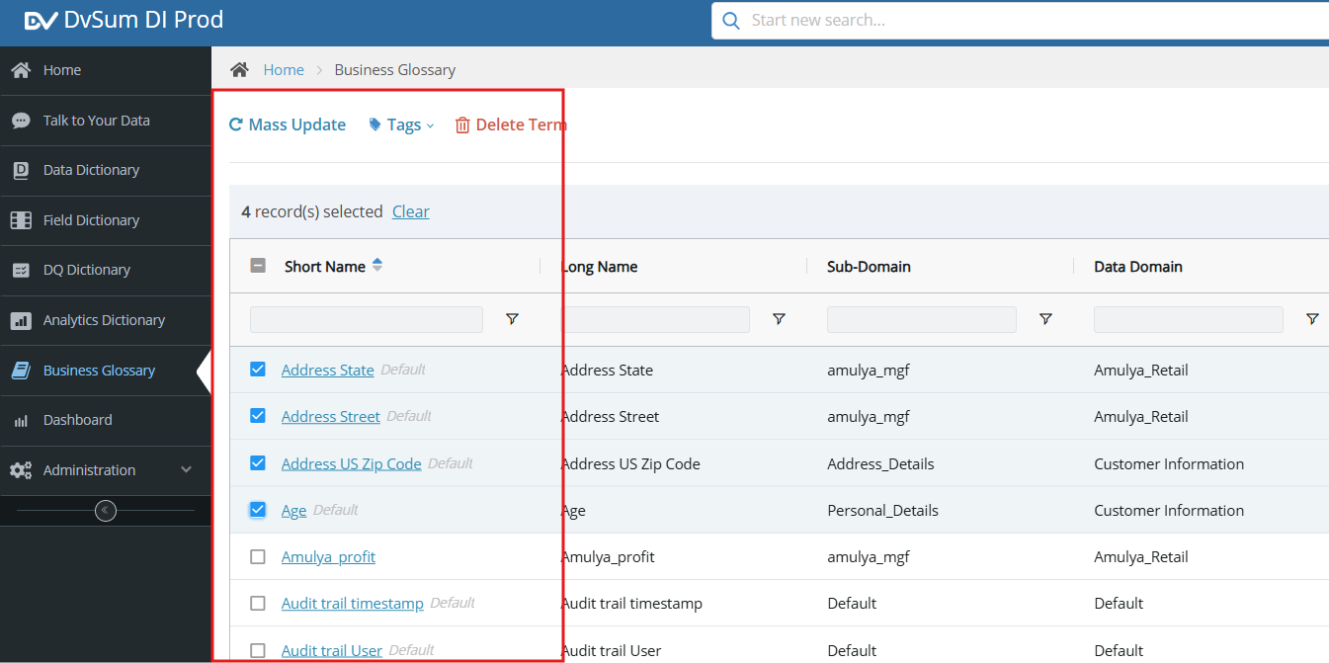

Now it has been implemented and we can perform a mass update for data classification in glossary terms.

Knowledge base article about mass update in DI for reference to the client:

<https://dvsum.zendesk.com/hc/en-us/articles/10582893963924-How-To-Mass-Update>

**2. Relationship Between Field Data Classification and Glossary Terms**

Currently, there is no direct relationship between the data classification of fields and the glossary terms they are linked to. Since glossary terms do not support data classification at this time, this issue will be relevant once the requested feature is implemented.

Next Step: Once glossary terms support data classification, we will be able to address this relationship effectively.

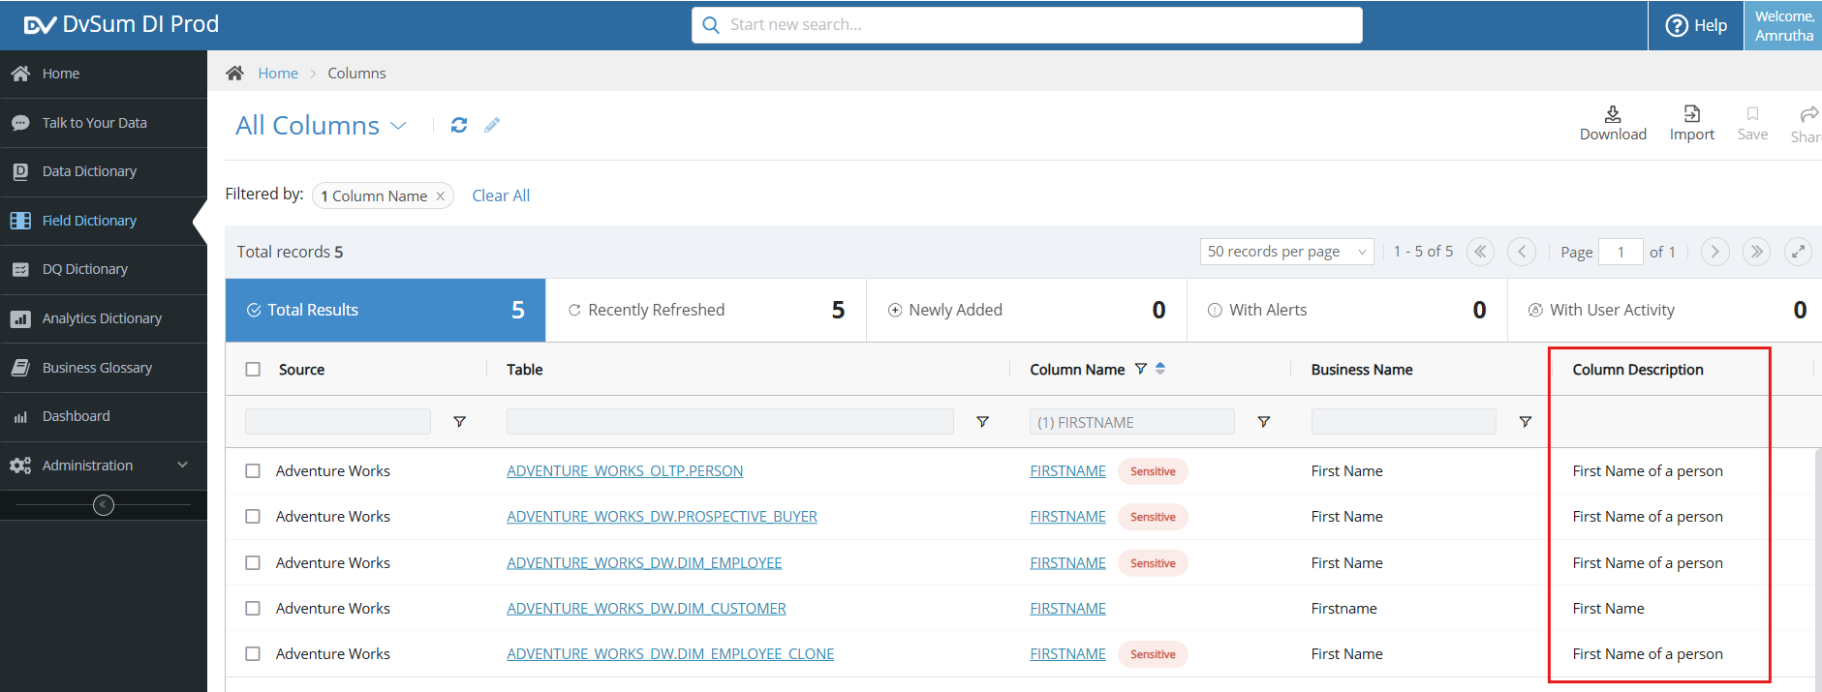

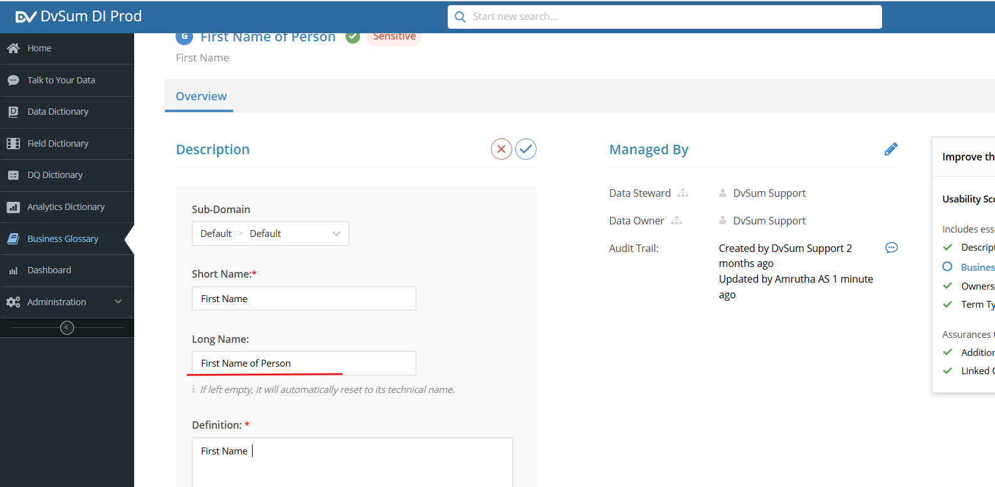

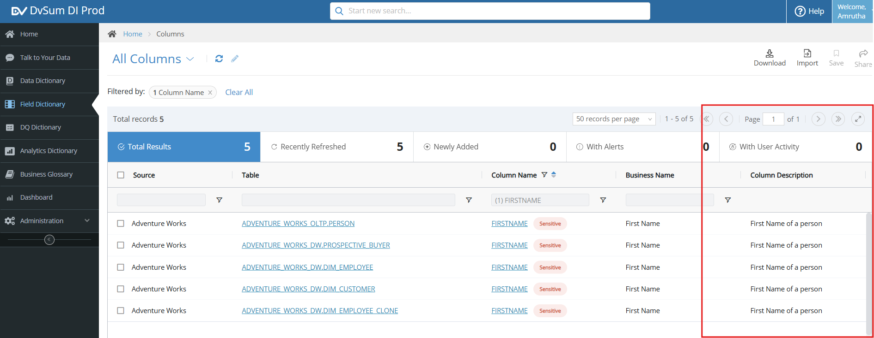

**3. Design Confirmation for Confidential Glossary Terms**

It is by design that fields linked to "confidential" glossary terms can display data without manual updates to their classifications.

Next Step: This design will change once the requested features for mass updates and data classification in glossary terms are implemented.

The ticket is being closed, and we have logged FR-979 for the enhancement. A follow-up ticket will be created once the enhancement is deployed to production.

**18. Incident #27523**

**Sub: UAT: Two rules alerting in DI, not in DQ**

**Question 1:**

Two rules which appear the same alert in DI and not in DQ. Shouldn't alert as they passed 100%

Dq-0006294 and DQ-0006295 both ran today 11/26 with different results.

**Solution:**

We found that the DI is functioning as expected, where it correctly triggers an alert for the rule even

though the rules have passed with 100%. This happens because the Threshold is set between 98-100,

and while there are no exceptions, the system still flags it as alerting.

In DQ, we’ve identified this as a bug causing the discrepancy, as it should also show alerting under the

same conditions. We have logged this internally as a bug, and our team will be working on fixing it. We

will update you once the issue is resolved.

Please refer to the attached screenshot for further reference.

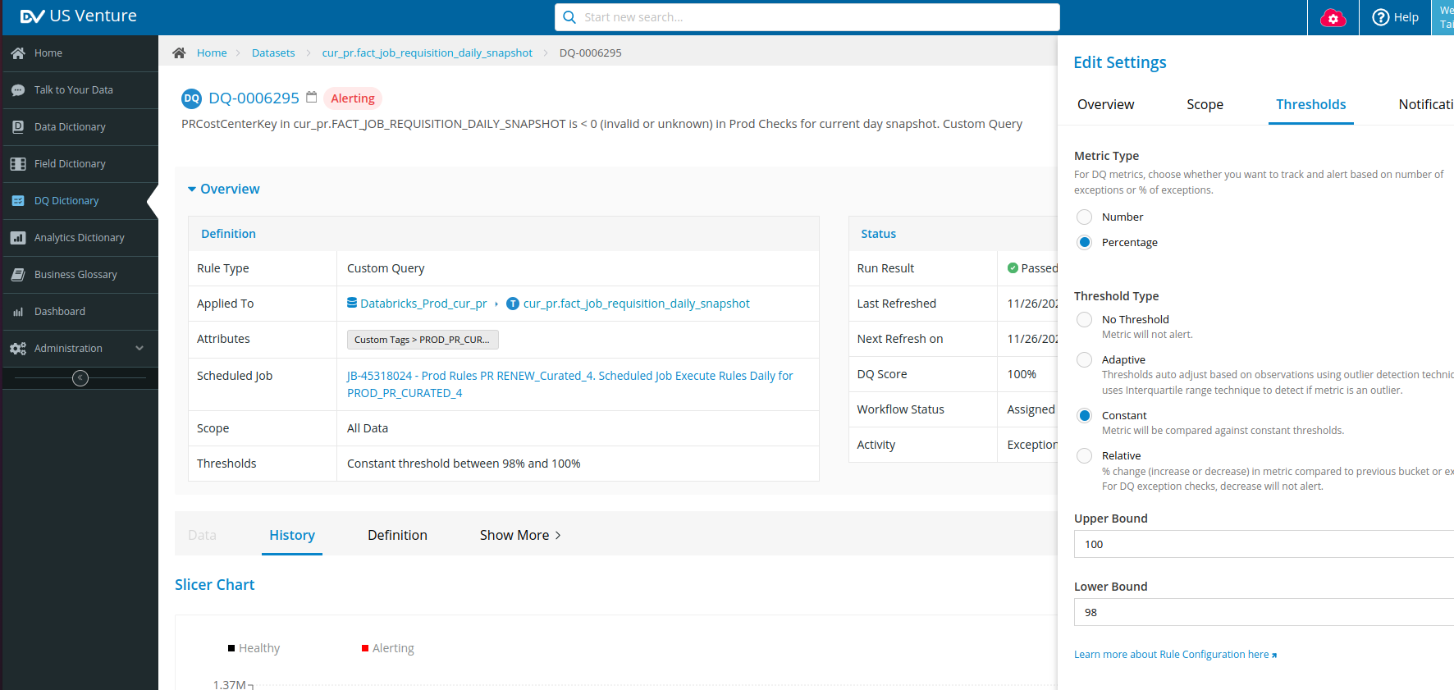

**Question 2 :**

I don't understand this and need a discussion I believe. In other words if it fits within the threshold it

does not alert like for numbers I put 1 to 6 and it only alerts when it is outside this threshold. That is

how it worked in DQ with percentage too if the percentage was displaying as 100% and the threshold

was 92-100% it did not alert.

**Solution:**

Based on Debra's comment, Hajra understands that she might be considering the DQ Score value as

the Percentage of Exceptions, but they are not the same. It is described in detail:

1. DQ Score represents the percentage of good or non-exceptional data. It is a measure of how much of your data meets the quality standards, without any exceptions. The DQ Score does not track exceptions but instead tells you how much of your data is compliant with the rule.

* For example, if you have 100 records and 95 are valid (no exceptions), the DQ Score will be 95%. In this case, the percentage of exceptional records (those that do not meet the rule) would be 5%, but the DQ Score is focused on the valid, exception-free data.

1. In DI, the alerting works based on the percentage of exceptions. This means the system tracks how much of your data has exceptions (i.e., data that doesn't meet the rule). If you set a threshold for exceptions (for example, between 98% and 100%), the system will trigger an alert if the percentage of exceptions falls outside that range.

* In your case, since the number of exceptions is 0, the percentage of exceptions is also 0%. This falls outside the threshold range (98%-100%) for exceptions, which is why the system is showing an alerting status.

This clarifies the difference between DQ Score and Percentage of Exceptions and explains why she is

seeing the alert in DI. The DQ issue, as previously mentioned, has been reported to the team.

**Question 3 :**

This is a change in functionality between DQ and the migrated DI rules, wait we expect is for you to

come up with how we should set up the rule so that we can replicate the functionality of what alerts

and doesn't. If there is a different recommended way to set up the rule please advise. If there are no

exceptions and/or data score is 100 then we do not want it to alert. please advise.

**Solution:**

To avoid the alert when there are no exceptions (percentage of exceptions is 0%), you can adjust the

Threshold Range. Instead of setting it to 98%-100%, you can modify it to start from 0%.

This setup works because the system evaluates the percentage of exceptions against the defined

range. When the range starts at 0%, it includes cases where there are no exceptions. Therefore, if the

percentage of exceptions is 0% (i.e., no exceptions exist), the system will recognize this as within the

threshold and will not trigger an alert.

Closed the ticket as this has been discussed with Debra.

**19. Incident #26656 for this incident follow-up ticket** [**#26769**](https://dvsum.zendesk.com/agent/tickets/26769) **is created.**

**Sub: New job add screen.**

**Question :**

Can we create jobs to catalog a source or tables from the create job screen like we could in legacy

DQ? We run a job each morning to catalog each source in the early morning.

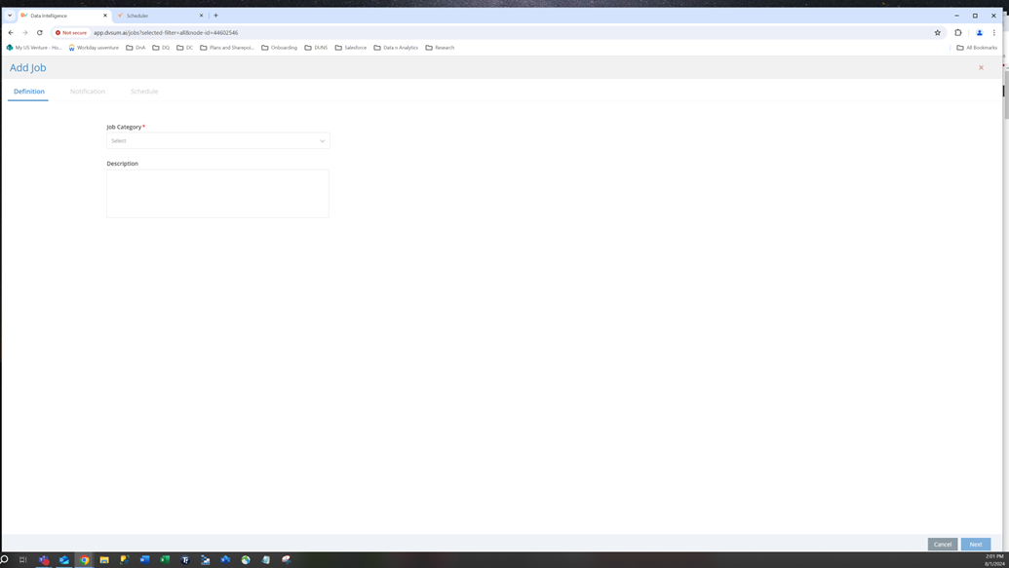

**Solution:**

Unfortunately, cataloging jobs for the sources cannot be scheduled from the Add Job detail page;

only profiling and rules execution jobs can be scheduled from there. To schedule a cataloging or

cataloging/profiling job, you can create a daily job from the settings tab of the Data Source.

This is a follow-up ticket.

As discussed in the call with Debra, she would like to have the cataloging option in the job detail page.

FR 716 has been logged.

The ticket is being closed. A new follow-up ticket will be created to inform the customer once the

feature is implemented.

**20. Incident #27158**

**Sub: Long Running scan MMASDB03**

**Question 1 :**

I have submitted a Catalog only scan job of MMASDB03 database which is DB2 type. The database has

76 tables and should have been finished quickly. However, it is still running for more than 3 hours.

Please advise.

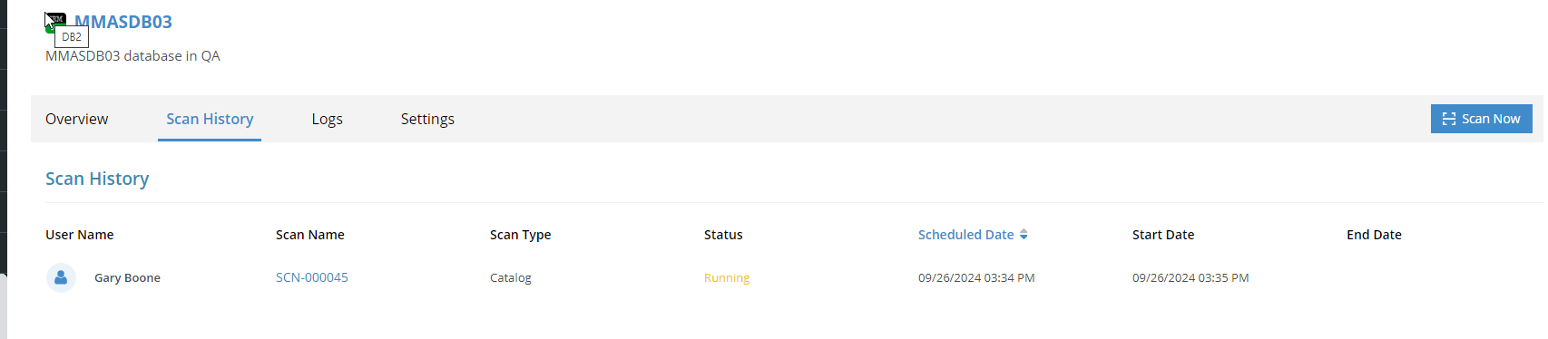

**Solution:**

1. In the scan logs for the "MMASDB03" data source, we found two tables containing spaces in their names. This caused the scan to get stuck in a running state and prevented it from completing.

2. Space in the table name prevents the scan from finishing, which explains why it ran for an extended period without completion.

**Resolution:**

1. After identifying the issue, we replicated the scenario in our DB2 environment and applied a fix.

2. If any DB2 source table contains spaces in its name, the DvSum system will automatically trim the space during the scan, ensuring the scan completes successfully and all tables are processed.

**Next Steps:**

1. For the current "MMASDB03" scan that is stuck (SCN-000045), please abort it by going into the scan details.

2. After aborting, rerun the scan on the "MMASDB03" data source. It should be completed successfully this time, and all tables will be available in DvSum.

3. Please verify on your end of the space in the table names. While the issue is now fixed for DB2 data sources, it’s a good practice to confirm this in your source database as well.



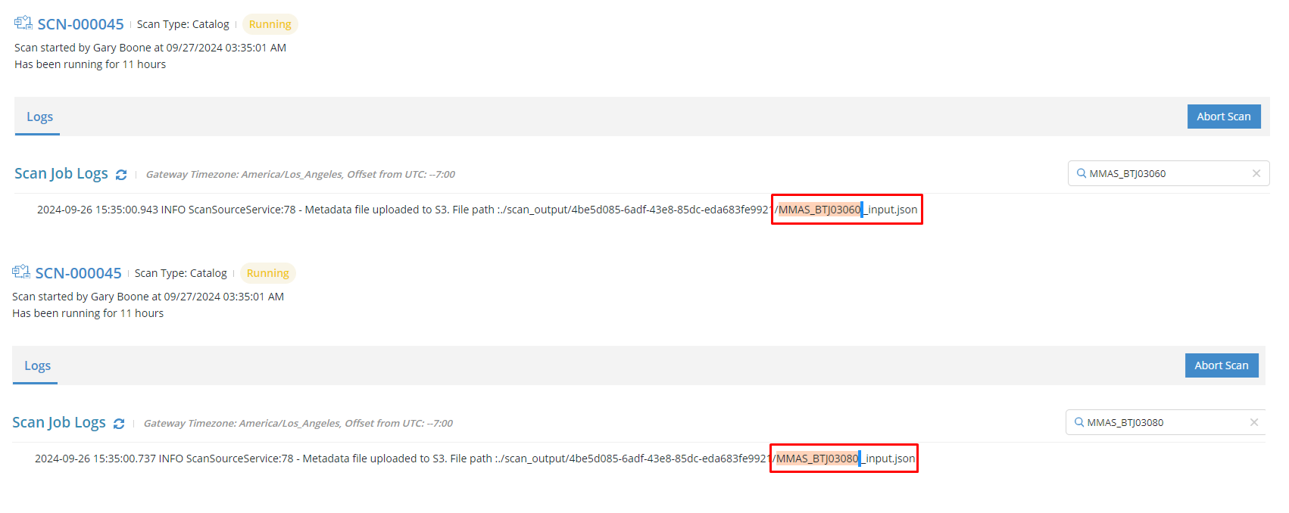

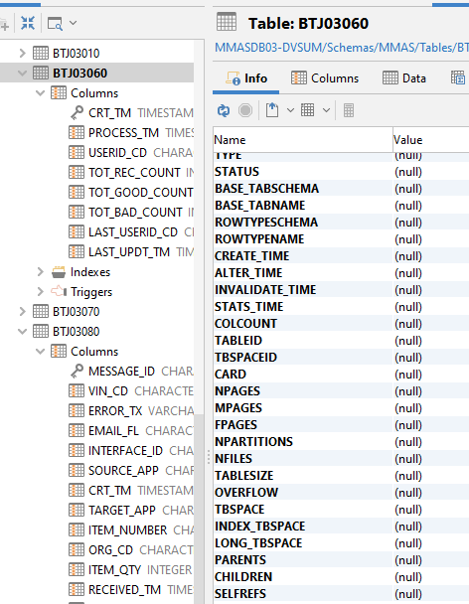

**21**.  **Incident #27423**

**Sub: Schedule timing - current and past times**

**Question:**

Please advise what you have done, probably related to our 'fall back' of daylight saving.The

schedule in DQ appears to have the wrong scheduled time on everything. And history was changed?

can you tell me what was done? It is weird since things I know ran at a specific time say they ran at

different time by the hour.

**Solution:**

We've successfully adjusted the scheduled jobs to reflect the one-hour change for daylight saving

time, so you should now see the job times updated accordingly. Please verify the job times on your

end to ensure everything appears as expected.

The recent issue was due to the Daylight Saving Time change, we last updated the timestamps in

March and made another adjustment this November.

Closed the ticket as there is no response from Debra.

**22.** **Incident #27482**

**Sub: View "VW_ITEMLOCRES" DVSUM**

**Question:**

I hope you are very well! I request your support to obtain the structure of the view “VW_ITEMLOCRES,”

which is in rule 6638. This is for validations that we are doing internally. Thank you very much for your

support! Greetings.

**Solution:**

I found the correct rule. I checked the rule definition and confirmed that the associated view is correct.

I also reviewed the profiling section and verified the view details there as well.

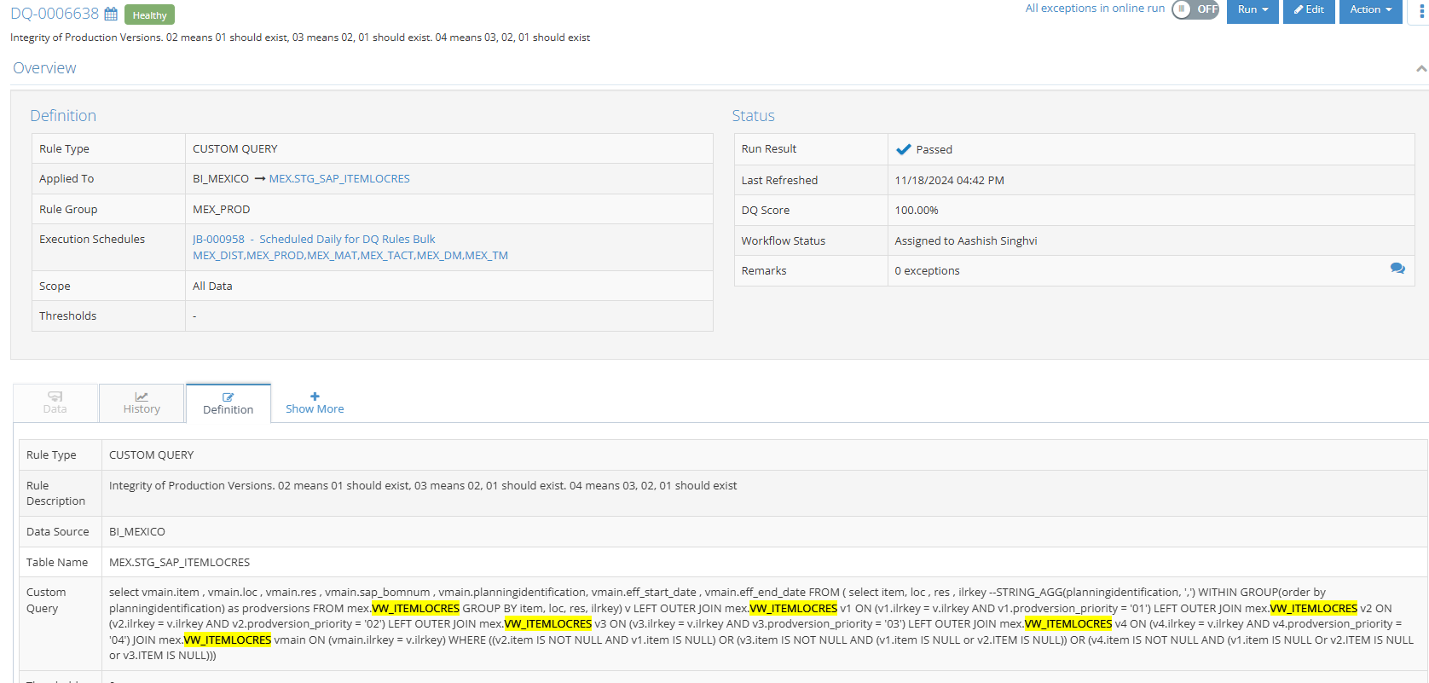

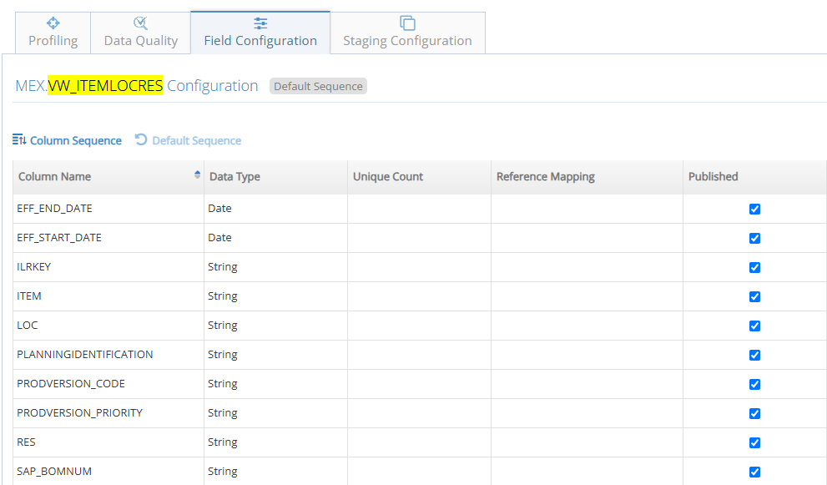

**Question 2:**

Thank you very much for your support Taimoor, **do you happen to have the script of the configuration**

**of that view, to see if it has any join, filter, etc?**

**Solution:**

Below are the script details for your reference.

Hope this helps with what you’re looking for.

CREATE VIEW [MEX].[VW_ITEMLOCRES] AS

select distinct item, loc, res, sap_bomnum, planningidentification, eff_start_date, eff_end_date,

SUBSTRING(planningidentification,1,2) as prodversion_priority,

SUBSTRING(planningidentification,4,1) as prodversion_code,

CAST(item as varchar)+loc+res as ilrkey

FROM MEX.STG_SAP_RESBOM;

**23. Incident #27539**

**Sub: DI -- signin screen timesout**

**Question:**

When signing on to DI screen the screen main data tries to refresh for very long time. It timed out

with the red letters on screen of 'Endpoint request timed out'. The cloud was green on the screen

when I tried this morning.

**Solution:**

The issue has been resolved. The problem was caused by an improper job migration, which has now been

Fixed.

Here is the screenshot for the reference

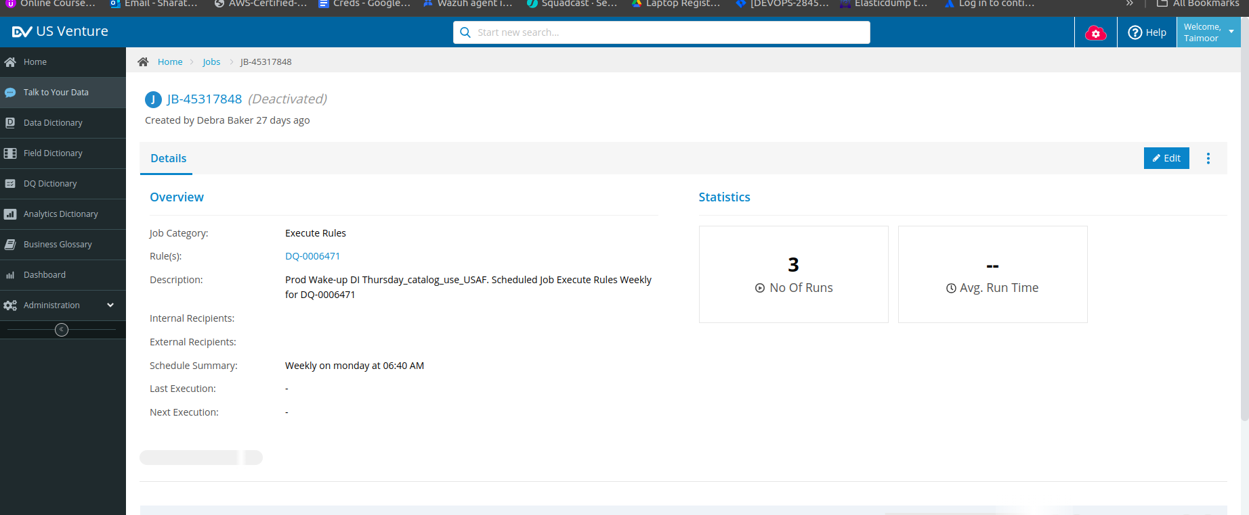

24. **Incident #27522**

**Sub: UAT: Job execution not reflecting date actual ran**

**Question 1:**

See behavior noticed in attached document, job activated indicates it starting running on a previously

scheduled date but actually started today.

Link for attached document:

https://dvsum.zendesk.com/attachments/token/ExkjzFfoP1RCSqO4UQOI5LfEd/?name=ran+today+not+considered+today.docx

**Solution:**

The reason the start time is shown as 11/7 is that the job was originally scheduled to run on that date

but was deactivated at the time. As a result, the system retained the original scheduled start date when the job was reactivated, which is why it displayed 11/7 as the start date.

If you'd like to see the actual run date, we’ve created a new view in Job Execution that includes an

Actual Start Time column. This new view needs to be created outside the job detail page, directly in

the Job Execution section. Once created, you can then go into the job detail page to view the Actual

Start Time and other relevant details.

Please refer to the attached screenshot for the reference. It can create additional views with the

required details as needed by referring to the screenshot.

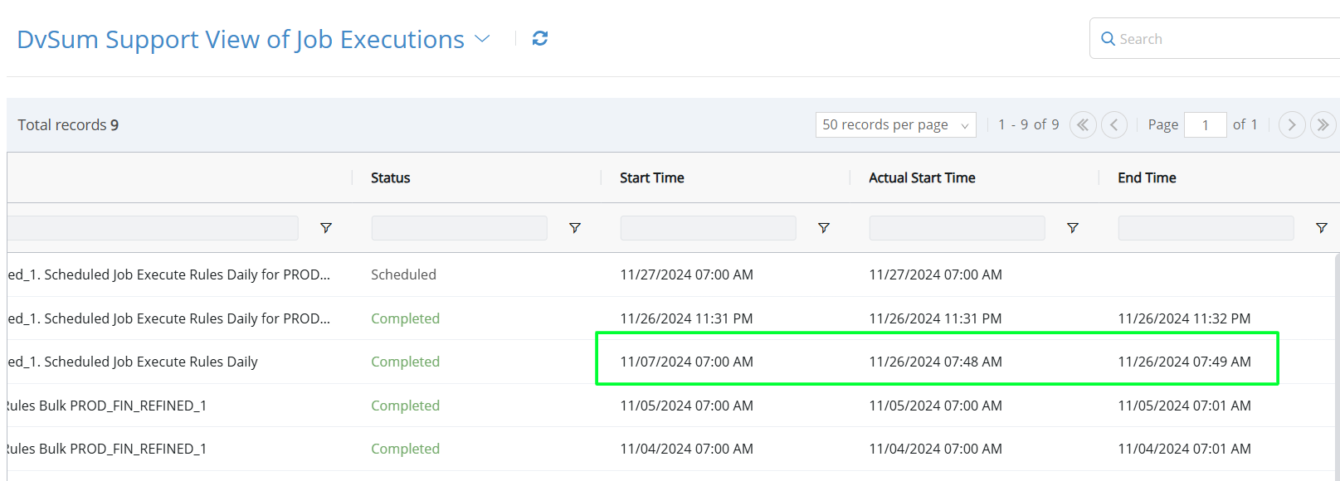

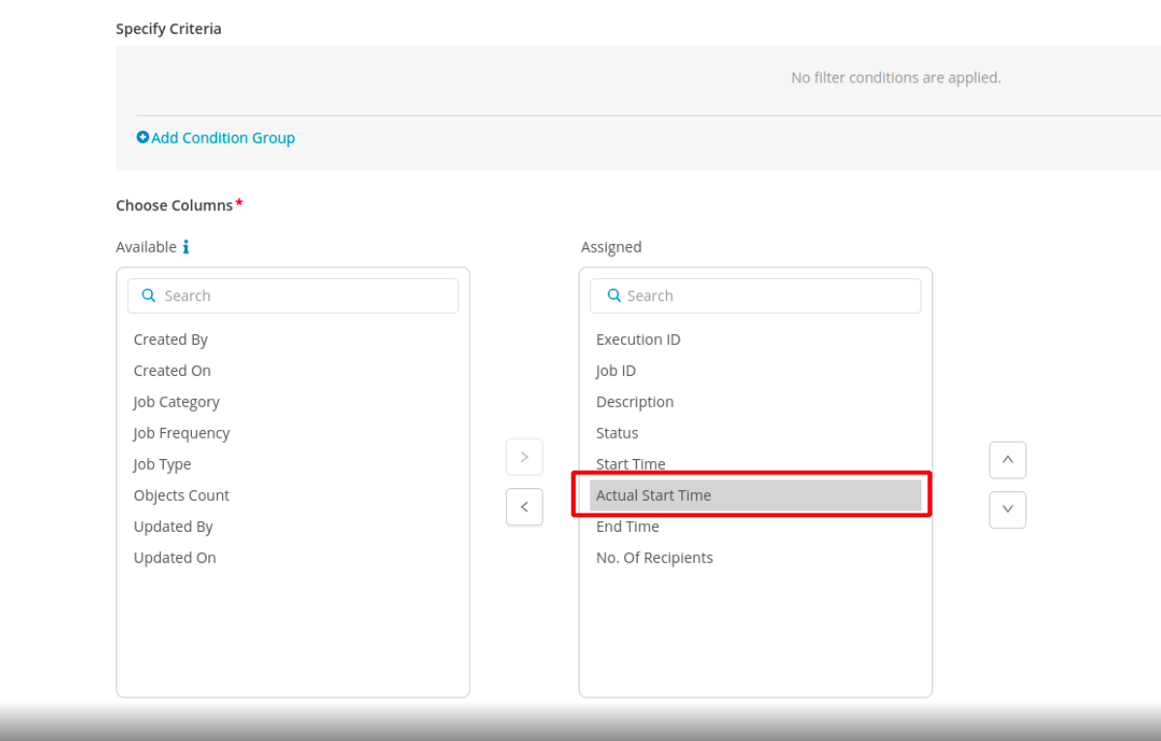

**Question 2:**

This is not 100% the same but very related. This is a download of the actual jobs run. Again we need

consistent date representation and the time zone displayed. As I am in CST I would prefer in my time

zone. Either way we need to have consistency and here is the report from when I ran jobs this

morning...after 7:00 CST.

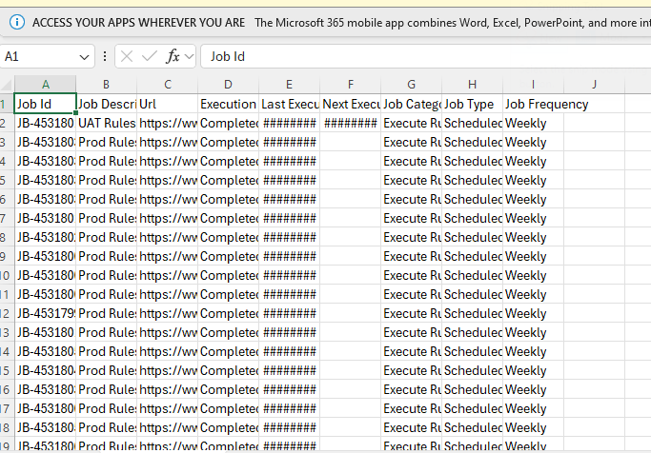

**Solution:**

By Referring to the above image, understand that the report is currently displaying the time/date in UTC, and you would prefer it to show in the user’s local time zone instead.

After discussing this with this internally and have logged a bug for it to be fixed. We will notify you once the change has been implemented.

FR-892 has been added. A follow-up ticket will be created once it is moved to production.

**25. Incident #27595**

**Sub: High Priority - setting data classification in DI, lost with conversion**

**Question:**

We need immediate help. As we converted to DI, I and Brian can not find out how we can update the data

classification on tables and fields. Lauren, Brian and i are all set up in the settings tab to be 'able to set

security admins'. But we can not find a way to set this up so that I can update the ones that need to be done

ASAP.

**Solution:**

To update data classifications and apply masking in DI, you need the Data Security Admin role. This role

allows to manage classifications and implement masking for sensitive data. Since users cannot assign

this role to themselves, Brian, as the account owner, can assign it to you.

**Steps:**

Assign Data Security Admin Role

* Brian can follow the instructions in the [**Data Security Admin**](https://dvsum.zendesk.com/hc/en-us/articles/22680186312468-Data-Security-Admin)**(**[**https://dvsum.zendesk.com/hc/en-us/articles/22680186312468-Data-Security-Admin**](https://dvsum.zendesk.com/hc/en-us/articles/22680186312468-Data-Security-Admin)**)** article to assign the role to you.

Update Classifications and Apply Masking:

* Once assigned, navigate to the Data Catalog to locate relevant tables and fields.
* Use the steps in the[**Data Masking**](https://dvsum.zendesk.com/hc/en-us/articles/23494629475604-Data-Masking)(<https://dvsum.zendesk.com/hc/en-us/articles/23494629475604-Data-Masking>) article to apply masking and classifications.

Verify Changes:

* After applying the updates, validate that PII fields are masked and classifications are set correctly.

**27. Incident #27689-URGENT**

**Sub: Unable to connect to Data Sources - Databricks**

**Question:**

"Databricks: Not able to establish the connection."

No other information to provide at this time.

**Solution:**

Shafaqat from the PD team has confirmed that he will be connecting with FDA at 7 PM PKT to resolve the Data Sources issue.

After connecting with the FDA team regarding the issues with the Databricks data source. Below are the updates:

**Issues:**

* Missing DvSum-ECSServiceRole stack (resolved).
* SSL handshake needs to be disabled.

**Update:**

* The DvSum team will provide an updated installer to address the SSL handshake issue

**The Databricks issue reported by the FDA team has been resolved.**

**Issue:** Unable to connect/authenticate to Databricks.

**Update:** We updated the configurations in the backend JAR file, provided the updated CloudSAWS JAR, and re-deployed CloudSAWS in their environment. This fixed the issue.

**Note:** For high-priority tickets, we need to follow the SLA process, which requires immediate attention. First, we should try to contact Taimoor or Hajra via Skype or Teams. If there is no response on Skype or Teams, we should reach out through whatsapp. If still no response, then need to follow the same for Jawad.

**28. Incident #27633**

**Sub: Question - how to use filter**

**Question:**

Debra is asking how to correctly use a date filter on the table view, specifically to filter by the "last

Profiled date." She’s likely referring to a way to view or sort the data based on the most recent date in

that column.

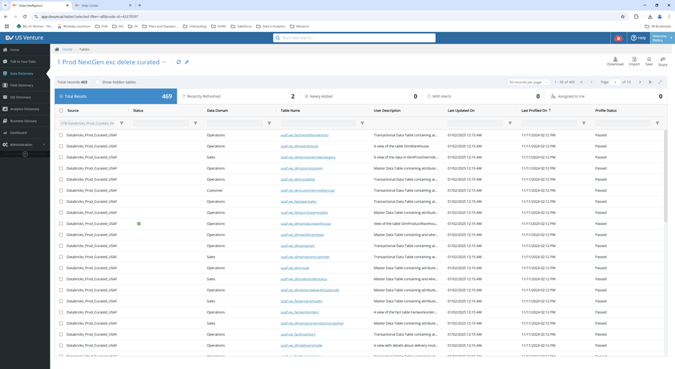

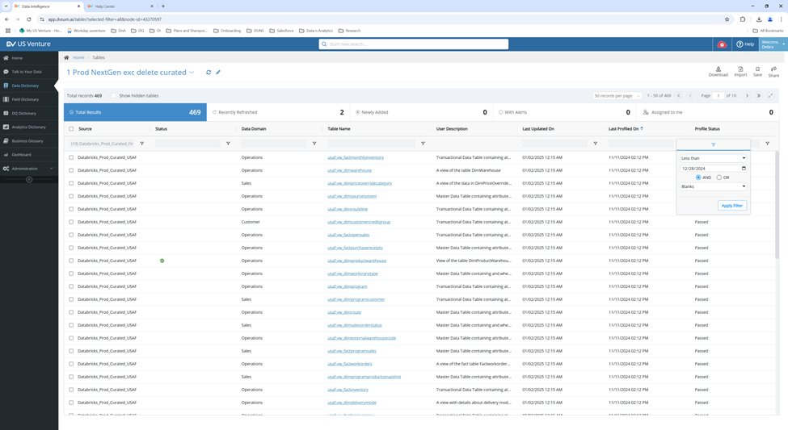

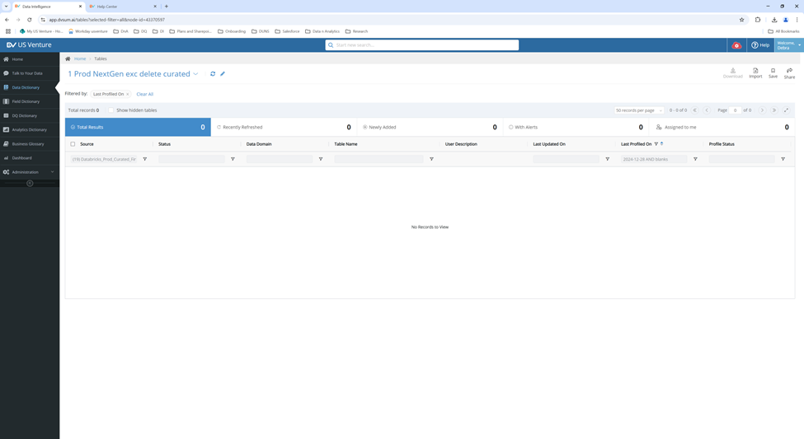

**Solution:**

Can filter the 'Last Profiled On' field for dates before 12/28/2024 by creating

view in the Data Dictionary and including screenshots to help her with the setup. We also

acknowledged her concern about the 'less than' filter behavior and logged it

as a feature request. The team is actively working on it.

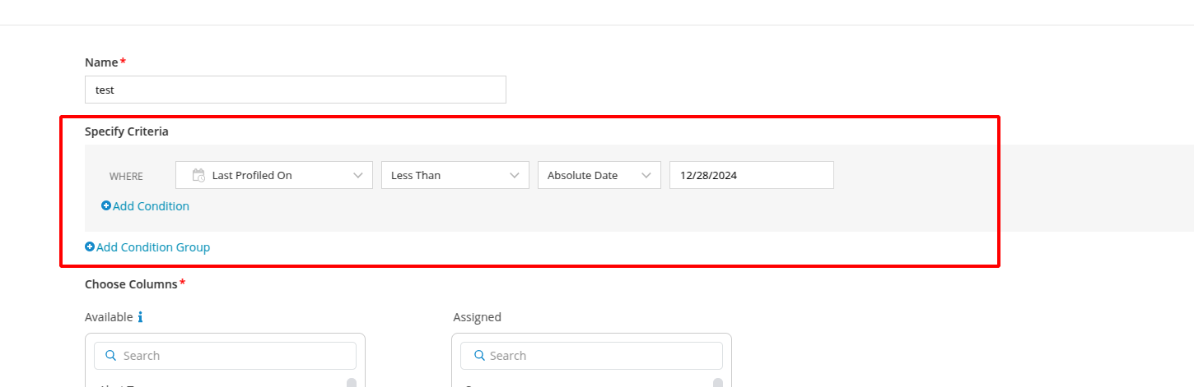

**29. Incident #27638**

**Sub: DvSUM.ai website down**

**Question:**

Shree reported that the DvSUM.ai website is down and requesting immediate assistance from

the team to resolve the issue as soon as possible.

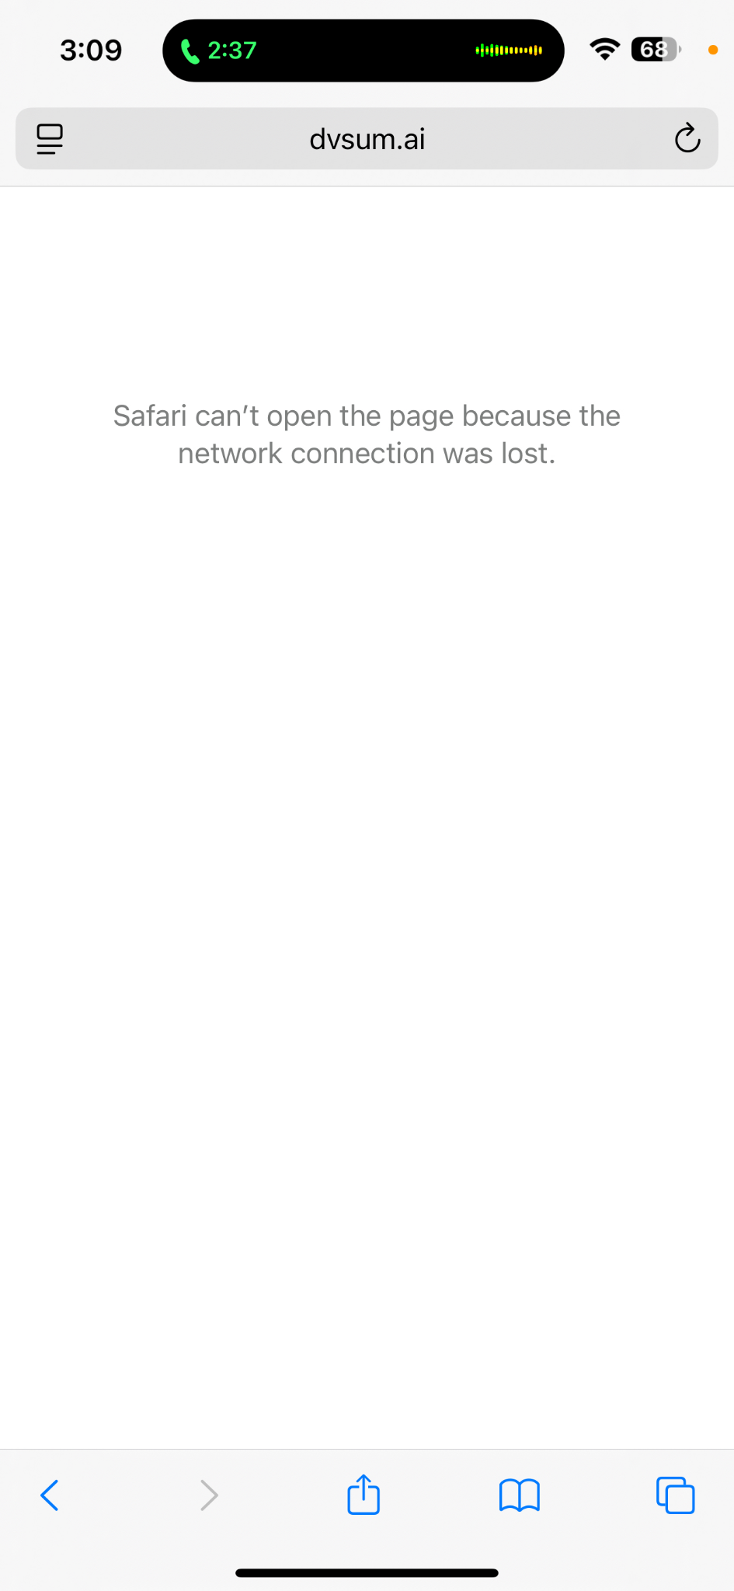

**Solution:**

In the reply to Shree, we informed him that the DvSUM.ai website is managed by the Marketing team.

we’ve added the Marketing team and Keirsten to the email, asking them to look into the issue and

provide updates to Shree.

**30. Incident #27637**

**Sub: My DvSum user on prod has expired.**

**Question:**

JC is requested us that is user account for prod.dvsu.com has expired and is requesting that it be

renewed or reactivated as soon as possible.

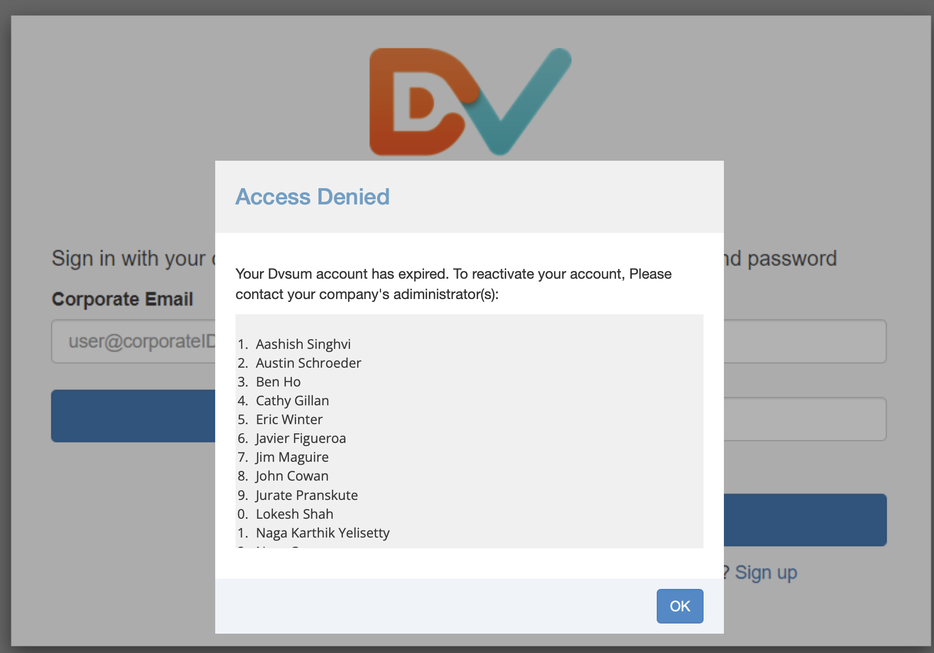

Solution:

We’ve successfully activated the requested access for John Cowan.

**31. Incident #27634**

**Sub: Question: Job scheduled**

**Question:**

Baker is asking if there’s a way to run a scheduled job outside of its usual schedule (without setting it

to run immediately), specifically if there's a way to delay or run it at a later time, such as one hour

later. She tried running a profile job immediately but was wondering if she could run a second one

today, without changing the job's schedule permanently (since adjusting the schedule would require

changing it back tomorrow). She's looking for an option to run the job at a specific time without

permanently altering its schedule.

**Solution:**

We explained how to run jobs outside their regular schedule without changing the original schedule. We

provided steps to run a job immediately by going to the Job Detail page and selecting "Run Now" from the

menu. We also explained how to run multiple jobs at once by selecting them from the Job Listing page and

clicking the "Run Now" button. Additionally, we attached a screenshot for reference.

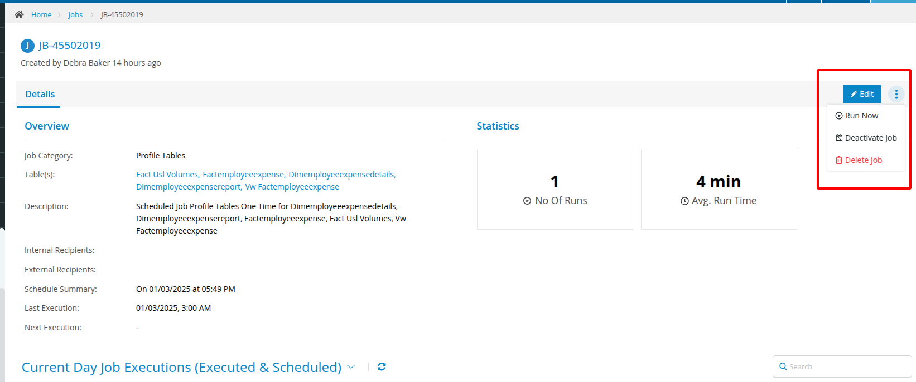

**32. Incident #27632**

**Sub: Re: Issue with Freshness Rule in DI - Follow up ticket for #27594**

**33. Incident #27631**

**Sub: Long running jobs - aborted today**

**Question:**

Debra reported that, as discussed in today's meeting with Hajra, she found several jobs that were

running for an extended period while the team was absent from the office. She is providing a list of

the jobs and their execution IDs for the ones she canceled today.

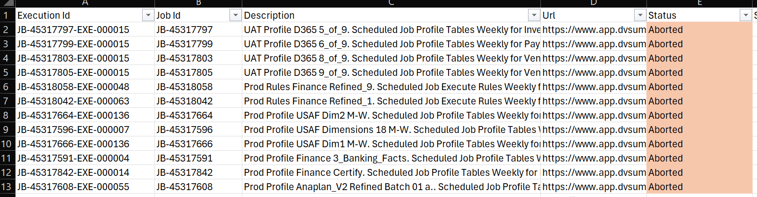

**Solution:**

After the Thursday call, we discussed the issue with our internal team and deployed a fix to production. This fix should prevent any long-running job issues in the future. We asked Debra to continue monitoring and let us know if she encounters any similar issues going forward.

**34. Incident #27619**

**Sub: Endpoint request timed out**

**Question:**

Matt is reporting that he wasn’t able to make edits to a specific domain, although he could edit other

domains without any issues. He’s asking the team to check the backend to see what might be causing

the problem. After removing the subdomain "Data Sub," he mentioned that he was able to edit the

domain again.

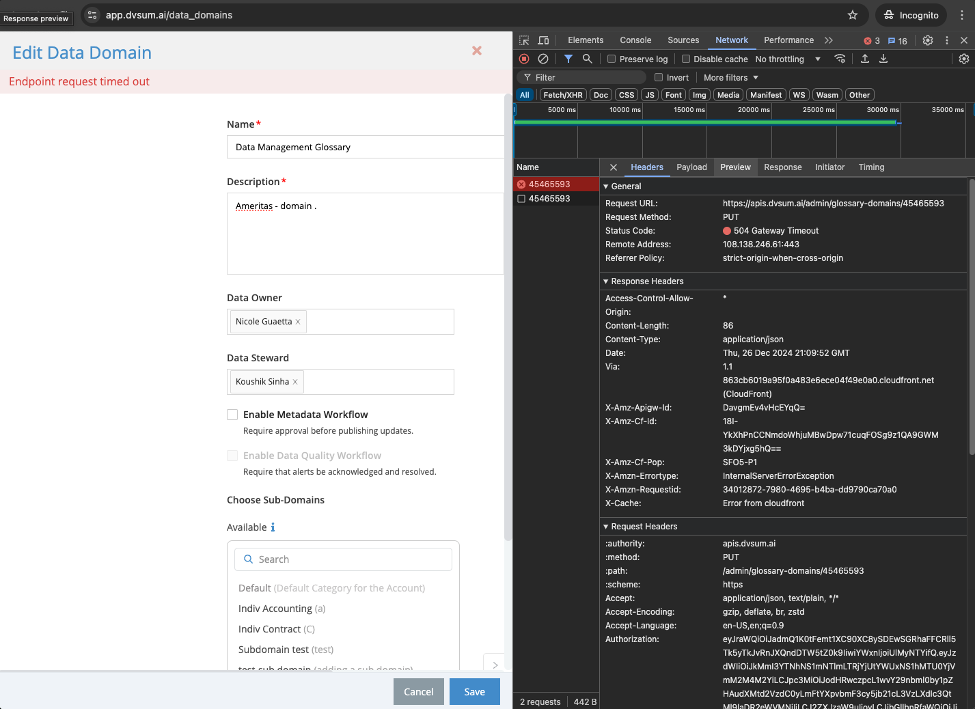

**Solution:**

**Currently Rafique is working on it and waiting for his reply. We have logged an FR for this and a follow up ticket will be created once it is deployed to the production.**

**35. Incident #27617**

**Sub: older functionality screen presentation in training video**

**Question:**

John is reporting that when clicking on a table name from the Data Dictionary tab, the training video

opens in a half-screen, whereas the expected behavior is for it to open in full screen on the overview

page. He is highlighting this discrepancy in functionality.

**Solution:**

We informed John that the help desk primarily handles product-related queries for

DvSum. Since his concern is related to training materials, we recommended that he contact the

training team directly at **training@dvsum.com** for assistance. We also let him know he can reach out

to us again if he has any product-related questions.

**36. Incident #27616**

**Sub: DvSum training video - 20 seconds duplicated**

**Question:**

John is pointing out that the training video has a 20-second duplication at the beginning of the clip,

meaning the same content is repeated in the first 20 seconds.

**Solution:**

We informed John that the help desk primarily handles product-related queries for

DvSum. Since his concern is related to training materials, we recommended that he contact the

training team directly at training@dvsum.com for assistance. We also let him know he can reach out

to us again if he has any product-related questions.

**37. Incident #27615 (Open)**

**Sub: CADDI LLA change request, customer name and last registration**

**Question:**

Marcelo is informing the team that the local team in Saint Lucia has requested the following changes:

1. To include the customer’s name in the "Key Facts" category list so that agents can confirm they are retrieving information for the correct customer, especially in cases where the account number was entered incorrectly.

2. In cases where the modem is offline, the "cmUptime" information is misleading, and he is asking if it can be swapped with either "cmDowntime" or "last registration" to provide more accurate details.

He is seeking feedback or action on these requests.

**Solution:**

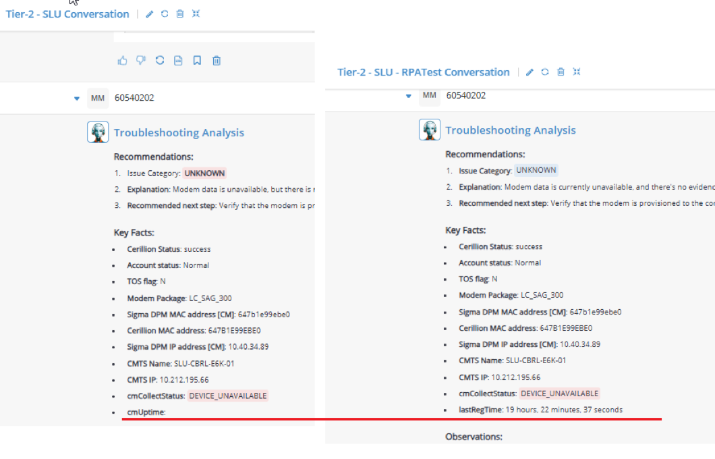

Last registration issue has been fixed by replacing the cmUptime with lastRegistration.

And the Customer name issue is in still pending status.

**39. Incident #27595**

**Sub: High Priority - setting data classification in DI, lost with conversion**

**Question:**

Debra is requesting immediate help with updating the data classification on tables and fields after the

conversion to DI. She and Brian are unable to find a way to update the data classification, despite

being set up as 'security admins' in the settings tab. She urgently needs assistance in updating the

data classification, particularly for People Resources (HR) items that contain PII (Personally

Identifiable Information) and need to be masked.

**Solution:**

We explained that to update data classifications and apply masking in DI, she

needs the Data Security Admin role. Since users can’t assign this role to themselves, Brian (as the

account owner) will need to assign it to him.

We provided the following steps:

1. Assign the Data Security Admin Role: Brian should follow the instructions in the Data Security Admin article to assign the role to Debra.

2. Update Classifications and Apply Masking: Once the role is assigned, Debra can go to the Data Catalog to find the relevant tables and fields, and follow the steps in the Data Masking article to apply masking and classifications.

3. Verify Changes: After making the updates, Debra should verify that PII fields are properly masked and classifications are set correctly.

**40. Incident #27594**

**Sub: Issue with Freshness Rule in DI**

**Question:**

Lauren is reporting an issue with the out-of-the-box freshness rule in the new module. She is trying to

update the rule's thresholds, but whenever she saves the changes (such as setting the upper bound

from 24 to 840), the rule reverts back to the original threshold after running it. She has attached

screenshots showing the issue, with timestamps to demonstrate the changes and the final result where

the upper bound reverts. She's asking for help with this issue.

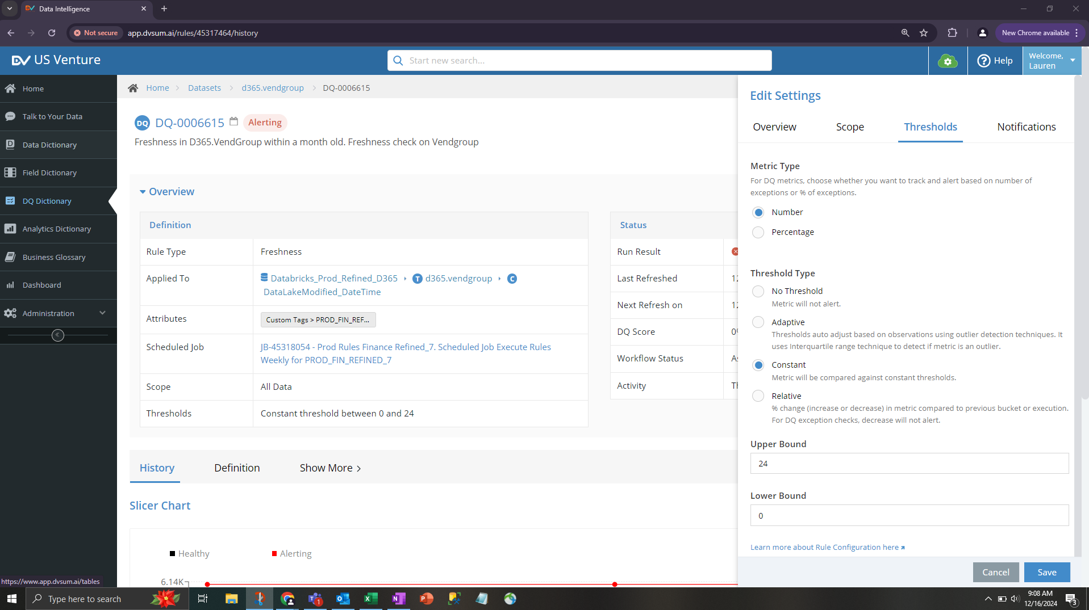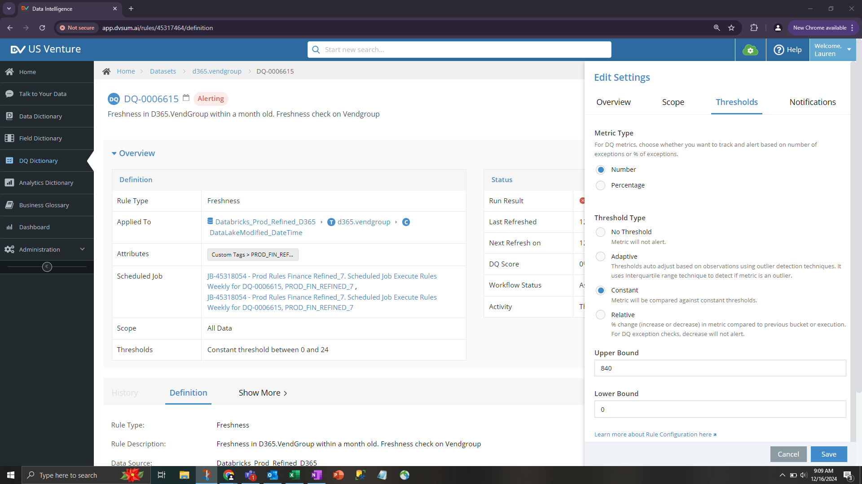

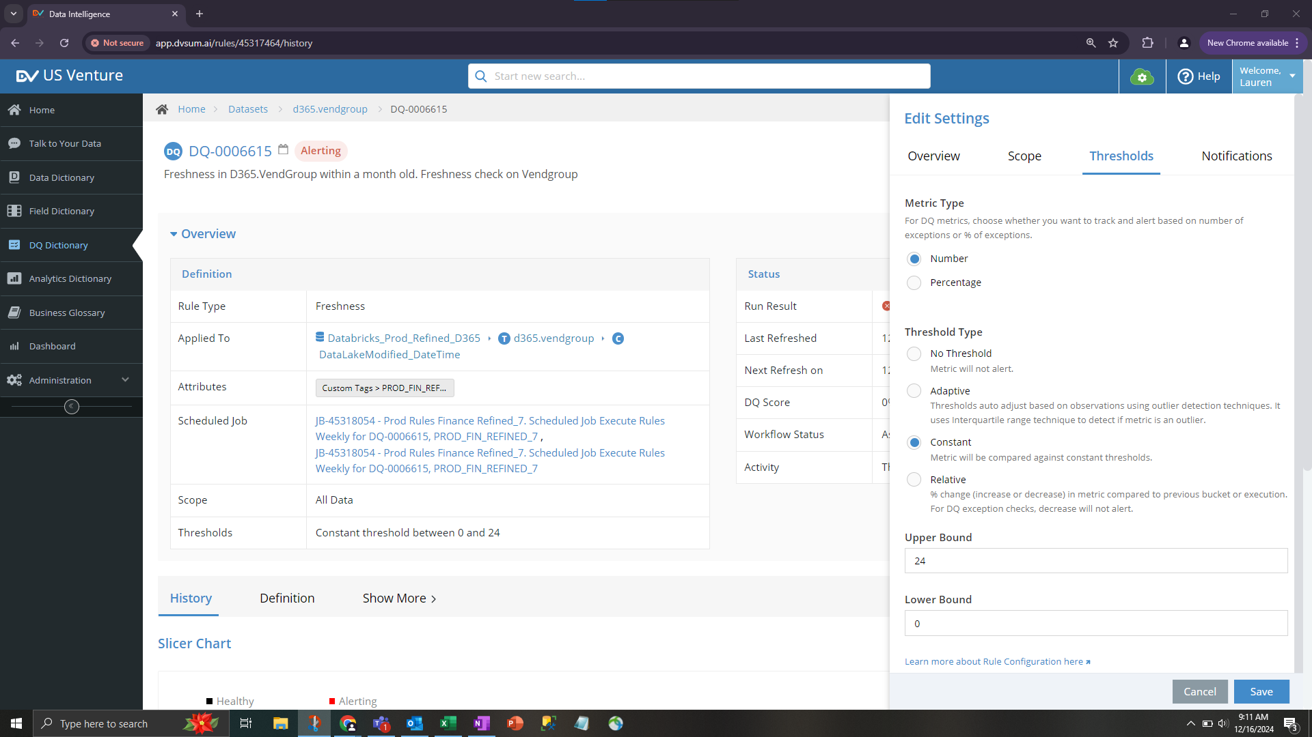

**Solution:**

In the reply to Lauren, we explained that the issue with the upper bound of the Freshness Rule not

updating when changes are made from the "Thresholds, we suggested that Lauren modify the upper bound

from the "Edit Rule Definition" section. She can go to the rule page, click on Edit, then in the Overview tab,

click on "Edit Rule Definition" under Priority to update the threshold to" settings has been identified. We’ve

logged a Feature Request (FR) to address this in a future release.

As a temporary workaround 840 and save the changes. We also provided a

screenshot for guidance.

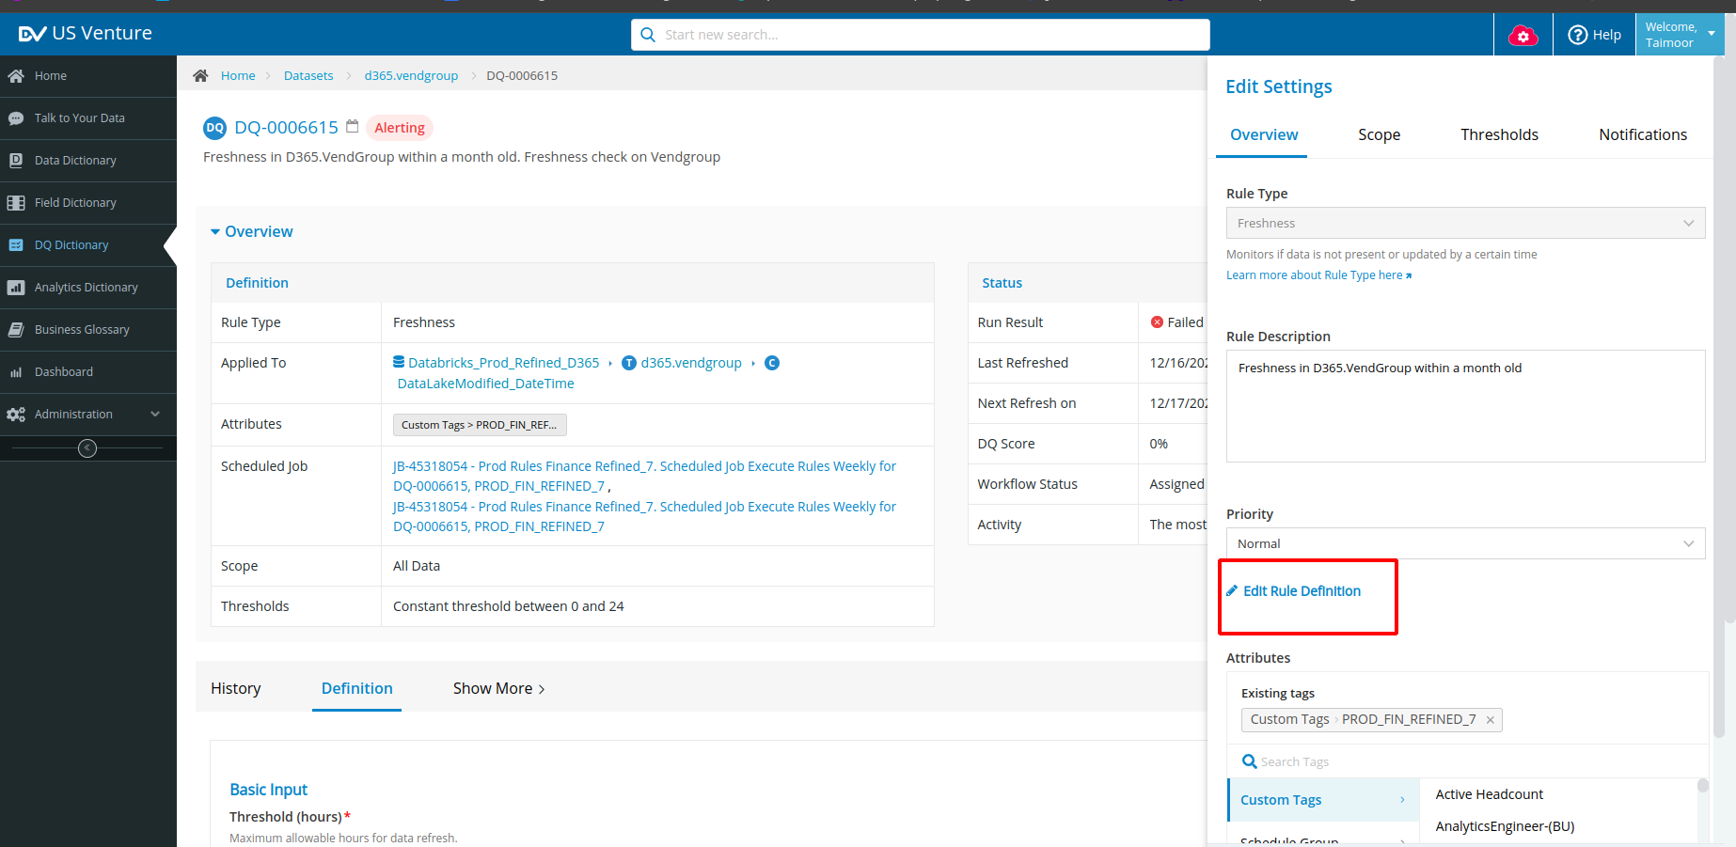

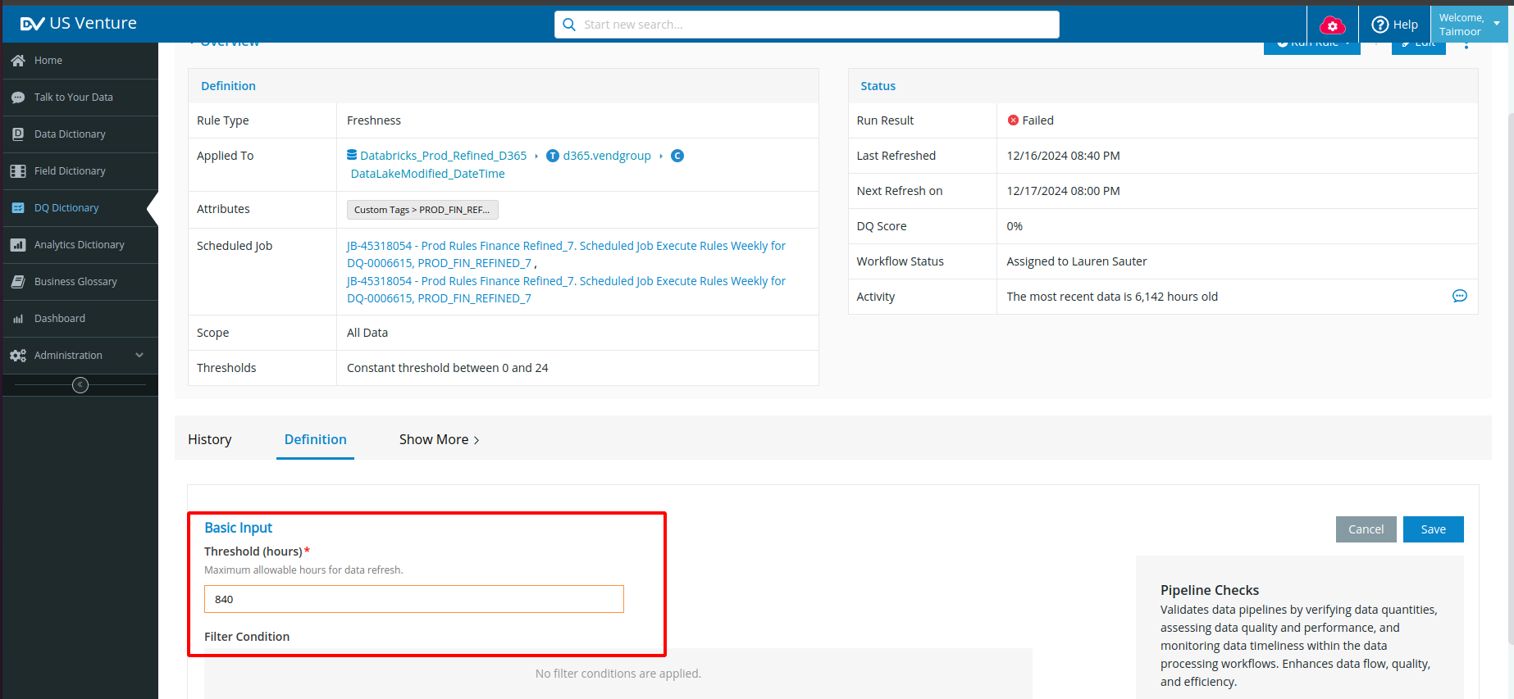

Help Center link for reference:

<https://dvsum.zendesk.com/hc/en-us/articles/25246892783380-Pipeline-Checks-Freshness-rule>

**41. Incident #27591**

**Sub: Refresh icon**

**Question:**

Aashish is suggesting that a "refresh" icon should be added in multiple areas of the platform (such as

in scans, jobs, or other places) so users can refresh the data without having to refresh the entire page

from the browser. This would provide a more convenient way for users to update data.

**Solution:**

We thanked him for the suggestion and mentioned that we would review the

areas where the refresh feature is needed. We’ll explore the possibility of implementing a refresh icon

so users can update data without relying on a browser refresh. We assured him that the progress would

be communicated.

Additionally, we informed him that, as discussed with Jawad from the PD team, FR-942 has not yet

been prioritized. We are closing the ticket for now, but a follow-up ticket will be created once the

enhancement is deployed to production.

**42. Incident #27589**

**Sub: Still getting main screen clocking/refreshing and failing regularly**

**Question:**

Debra is reminding the team that there’s an issue with the main screen, where it continuously shows a

clocking/refreshing screen and then times out with a connection error. While it's not a major issue,

she believes it indicates that something may not be set up correctly or efficiently, especially since

everything else is connecting fine.

**Solution:**

We informed her that we were unable to replicate the issue on our end. We

requested additional details, replication steps, or relevant screenshots to better understand and

address the problem. Since we didn’t receive a response, we decided to close the ticket for now. We

also logged a Feature Request (FR-966) for the issue and mentioned that a follow-up ticket will be

created if the issue occurs again.

**43. Incident #27583 (solved)**

**Sub: Null vs Blanks Issue**

**Question:**

I am following up on a ticket I had submitted a while back regarding Nulls vs Blanks checks in Data

Quality. I was informed that the issue would be resolved in a future enhancement that was on the road

map. I believe the timing aligned with the go live of the one module. I am wondering when this will be

resolved. I was creating new DQ rules in the Data Intelligence module and noticed the same issue. Nulls

and Blanks are being considered one in the same in this module too. With the DQ checks we run we need

to be able to differentiate Blanks vs Nulls. I am currently getting around the out of the box rules with

custom queries.

**Solution:**

steps:

1. Regarding the Blanks rule, you mentioned that blanks should be considered. Could you clarify which values you expect to include? Should only empty strings ("") be treated as blanks, or should NULL values also be considered? (Here, NULL does not refer to the text "null.")
2. For the ValueRange rule, there is an option to include blanks. How would you like blanks to be handled in this context? Should they be treated differently from NULL values?
3. For the query "Where CustomerGroup is null," should both empty strings ("") and NULL values be considered as representing empty data

* highlighted significant manual effort due to copy-pasting from the customer
* **Customer liked the existing solution for blanks and suggested a similar approach for nulls.**
* After the call, this was categorized as a P2 FR with an estimated resolution of 3-6 months.

**44. Incident #27582**

**Sub: Request - what is eact filter to show today's scheduled / completed executions**

**Question:**

Debra is stating that she wants to replicate today's executions in her time zone so she can change

fields or the order of them, but she is encountering an issue where it is not working as expected. She

may have attached something for reference to help clarify the problem.

*Please advise how I can write the filter to show the current days executed and scheduled job executions like the standard available one. I want to build so I can change fields show/order but I only get the scheduled ones and they cover today and tomorrow*

*I tried using start date >= relative 0 and start date < relative 1*

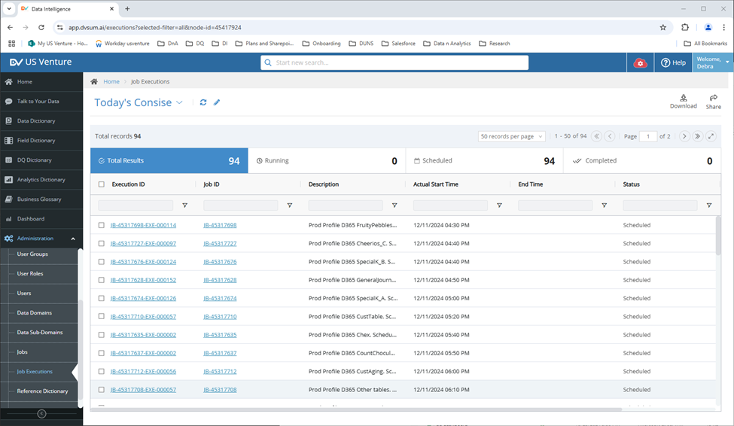

**Solution:**

In the reply to Debra, we provided a solution to filter for jobs executed and scheduled on the current

day. We suggested switching from the "Relative" option to the "Absolute Day" option to ensure the

filter only retrieves data for the current day. This setup will also include all statuses, such as Running,

Scheduled, and Completed. We attached a screenshot to illustrate the configuration.

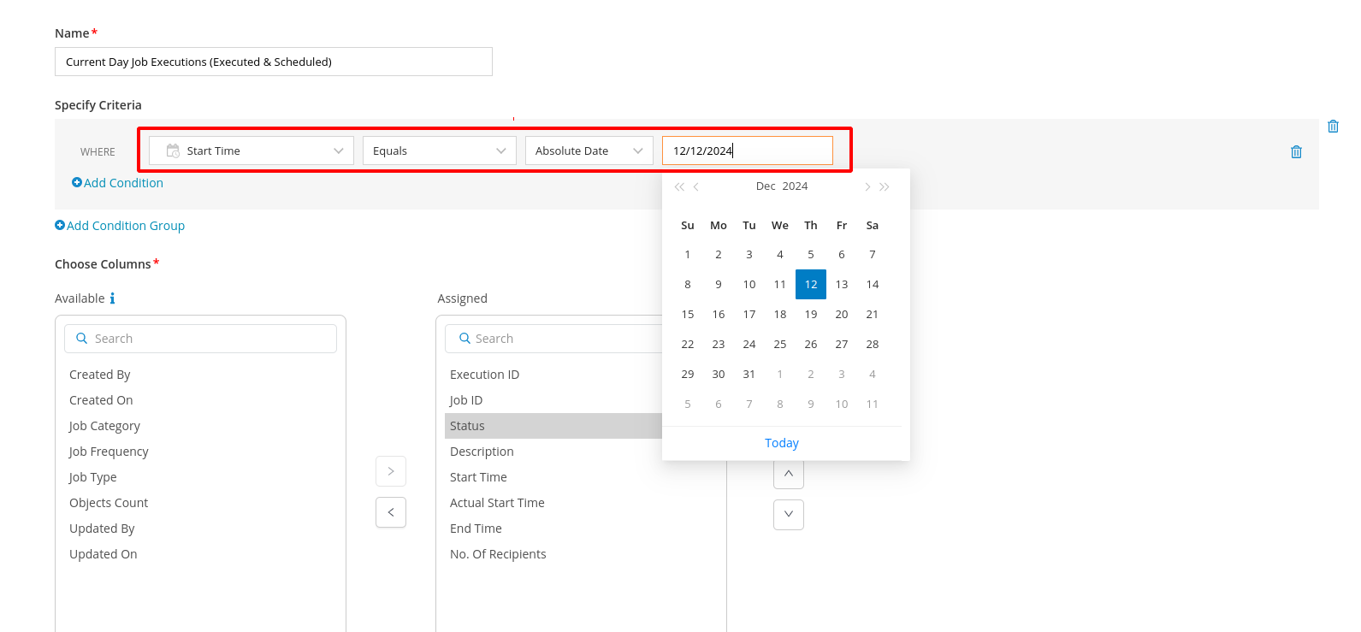

We provided instructions for filtering specific job statuses like Running, Scheduled, and Completed for the current day. We explained that she can customize the view by adding filter conditions based on her requirements. We also attached a screenshot to show how to set up the filter.

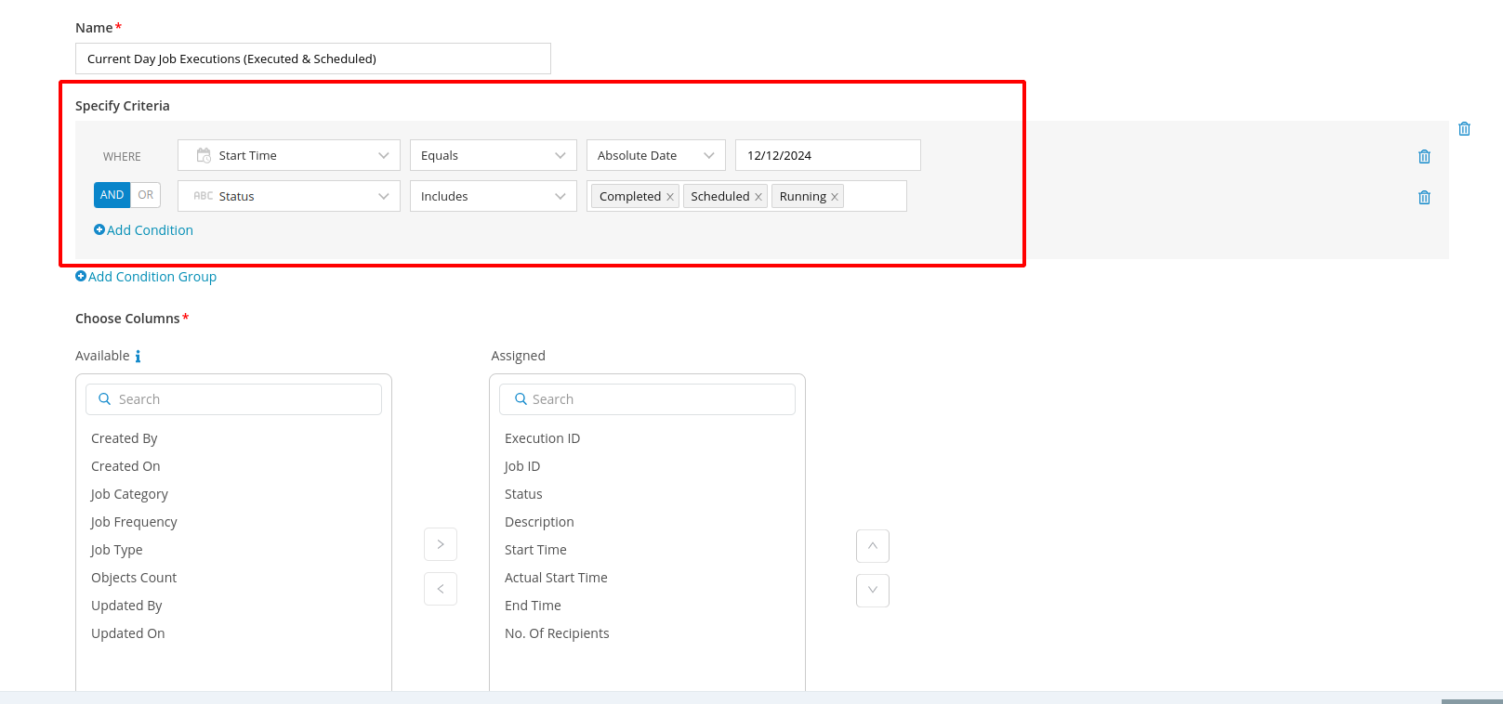

We provided instructions on how to customize the fields displayed in the view. We explained that she

should navigate to the Edit View section, select the desired fields from the "Available" section, and move

them to the "Assigned" section. Additionally, she can reorder the fields using the "Align Up" or "Align

Down" options. We also attached a screenshot for reference.

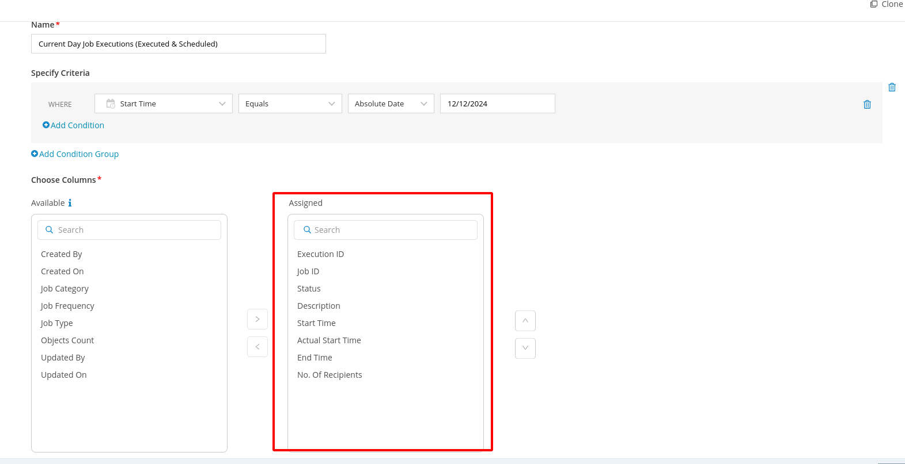

**45. Incident #27577**

**Sub: I am in December. Why does the screen say Nov 2024**

**Question:**

The splash screen shows information from the last major deployment, which was in November 2024(Actual date was December 2024).

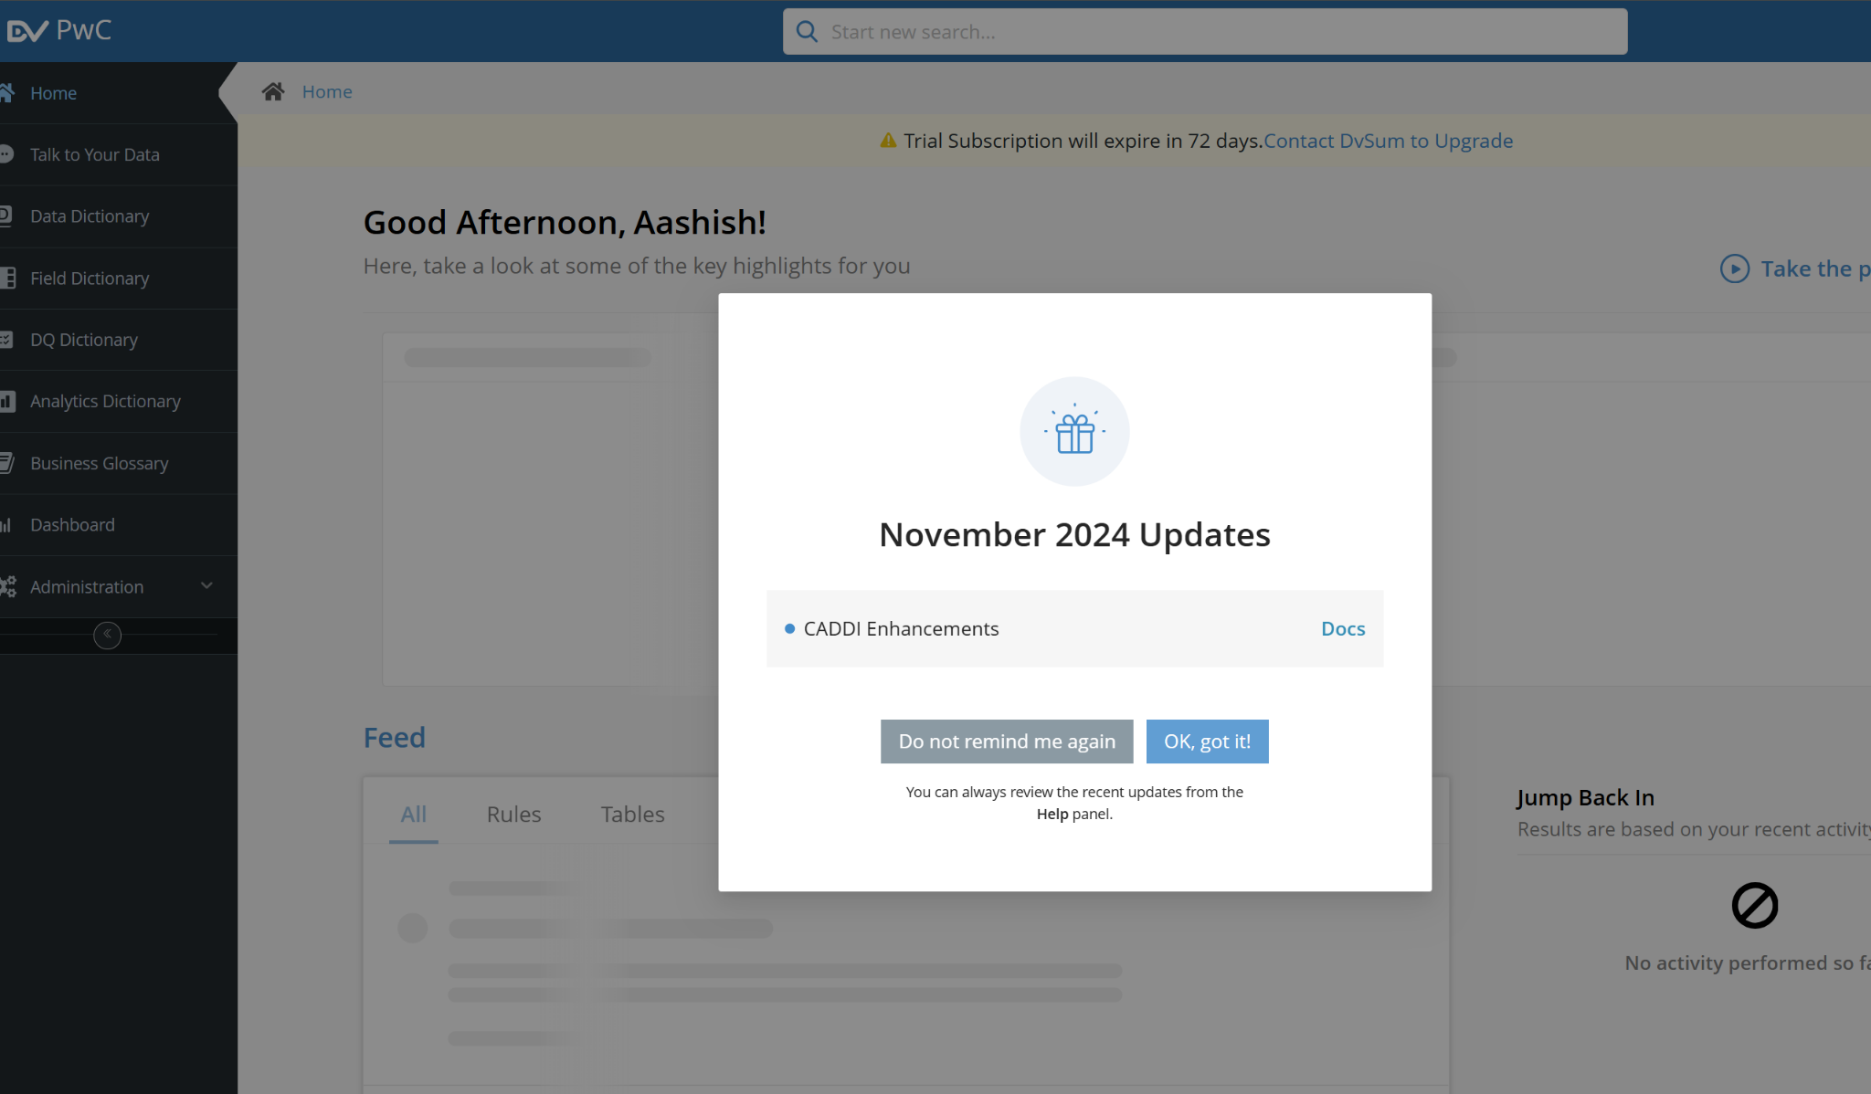

**Solution:**

We explained that the splash screen currently displays the most recent major

deployment, which included the "CADDI Enhancement." We clarified that if he prefers not to see the

splash screen, he can select the "Do not remind again" option. Alternatively, clicking "Okay, Got it" will

prevent the splash screen from reappearing unless he logs out and logs back in. We confirmed that

This behavior is intentional, as the splash screen highlights key updates from the last deployment.

Additionally, we informed him that a new splash screen, reflecting the January 2025 updates, will be

released on January 14th, 2025, as part of the Lineage epic. Once deployed, he will see the updated

Information. Now the issue got fixed and we can see the updated information as we are in January 2025 where the splash screen reflects the same.

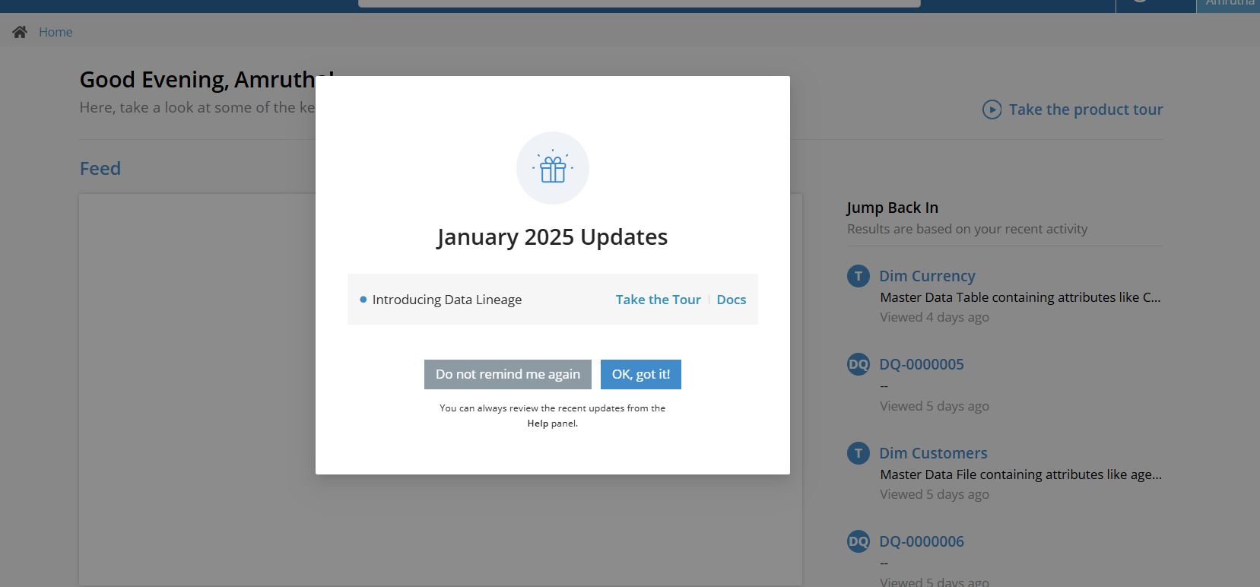

**46. Incident #27570**

**Sub: Delete tables from Data Dictionary doesn't work**

**Question:**

Aashish is reporting that the functionality to permanently remove tables from the Catalog is not

working as expected. He has attached screenshots as proof of the issue and is requesting that this be

logged as a HOTLIST Feature Request (FR) for the Product Team to address.

**Solution:**

We explained the current functionality for deleting tables from the Data

Dictionary:

- Deleted Status: Only tables with a "Deleted" status can be permanently removed. Tables with any other status cannot be deleted.

- Scenario for Undeletable Tables: If a table exists in an actively scanned schema, its status will be something other than "Deleted," preventing it from being removed.

To enable deletion, below is detailed steps:

1. Remove the schema containing the table from the data source by moving it from "Selected" to "Available."

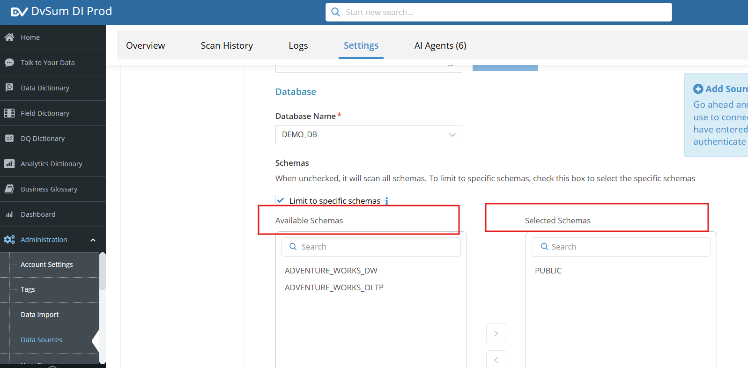

2. Alternatively, he can switch to scanning a different schema.

Once the schema change is made and a scan is performed, the table’s status will update to "Deleted," allowing it to be removed.

We suggested verifying the table’s status and referenced a screenshot for clarity. We also offered

further assistance if needed.

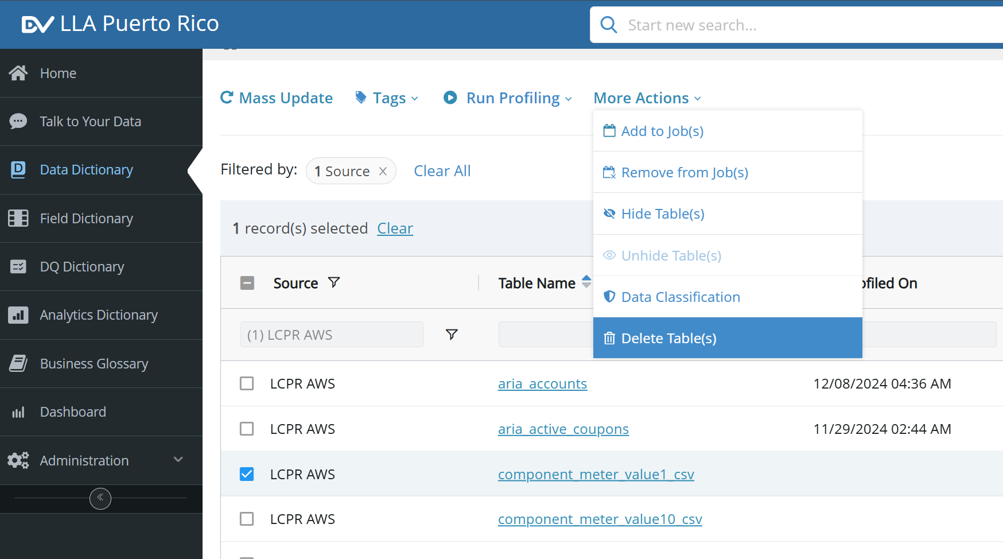

Reference screenshot for undeletable tables:

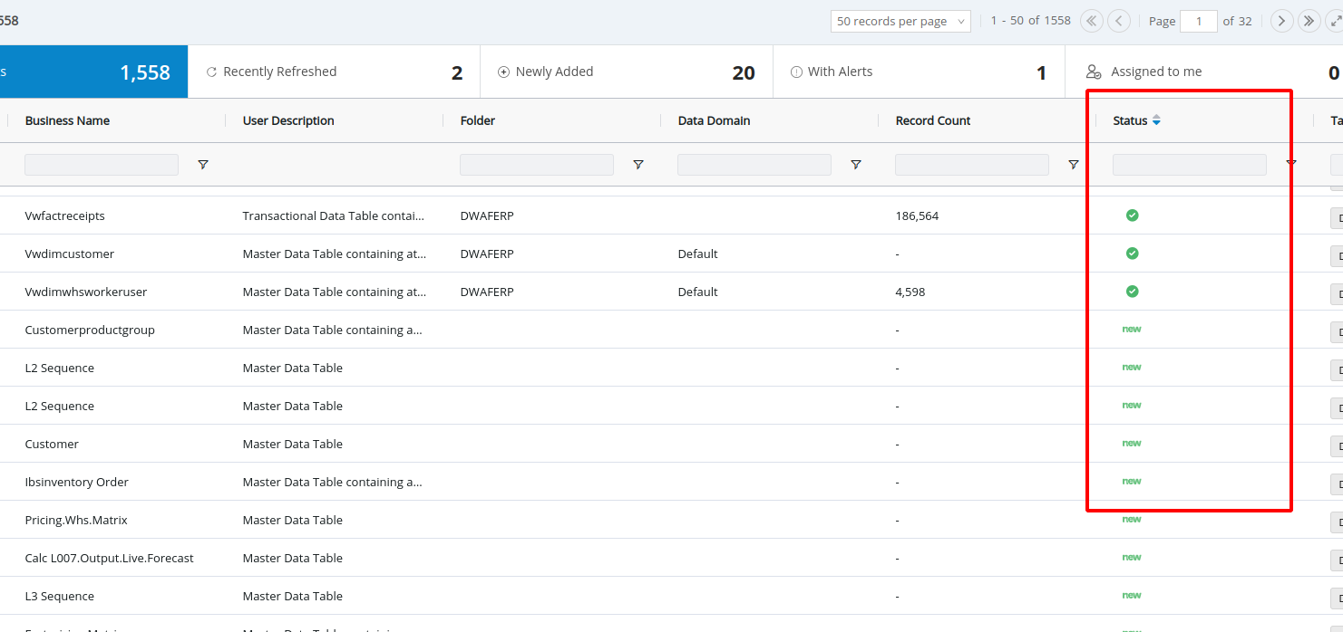

If we try to delete the marked tables in the above screenshot we will get the pop-up message as shown in the below screenshot.

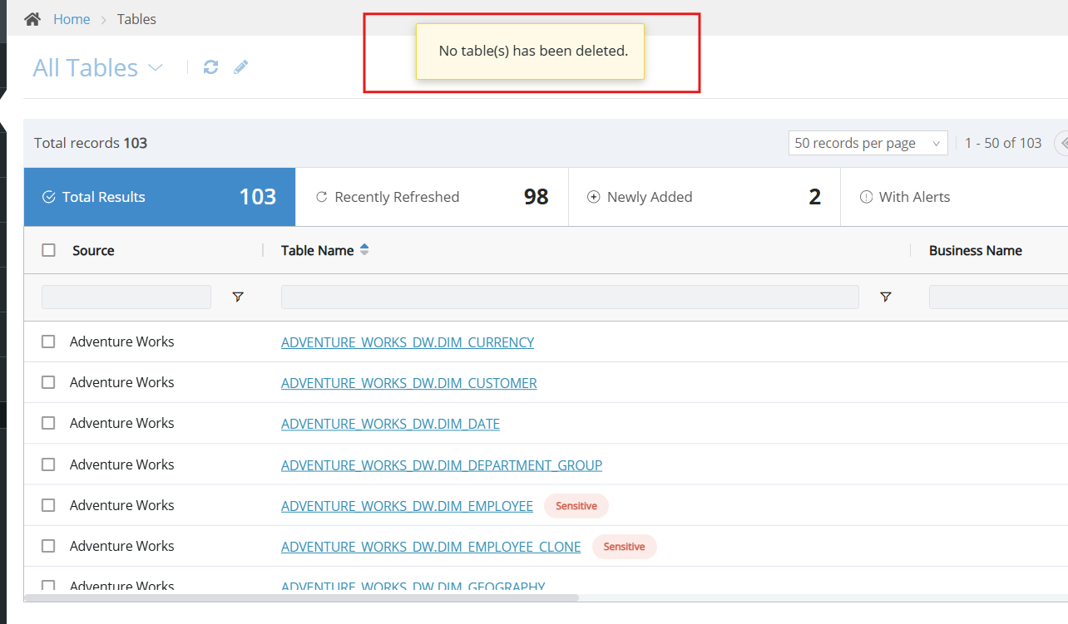

Reference screenshot for deletable tables:

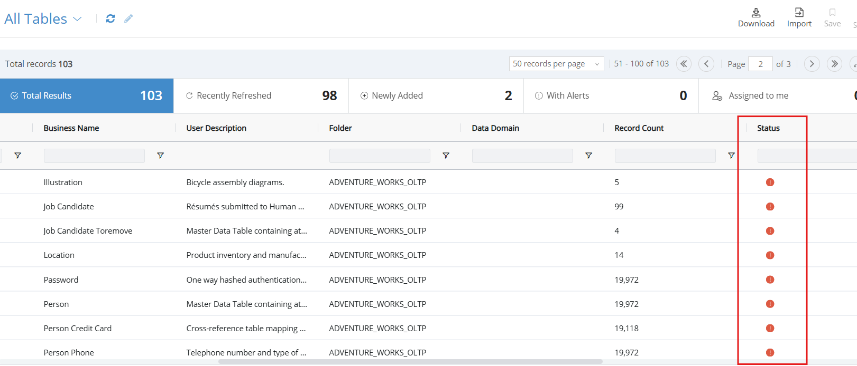

If we try to delete the marked tables in the above screenshot, the tables will be deleted and we will get the pop-up message as shown in the below screenshot.

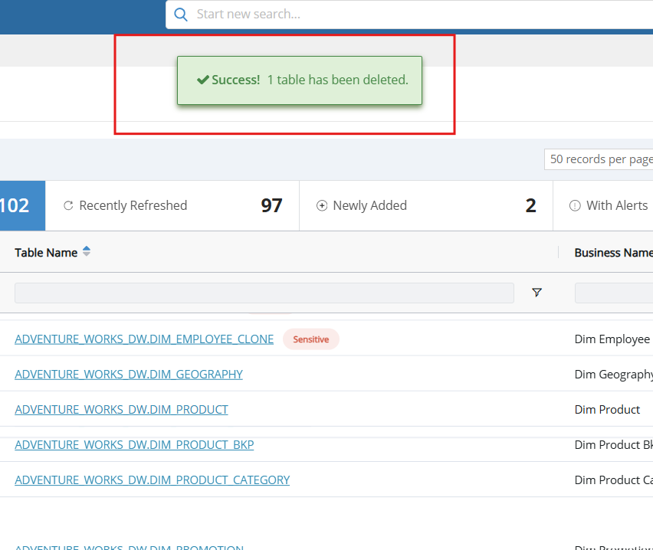

**47. Incident #27565**

**Sub: CADDI does not generate SQL**

**Question:** Why is CADDI not generating SQL. It is a simple 2 table, few columns design.

**Solution:**

The issue has been identified and logged under FR-901 for further investigation. A fix is being

implemented and will be deployed to production. Once deployed, a follow-up ticket will be created to

Verify.

We logged an FR - 901 and closed the ticket informing that a follow up ticket will be created once the fix is deployed to the production.

**48. Incident#27563**

**Sub: CADDI Bot Training**

**Question:**

Evan is reported that he is currently going through the CADDI Bot training and will need

credentials to access the platform. He is requesting the necessary credentials.

**Solution:**

We informed him that the help desk is primarily for DvSum product-related

inquiries. Since his request is related to training, we advised him to submit it to the training team at

**training@dvsum.com** for assistance.

**49. Incident #27562**

**Sub: RE: [DvSum] Re: DvSum Alert. JobJB-002341 Scheduled Daily for DQ Rules DQ-0001657 (MG**

**Freight Calculation Errors) completed**

**Question:**

Karthik reported this issue by saying that they are not receiving emails for a newly created DvSum alert

when the "Send email on alerts" option is selected. However, the alert works fine when the option is

Unchecked on ticket #27525 and we closed that ticket after replying to him but he raised an above

ticket by saying issue is not resolved.

**Solution**:

We provided an explanation of how the email notification settings work for alerts:

1. Send Schedule Completion Email: When selected, this option sends email notifications for all job statuses, including successful ones and those with exceptions.

2. Send Email Only on Alerts: This option sends emails only when the job status moves to "Alerting" (i.e., when exceptions exceed the defined thresholds). If exceptions occur but the metrics stay within the threshold limits, the status is considered "Healthy," and no emails are sent.

Key Dependency: We clarified that the "Send Schedule Completion Email" option is a prerequisite for the "Send Email Only on Alerts" option. The latter cannot be selected independently and requires the former to be enabled.

Explanation of Karthik's Scenario: We explained that when only "Send Schedule Completion Email" is selected, emails are received for all statuses. However, when both options are selected, the configuration only sends emails when there are alerts. Since the rule Karthik is running has exceptions but remains in a "Healthy" status (because the thresholds aren't defined), no emails are triggered under this setup.

We also included a screenshot for further reference.

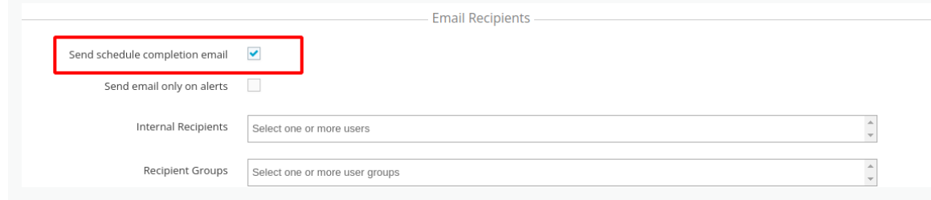

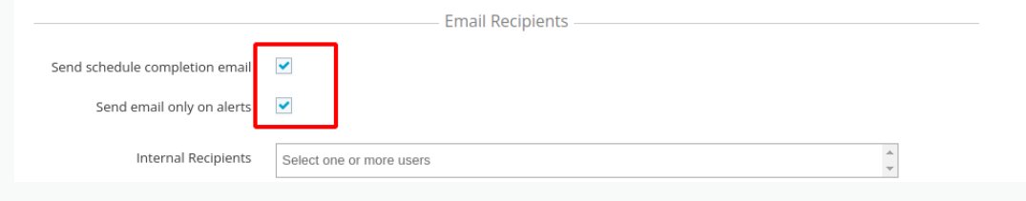

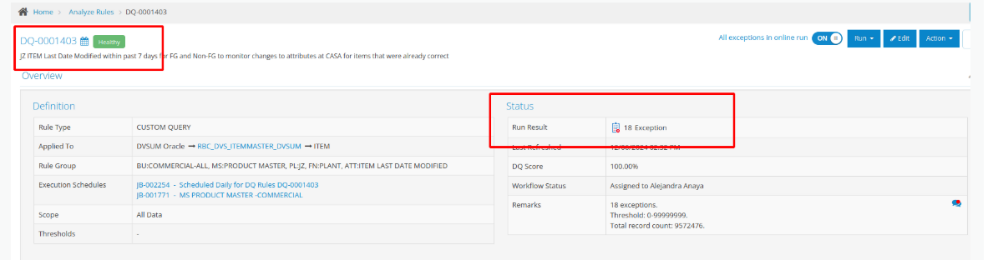

And in the same ticket he requested for another support, that is guidance on how to set up thresholds,

specifically whether the thresholds should be configured at the application level or if they are set at the

individual alert/user level.

In the reply to Karthik, we clarified that thresholds are rule-specific and not tied to the application or

individual alerts/users. We provided detailed steps on how to set up thresholds for his rules:

1. Go to the Rule Detail Page: Navigate to the Rule Detail Page of the rule you want to modify. (We included a link to a help article for more information.)

2. Choose the Metric Type: Select how you want to track exceptions:

- Number: Track the actual number of exceptions.

- Percentage: Track the percentage of exceptions relative to the total data.

3. Select the Threshold Type: Choose the method for evaluating the metric:

- No Threshold: No alerting based on thresholds.

- Constant: Compare the metric to a fixed threshold value.

- Relative: Compare the current metric with the previous one, triggering alerts if there’s a significant increase or decrease.

-Adaptive: Automatically adjust thresholds based on outlier detection techniques (Interquartile range).

4. Set the Upper and Lower Bounds:

- Upper Bound: Define the maximum acceptable value for the metric.

- Lower Bound: Define the minimum acceptable value for the metric.

5. Save Your Settings: Once you have configured the thresholds, click Save to apply them to the rule.

We also mentioned a screenshot for reference to help guide him through the process.

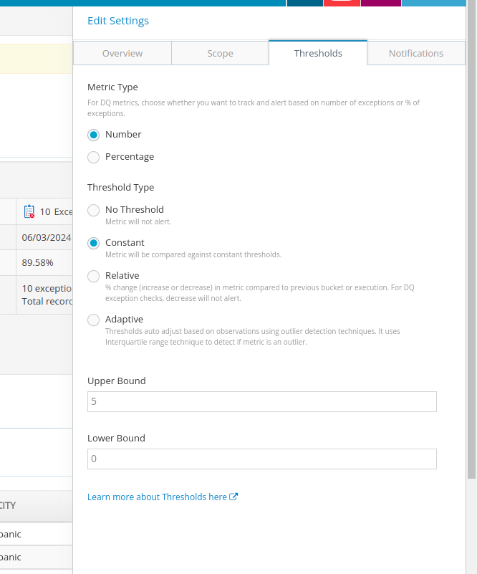

**50. Incident #27560**

**Sub: Security Risk: Ability to log in to DvSum Exception through Email link**

**Question:**

Brian is reporting that, as part of the UAT testing, he tested the former security checks that were in

place in the legacy DQ module. He notes that previously, when an exceptions report was produced, a

person with the link could not directly access the data exceptions from the "download report" link

without first logging in with their credentials. However, after testing, he discovered that this security

feature has not been re-enabled in the current system.

**Solution:**

We clarified how security access for exception reports is managed:

- Unauthorized Users: Users who are not on the authorized user list or do not have an account on the DI platform will not be able to directly access the UI via the "download report" link. They will be prompted to log in with valid credentials before they can access the report.

- Logged-in Users: For users who are already logged in, the system recognizes their credentials through a plugin, allowing seamless access to the report data.

- Permissions: Users without an account or the necessary permissions will remain unable to view the report data.

We invited Brian to share any further concerns or questions regarding this functionality.

**51. Incident #27560**

**Sub: Security Risk: Ability to log in to DvSum Exception through Email link**

**Question:**

Debra is stating that not all rules were added to the list, and she is referencing a list of 39 job groups.

She is asking to ensure that these job groups are scheduled properly. It seems she needs help

ensuring that all rules are included in the scheduling process.

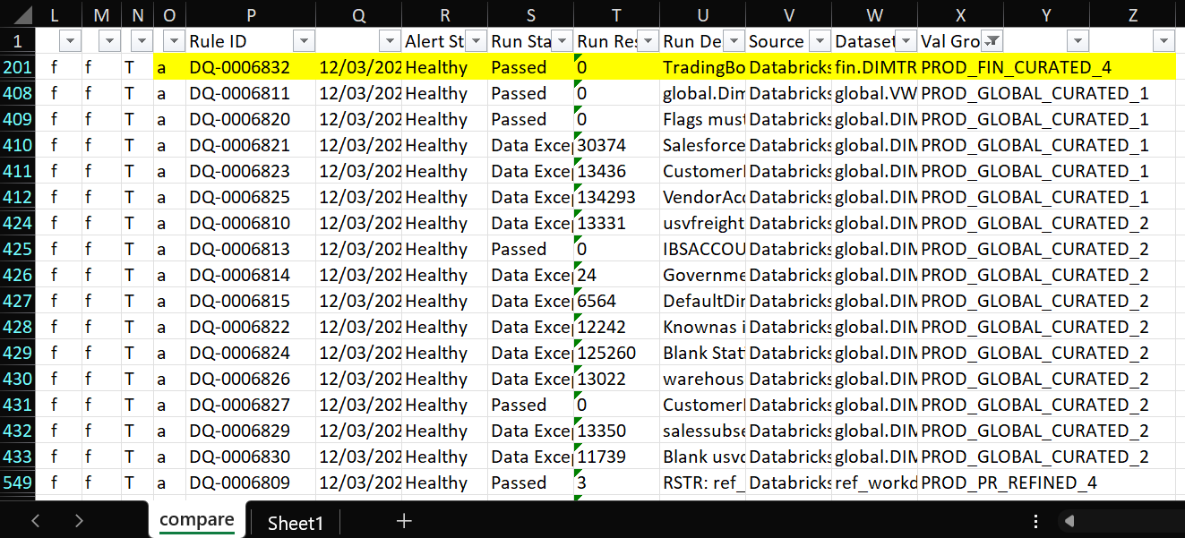

Solution**:**

The request is part of the migration tasks managed by the Internal team.

**52. Incident #27555**

**Sub: Need 11 jobs created for testing - rules never run; see details below for Hypercare**

**Question:**

Debra is requesting that jobs be created for testing, as the rules for certain test scenarios have never

run. She has provided a list of test rules for which jobs need to be created, including:

- TEST_FIN_REFINED_1

- TEST_FIN_REFINED_2

- TEST_FIN_REFINED_3

- TEST_FIN_REFINED_4

- TEST_FIN_REFINED_5

- TEST_FIN_REFINED_6

- TEST_FIN_REFINED_7

- TEST_FIN_REFINED_8

- TEST_PR_CURATED_1

- TEST_PR_REFINED_1

- TEST_USAF_CURATED_1

She is likely asking for help in setting up or triggering these jobs as part of a testing or Hypercare

Phase. Provided list of in Excl sheet for reference:[need job scheduled](https://docs.google.com/spreadsheets/d/1kmfuy-f_k8IORxi_uxxg41IqgtgjFe3v6UHmZPug-b8/edit?pli=1&gid=1378690186#gid=1378690186)

**Solution:**

We provided an update regarding her job creation request. We mentioned that, as

discussed in the previous support call, we have created jobs for the specified test rule groups with a

weekly frequency set for Fridays. The jobs for each rule group are listed with their corresponding job

IDs:

- TEST_FIN_REFINED_1: JB-45427742

- TEST_FIN_REFINED_2: JB-45427744

- TEST_FIN_REFINED_3: JB-45427747

- TEST_FIN_REFINED_4: JB-45427756

- TEST_FIN_REFINED_5: JB-45428211

- TEST_FIN_REFINED_6: JB-45428742

- TEST_FIN_REFINED_7: JB-45428746

- TEST_FIN_REFINED_8: JB-45428754

- TEST_PR_CURATED_1: JB-45428758

- TEST_PR_REFINED_1: JB-45428763

- TEST_USAF_CURATED_1: JB-45428792

We concluded by offering further assistance if needed.

**53. Incident #27549**

**Sub: Rules needed to be copied from DQ to DI for GLOBAL**

**Question:**

Debra is requesting additional rules to be added for the global setup, as the MDC (presumably a data

validation or processing tool) is not functioning correctly. She mentioned that there is too much data

highlighted and listed incorrectly on the report, making it unusable for fixing data rules. Specifically,

she’s asking for the following rules to be addressed:

- 6810

- 6811

- 6813

- 6814

- 6815

- 6820-6827

- 6829

- 6830

She likely wants these rules to be corrected or added to resolve the issues with the MDC functionality.

**Solution:**

The request is part of the migration tasks managed by the Internal team.

**54. Incident #27547**

**Sub: Funcationality differes two rules DQ vs DI**

**Question:**

Debra is describing an issue with a filter that was previously used in DQ to run rules on specific days,

even when set to run daily. The filter no longer works the same way and causes errors on days when it

shouldn't be checking. She is asking for guidance on how to replace this filter for the specific rules

DQ-0005186 and DQ-5185 to ensure they run correctly only on the intended days.

**Solution:**

We explained that while the functionality in DI differs slightly from DQ, it is still

possible to run rules on specific days by applying filters directly within the DI platform. Here’s the

guidance we provided:

1. **Navigate to the DQ Dictionary page** in DI.
2. **Apply the desired filter** to isolate specific rules like DQ-0005186 and DQ-5185.
3. **Select both rules** and use the **Run Now** button at the top left to execute the rules immediately.

We also attached a screenshot to demonstrate these steps. Lastly, we offered Debra the opportunity to clarify her request if we misunderstood anything, ensuring we address her needs correctly.

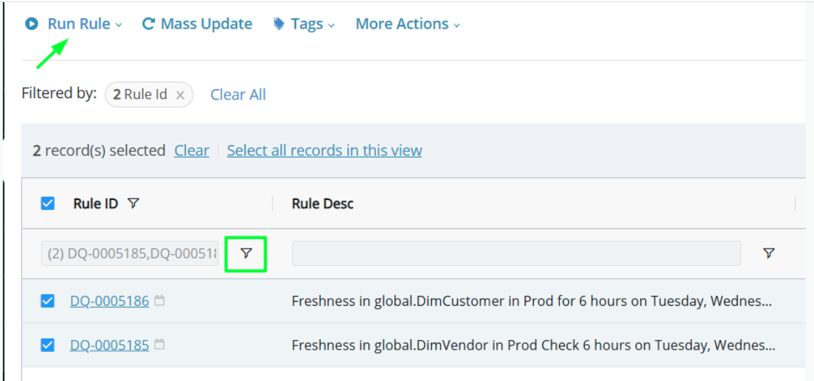

**55. Incident #27546**

**Sub: Rule description blank 6012 and 5816**

**Question:**

Debra is asking why the rule description appears blank in the view, but shows up when she enters the

details of the rule. She mentions that there used to be both a rule description and a run description,

and she is wondering if only one description is available now. She is also seeking clarification on why

the description doesn't show up in the view.

**Solution:**

We explained that the issue with the missing Rule Description on the "View"

page for rules 6012 and 5816 has been resolved. The description should now be visible on both the

View page and the rule details page.

We also clarified that in DI, there is no separate Run Description column like in DQ. Instead, all

relevant information is now included within the Rule Description field.

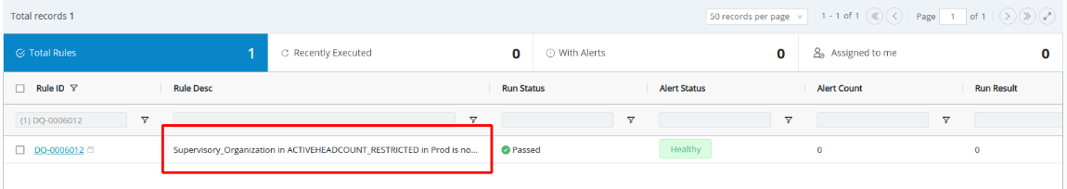

**56. Incident #27545**

**Sub: DQ-0006152 invalid**

**Question:**

Debra is reporting that rule DQ-000652 is now invalid in DI, despite working fine earlier and still

functioning properly in DQ. She mentions that the error message indicates the converted SQL is

incorrect, which is causing the issue in DI. She is asking for assistance in resolving this discrepancy.

**Solution:**

We acknowledged her concern and explained that after investigating, we

found that the rule in DI was identical to the DQ rule. The only difference identified was the placement

of the filter conditions, which was the same as it was earlier. This explanation indicates that the issue

might be related to how the filter conditions are being handled in DI.

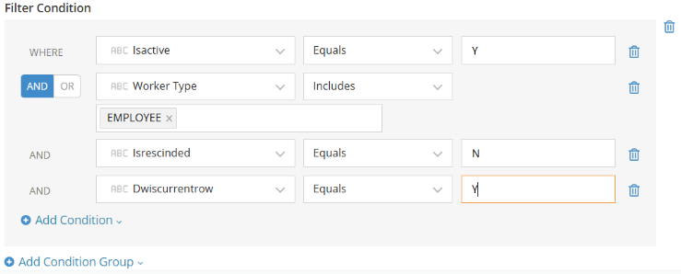

We adjusted the filter conditions and re-ran the rule, and it worked as expected.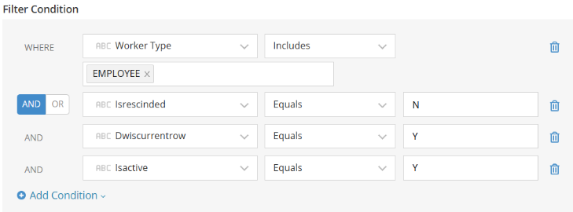

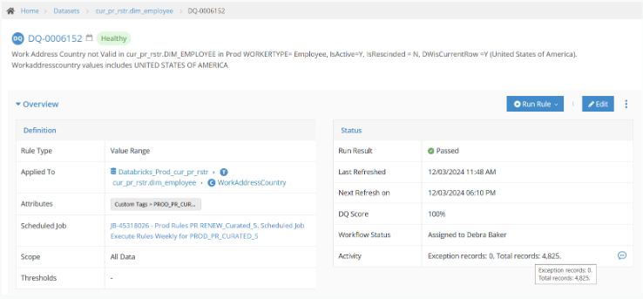

**57. Incident #27544**

**Sub: Table looks up don't appear to work now, or ignore case**

**Question:**

Debra is reporting that several rules using tables, including DQ rules 5903, 5823, 5893, 5822, 5981,

5823, and 5961, are no longer working properly in DI. She mentions that some of these rules

had the "Ignore Case" option checked and worked fine in DQ, but not in DI. She also notes that

there are discrepancies in the number of exceptions and alerts: today, there were 4 exceptions in

DQ but 11 exceptions, 6 invalid, and 4 alerts in DI for People Resources. Debra is unable

to find any correlation to changes on the US Venture side and is seeking assistance with resolving this

Issue.

**Solution:**

We informed her that a fix has been applied to the issue related to table

lookups and the "ignore case" functionality in DI. After the update, all the mentioned rules (5903,

5823, 5893, 5822, 5981, and 5961) passed successfully in DI. We also offered further assistance if

Needed.

**58. Incident #27543**

**Sub: Duplicate jobs - 3**

**Question:**

Debra is reporting that three jobs (USAF Curated_7, Curated_8, and Curated_9) seem to be set up

twice each in the production environment. She is asking for a review to identify what might be causing

this duplication.

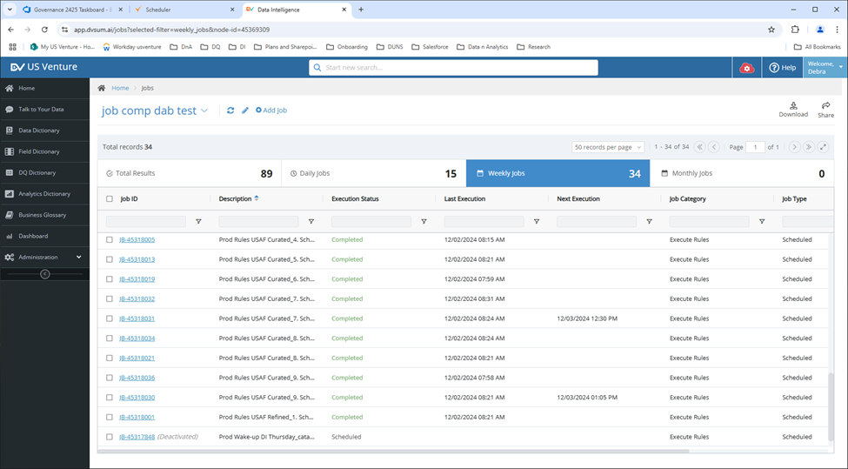

**Solution:**

We looked into the issue and discovered that the jobs for curated_7, curated_8, and curated_9 were

duplicated during the migration process. We suggested that you can delete the duplicate jobs to clean

up the scheduler.

**59. Incident #27229**

**Sub: Welcome to DvSum CADDI Bot Training**

**Question:** This training says I need an endpoint and credentials for snowflake (URL and password). Please send.

**Solution:** Team provided the endpoint and credentials requested by the customer for the Snowflake demo instance:

Host: https://cs88416.ap-southeast-1.snowflakecomputing.com

Database: DEMO_DB

Warehouse: COMPUTE_WH

Password: DataInsightsUnleashed

And informed that they can also find this information under the "Prerequisites" section in the CADDI BOT TRAINING.

Link for that : <https://dvsum.talentlms.com/unit/view/id:2596>

**60. Incident #27232**

**Sub: UDT_MECHEFFICIENCY_FE (JV) Data Update Problem**

**Question:** I ask for your support to validate the update and synchronization of the table shown in the attached image because some rules are being shown with exceptions that should not be shown.(JV)

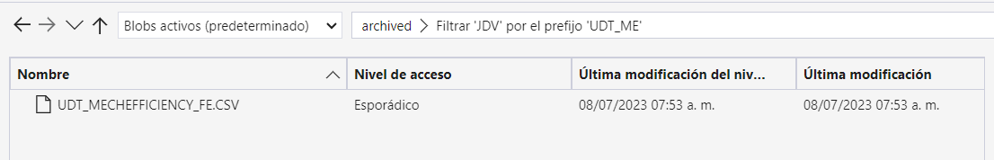

**Solution:**

**61. Incident #27234**

**Sub: Gateway IP change and SSL certificate implementation**

**Question:** I wanted to check with you if we have any article related to how to modify the IP of the DVSUM gateway. Also, is there any article related to the implementation of an SSL certificate on the gateway?

**Solution:** We have shared the article on gateway installation for SSL implementation on the gateway, including a section on SSL configurations as per the request.

And shared the gateway installation article for the reference:

<https://dvsum.zendesk.com/hc/en-us/articles/29188280659988-Gateway-Installation>.

And took the clarification whether they are looking to change the host's IP where the gateway is installed, or is there something else they have in mind?. And informed them that if they are looking to modify the gateway host, this can be done through the UI under the "Gateway" tab in the account settings, within the administration section, by editing the gateway.

Then the customer confirmed that they are changing the Host’s IP where the gateway is installed and shared the image for reference.

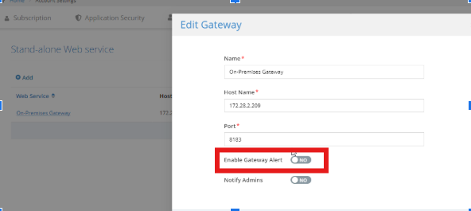

And customer asked about the “enable gateway alert” and asked for clarifications for the difference between those 2 options(“enable gateway alert” and “Notify Admin”).

For this we informed the client that enabling this option will send an alert to the owner and admins if the gateway unexpectedly goes down. And they'll receive an email notification in such cases and gave the detailed explanation of the distinction between Gateway Alerts and Notify Admins:

• When Enable Gateway Alert is set to "Yes" and Notify Admins is set to "No," notifications will only be sent to the owner.

• When both Enable Gateway Alert and Notify Admins are set to "Yes," notifications will be sent to both the owner and the admins.

• If Enable Gateway Alert is set to "No," no notifications will be sent for this specific gateway.

**Then for this Aashish commented as below**:

Below is an explanation of what happens. This is a rarely used functionality, more importantly, I don’t think it is effectively serving what it is supposed to. Matt pointed that out too.

The whole goal should be, rather than the user having to report that there is a problem, if Gateway is having a problem, then the Admin is notified proactively.

But it should be tied to the whole improvement we are doing with Heap crash, slowness, and ofcourse if it is down.

@Jawad Butt, @Shafaqat Ali : can you have a conversation with Matt (involve Shree) into if the current behavior is fine (as long as it works) or it requires tweaking and just make it part of the “SAWS Resiliency Epic” that is on the deck and work has been done on that (not in Prod). Just reconcile into that design and it will be implemented after the DQ enhancements. (in 4-5 weeks)

Based on this Matt had a call related to gateway update DNA SSL implementation with customer and FR was logged based on Aashish comment.

**62. Incident #27236**

**Sub: Unified platform Job Scheduler questions/issues**

**Question:** Aashish raised this ticket by telling that:Kindly analyze these observations below and by Monday afternoon, confirm back to me, if these are expected behaviors or missed items in testing of the solution.

On the UI itself,

The number of rules is 3. The description of rules is 4.

Expected behavior:

It doesn’t matter if the rules were 2 before or 4 or 3 now. If the description is not user provided and generated, it should be made consistent

In the email, I see Start Date and End Date as 12:00 PM PKT. I don’t know how PKT even gets printed. The UTC is UTC, the person who set the time was in PT timezone.

Expected Behavior:

If the Start and End Date email is not handled to do the same that UI did, which is dynamic based on user’s timezone, then at a minimum, it should have said 12:00 AM PT or it could have said 8:00 am UTC.

Ideal Behavior:

If the email is static for all users in distribution, then the reference timezone of creation HAS TO BE STORED. Which means, when the job is created, you should have STORED the timezone, so you can use to print it back.

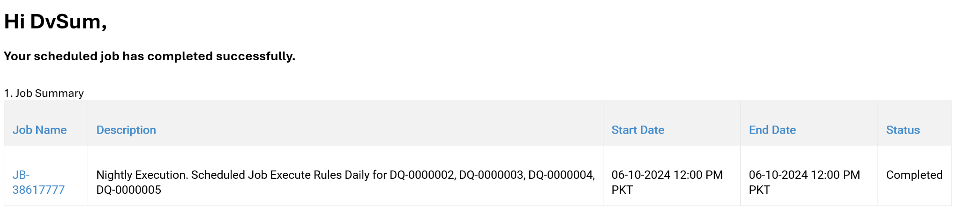

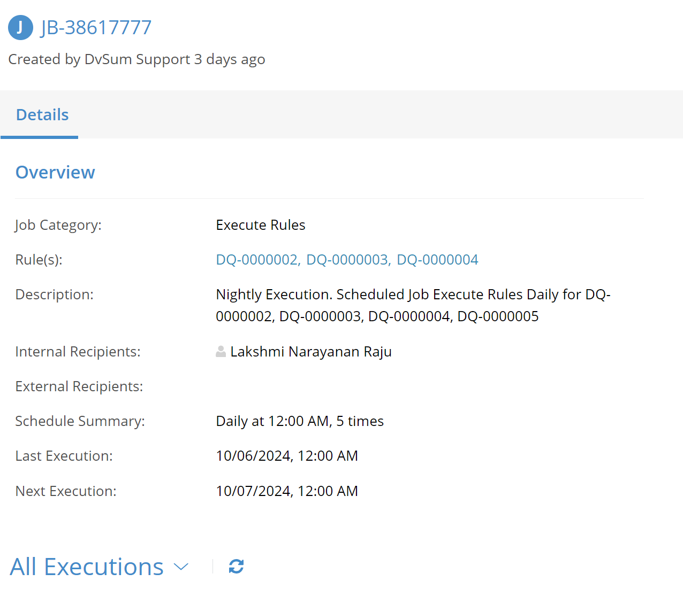

And he also added:

Make sure the 3rd issue that I reported before (jobs don’t show up) is also fixed.

4. It is related to 3rd issue. We keep saying, the job doesn’t contain the rule, but the RULE IS ADDED to the job, that is why it ran. So atleast be consistent, even if logic is wrong.

Make the functionality like this.

5. Workflow shall no longer be controlled by this implicit assumption of job. Add a switch in UI to say – workflow enabled (like we had in DQ Legacy). If it is workflow enabled, then it shows workflow actions etc. If it is not, it won’t. Disconnect from implicit assumption of job and workflow.

6. In the list of jobs that show up that I can connect to. (Item #3), show all the jobs that are “Rules related” that have atleast 1 schedule remaining. Meaning to say, if there is a temporary schedule of jobs, which have all run and no longer “ACTIVE”, then obviously, don’t show them. How you do that is not by looking at the schedule, but by having a field on the JOB that represents “ACTIVE” or not “ACTIVE” or by setting a field called “NEXT_SCHEDULE”. Then we can simply use the filter where the job where next_schedule is not blank.

7. In the Rule Detail page, where we have the scheduled information in the header, see, if can now leverage information from 6 and use min(next_schedule) to display when the rule will be automatically run next. I can review mockups if you show me.

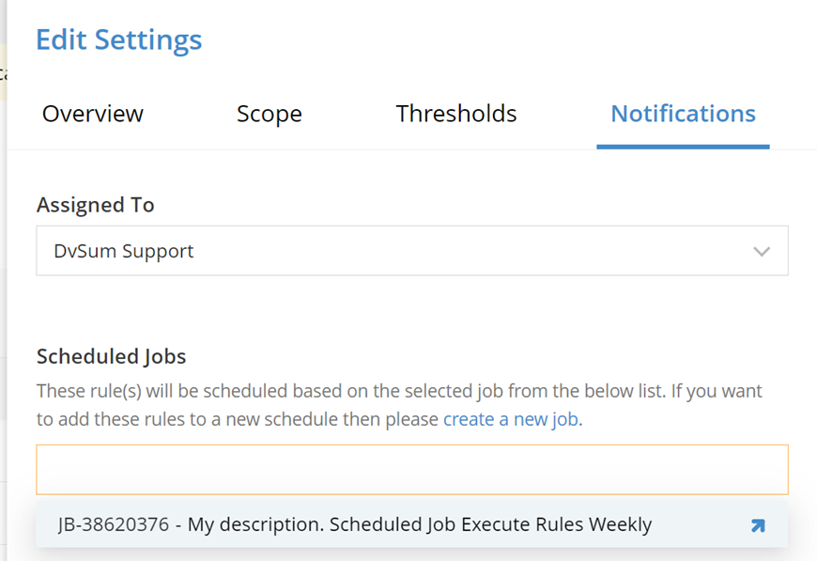

**Solution:** We ensured him that the cases he had mentioned were thoroughly tested before sharing the details with him.And gave the updates as below:

**Rule Description Inconsistency:** The issue has been reproduced, and a ticket has been logged. While the workflow functions as expected when editing the schedule and adding/removing rules, the issue arises when a rule is added to a scheduler from the rule detail page.

**Timezone Handling in Emails:** The issue occurs when the same user logs in from different timezones. In this case, it seems that you encountered the issue on the LLA dev account, which is frequently used by Faiz. He likely logged in before the job ran, causing the job to pick up the PKT timezone and display that in the email. However, this is not a real-world use case and would not happen with actual users.

**Proposed Changes:** A feature request has been logged in Airtable regarding the observations discussed in points 4-7 from the previous correspondence. Ramana will be working on implementing the proposed changes, which include allowing for more flexible job assignment and enhancing the visibility of job schedules.

We implemented a fix based on Aashish's feedback regarding job assignment for limited-occurrence jobs. Now, jobs with a defined number of occurrences (such as recurring jobs set to end after several executions) will be displayed and available for assignment as long as there are future scheduled occurrences. This adjustment removes previous restrictions, ensuring that all valid recurring jobs, except one-time jobs, appear as assignable and visible in the job list. And also informed him that we've resolved the issue he reported regarding the mismatch between the number of rules and the rule description on the UI. Previously, the description was not aligning with the actual number of rules displayed. This has now been fixed, and the description will be automatically updated whenever rules are added or removed from the job, ensuring consistency with the number of rules. Then we've closed this ticket.

**63. Incident #27240**

**Sub: Sensitive information publicly available on support page**

**Question:**[**https://dvsum.zendesk.com/hc/en-us/articles/360055209472-S3-Source-Configuration-on-AWS**](https://dvsum.zendesk.com/hc/en-us/articles/360055209472-S3-Source-Configuration-on-AWS). This page provides an example of how to create policies and uses screenshots. These screenshots are from our own application and contains ARN keys etc.

I don’t think this is a good idea to not redact the sensitive information in the screen. Please confirm with Shafaqat and if he says yes, then get this article private first and then get the screenshots updated by hiding the sensitive information before making it live again.

**Solution:** The team made the necessary changes and ensured that sensitive information in the screenshots was appropriately redacted.

**64. Incident #27262**

**Sub: RE: DVSum Troubleshooting \\ Action API error**

**Question:** They mentioned that they are facing an issue in CAADI and shared a reference image of the problem. They also noted that they had encountered the same issue previously.

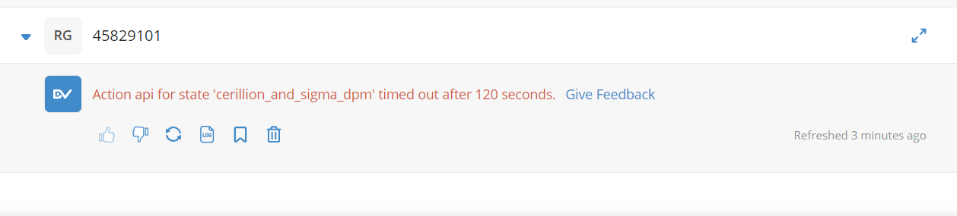

**Solution:** The team identified the cause of the issue and informed the client that it occurred because the RPA bot did not receive the specified order. They clarified that the bots are functioning as expected and shared an image for reference.

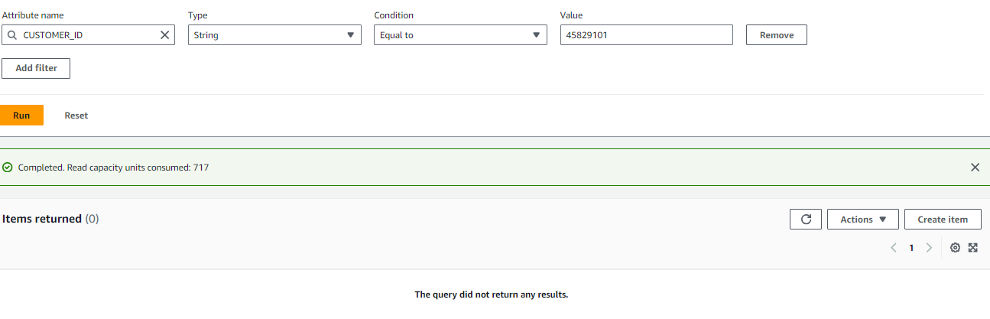

For further investigation, we requested the client to share the RPA execution ID and the bot link where the error occurred.

The client then shared the requested RPA execution ID, the bot link, and the customer ID they were searching for.

Bot link: <https://www.app.dvsum.ai/chat/44992380>

Customer id: 45829101

RPA execution ID:

44992380_241007124008_f6fc268c-876d-4d2d-9fd7-494438700f19:cerillion_and_sigma_dpm:api:sHhTE/jgi8v/iZqy91z7qAbIxDXu6ceJ5j5AcHncYIM=

Then we found and fixed a problem with the RPA bot. The issue was that the API endpoint was sending the bot load to bots that weren't running, which caused it to stop working. We’ve now redirected the load to the bots that are running.

**65. Incident #27264**

**Sub: catalog and profile can't see log**

**Question:** A catalog and profile was run Friday on our d365 source. It took longer than usual to bring up the log. What size limitation impacts this? scan name scn-000154.

**Solution:** The team resolved the issue and informed the client that they can now view the scan logs. They also provided context on why the issue occurred, explaining that while the logs were being generated on the back end, an error on the front end prevented them from being displayed for this specific data source. The issue has been promptly addressed, and the client should now be able to view the logs as expected.



**66. Incident #27265**

**Sub: CADDI training bot access**

**Question:** Hello how do I get access to the Adventure Sales bot and Adventure works product buyer bot?

**Solution:** First, we shared the following articles:

* **Creating the Adventure Sales Bot and Adventure Works Product Buyer Bot**: *Configuring CADDI - Creating Chat Bots – Help Center (zendesk.com)*
* **Managing & Sharing Bots**: *dvsum | CADDI Bot Training | Share & Manage Your Bots (talentlms.com)*

Then, Aashish advised us to clarify which account the client is using. He also mentioned that if they are using a demo or training account, these are administered by the pre-sales team (Matt, Zaki). In that case, they should be instructed to reach out to the pre-sales team for further assistance.

Then we asked the client which account they were using, and they confirmed that they were using the demo account. So we informed the client that demo and training accounts are typically managed by the pre-sales team (Matt, Zaki) and recommended client to reach out the pre-sales team for further assistance.  
This is the video link for share and manage the bot:

<https://dvsum.talentlms.com/unit/view/id:2619>

**67. Incident #27267**

**Sub: CADDI response format issue**

**Question:** While they are using bot, they have noticed some formatting issues. And asked for an update on the formatting issue, which was likely reported by Matt on September 27th?

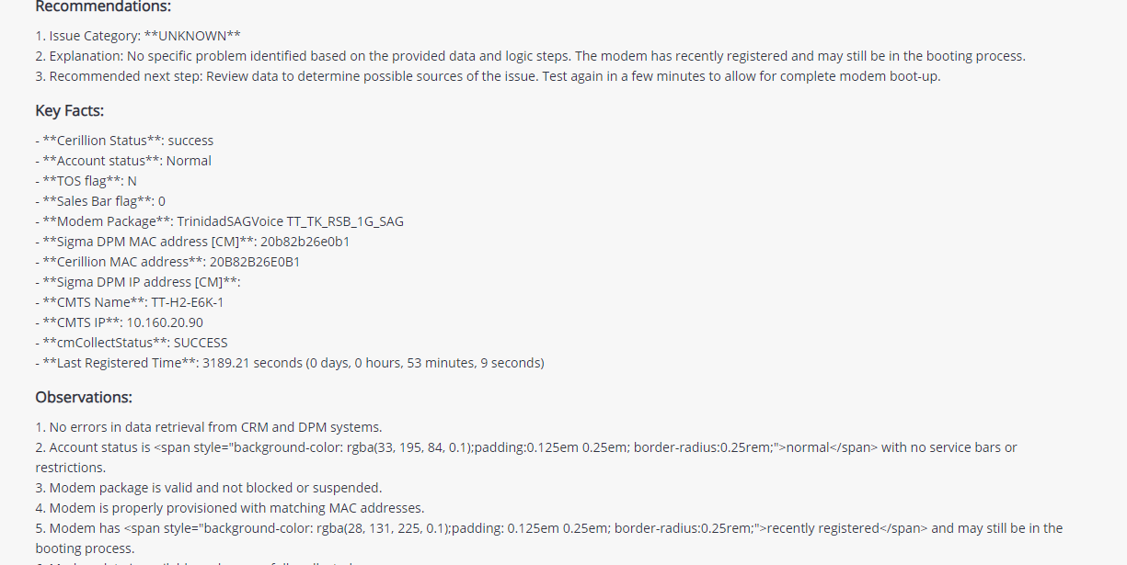

**Solution:** The team informed the client that the issue has been investigated and found that Matt had already notified the product team. We also informed the client that we will provide an update once the issue is resolved. After logging the FR, we closed the ticket and mentioned that a follow-up ticket will be created once the issue gets fixed.

**68. Incident #27290**

**Sub: no telemetry data**

**Question:** Ravi is reporting the following issue for several cases, where no NXT data is available, please provide feedback on this.

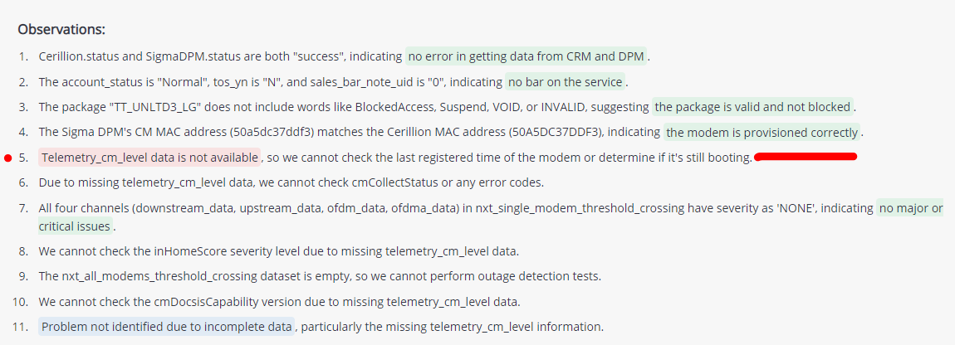

**Solution:** First, we logged an FR. Then the client reached out asking for confirmation on whether they need to change the endpoint URL or IP address for NXT, based on the response they received from the NOC. They also mentioned that they are still facing the issue and expressed surprise, saying they haven’t received any reports from Jamaica regarding issues. They are waiting for a response from Sibeko. Additionally, they inquired if there's a possibility that the UAT bots are pointing to a different NXT URL than the production bots in Jamaica. The team then had a call with the client. Later, the client shared their response with Matt, stating that the problem was resolved. Based on that response, the ticket was closed.

**69. Incident #27291**

**Sub: CADDI not properly generating queries**

**Question:** Can you help troubleshoot this why no sql is getting generated.

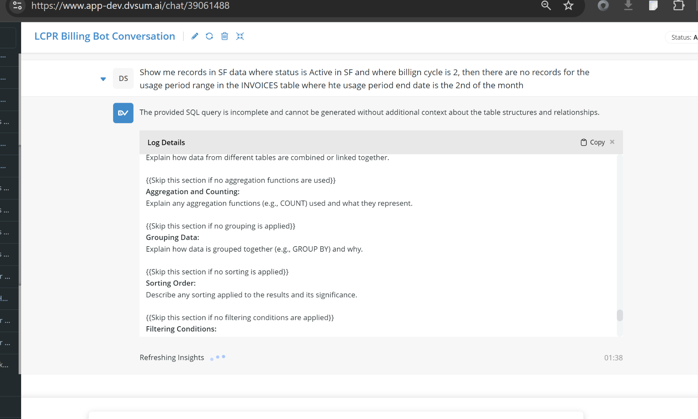

**Solution:** First, we logged the FR. Then, the issue preventing SQL generation was addressed, and we informed Aashish that it is now functioning correctly, and he can see the SQL output as expected.

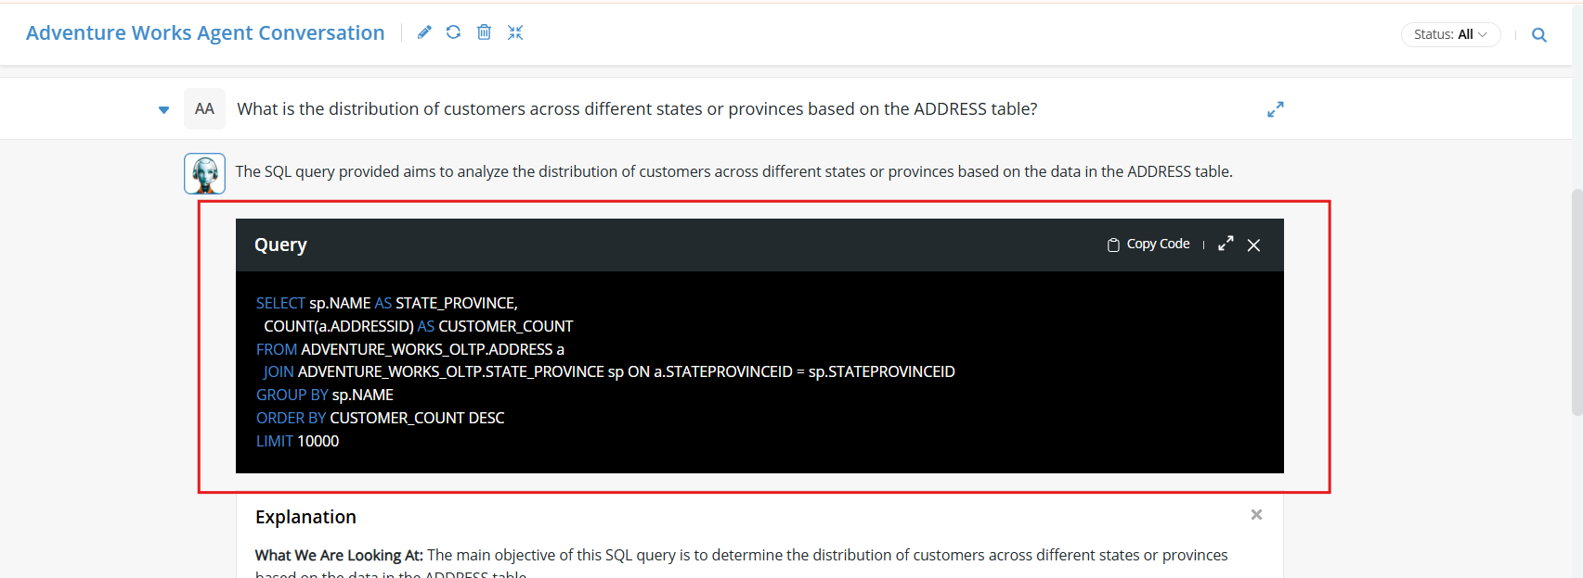

**70. Incident #27292**

**Sub: Customer Queries do not execute in US Venture DQ since the upgrade this morning.**

**Question:** we ran the catalog and profile when we upgraded the gateway this morning in DQ, and they were both successful. However, I'm encountering significant issues running any rules now, and I'm unaware of any other changes that might have occurred.

The error message we're receiving is the same across all failed rules:  
 'Execution of rule failed. Please check the test definition for any typos and try again.'  
 This message doesn’t provide any useful information about the actual issue.

For example, when running the current day custom query, I noticed that Annika had tried to run some new rules she created during the upgrade downtime. I initially thought the issue was due to the brief downtime. But upon reviewing the times, I realized the rules were run over a much longer period, including after the system was back up.

I ran those same rules, and they all failed. They used a similar custom query that checks dates. Based on a previous comment regarding a date field, I suspected this might be related to a change in the date field format. The query in question used current_date(), like this:  
DQ-0006329 Select * From (SELECT Max(Refined_ModifiedDateTime) as ModDate FROM d365.CUSTTRANSOPEN ORDER BY ModDate desc) Where ModDate < Current_Date().

The rules Annika created, which ran fine before the upgrade, failed when I reran them. Then I noticed that none of our wake-up rules are running. Most of these rules use current_date() or limit 1. I tried different versions and queries, but they all failed.

I also ran 3 other jobs of rules that had successfully run this morning before the gateway installation. While a number of them completed successfully, several others failed, including DQ-0006034, 6026, 6011, 6008, 6035, 6024, 2459, and 2458. Out of 79 records, 8 custom queries did not run.

Since the upgrade, I have not been successful in running any custom queries in DQ.

**Solution:** For this first we logged FR. Then the team informed the client that the issue with the custom queries has now been fully resolved. After reviewing their feedback, we looked into the possibility that the recent gateway upgrade was the cause. However, after a thorough investigation, we determined that the root cause was an internal backend glitch, which affected the rules they mentioned. And we made it a priority and quickly applied a fix. The custom queries should now work as expected and return the correct results without any further issues. Then the fix was implemented, later when the client rerun the rule, the rule was run successfully.

**71. Incident #27314**

**Sub: After running online profile, the page doesn't reflect updated**

**Question:** Go to a table. Click on the Data tab. Click on Run Profiling Online. When profiling finishes, the data in the tab (record count) doesn’t refresh.

In Rules, when we finish a rule execution online, the page automatically refreshes. The same should be done for Profiling. When it finishes, the page should automatically refresh. Ideally not page refresh but content refresh. The page might be locked because someone is editing the column section.

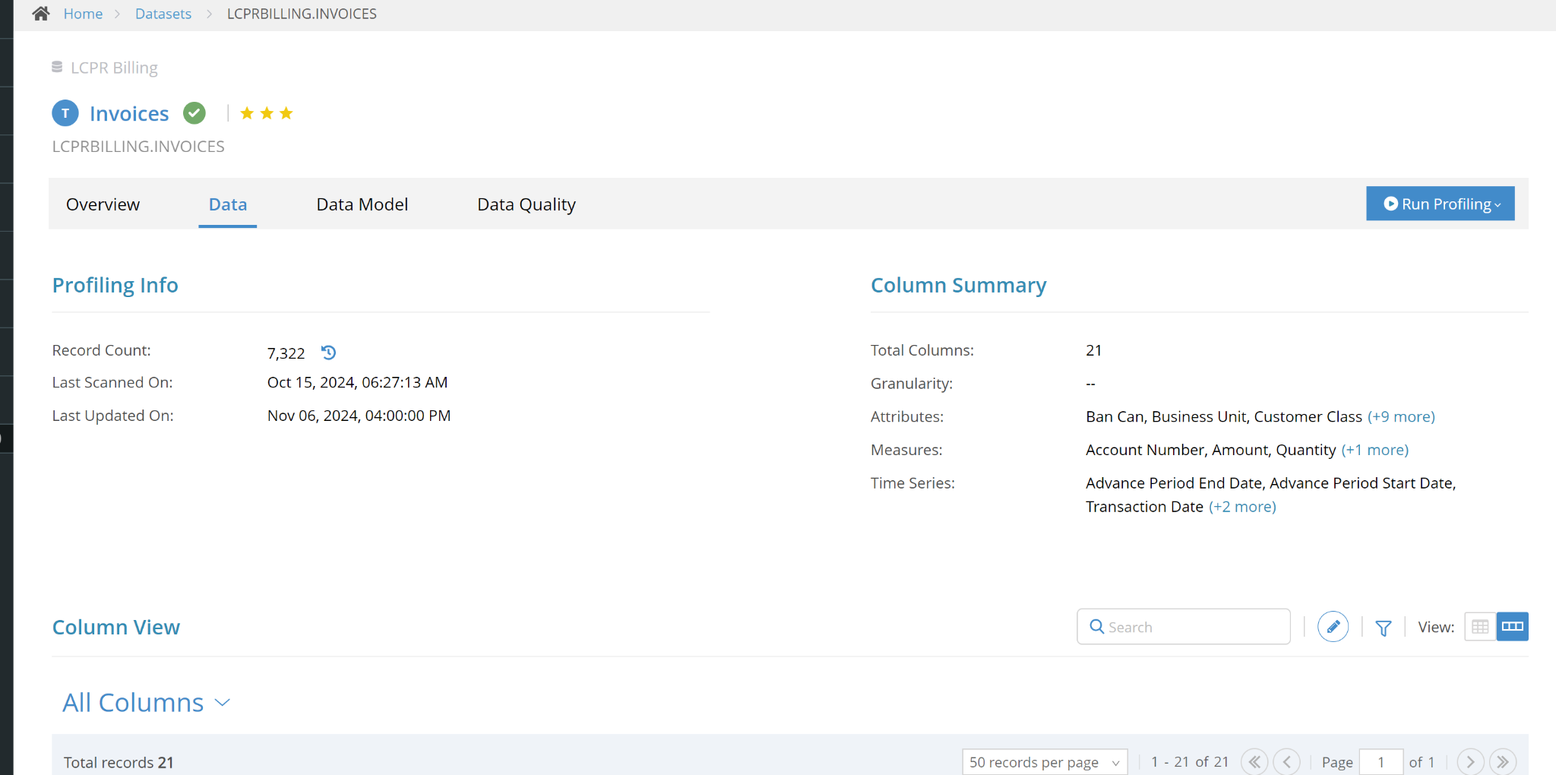

**Solution:**  The FR was logged and then the issue with the record count not refreshing in the Data tab after running profiling online was fixed. Now, once profiling is complete, the content will refresh automatically, ensuring accurate data display without the need for a full page reload.

**72. Incident #27454**

**Sub: Follow-Up: CAM, Venezuela & Guatemala DVSUM Rules**

**Question:**

asking for help to modify the dashboard so that only the CAM (likely a specific metric or data

category) is visible. He wants to remove the GTM and VEN metrics from the display, but he also needs

to create some additional measurements related to GTM and VEN first, likely for comparison or some

other purpose before filtering them out. Essentially, Tomas wants to clean up the dashboard to only

show the relevant CAM data.

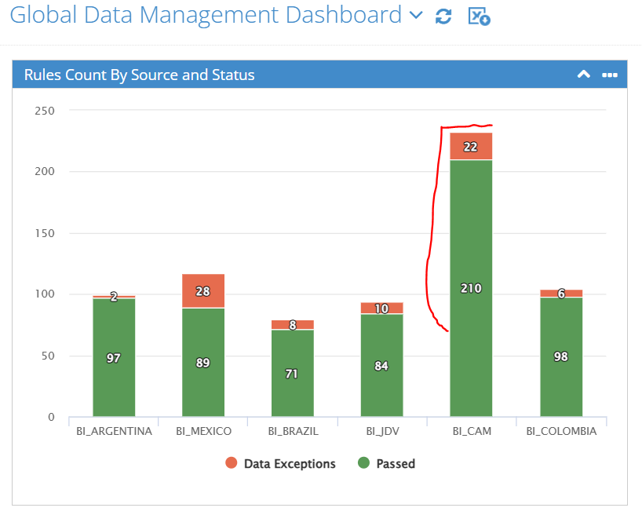

**Solution:**We investigated the issue with the widget and found that the high values for BI_CAM were due to the

inclusion of both GTM and VEN data sets in the same source. The new rules for GTM and VEN were

causing these elevated numbers to appear.

To fix this, we updated the widget to exclude the GTM and VEN rule groups. As a result, you should

now see a more accurate and normalized graph and figures for the BI_CAM source on the dashboard.

If you want to further review or make adjustments, you can edit the widget directly by going into the

view settings within the widget editor. We've attached a screenshot for your reference to help guide

you through it.

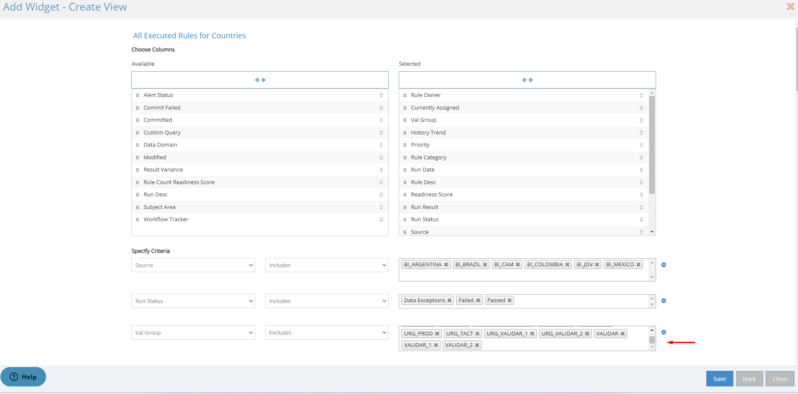

**Before the update.**

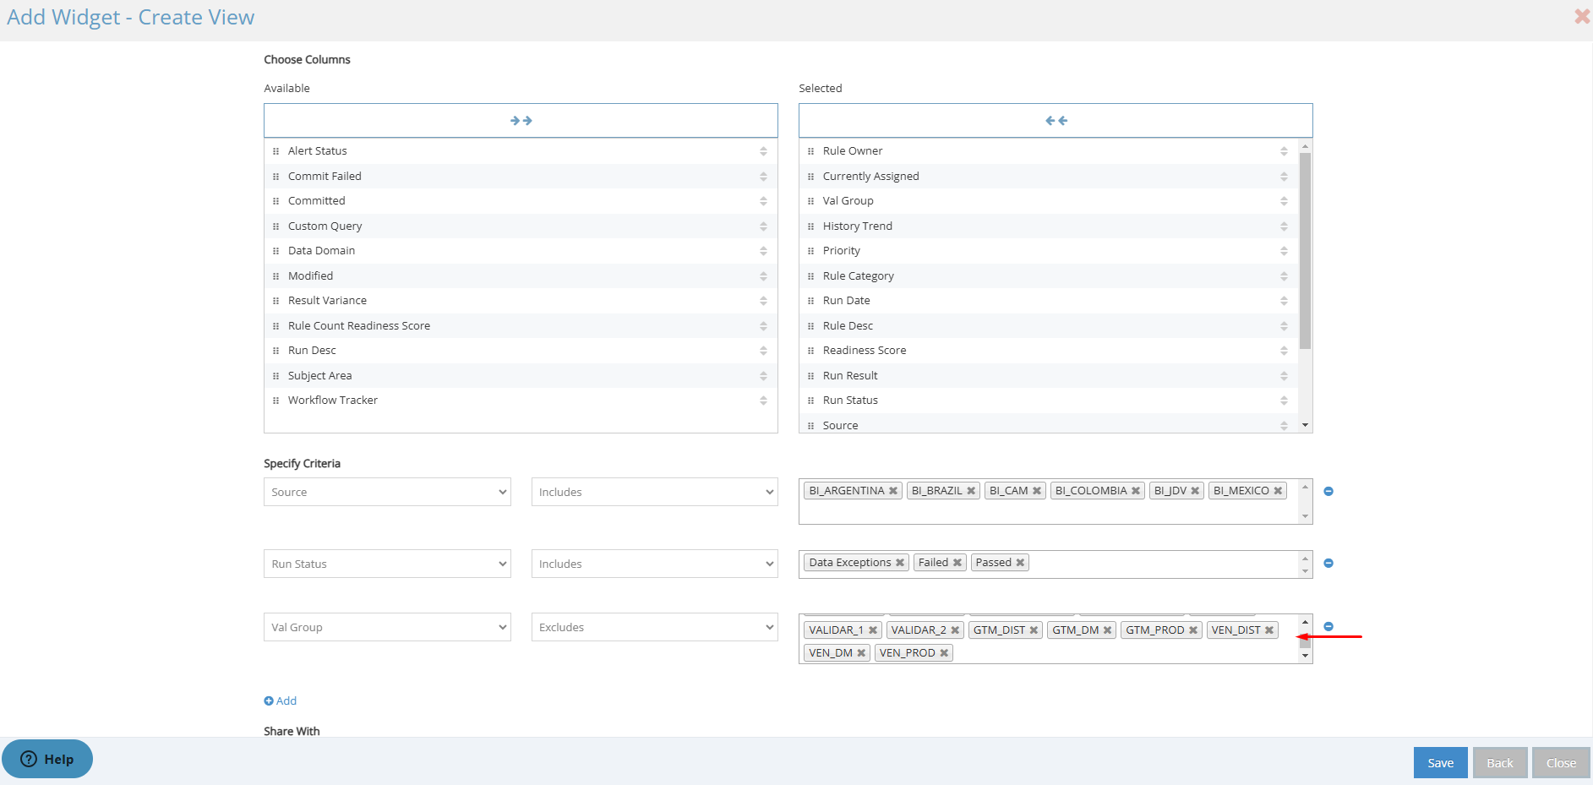

**After the update.**

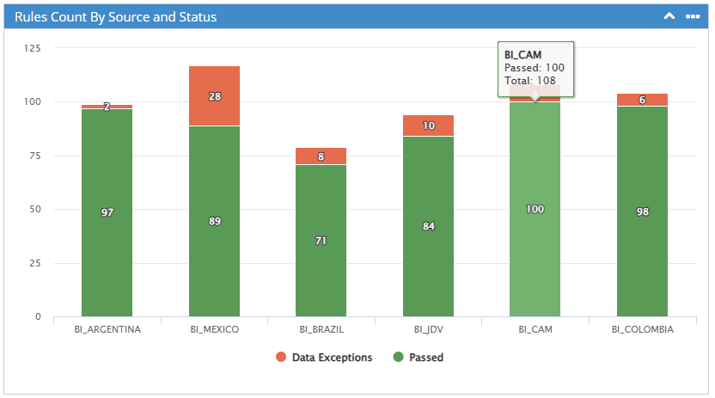

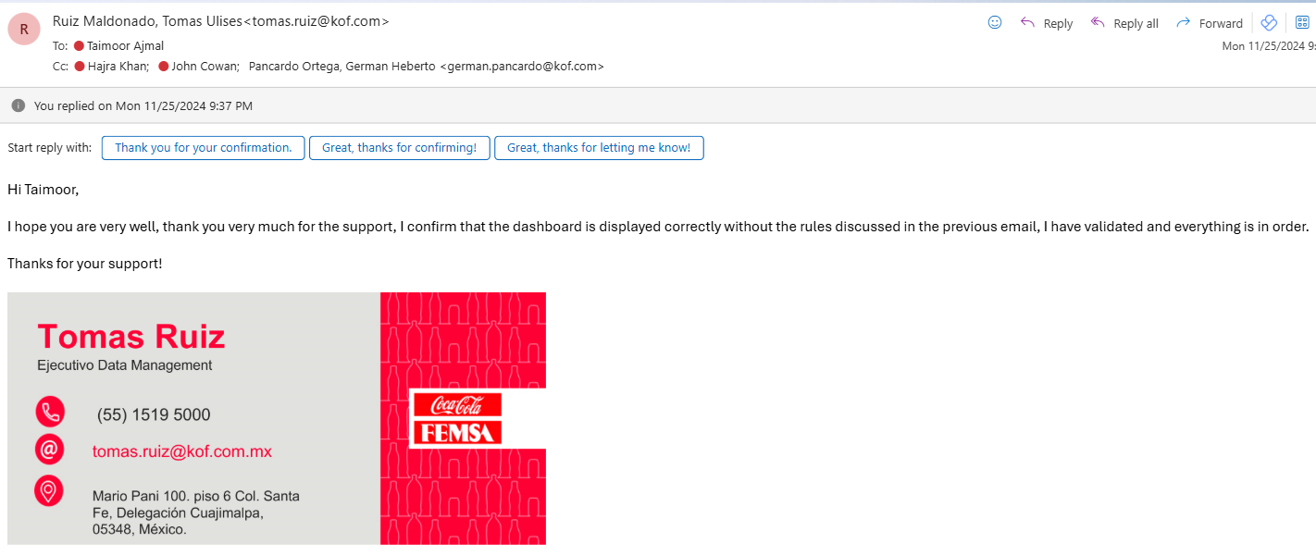

**We got a reply that its working fine.**

**73. Incident #27444**

**Sub: System change with syntax and dates? New**

**Question:**

She's bringing up an issue where, after the recent update to the cdata driver (which involved changing

the date syntax), she encountered five rules that failed today with an "invalid" error. These failures are

new and didn’t occur before the update. She’s likely seeking clarification or assistance to understand

why these specific rules are now causing errors, even though the update should have been

implemented without such issues previously.

**Solution:**

We looked into the issue and found that two of the DQ rules (DQ-0006757 and DQ-006008) had been

deleted, which is why they were showing as "invalid." For the remaining rule (DQ-0005961), we

confirmed that it has now passed successfully without issues. We've attached a screenshot for

Confirmation.

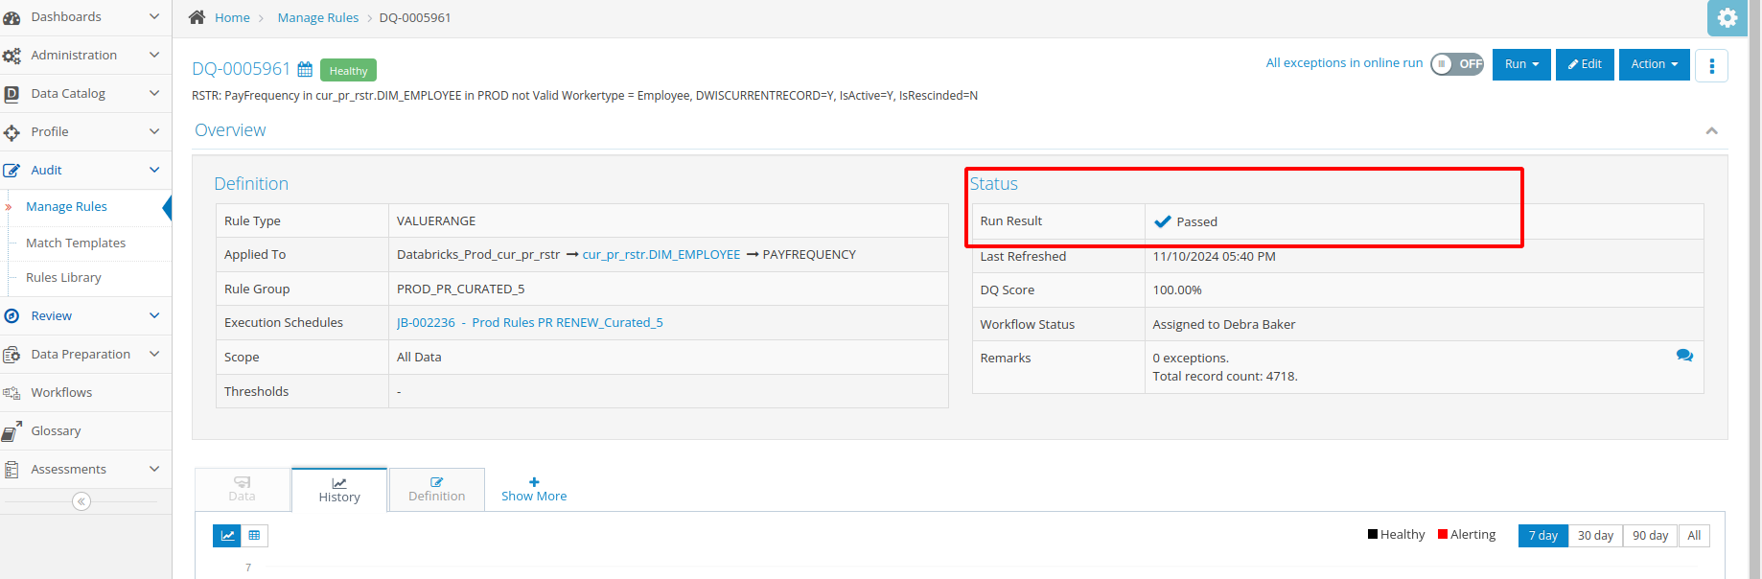

**74. Incident #27440**

**Sub: New Error Message on Invalid DQ Rule**

**Question:**

She’s reporting a new issue where an out-of-the-box "blanks" rule (DQ rule number 6687), which was

previously running without any issues, is now returning an error message and is marked as "invalid."

She’s attached the error message for further investigation and is seeking assistance to resolve this

Issue.

**Solution:**

We looked into Lauren’s concern with DQ Rule #6687, which was previously showing an error. After

checking, we found that the rule is actually passing successfully now. To confirm, we’ve attached a

screenshot showing the rule running without any issues.

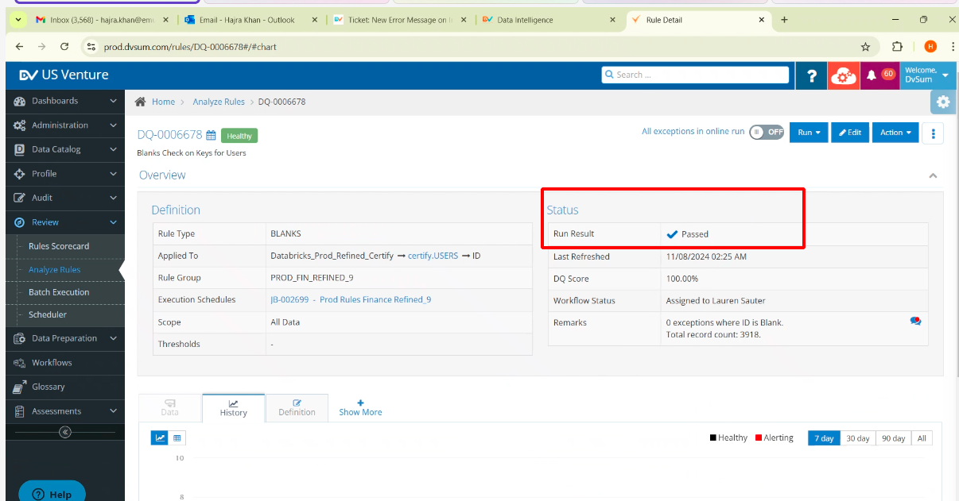

**75. Incident #27439**

**Sub: DI -- signin screen timesout**

**Question:**

She’s encountering an issue when logging into the DI screen. The main data is taking a long time to

refresh and eventually times out, displaying an "Endpoint request timed out" error in red letters.

Despite this, the cloud status was green when she tried accessing it earlier this morning. She’s likely

seeking help to resolve the timeout issue and understand why the screen isn't refreshing properly,

even though the cloud status appeared fine.

**Solution:**

We followed up on Debra’s issue with the DI Home Screen not loading properly. After observing the

issue during the call, we reached out to ask if she’s still experiencing the same problem. We requested

a screenshot of the Home Screen from her, which would help our team troubleshoot further. This

additional information would be very helpful for resolving the issue more effectively.

**76. Incident #27436**

**Sub: training video garbled...can you help fic it?**

**Question:**

Here Shree having an issue with a training video where the audio or video is garbled, making it difficult

to understand or view properly. Shree is likely asking for help to fix this issue, so they can access the

content correctly.

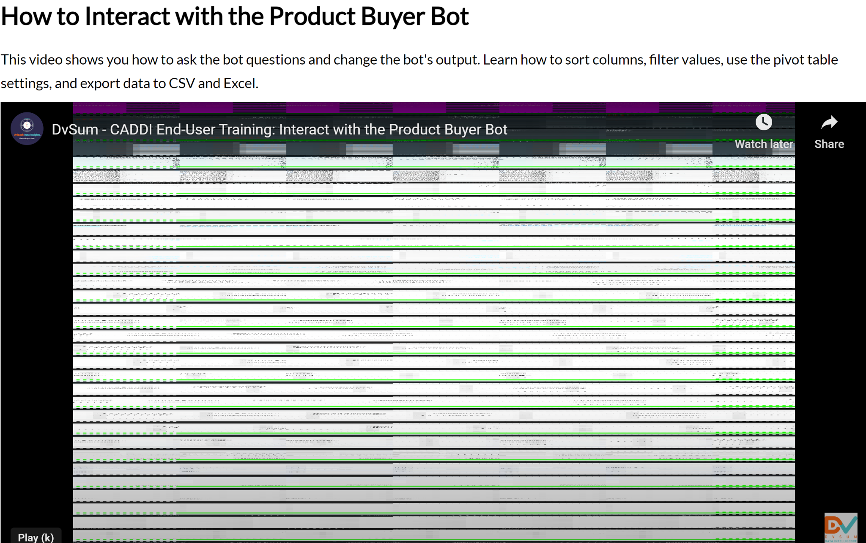

**Solution:**

Since the issue isn’t related to the DvSum product, we forwarded the request to the appropriate

training team (@DvSum Training) for further assistance. This way, they can help Shree resolve the

issue with the video.

**77. Incident #27432**

**Sub: New DVSUM rules for multicategories area ( Colombia and Brazil)**

**Question:**

Tomas asking to replicate the existing rules, DQ-0008750 and DQ-0008751, for use in Colombia and

Brazil. This likely involves creating similar rules for those regions based on the current ones, ensuring

they are applied correctly for each country.

**Solution:**

In the last bi-weekly call with the customer on 25 Nov, 2024, we discussed the request to replicate

the rules for Colombia and Brazil. We provided the customer with the relevant details and

demonstrated how the rules can be cloned. As the issue was addressed and resolved during that call,

we’ve marked this request as solved and closed.

**78. Incident #27430**

**Sub: BSC - Account expiry**

**Question:**

Pavan is requesting that the email address pavan.ramakrishna+bsc@dvsum.com be unlocked on the

BSC account as soon as possible. He’s asking for an immediate update once the action has been

completed.

**Solution:**

We reported this to Ramana and he updated the account.

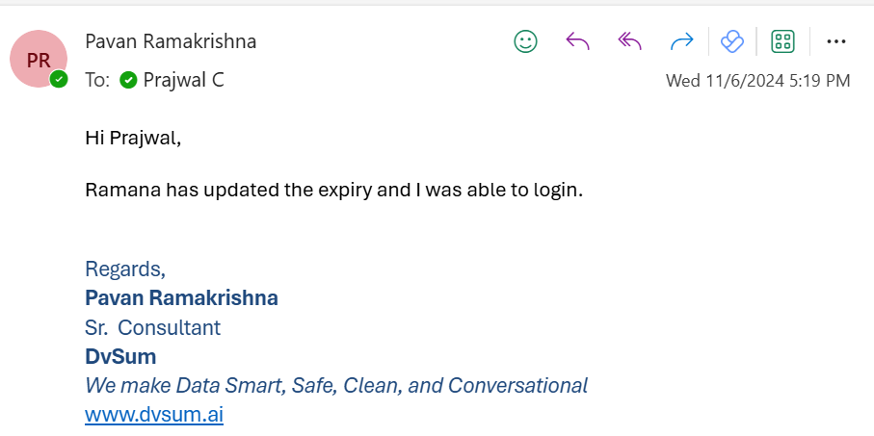

**79. Incident #27423**

**Sub: Schedule timing - current and past times?**

**Question:**

She is asking for clarification on what changes were made, likely related to the "fallback" of Daylight

Saving Time. She’s noticing that the schedule in DQ (likely referring to a scheduling system or data

query) now shows incorrect times for all scheduled events, and she’s concerned that the history has

been altered as well. She’s requesting an explanation for these changes and to understand what

caused the discrepancy.

**Solution:**

We informed Debra that we’ve successfully adjusted the scheduled jobs to account for the

One-hour change due to Daylight Saving Time. We requested that she verify the job times on her end to

confirm that everything is updated as expected. The issue was caused by the recent Daylight Saving

Time change, with timestamps last updated in March and another adjustment made in November. We

apologized for any inconvenience and assured her that moving forward, we will proactively manage

these changes to avoid future issues.

**80. Incident #27404**

**Sub: DVSUM support mails being quarantined by Ms defender**

**Question:**

Marcelo is informing the team that some of their emails are being held in quarantine by Microsoft

Defender within his domain. He’s not sure if anything can be done to prevent this, but he wanted to

make the team aware of the issue. He hasn’t been able to find a way to whitelist the emails on his side,

possibly because Microsoft Defender is flagging them due to suspected sender spoofing.

**Solution:**

Marcelo informed us that some of our emails are being quarantined by Microsoft Defender. In

response, we checked our side and found no issues that would cause the emails to be flagged. We

suggested that Marcelo’s internal team review their Microsoft Defender settings to address the

problem. We also offered further assistance if needed to help resolve the issue.

**81. Incident #27402**

**Sub: Distribution List Request - DvSum Alert. JobJB-001856 Commercial Rule 1433 weekly run**

**(Commercial: Onhand Items with Zero Cost in Warehouse...) completed**

**Question:**

Olga is asking for a few individuals to be added to the DvSum Rule distribution list. She likely wants

These people receive notifications or updates related to the DvSum rule.

**Solution:**

Olga requested to add certain individuals to the DvSum Rule distribution list for Job Completion

emails related to JB-001856. We completed the request by adding the new recipients as External

Users (since they weren’t listed as DvSum users) and removed the person she asked us to take off the

list. We provided a screenshot for reference and offered further assistance if needed.

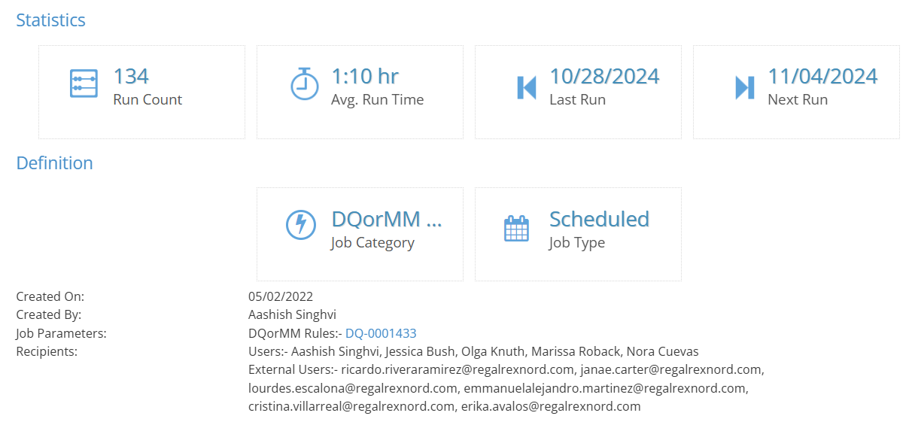

**82. Incident #27397**

**Sub: LLA, change expiration date for all users**

**Question:**

Marcelo is stating that there is currently no need for a user expiration date. However, he’s asking if it’s

possible to set a uniform expiration date for all users (for example, January 11, 2030) in bulk. He’s

looking for confirmation on whether this mass update can be done for all users at once.

**Solution:**

Marcelo asked if it was possible to set a uniform expiration date for all users. In response, we

confirmed that mass updates can be done from the backend. We’ve set the expiration date for all active

and invited users to January 11, 2030 as requested. We also offered further assistance if needed

**83. Incident #27397**

**Sub: LLA, change expiration date for all users**

**Question:**

Amilcar is trying to understand a discrepancy he’s noticing in CADD. He’s seeing an error message that

says, “error pulling data from CRM and DPM,” but he believes that if the Cerillion status is “success,”

the error message should only mention “error pulling data from DPM.” He’s highlighting that the Sigma

DPM status is showing an error with a message stating, “Unable to reach sigma dpm,” but the Cerillion

status shows “success.” Amilcar is looking for clarification on why both CRM and DPM are being

mentioned when Cerillion is successful.

**Solution:**

Matt and Vishal had a call with LLA to discuss the issue. Vishal provided a response, which is shown

in the attached screenshot. As a result, the ticket is now being closed.

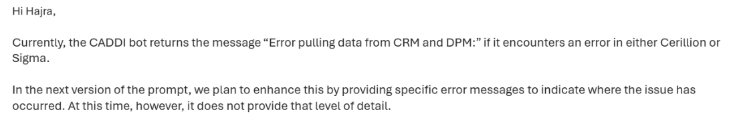

**84. Incident #27382**

**Sub: BSC | Query - Data Import failure on Data Source name**

**Question:**

Pavan experiencing an issue when trying to import a field dictionary for **BSC**. The import failed for

the data source named "MemberDNA (MBRNA_PRD)" due to the parentheses in the name. After

Renaming the data source to "MemberDNA" The import was successful.

Pavan is asking if non-alphanumeric characters (like parentheses) are supported in data source

names during data imports. If not, he’s suggesting that either the use of such characters be restricted

or that they should be allowed during the import process.

**Solution:**

Pavan reported an issue with importing a field dictionary for a data source with parentheses in the

name. We replicated the issue on our end using the same data source name ("MemberDNA

(MBRNA_PRD)") and found that the import worked successfully. However, after further checks with

our development team, we identified that the issue could be related to non-alphanumeric characters

in the file name, not the data source name.

We clarified that there are no restrictions for non-alphanumeric characters in the data source names

themselves. To investigate further, we asked Pavan to share the exact file name being used for the

import to help pinpoint the issue.

Then, Pavan informed us that the case can be closed since he renamed the file he used for the

upload. He mentioned that he will retry the action for a different source at a later time and will confirm

whether he’s able to open it successfully.

An article link for reference:

<https://dvsum.zendesk.com/hc/en-us/articles/11197801100820-How-Generic-Data-import-works>

**85. Incident #27376**

**Sub: DATEFROMPARTS in MDC rule now failed, similar but different as we didn't code this**

**Question:**

From Deb's perspective, she’s reporting an issue with the DATEFROMPARTS function in the MDC

rule DQ-000322 (DimWarehouse), which is now failing. She believes that this error may not be

something that was specifically coded by her team, but rather part of the auto-generated rules.

She’s asking for verification on whether this is indeed the case. Deb also mentions that she noticed

three other rules (DQ-0001197, DQ-0003747, DQ-0004216) timed out previously and were closed

without any additional details. These rules hadn't been modified in a long time, but one might have

had a table update for dimproductsegment, which could be related to the issue. She noted

that she reran those three MDC rules, and they ran successfully, but she still doesn't understand why

they initially timed out.

Deb is primarily concerned with DQ-0003222 now and is seeking clarification on the issue and its

connection to the auto-generated rules.

**Solution:**

We analyzed the issue Deb reported and determined that it was related to the date format discussed

earlier. We’ve made the necessary adjustments, and the issue should no longer affect this rule

(DQ-0003222) or any future ones. We asked Deb to run the rule once and let us know if it works.

And she confirmed it was scheduled successfully.

**86. Incident #27375**

**Sub: DATAFROMPARTS failure in custom query provided for rule DQ-0004155**

**Question:**

Deb reporting that a custom query rule (DQ-0004155), which was created to replace the MDC

function, is now failing due to an issue with the DATAFROMPARTS function. This issue arose with a

new connection. Debra recalls that Hajra had mentioned the need for recording in relation to this, and

She's asking for details on the required format to resolve the problem. She’s seeking clarification on

how to proceed with fixing the issue in the custom query.

**Solution:**

Debra reached out regarding the failure of the DQ-0004155 custom query rule with the

DATAFROMPARTS function. In response, we clarified that the rule is associated with the

Databricks_Prod_Curated_USAF data source, which was updated during a recent call with Debra. We

reminded her that since the OAuth secret key was added, adjustments are needed in the custom query

rules to ensure they work correctly.

We provided an example of the required change in date format: the current format of

DATEFROMPARTS(2024,01,01) should be replaced with TO_DATE('2024-01-01','yyyy-MM-dd') for

proper functionality.

**87. Incident #27361**

**Sub: New execution error: USAF Rule DQ-0004370 and others**

**Question:**

Deb is reporting a new execution error for the USAF Rule (DQ-0004370) and a few others

(DQ-0004369, DQ-0004368). The error message states: " this optional feature." She mentions that this

rule set was established a while back to handle orphan records, and no changes have been made to

the rule since then. However, the rule is no longer running as expected, and she’s seeking assistance

to resolve the issue.

**Solution:**

Debra reported an issue with the USAF Rule DQ-0004370 and others not running due to an error after

no changes were made. In response, we confirmed that the rules ran fine after the gateway upgrade,

indicating that the issue might have been related to the previous configuration or environment before

the upgrade.

**88. Incident #27468**

**Sub: Issue on Data Dictionary View**

**Question:**

Please take a look at the earliest convenience. Customer BAH (ldangeti_dhanalakshmi@bah.com) tried a

new Create View off of Data Dictionary mistype format for Record count filter. She is doming

implementation now, so I want to have this looked at soon. Image included, and video comments, three

sections to review if needed: 1. Beginning to about 5 minutes. Then also at 8:30 until end. Notes: a.

Cleared cached, logged in and out. Logged in with another browser with the same userID. Issue remained

across browser sessions.



**Solution:**

We have resolved the issue with the assistance of our PD team, and the issue is now

resolved. However, we kindly request that you avoid using comma in specific criteria (e.g., 100,000)

as it may cause the same error .

This is a data mistype issue. The record count entry field should be configured to accept numeric input

only, not as a text field. The permanent fix should enforce numeric validation and handle formatting to

avoid such errors.

**2. Incident #27471**

**Sub: Data Governance workflow not applied at field dictionary level. FR 862**

**Question:**

Adding this ticket to track a larger issue uncovered by Lakshmi at Booz Allen. I've included Matt on this.

“ The Data Governance workflow is not applied at the field dictionary level." is the important longer-term

issue for FDA.

This is FR 862.".

To Matt's point, a review of not only the one field mistype, but instead all data governance rules (all

mismatches) are followed through. Matt, at your convenience, please free free to chime in. I'll keep this

in here as tracking, but I do not have visibility into FR's. So please update this type as normal for

Support tracking FR's. When FR planned, then tested, then scheduled for rollout.

**Update - Matt explained to me that FR 862 is a different subject entirely. So please close/delete this**

**ticket.**

**Solution:**

The ticket has been reviewed, and it was confirmed that FR 862 is unrelated to the described data

governance concern. The ticket will be closed to avoid redundancy. The broader data governance issue

will be tracked separately, ensuring all mismatches and rules are reviewed and addressed appropriately.

**3. Incident #27472**

**Sub: Add Booz Allen as organization to Zendesk**

**Question:**

Please add Booz Allen as an organization into Zendesk. As I am beginning to direct Booz Allen

questions as appropriate to Customer Support, we need to identify the ticket is from Booz Allen. No

immediate rush on this, but early next week would work. Thank you.

**Solution:**

Booz Allen (BAH) has been added as an organization in zendesk and updated in the requested field in

the screenshot below.

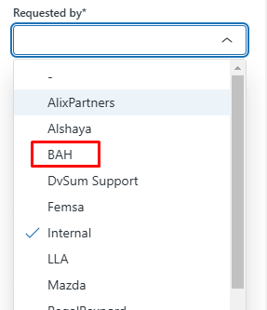

**89. Incident #27487**

**Sub: scheduling help needed Prod**

**Question:**

Jobs were not running in PROD for today when I looked

I did restart vm although I did not see it being an obvious problem

Jobs running from yesterday happened some where held - who did this?

Can't see jobs on display that are completed??????? this makes hard to manage especially in this

Situation.

**Internal note: - for my understanding - with regards to the jobs (rule jobs?): How long**

**Can jobs take?**

**Solution:**

After reviewed the scheduler and noted that most jobs from yesterday and today have been completed

successfully, except for a few. Two jobs from yesterday are still in a running state, a couple appear to

have been aborted (likely by you), and some are on hold. The rest are scheduled and will run as

expected.

This issue doesn’t seem related to testing, as our primary focus has been on the DI platform, not DQ.

It’s possible the scheduler was stuck due to the gateway, but after restarting the VM, jobs now appear

to be running and completing properly.

**Execution time depends on the size of the data the rule is running for and the job type (Catalog,**

**profiling, or Rules).**

Closing this ticket as we have received the follow-up ticket from Debra.

**90. Incident #27495**

**Sub: Can you promote my trial DvSum environment to full version**

**Question:**

Can you please promote my tenant to a full version for my own testing and use. I have already hit the 2

data source limit.

[cid:b170f6bb-b1f6-4f6a-be66-0f88fb81ae1e

Please let me know if this is possible.

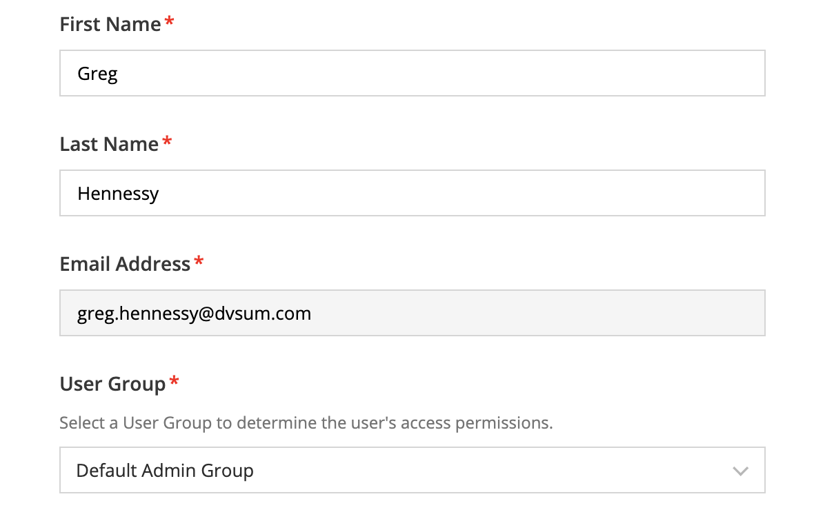

**Solution:**

We’ve updated your account to reflect the full version. Please log out of your account and log back in

to ensure the changes take effect. If you encounter any issues or have further questions, feel free to

reach out.

Since we have received the follow up ticket on this, we are closing this one.



**91. Incident #27498**

**Sub:** Fw: Work Order Ticket #3587699 was Closed: Need DvSum Dq logs for 11/16, 11/17, 11/18 asap

**Question:**

This is the log from the issue on Saturday that shut down the processing and then couldn't connect.

We had no jobs running from sometime Saturday to Monday when I noticed. Can we tell what caused

the issue?

I see suspect statements on 11/16 in the log around 14:25 of an error on CustomSync AND then at

18:50 the handshake failed. There are no log entries until 11/18 after 8:00 am.

With the conversion, I'm not sure what steps need to be taken, but we would like to understand the

Cause

**Solution:**

1. Log File Ambiguity:

The log file you shared is for the 18th; however, it contains logs from both the 16th and the 18th. This is unusual. Could you confirm if the server time was changed at any point?

1. SAWS Stoppage:

On 2024-11-16 at approximately 22:47:57, SAWS stopped and was later restarted (likely manually) on 2024-11-18 at around 08:27:33, as indicated in the attached image.

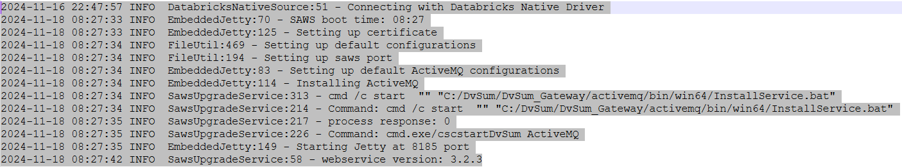

Based on the logs, the potential reasons of SAWS stoppage could be:

Manual intervention: It was stopped manually. However, I assume this is unlikely since you would likely be aware if this were the case.

Network issue: The logs suggest potential network-related problems during this timeframe, as these errors were observed prior to the stoppage.

Here are two relevant logs that you may share with the network team for further analysis:

2024-11-16 18:50:48 ERROR TLSHttpsRequestor:216 - Exception: javax.net.ssl.SSLHandshakeException: Remote host closed connection during handshake at sun.security.ssl.SSLSocketImpl.readRecord(Unknown Source) at sun.security.ssl.SSLSocketImpl.performInitialHandshake(Unknown Source) at sun.security.ssl.SSLSocketImpl.startHandshake(Unknown Source)

2024-11-16 21:49:10 ERROR TLSHttpsRequestor:216 - Exception: java.net.SocketException: Software caused connection abort: recv failed at java.net.SocketInputStream.socketRead0(Native Method) at java.net.SocketInputStream.socketRead(Unknown Source)

These errors suggest that:

* There may have been a network policy update, or
* Access to https://prod.dvsum.com was blocked (e.g., due to firewall restrictions)

Could you please check with the team if they are aware of any network issues or updates to network policies around this time?

During the call Debra confirmed that the SAWS stopped on its own, and no manual intervention occurred. We suspected a network-related issue, such as a firewall blockage, and requested Debra to check with the network team for further investigation. Debra agreed to follow up with the network team and will share any additional findings. We will also analyze the logs further and get back to Debra with the findings.

**Since there is no response from the user we are closing this ticket.**

**92. Incident #27500**

**Sub: LCPR DvSum access shows me as a trial user?**

**Question:**

When I access lcpr, it shows me as having a trial subscription. I will need access to multiple

production instances similar to Matt and Vishal. Can you help set my rights to make me a production /

full user for all?

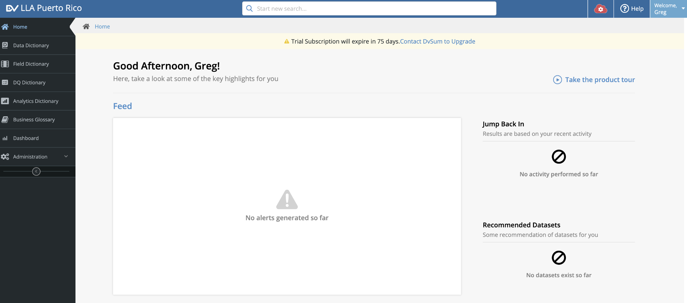

**Solution:**

Just to clarify, there are no limitations on your trial account, but as per your request, we've upgraded

your account to an active status and removed the trial designation. This means you now have access

to the production instances, similar to Matt and Vishal, although Matt also started with a trial account.

Closed the ticket.

**93. Incident #27503**

**Sub: Please explain error**

**Question:**

In DQ, reran 4 jobs - total 127 jobs close to each other. 1 rule gave an error - please explain the error.

This is a new message to me. See document

Connection error 11/21 rerun of 4 jobs

New error in DQ – reran a set of jobs this afternoon. As the tables weren’t loaded on time this morning. The system was up as all the other rules ran as expected, this is the only technical failure.

Received a new error on this rule, can you please explain what this error message means:

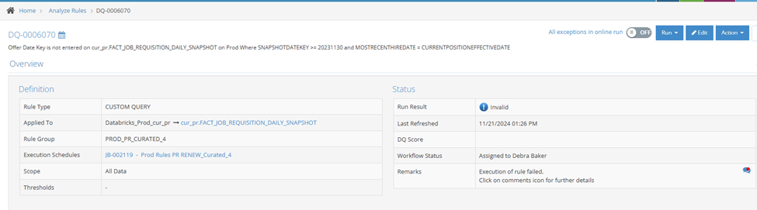

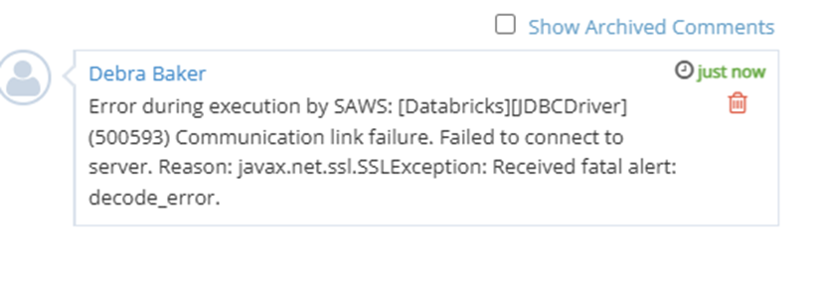

**Solution:**

Cloned the rule and ran it ([DQ-0006833](https://prod.dvsum.com/rules/DQ-0006833)), and it worked successfully. Upon further analysis, it

determined that this error message likely occurs due to an issue on the server side where the

Databricks cluster is hosted.

The simplest solution for this error is to re-run the rule, which should resolve the issue.

Closed the ticket.

**94. Incident #27504**

**Sub: Currently run way too long catalog and profile for file in DI**

**Question:**

See attachment for jo.

Please cancel as soon as possible once investigated especially if using cpu/space, etc.

Another way long catalog and profile

This is a different file I believe than the one I had a previous ticket, it looks like it was running since

Yesterday. Please advise. Please cancel it as soon as you can after investigating.

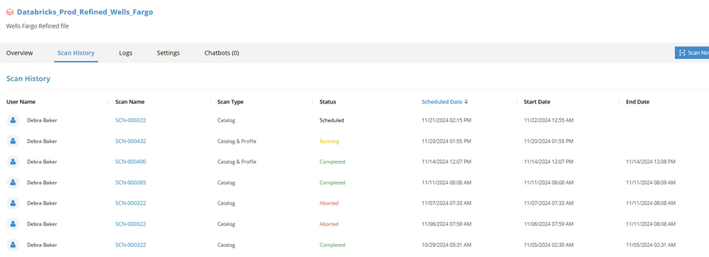

**Solution:**

Request [#27506](https://dvsum.zendesk.com/agent/tickets/27506) "DI Catalog only taking abnormall..." was closed and merged into this request. Last

comment in request [#27506](https://dvsum.zendesk.com/agent/tickets/27506):

As communicated in the other thread, our team is investigating the issue to determine the root cause.

For now, we rescheduled the scan, and it completed successfully within 1 minute.



DI Only catalog which can take 1 min, already running 20 minutes

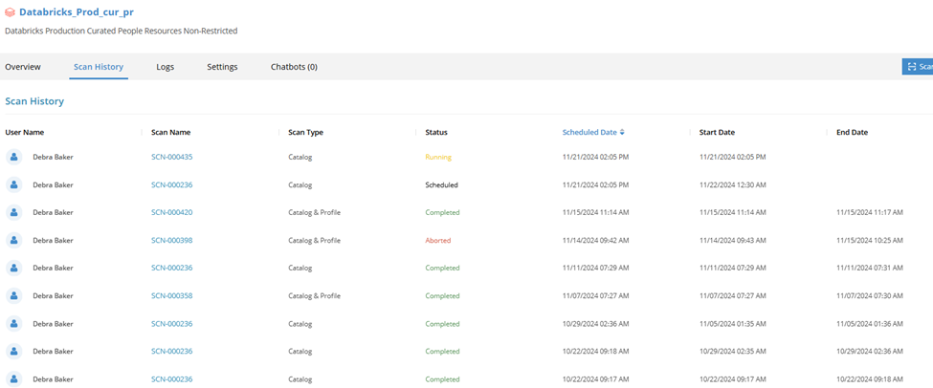



**This request was closed and merged into request** [**#27519**](https://dvsum.zendesk.com/agent/tickets/27519) **"Prod/UAT: 5 jobs to catalog only.**

**95. Incident #27506**

**Sub: DI Catalog only taking abnormally long**

**Question:**

Another example submitted this afternoon , should be 1 minute, still running over 20 minutes.

Please cancel after investigating.

DI Only catalog which can take 1 min, already running 20 minutes



**Solution:**

As communicated in the other thread, the team is investigating the issue to determine the root cause.

For now, it rescheduled the scan, and it completed successfully within 1 minute.



This request was closed and merged into request [#27504](https://dvsum.zendesk.com/agent/tickets/27504) "Currently runs way too long catalog.

**96. Incident #27519**

**Sub: Prod/UAT: 5 jobs to catalog only last night, still indicate running**

**Question:**

Catalog jobs were stuck in a "running" state due to a system glitch, though they consumed no

resources or logs.

Inconsistent network settings or timeout configurations may have caused delays or false "running"

states during busy periods.

Previous incomplete jobs and lack of detailed error messages complicated identifying the root cause.

**Solution:**

Implemented a fix to resolve the stuck "running" state issue and monitored for successful job

Completion. Suggested using the "Scan Now" option to rerun catalog scans while investigating.

Recommended reviewing network and timeout settings to ensure they are optimized and accurately

reflect system status.

**97. Incident #27520**

**Sub: UAT: Time Zone of scheduled Jobs**

**Question:**

I am confused as to the time zone items are scheduled in and display.

Within DI for UAT Testing,

I looked at some of the jobs and activated them to have them run. I was looking at the rules that are

run daily. Here is one example in the attachment if i can get to work, otherwise will attach in response

Email

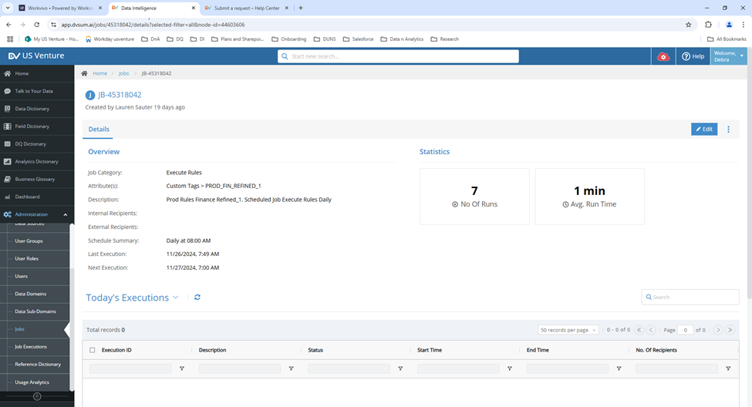

**Solution:**

FR 872 has been logged.

The fix has been implemented. Going forward, job times will now be displayed according to the

Daylight Saving Time changes.

**98. Incident #27521**

**Sub: UAT: Summary email removed useful summary table**

**Question:**

For UAT testing, it has been noticed that the summary table indicating the number of rules in the job,

number passed, number failed, number invalid, number exceptions, and % amount no longer appears in

the report.

Was this removed for a specific reason or was the functionality accidentally not included? This was.

helpful and you as a person receiving the report could determine if action immediately or not without

reading the results of every rule and potentially miss a issue

**Solution:**

The issue fix has been implemented, and the Execution Summary is now visible in the email, just as it

was in DQ.

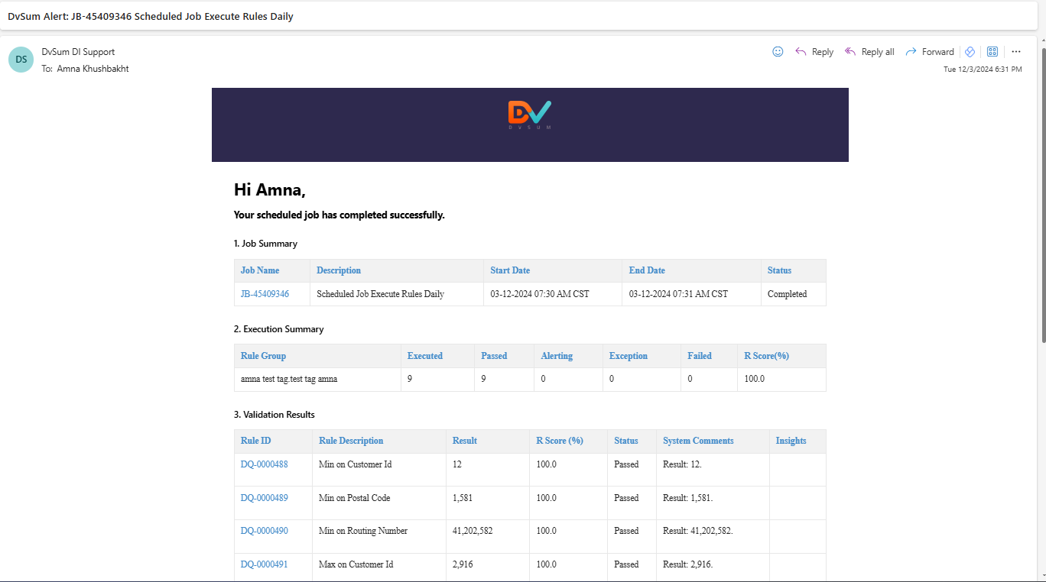

**99. Incident #27525**

**Sub: DvSum Alert. JobJB-002341 Scheduled Daily for DQ Rules DQ-0001657 (MG Freight Calculation**

**Errors) completed**

**Question:**

We are not receiving email for the below newly created DVsum alert if I select the ‘Send email on alerts’

option. Working fine if Unchecked. Could you please check and advise.

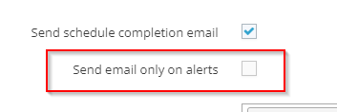

**Solution:**

1. Job-Level Notifications:

In the screenshot it looks like the "Send schedule completion email" option is selected. This ensures

That the receivers receive an email notification for the scheduled job and associated rules, regardless

of whether the rule passes or has exceptions.

If you select the "Send email only on alerts" option, you’ll only receive email notifications when

exceptions occur

1. Account-Level Notifications:

To configure your email notification preferences, log in to your account. Click the "Welcome" dropdown at the top-right corner of the screen, select "Profile," and navigate to the "Email Notification" tab to set your preferences.

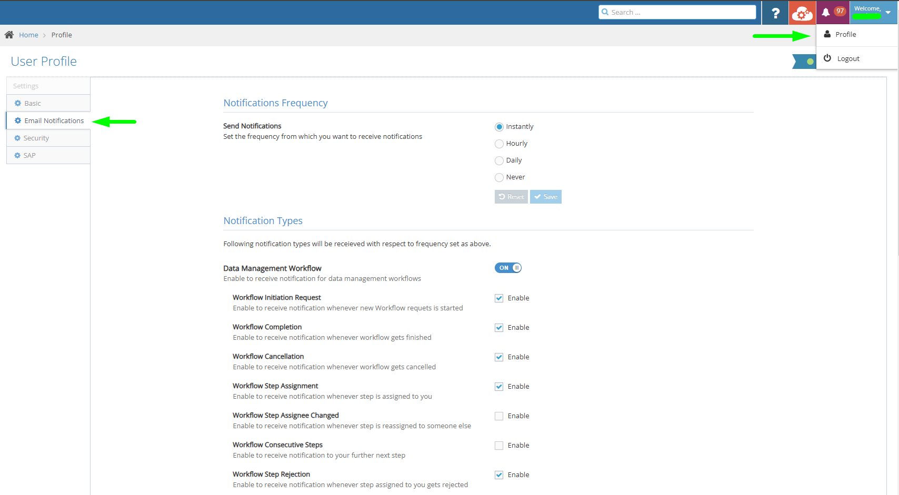

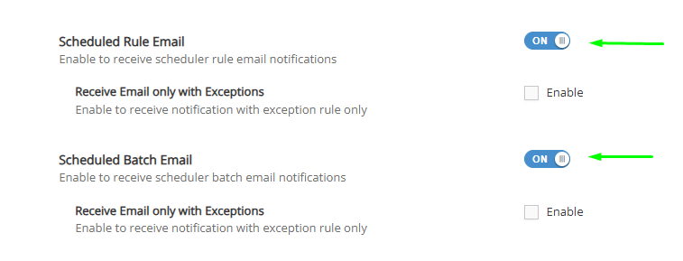

**100. Incident #27530**

**Sub: Custom Filters created in Dashboards cannot be deleted**

**Question:**

Create a filter for a rule and Dashboard.

Then I want to delete that filter that was saved as a template, it cannot be deleted?

The whole feature about common filter needs enhancement, it is not thought through properly.

Create an FR and ask the Product Team to talk to me to make this production support enhancement.

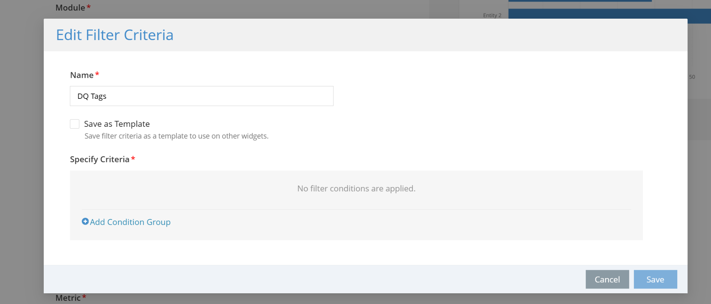

**Solution:**

Closing this ticket for now, and a follow-up ticket will be created once the enhancement is deployed to

Production, after discussion with Jawad from the PD team, FR-884 has not yet been prioritized.

Now the field “Save as Template” has been removed. And below is the image for reference.

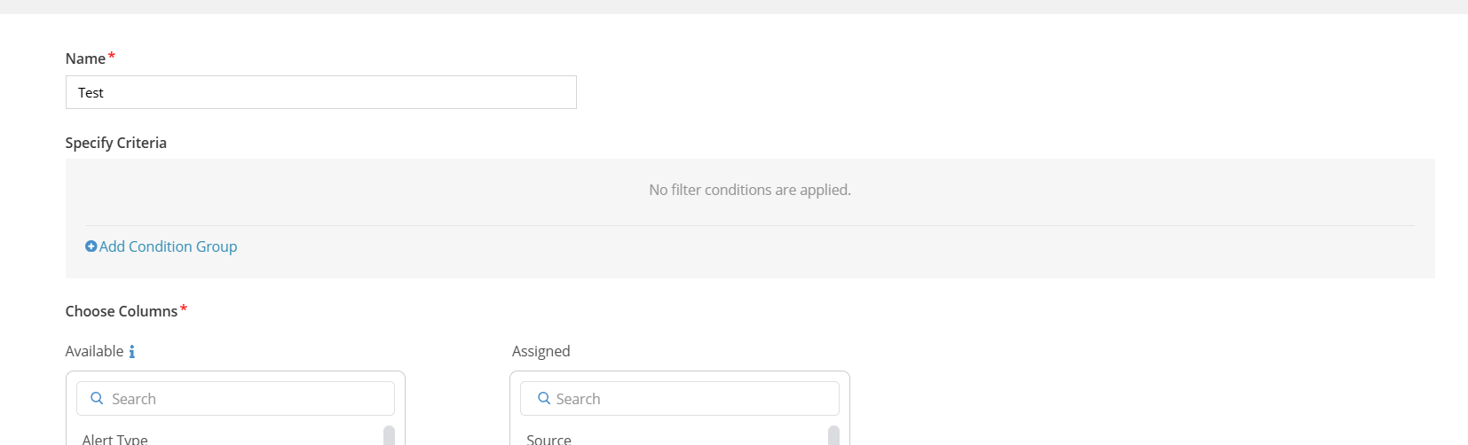

**101. Incident #27531**

**Sub: External Recipients list is not friendly**

**Question:**

Very standard way to parse emails in external text fields. Every saas system makes it easy to add

Users.

You add an email in one line and it validates the email. You give the option for person creating to say à

invite the user to DvSum.

The request would go to Admin to approve the request to add the user.

Otherwise, the user should be added as “External User” without any validation for purpose of

Distribution.

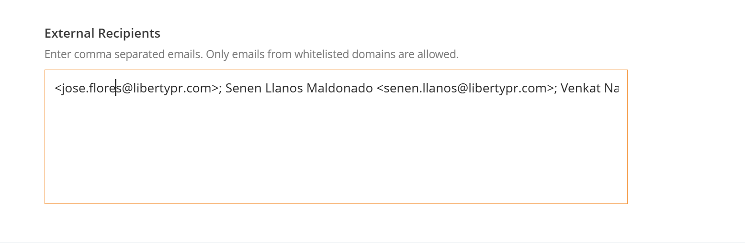

**Solution:**

Closing this ticket for now, and a follow-up ticket will be created once the enhancement is deployed to

Production, after discussion with Jawad from the PD team, FR-885 has not yet been prioritized.

An article link for reference:

<https://dvsum.zendesk.com/hc/en-us/articles/360015357854-Can-I-add-users-outside-DvSum-as-Watchers-in-Workflow-execution-or-as-External-Recipients-in-Scheduler>

**102. Incident #27532**

**Sub: Typo Text in Job description**

**Question:**

Created by Aashish Singhvi 3 seconds. What does it mean?

It should say Created by Aashish Singhvi 3 seconds ago. It shows up after the first call when you

re-load the page.

Check and submit as part of minor request to fix it.

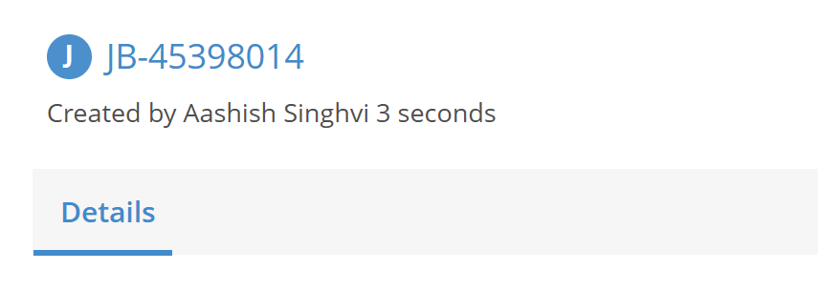

**Solution:**

Implemented a fix based on the feedback regarding the typo in the Job Description. The text

previously displayed as "Created by Aashish Singhvi 3 seconds" now correctly shows as "Created by

Aashish Singhvi 3 seconds ago."

FR 886 has been logged.

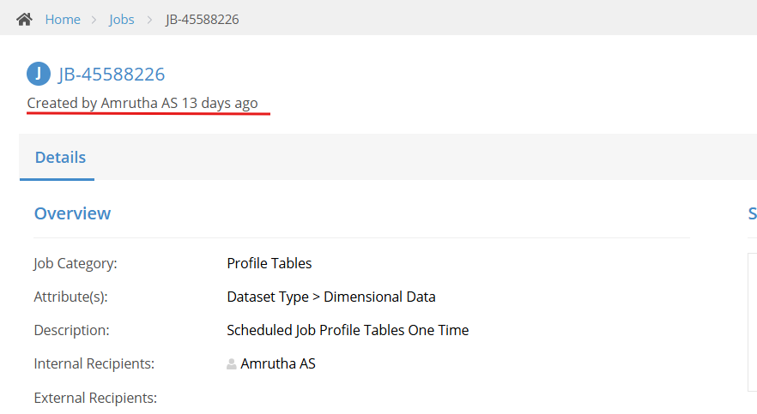

**103. Incident #27540**

**Sub: Activating Jobs and getting them to actually schedule**

**Question:**

I activated some of the jobs and they don't appear to be scheduled tomorrow as expected.

See attachment

Jobs were scheduled to today or tomorrow date. Didn’t run, used run now on all. They still don’t have

a next execution. How do we get the ones that don’t to have the scheduled time? I want to review

schedule for tomorrow and can’t figure out how to.

Need the exact way to reactivate a job.

Scenario 1: Before I activated and then updated schedule. They had all run right away due to 11/7

scheduled date previously. I don’t want them to necessarily run when setting active.

Scenario 2: So this time I updated schedule to today or tomorrow. Activated. They didn’t run or have a

next execution date. The ones that didn’t I did run now, which isn’t what I necessarily wanted but. They

ran and there is still not a next execution. I did do two different dates which might make difference but

if I listed tomorrow, why is that not listed?

How do we get scheduled for tomorrow?

Some did work – maybe date I scheduled? Some of these were set up last week with scenario 1

above.

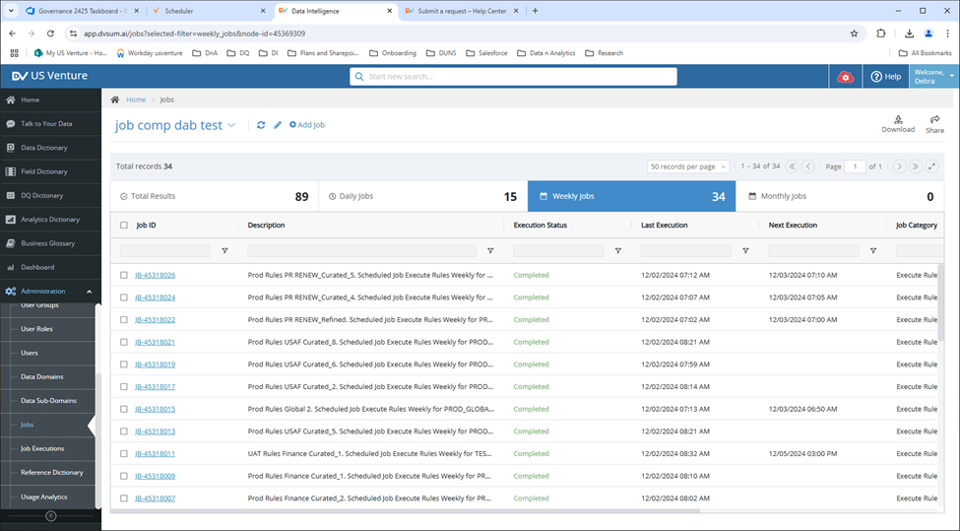

**Solution:**

The scheduling logic was fixed to ensure that the next_execution_date is updated correctly whenever

a job’s schedule is modified and reactivated. This update has been implemented, and the issue is now

Resolved.

**104. Incident #27541**

**Sub: DI: Jobs view for tomorrow in our timezone and no deactivated jobs**

**Question:**

Please see the attachment

Future view – no deactivated and correct date according to our time zone.

How do I schedule a view of tomorrow’s only scheduled jobs?

This is confusing what I created now as I put relative date of 0 for start and 2 for end. I don’t have enough to show what happens if jobs yet scheduled today but it has to show them. I don’t have enough for the end right now either

I guess this might be related to time zones? Since the times ran show next day.

Also with the same I need to make sure we don’t show the deactivated jobs if they fall in the time zone and I don’t see a way to do this.

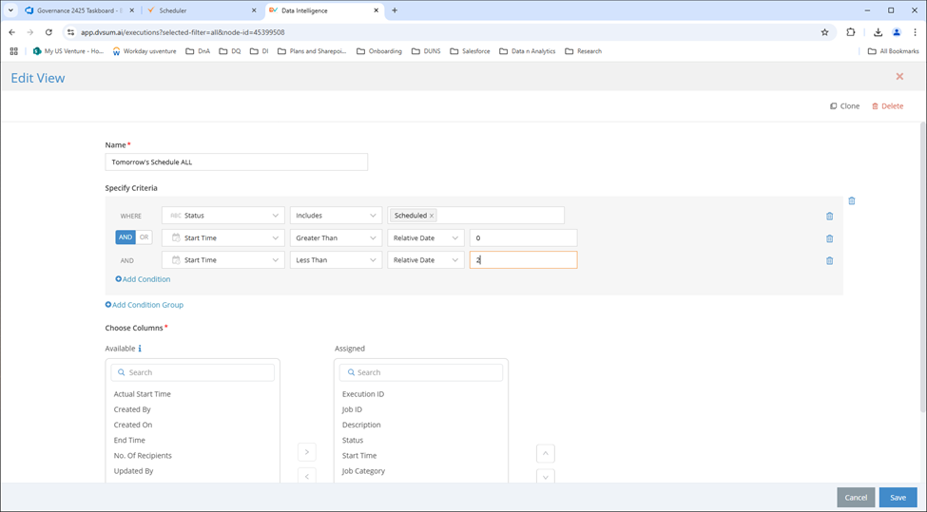

**Solution:**

1. Excluding Deactivated Jobs:

Currently, the platform doesn’t have an option to filter out deactivated jobs in the scheduling view. We’ve logged a Feature Request (FR) for this functionality, and we will keep you updated on its progress.

2. Creating a View for Tomorrow’s Scheduled Jobs:

We’ve created a view named "Tomorrow_schedules_only" in the job description, as shown in the attached screenshot. This view displays jobs scheduled for tomorrow.

**Note:**

The filter uses relative time values, which are time-specific.

For example:

0-1 means the range starts from now (e.g., 5 PM today, at the time you specify the criteria) and covers the next 24 hours.

1-2 means the range starts from tomorrow (e.g., December 5th at 5 PM) and covers until December 6th at 5PM

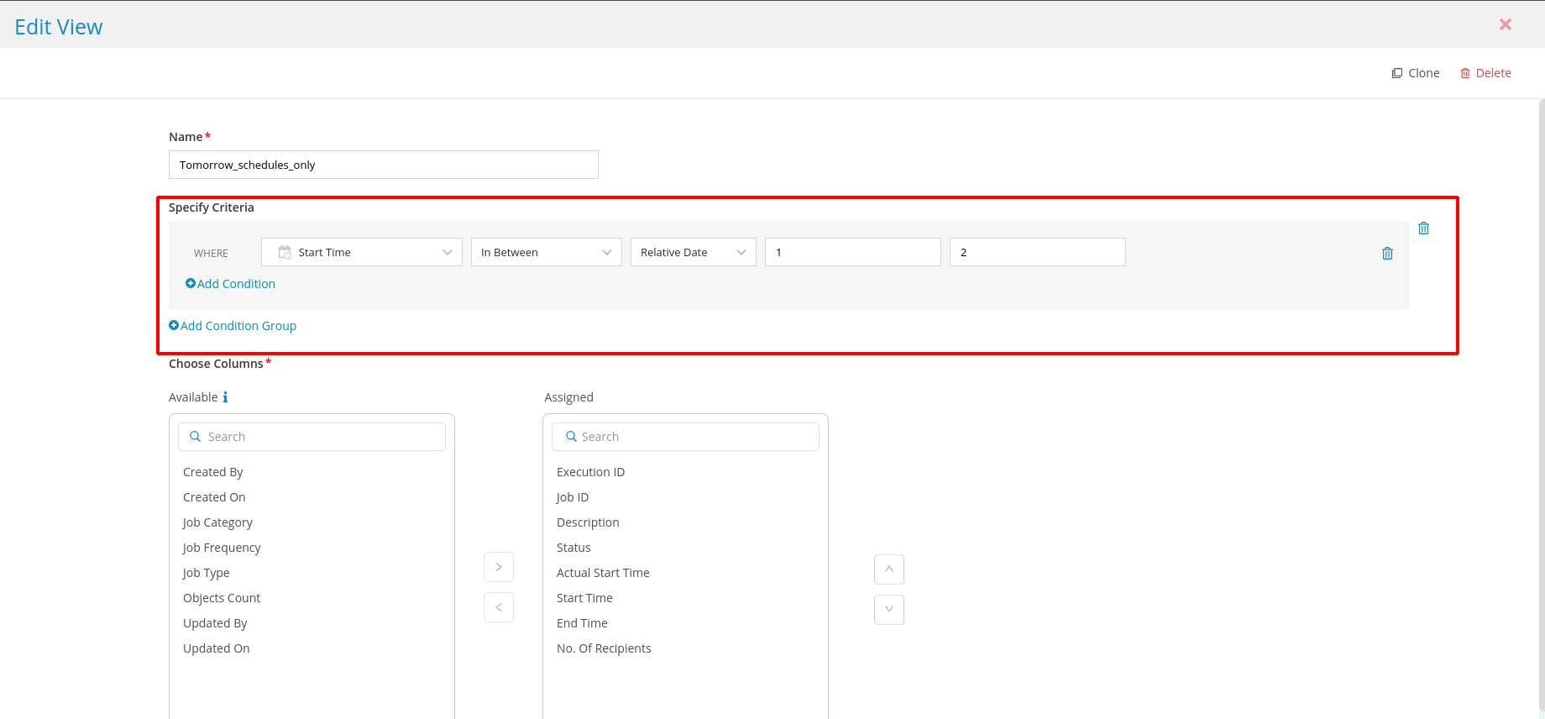

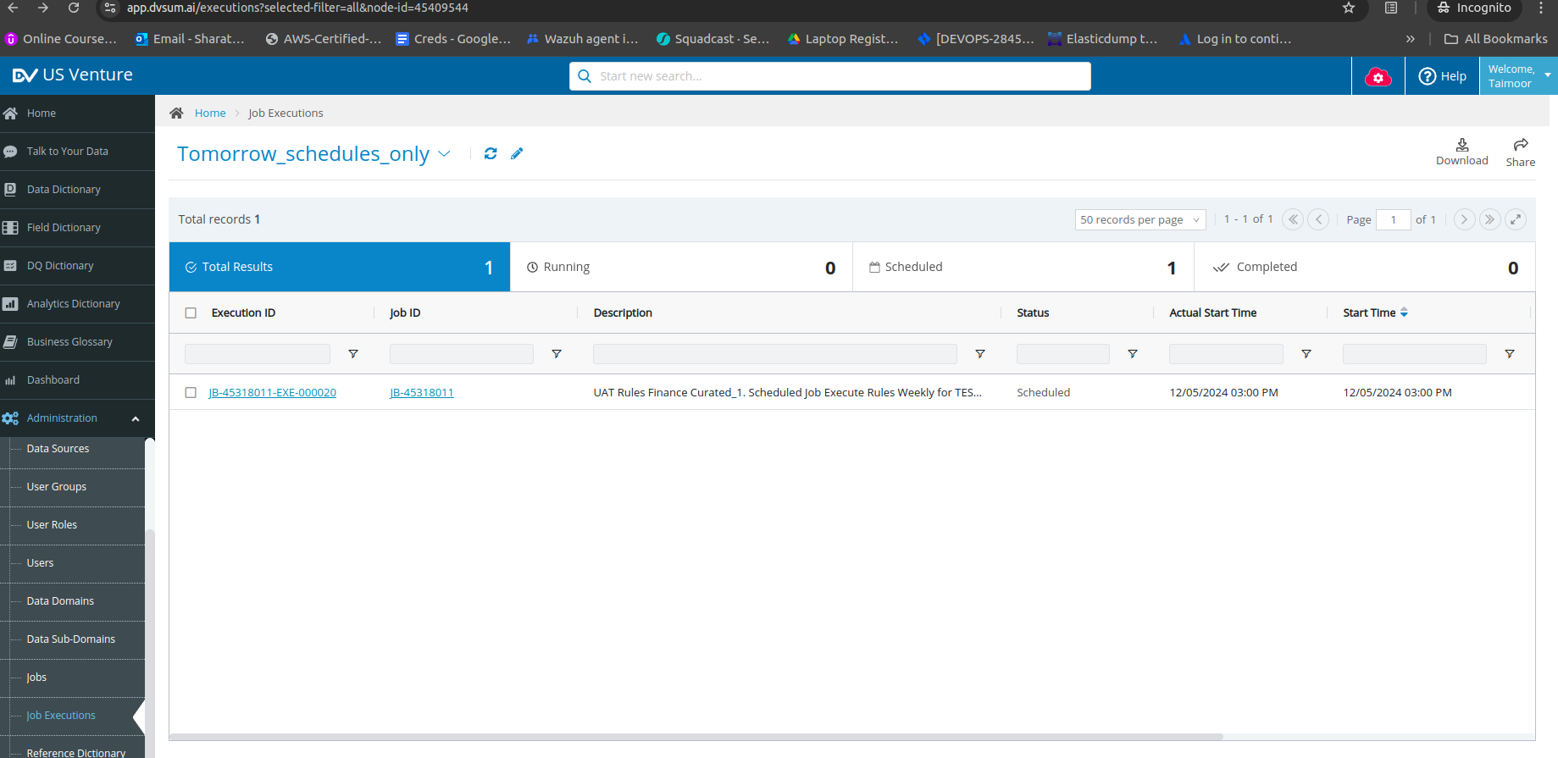

**105. Incident #27542**

**Sub: RE: [DvSum] Re: DvSum Alert. JobJB-002341 Scheduled Daily for DQ Rules DQ-0001657 (MG**

**Freight Calculation Errors) completed**

**Question:**

**This is a follow-up to your previous request** [**#27525**](https://dvsum.zendesk.com/agent/tickets/27525) **"DvSum Alert. JobJB-002341 S..."**

**106. Incident #27543**

**Sub: Duplicate jobs - 3**

**Question:**

Three jobs appear to be set up 2 times each for prod rules usaf curated_7, curated_8, and curated_9

Please review and let me know what you find.



**Solution:**

The duplication of the jobs curated_7, curated_8, and curated_9

likely occurred during the migration process. The duplicate jobs can be deleted to streamline the

Scheduler.

**107. Incident #27544**

**Sub: Table looks up don't appear to work now, or ignore case**

**Question:**

All of these using tables no longer work, some had the ignore case checked, they worked fine in DQ

but not in DI Dq 5903,5823,5893,5822,5981,5823, and 5961. Today 4 exceptions in DQ and no alerts,

but 11 exceptions and 6 invalid and 4 alerts in DI for People Resources, haven't found any correlation

to any changes on US Venture side. DI

**Solution:**

applied a fix to the issue with table lookups and the "ignore case" functionality in DI. After the update,

all jobs, including the rules 5903, 5823, 5893, 5822, 5981, and 5961, have passed successfully in DI

**108**. **Incident #27293**

**Sub: Re: Mazda DQ Rules : DQ33 - 38**

**Question:**

The rescanning did not resolve the data type being incorrectly captured. Here below DDL from where the scan is retrieving the technical metadata. Here is the link within DvSum to the table:

https://www.app.dvsum.ai/tables/44880132/data?selected-filter=all&node-id=44835394<https://urldefense.proofpoint.com/v2/url?u=https-3A__www.app.dvsum.ai_tables_44880132_data-3Fselected-2Dfilter-3Dall-26node-2Did-3D44835394&d=DwMF-g&c=TjG9Ta5PltfpvywVgozrAA&r=QbLsFItGPyQuOkTFKQcCfOhLZU8NiziHyRtEv-ipxK4&m=Qcu_mdryV8Tjq3fpb7SRKXJlQpoQo2pioj4fUgqzs7ZmpekWHlPcp5QCosu-CejN&s=mhml1aGs9-gP2hraM0InoSwGw1oTunNevC1bXRhzn_8&e=>

We are not sure where the issue is occurring.

DDL in Oracle

CREATE TABLE RPR_STG.FW_ACCESSORY_REPAIR_ORDERS

(

RO_COMPLETION_CALENDAR_DATE DATE

, PART_NAME VARCHAR2(1000 CHAR)

, PART_NUMBER VARCHAR2(1000 CHAR)

, PART_CATEGORY VARCHAR2(1000 CHAR)

, PART_MINOR_CATEGORY VARCHAR2(1000 CHAR)

, CLAIM_CODE VARCHAR2(1000 CHAR)

, CLAIM_PROBLEM_CODE VARCHAR2(1000 CHAR)

, CLAIM_SEQUENCE_NUMBER VARCHAR2(1000 CHAR)

, TOTAL_CUSTOMER_PART_AMOUNT VARCHAR2(1000 CHAR)

, TOTAL_INTERNAL_PART_AMOUNT VARCHAR2(1000 CHAR)

, TOTAL_WARRANTY_PART_AMOUNT VARCHAR2(1000 CHAR)

, RO_DEALER_CODE VARCHAR2(1000 CHAR)

, MODEL_YEAR VARCHAR2(1000 CHAR)

, CARLINE VARCHAR2(1000 CHAR)

, TRIM VARCHAR2(1000 CHAR)

, MODEL VARCHAR2(1000 CHAR)

, REPAIR_ORDER_PART_QUANTITY VARCHAR2(1000 CHAR)

, VIN_CODE VARCHAR2(1000 CHAR)

, LAST_UPDT_DT VARCHAR2(1000 CHAR)

)

LOGGING

TABLESPACE TS_RPR_STG

PCTFREE 10

INITRANS 1

STORAGE

(

INITIAL 81920

NEXT 1048576

MINEXTENTS 1

MAXEXTENTS UNLIMITED

BUFFER_POOL DEFAULT

)

NOCOMPRESS

NO INMEMORY

NOPARALLEL

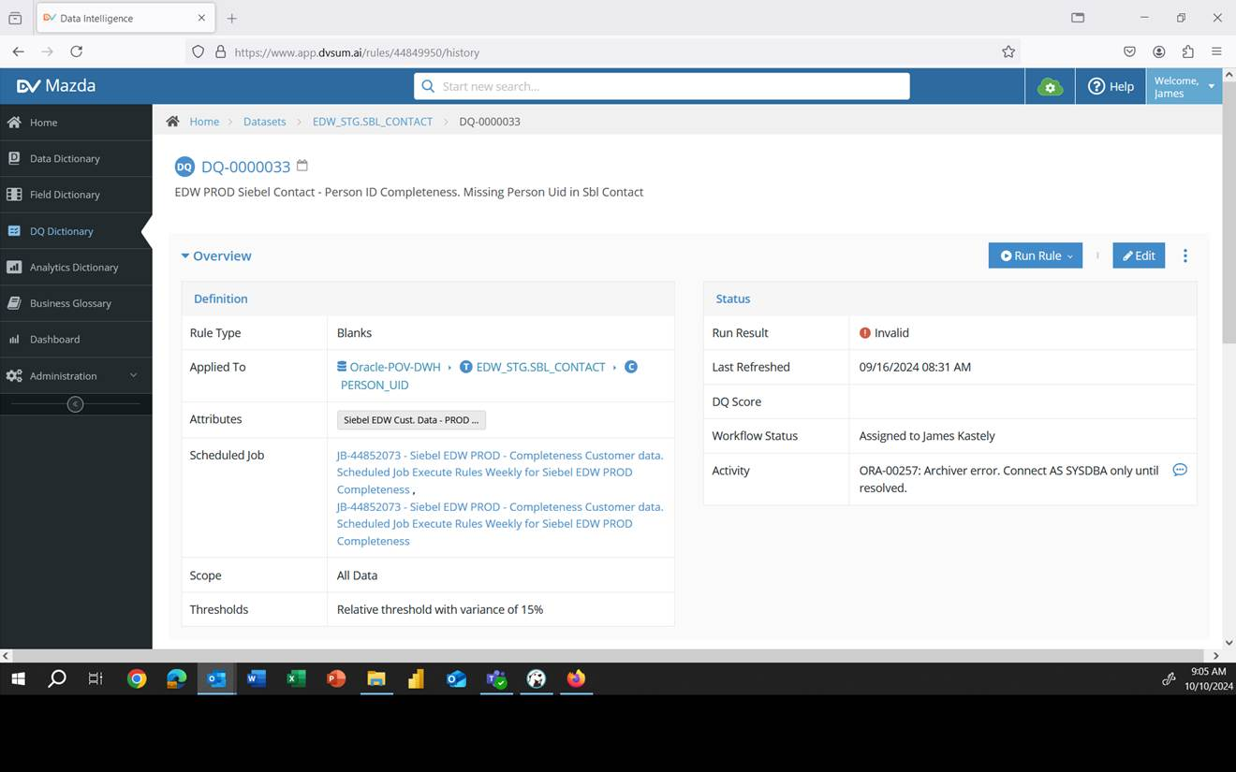

**Solution:** The team has reviewed the DDL shared by the client to investigate why the column data type isn’t appearing in DvSum after the scan. We will provide an update soon.

Meanwhile, the client raised a concern, mentioning that they made a mistake while setting up data quality rules DQ33-DQ38. They intended these rules to point to the table 'OracleProd-DWH' but accidentally pointed them to 'Oracle-POV-DWH.' The client asked whether they can edit the rules to point to the correct database or if they need to clone the rules and create six new ones to replace DQ33-DQ38.

For this we informed the client that they cannot change the data source simply by editing the existing rule. We advised them that the best approach would be to clone the rule, as this provides an option to select the correct data source, allowing them to point it to the appropriate database. We also recommended ensuring that the rule they are cloning has the same table and column structure as the target database.

Alternatively, we suggested that they can create a new rule on the correct database and delete the existing rule that points to the wrong database. The client confirmed that they will proceed with cloning the rule.

An article link for cloning the rule:

<https://dvsum.zendesk.com/hc/en-us/articles/27010646948884-Clone-Rule>

**109. Incident #27297**

**Sub: Upcoming Netezza Data Source Deployment on October 14th**

**Question:** This ticket is to inform the team about an important update to our DI application, scheduled to be moved to production on Monday, October 14th. Below is a summary of the key change:

Netezza Data Source:

* Support for the Netezza data source has been added. Users can now configure and use Netezza in the DI application.
* A gateway update will be required to enable this feature.

A post-production email will be sent on October 14th, including gateway links for both Linux and Windows environments.

We highly value your feedback and believe these updates will enhance the overall user experience. If you have any questions, concerns, or feedback, please don’t hesitate to reach out.

**Solution:** For this QA team requested support from the PD team for the Gateway upgrade scheduled for BSC on October 15th, highlighting the lack of detailed documentation on DvSum Zendesk for the upgrade process. The team acknowledged the importance of notifying the PD team, given the significance of the customer, but emphasized that the upgrade could be handled internally without direct involvement from PD. They clarified that upgrading the Gateway is essentially the same as performing a fresh installation, making the process more straightforward compared to previous methods like Ansible, which were more complex. While the absence of comprehensive documentation remains a concern, it is not expected to impact the successful completion of the Blue Shield upgrade. Additionally, Zaki was requested to remain on standby as a precautionary measure during the upgrade. Considering this, Aashish requested the creation of a KB article detailing the Gateway upgrade process for both Linux and Windows platforms. He emphasized the importance of ensuring that the upgrade articles are linked with the Gateway installation articles, creating a seamless and interconnected reference for users. This approach aims to address the current documentation gap and provide clear guidance for future upgrades. After the article was created, we informed Aashish that the documentation for the Gateway upgrade process had been completed, and the deployment of the data source was successfully executed. Then we proceeded to close the ticket.

**110.Incident #27309**

**Sub: error getting data from cerillion CADDI**

**Question:** Team we are getting errors on getting info from Cerillion can you check any problems on RPA side?

Execution started: 44995112_241014102638_f52a0a46-cc64-4a43-9689-6ae574311915

Starting analysis for customer id: 60037591

Executing action api for state cerillion_and_sigma_dpm

RPA Execution ID:

44995112_241014102638_f52a0a46-cc64-4a43-9689-6ae574311915:cerillion_and_sigma_dpm:api:0b3AgoJiBiU9m8mwWsEJXpvXx1TpLROO0n5mLYnxQds=

Detected MAC Address from Sigma DPM

MAC Address: acf8cc5c7c93

**Solution:** We resolved the initial issue the client was experiencing.

However, they later reported another issue with the Sigma response.

For account 20296601, they observed the message: 'No data available in Sigma DPM,' despite the account being valid for JM and TT. We informed the client that the required information was located on the second page of the Sigma interface. The issue occurred because the BOT did not search this page.

We addressed this problem and provided an update once it was resolved. After fixing the issue, the client confirmed that they were able to retrieve the details from Sigma, and the ticket was subsequently closed.

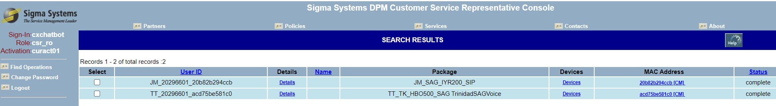

**111. Incident #27315**

**Sub: Error in display of profiling values**

**Question:** Transaction date has min – max values of 10/7/2024 and 10/8/2024.

Yet in profiling ref page of column, it shows distribution as 10/6 and 10/7. It is WRONG.

The date fields in the profiling section SHOULD not be connected to UTC or user local. This is not log and DvSum information. This is data, it should be what it is. Referred with an example,

**Example:** https://www.app-dev.dvsum.ai/tables/38577695/data?selected-filter=all&node-id=37697805 (https://www.app-dev.dvsum.ai/tables/38577695/data?selected-filter=all&node-id=37697805)

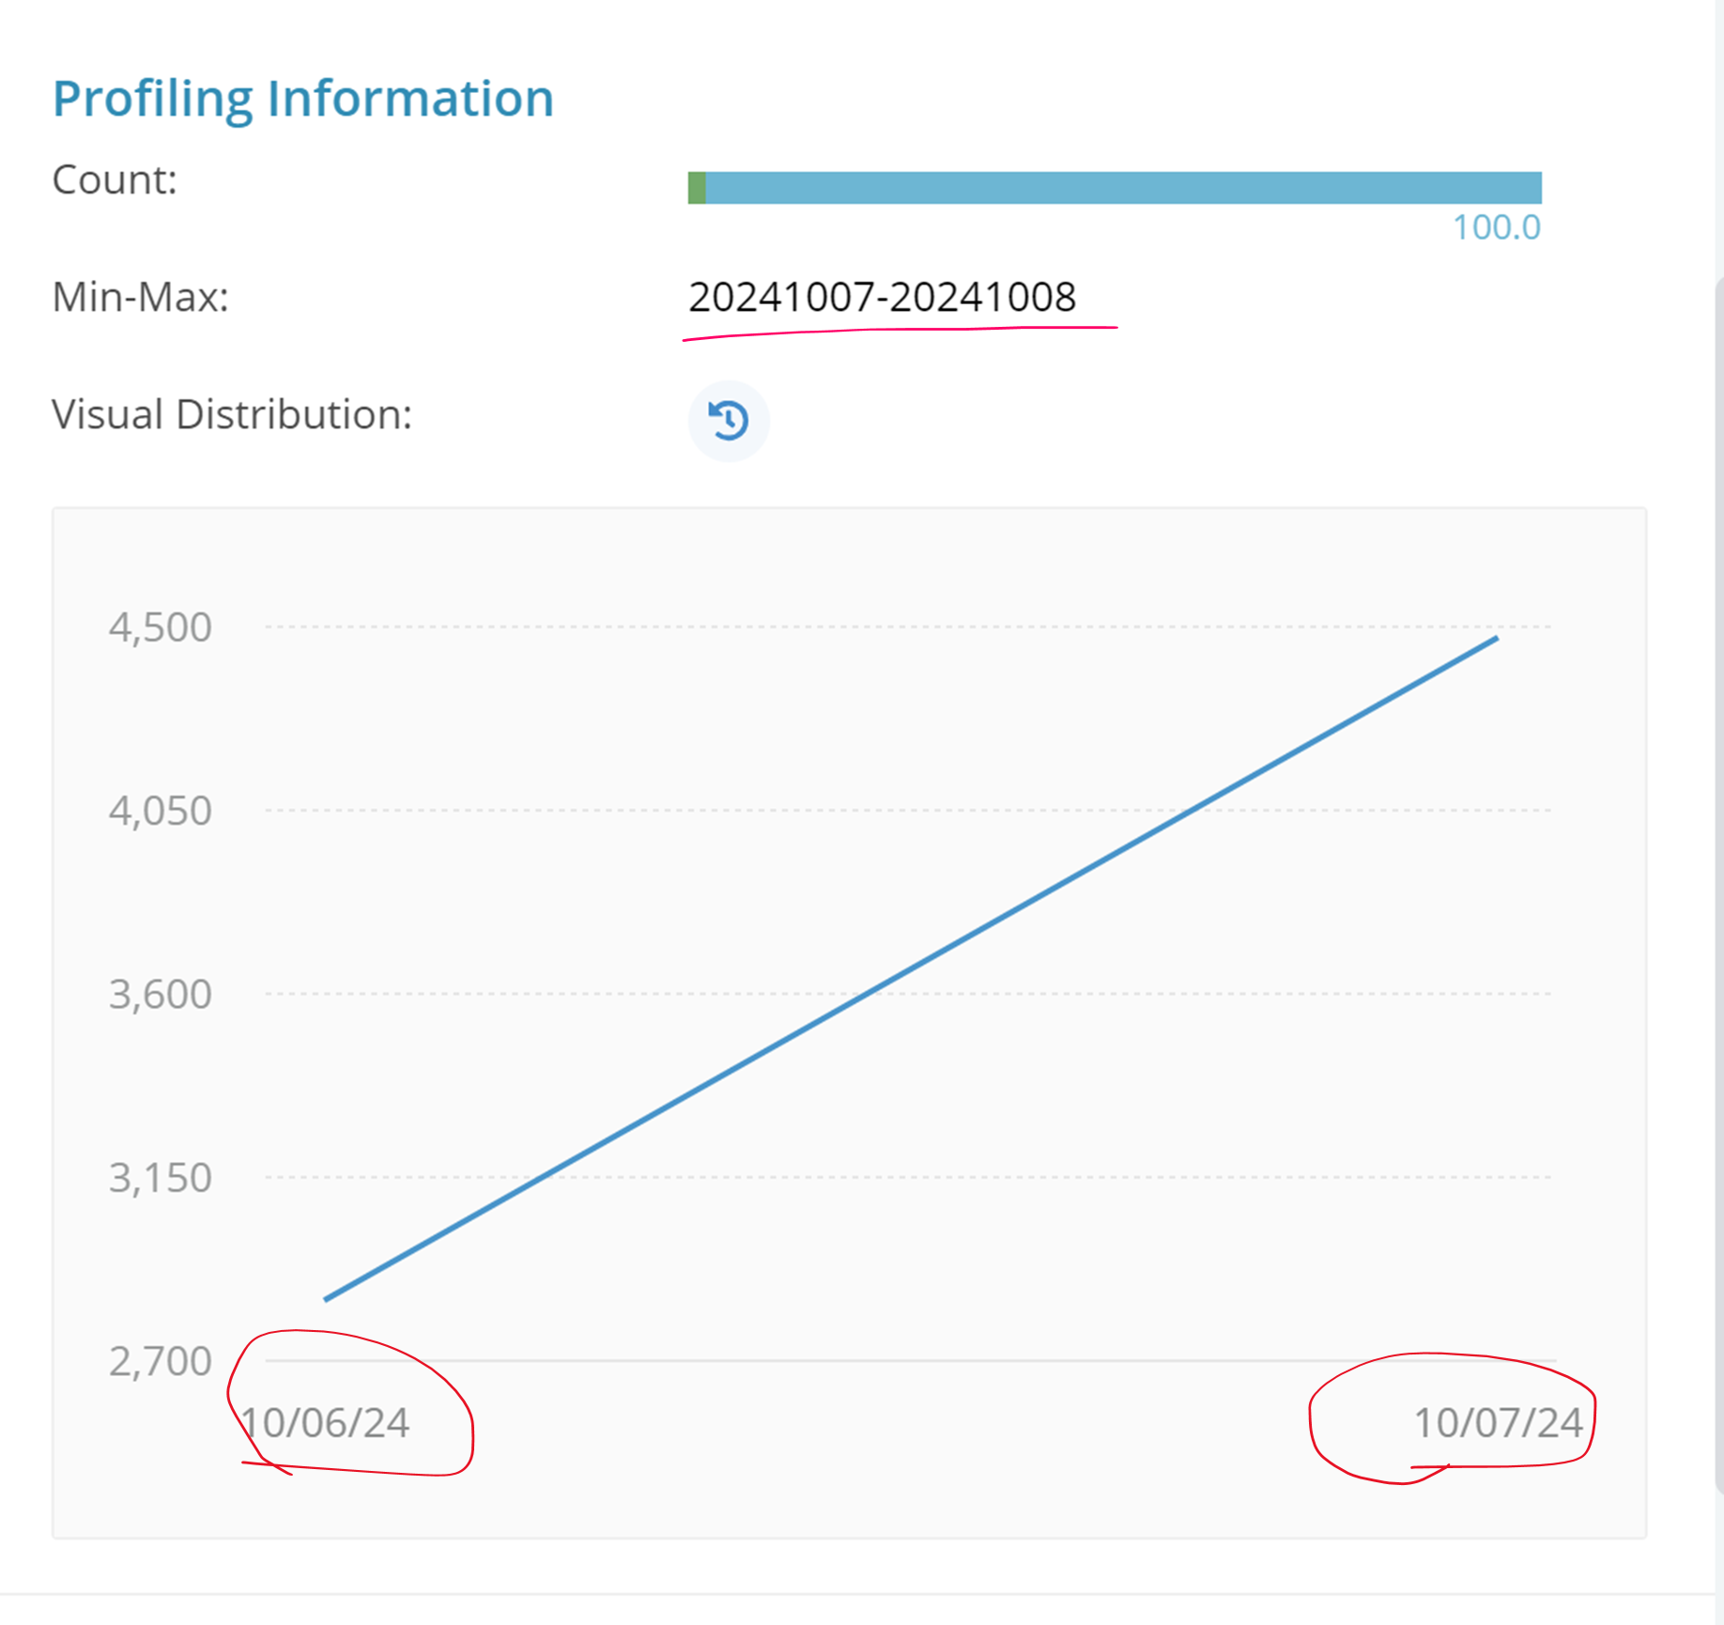

**Solution:** First, we logged a FR for this issue. Later, the issue with the transaction date distribution on the profiling reference page was resolved. The date fields in the profiling section are now accurately reflecting the data as-is, without any adjustments related to UTC or user local settings.

Now it is fixed. Below image is for reference.

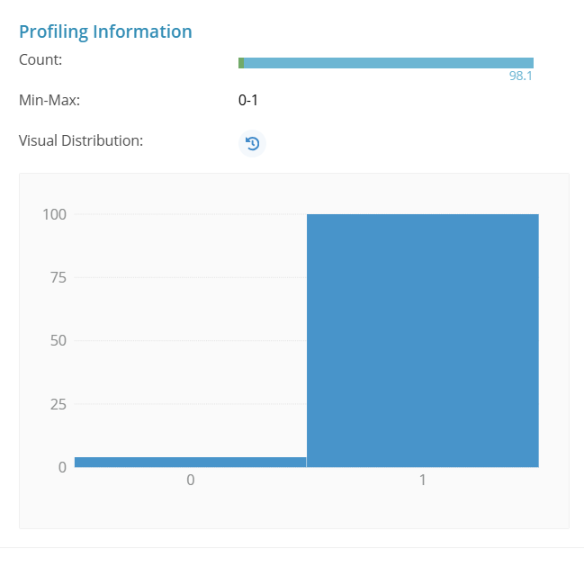

An article link for reference:

<https://dvsum.zendesk.com/hc/en-us/articles/202846854-Review-Profiling-Results>

**112. Incident #27322**

**Sub: Re:New Feature Request Added - # 812Data Sources-Detail Page (Reopened ticket for Incident #27315)**

**Question:** This ticket was raised by Aashish asking that Is the support team creating these FRs, I presume?

Can you confirm, what is the value added by the support team? Did you double check and confirm the problem, did you replicate the problem for the Engg team in the Dev environment, did you look up another FRA to confirm this is not reported already? Did you correctly assess my requirement to determine severity?

Or did you just take my exact comment as is and created FR?

Can you clarify?

**Solution: "**We provided with a detailed breakdown of how we proceed after receiving a query via the support email:

Step 1: We send an initial acknowledgment.  
Step 2: We internally review the issue, and if we agree with the findings, an Assembla ticket is created, followed by a Feature Request (FR) in Airtable.  
Step 3: We check if the FR is already in the backlog. If not, we create a new one. If it exists, one of the duplicates is marked as invalid.  
Step 4: Regarding severity, the ticket is initially assigned to Jawad, who discusses it with either you or Matt to determine the severity. Based on the final priority, Jawad creates the release plan accordingly.  
Step 5: For this particular bug, we conducted an internal analysis and found your observations to be accurate. The ticket remains open, and Jawad was informed of the update last night.

**113. Incident #27323**

**Sub: Question: Can we designate a field on a table not be included in profile - to be skipped**

**Question:** Can a field/column be set up in the system to not be included in a profile?

As you know we have two fields that abend on tables they are in -- they are fields that were generated by the process tools we use and usually at the end of the file. i think they are generated if we used delta tables. DvSum is not handling them, we can't change anything about them and we don't need them to be profiled.

Is there anyway for this to be flagged so we don't spend the cost and see the errors in the log, so we can easily tell if there are other errors we care about.

alternatively

please update system to handle these fields

I noticed another field I think may not be handled on a table I profiled -- it was a python structure. Do you expect to handle that every? I've only seen it once so far and it was likely not the end file but one in process.

**Solution:** We informed the client that they can hide the columns to prevent them from being processed and asked them to confirm which fields need to be excluded so we can address this. Additionally, they mentioned a field (Python structure) that wasn’t handled during profiling. We requested the name of that field so we can investigate it further.

For this we received confirmation from the client that they know how to hide items and will proceed with that approach if they decide to handle it this way. As for the Python structure, they couldn't locate the specific area, and it may have been an area that was accidentally profiled. The client mentioned they do not expect this to occur in the future.

Based on this confirmation we closed the ticket.

114 **.Incident #27327**

**Sub: "Couldn't get data" message**

**Question:** I wanted to confirm if this issue is logged by you

Sometimes, after the RPA execution message appears in the log, we get the “Couldn't get data, try asking the question another way.” Under the log box. However, process keeps going and eventually even delivers results.

This was run against TT UAT bot.

After a minute or so:

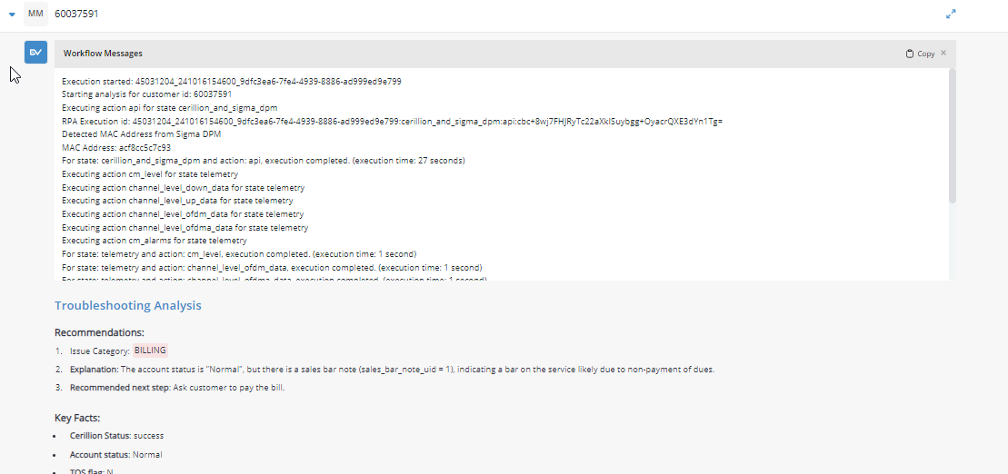

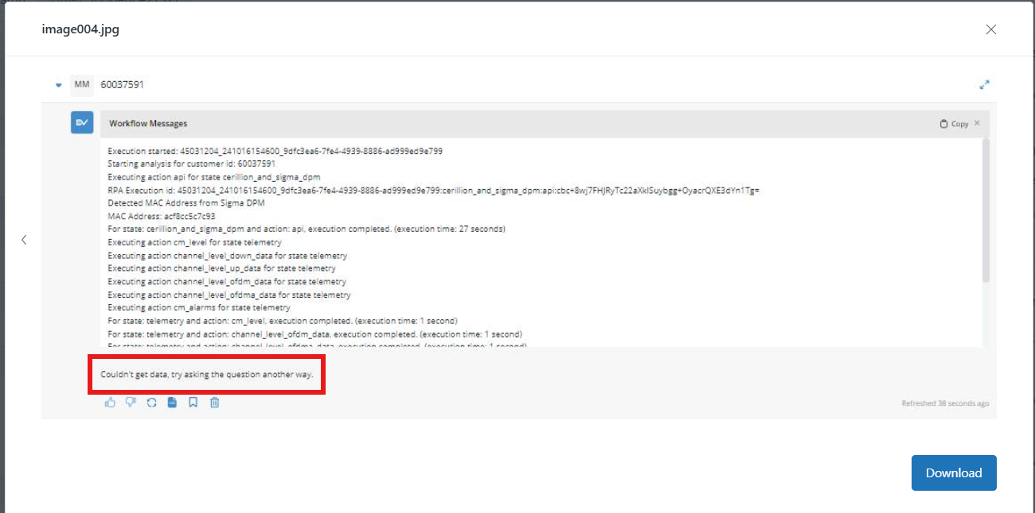

**Solution:** The Product Development team identified the root cause of the issue and worked on a fix. We confirmed that the solution will be rolled out by next week. After logging a FR, we closed the ticket.

**115. Incident #27329**

**Sub: Missing Rules After Data Source Elimination in DvSum**

**Question:** I need your help. I have created a lot of rules in DvSum. Someone on the Mazda team eliminated a data source ( OracleProd-DWM ) and tried to combine it with ( Oracle-PROD-DWH ). The result is I lost access to a lot of rules. Looking in DQ Dictionary I am missing the following Rules

Job : JB-44852073 Rules : DQ 39 - 46, 48- 49. 78 - 83

Job : JB-44888361 Rules : DQ 50 - 53

Job : JB-44894588 Rules : DQ 54 - 68

Job : JB-44992460 Rules : DQ 74 - 77

I can see the jobs but not the rules. I do not see the rule in DQ Dictionary, however looking at the job I can see the rule but when I click on the rule I get a message that says “URL not available”. Can you help find the rules so I do not have to enter them again ? The Mazda team is ‘trying’ to fix the issue however I do not have a lot of confidence that they know DvSum well enough to find my rules and correct the problem.

**Solution:** We restored all the deleted rules,

Rules : DQ 39 - 46, 48- 49. 78 - 83

Rules : DQ 50 - 53

Rules : DQ 54 - 68

Rules : DQ 74 - 77

And connected with the new data source “OracleProd-DWH”.

**116. Incident #27146 for this incident a follow up ticket#27330 is created.**

**Sub: Re: DvSum Question : Table ( EDW DEV ) RPR_STG.FW_ACCESSORY_REPAIR_ORDERS**

**Question:** I set up 3 Data Quality Rules to run on a table from the EDW DEV environment. ( RPR_STG.FW_ACCESSORY_REPAIR_ORDERS )

Rules : DQ 69 – 71. I found out that I lost access to the tables. I contacted the EDW team and regained my access. I ran the rule this morning and the error is I do not have access. Does that mean I need to create the rules again since my access lapsed ?

[ERROR : Table does not exist][cid:image008.jpg@01DB0F27.5CB70100]

Actually I think they reloaded the table ( RPR_STG.FW_ACCESSORY_REPAIR_ORDERS ) with some changes.

I noticed a that the data element changes. ( LAST_UPDT_DT ) in the DvSum Data Dictionary is defined as a date field. When I look at the EDW ( DEV ) the LAST_UPDT_DT is now a character field. Does that mean the table needs to be reloaded to the DvSum Data Dictionary ?

See below.

[Last Updt Dt : Defined as Date Field][cid:image011.jpg@01DB0F27.5CB70100]

[EDW DEV : LAST_UPDT_DT defined as character field][cid:image014.jpg@01DB0F27.5CB70100]

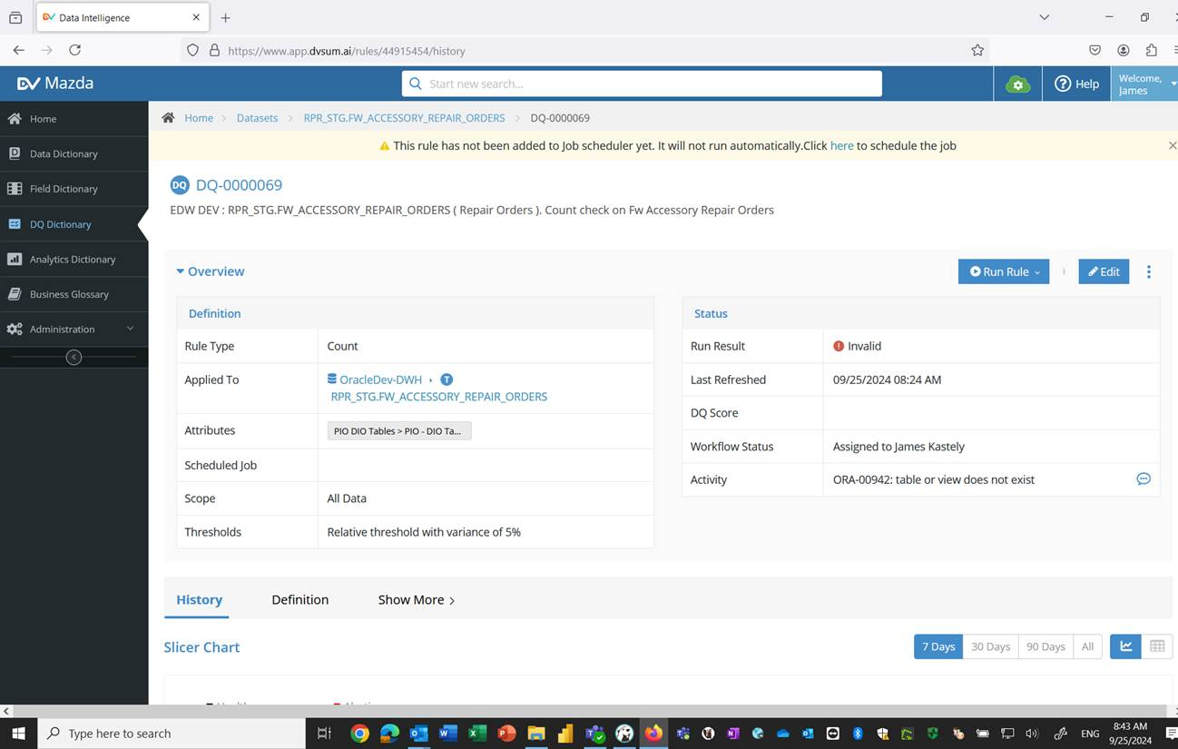

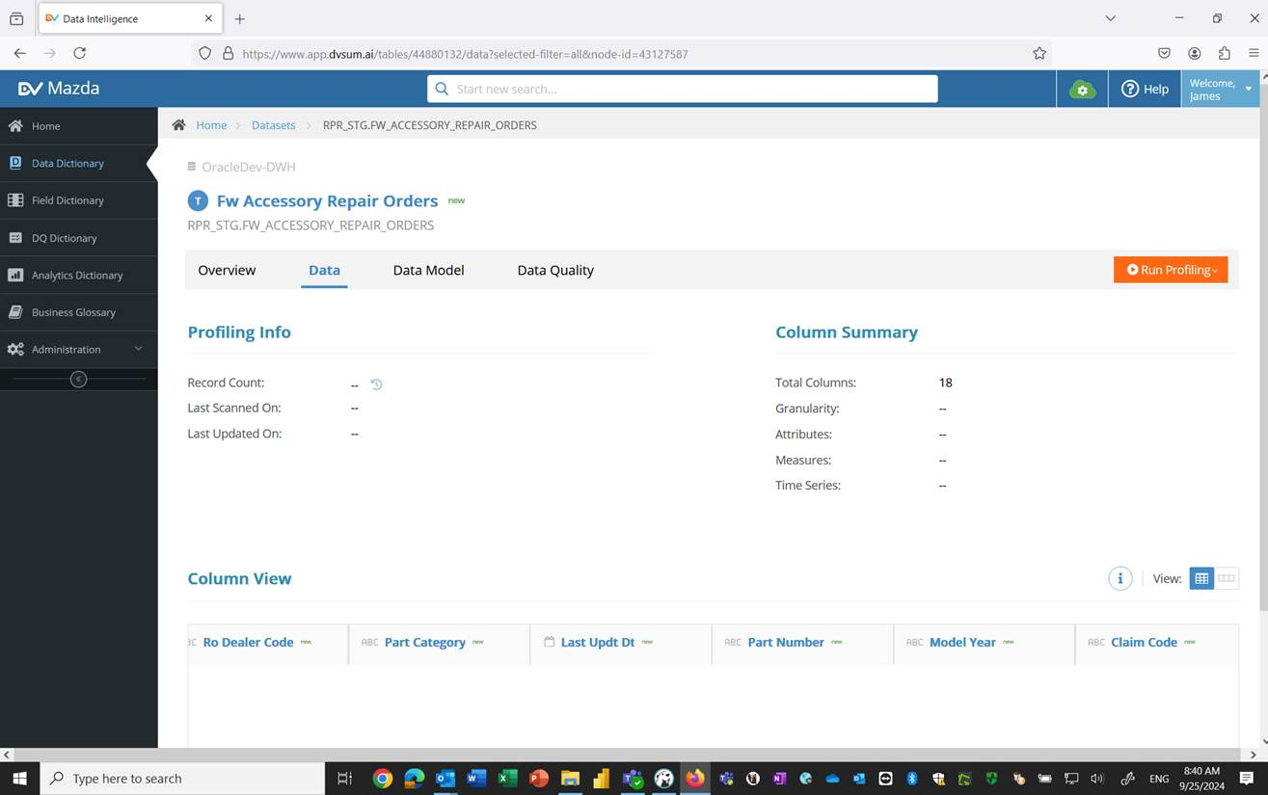

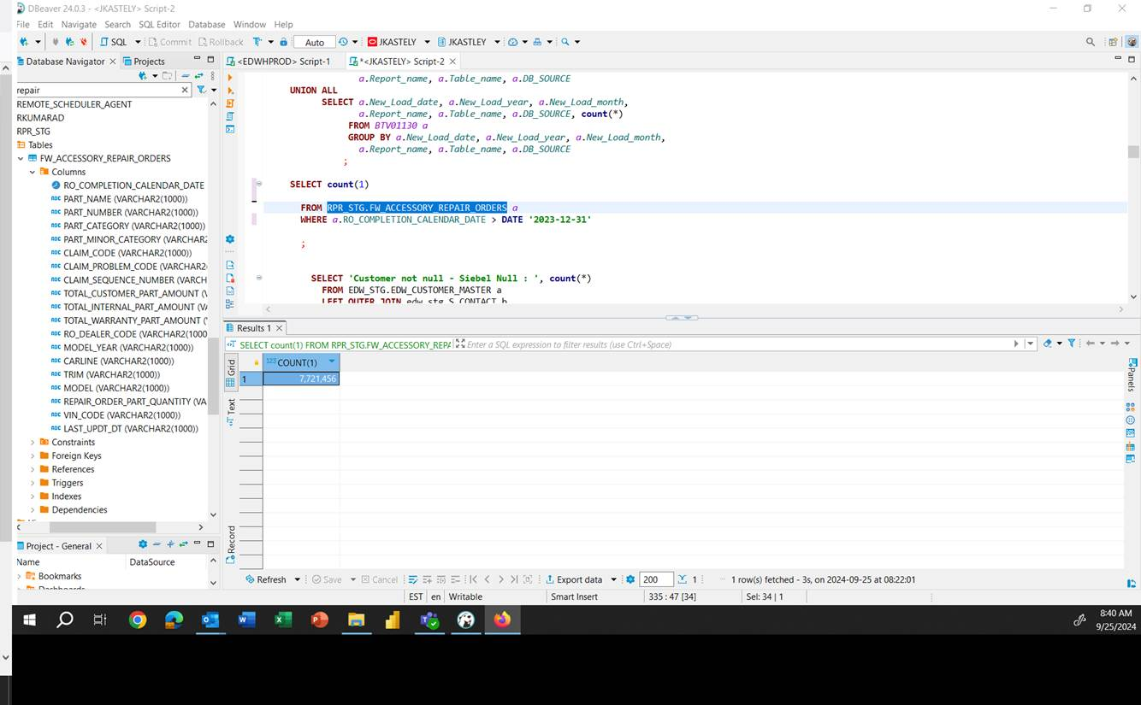

**Solution:** To resolve this, we informed them to run a scan on EDW_DEV so that the updated table information would be brought into DvSum. Once that’s done, we advised them to re-run the rules, which will resolve the issue. After getting the confirmation from the client as the issue is fixed we closed this ticket.

Then customer raised the follow-up ticket **#27330**

**Question:** I would like to address this issue again at the meeting on Oct 23rd. Ticket # 27146. The Mazda team set up a full scan for the EDW DEV environment every Monday evening at 7 pm. After the scan on Oct 14th the issues did not get fixed.

Ticket Incident #27146 - Table ( EDW DEV ) RPR_STG.FW_ACCESSORY_REPAIR_ORDERS - Taimoor has responded to the ticket: To resolve this, please run a scan on EDW_DEV so that the updated table information is brought into DvSum. Once that’s done, try re-running the rules, and it should resolve the issue.

**Solution:** For this, we asked them 1.to confirm if the table still exists in the schema and 2. to provide the total number of tables in the schema. We informed them that, based on the last scan, we can currently see 3,878 tables. 3.The scan insights indicate that tables were not found—could this table be one of them? Additionally, 4. we inquired if there is a possibility that the table has restricted access, which might explain why the scan couldn't detect it.

Then we got answers for this questions with following screenshots,

( 1 ) It appears the red circle with the ! means it is deleted. ( See below ) Shoudn’t a new scan just bring it back. Reload the table ?

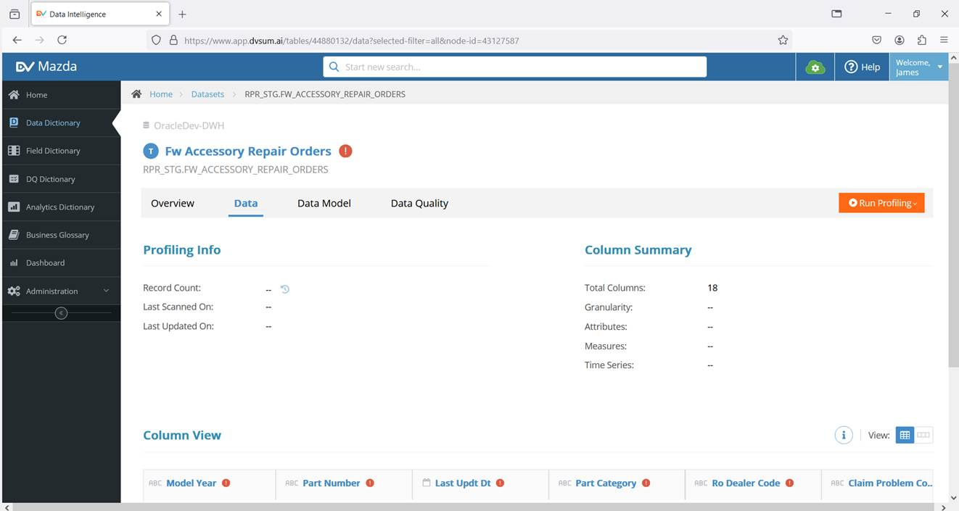

( 2 ) Schema RPR_STG. In OracleDev-DWH has 1,180 tables ( See below )

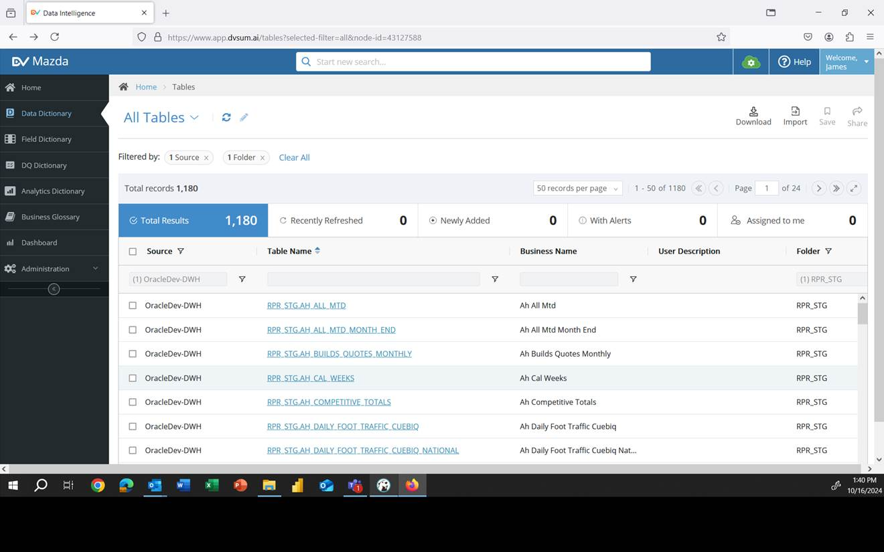

( 4 ) I can see the table in the Mazda EDW. ( See Below )

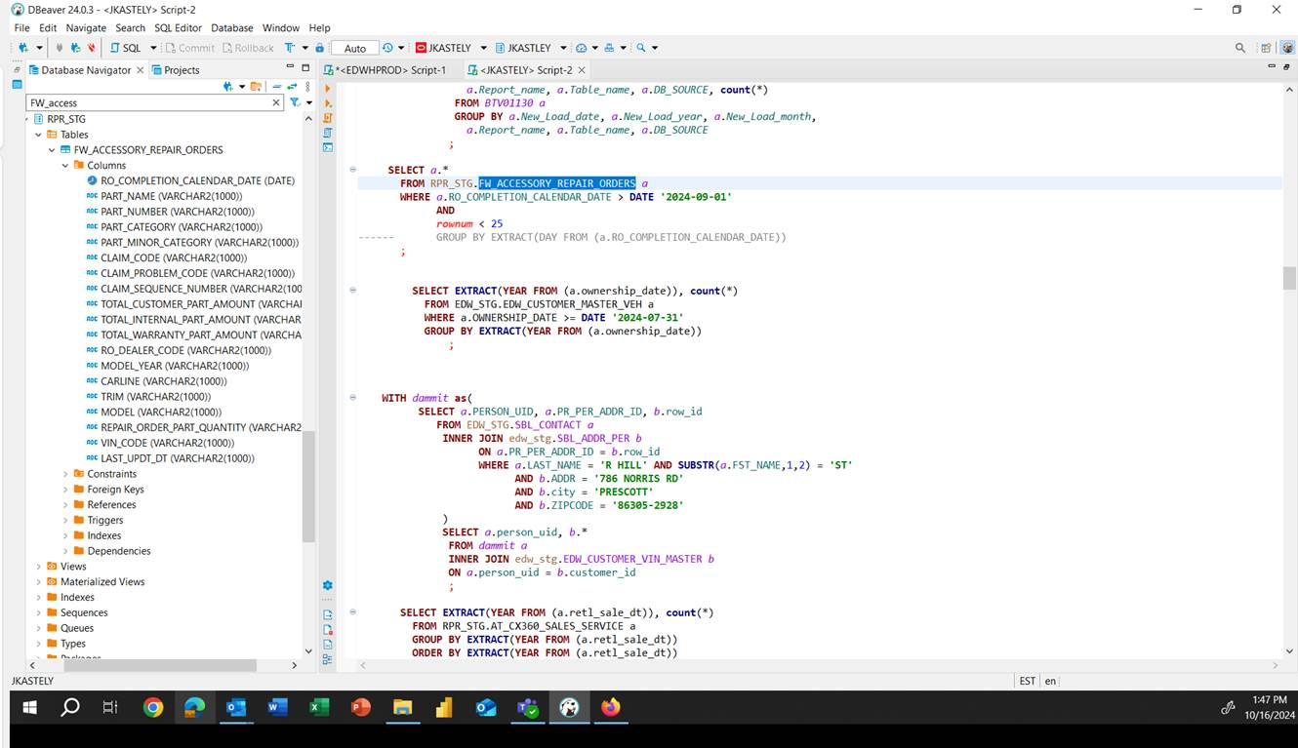

And for the 3rd question After filtering the RPR_STG, we found 1,180 tables as mentioned. Out of these, we observed that 10 tables have the status 'deleted,' and the table in question is one of them (see screenshot below)

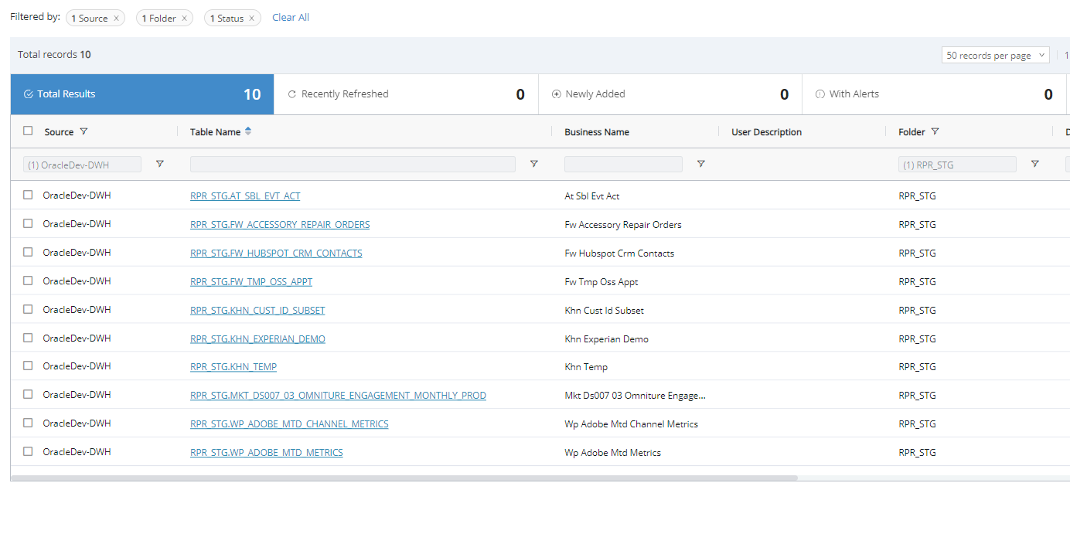

We identified that the issue could be due to a permissions problem for this specific table. While the table clearly exists in the schema, the scan is unable to read it. After connecting with client directly and adding the permissions they wanted, we closed this ticket.

**117. Incident #27333**

**Sub: *IMPORTANT* 37 Rules Missing in Data Quality**

**Question:** Yesterday I was working on creating many rules in the Data Quality module and putting them in new val groups. At 4:30PM CST on 10/16 I saw all of the rules I created and they were in the proper groups. Today when I logged in 37 rules are completely missing and the val group 'TEST_FIN_REFINED_1' is also gone. Below is a list of all the rule ID's that are now missing. Most of the rules were freshness checks and some custom queries on the Anaplan_v2 schema in the UAT environment.

6358, 6359, 6360, 6361, 6362, 6363, 6364, 6365, 6366, 6367, 6368, 6369, 6370, 6371, 6372, 6373, 6374, 6375, 6376, 6377, 6378, 6379, 6380, 6381, 6382, 6383, 6384, 6385, 6275, 6276, 6277, 6278, 6279, 6280, 6281, 6282, 6283.

I verified that nothing has changed with the schema and all of the data has been recatalogged and is showing up as expected. Please look into this issue for me.

**Solution:** The client is reporting that as soon as they submitted the ticket, all the rules and the Validation Group (Val Group) were restored, but they are unsure of the reason. They would still like to understand the root cause of the issue. Upon investigation, it was determined that the disappearance of the rules could have been caused by two potential factors: if the table was hidden by another user or if the Data Quality module was disabled in the module settings.

**118. Incident #27354**

**Sub: Sigma error, but Sigma MAC available**

**Question:** Is this expected? We see that Sigma DPM status is “error”, but we have a “Sigma DPM MAC address” shown. Can you confirm where the mac is coming from? Or the nature of the error?

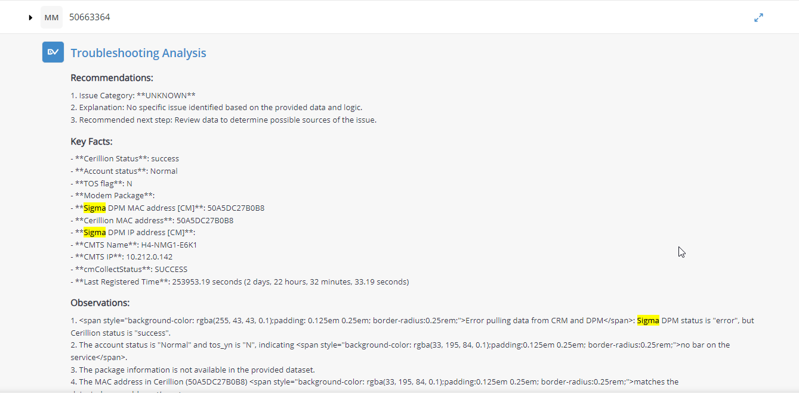

**Solution:** We requested the client to provide both the Execution ID and bot details so we could provide a more accurate response. This was necessary because the logic we're dealing with is tied to CRM data, and these details would help us better understand the context and ensure we provide the correct information.

The issue was then handled by Matt and Vishal, and Shubra fixed the issue and provided the necessary guidelines. Later, based on Matt's confirmation that Vishal pushed the fix into all four of LLA's bots, we closed the ticket.

**119. Incident #27340**

**Sub: Need this source to have updated scan**

**Question:** This resource was updated to our newest service principle and connection to dbsql. It is the only one that the updated scan date has not been successful since. There are two jobs that say they are running, Have tried to Abort both. Please review and assist.

Databricks_Prod_ref_workday_rstr Last successful was 10/3.

**Solution:** While investigating the issue reported by the client, we noticed that a catalog scan was successfully completed yesterday at 7:31 PM. We advised them to schedule both a Catalog and Profile scan, as they should also complete successfully. Additionally, we recommended aborting any previously running scans to ensure smooth execution of the new scans

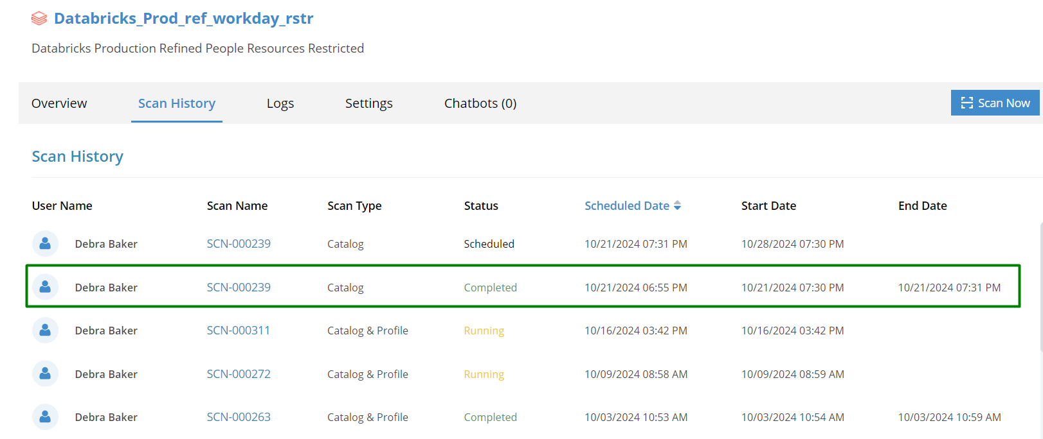

**120. Incident #27637**

**Sub: My DvSum user on prod has expired.**

**Question:** John Cowan's user account for prod.dvsum.com has expired, and he has requested to renew/reactivate it. Along with this, he also requested to activate two additional user accounts:

* john.cowan+mazda1@dvsum.com (app.dvsum)
* john.cowan+regal1@dvsum.com (prod.dvsum)

**Solution:** We successfully activated the requested access for his account.

**121. Incident #27642**

**Sub: DvSum Emails not coming through**

**Question:** DvSum rule Rule 1433 email hasn’t come through. Can you please look into it? Thank you.

"This email and any attachments may be confidential or legally privileged and are intended solely for the use of the individual or entity addressed. If you have received this email in error please notify the sender and delete it from your email system. Additionally, you are notified that disclosing, copying, distributing or taking any action or reliance on the contents of this information is strictly prohibited.”

**Solution:** We informed the client that the DvSum Gateway (SAWS) is currently unable to establish a connection with the application, which is causing jobs to remain in the scheduled status and preventing DvSum emails from being sent. The issue was escalated to Karthik and Nora, requesting them to restart the DvSum Gateway (SAWS). Once the gateway is restarted, the jobs will process successfully, and the emails will be sent as expected.

**122. Incident #27645**

**Sub: Convert the CommScope account from Trial to Regular**

**Question:** Please convert the CommScope account from Trial to a Regular account.

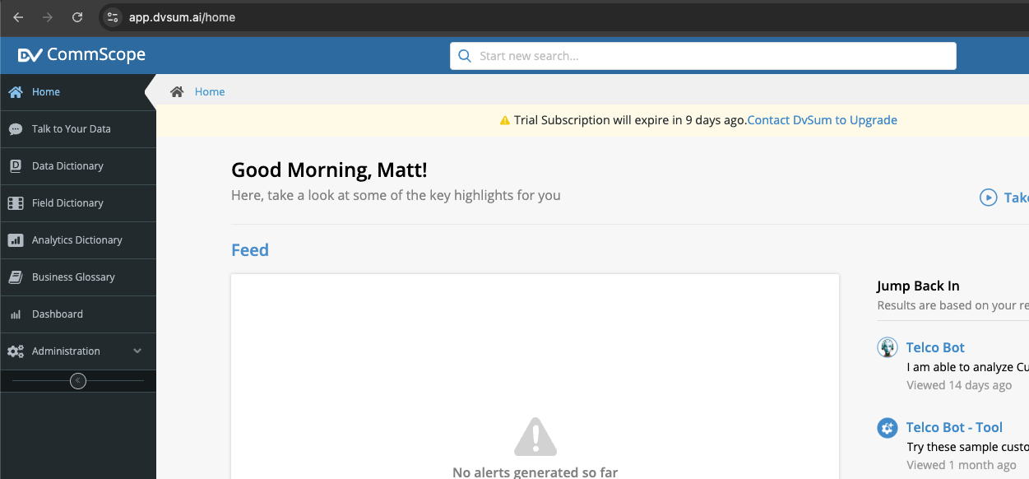

**Solution:** With the help of the PD team, the account has been successfully updated to an Enterprise plan.

**123. Incident #27653**

**Sub: List of issues / tickets created since 12/1 regardless of status**

**Question:** User requested the list of all tickets/issues reported since December 1, 2024, including both closed and in-progress ones, related to the DI module.

**Solution:** As requested, We prepared the report detailing the tickets reported since December 1, 2024, to date. The report includes a breakdown of Solved/In-Process and Open tickets. And shared the document for their review.

Below link is list of all the tickets requested:

<https://docs.google.com/spreadsheets/d/11mgk_1EtPxRlQIN_fJ-TDz8wNFrHiSTR7R9tpXFh2mU/edit?gid=273840689#gid=273840689>

**124. Incident #27701**

**Sub: Need access to DvSum demo again. See below**

**Question:** Please renew my CommScope demo membership

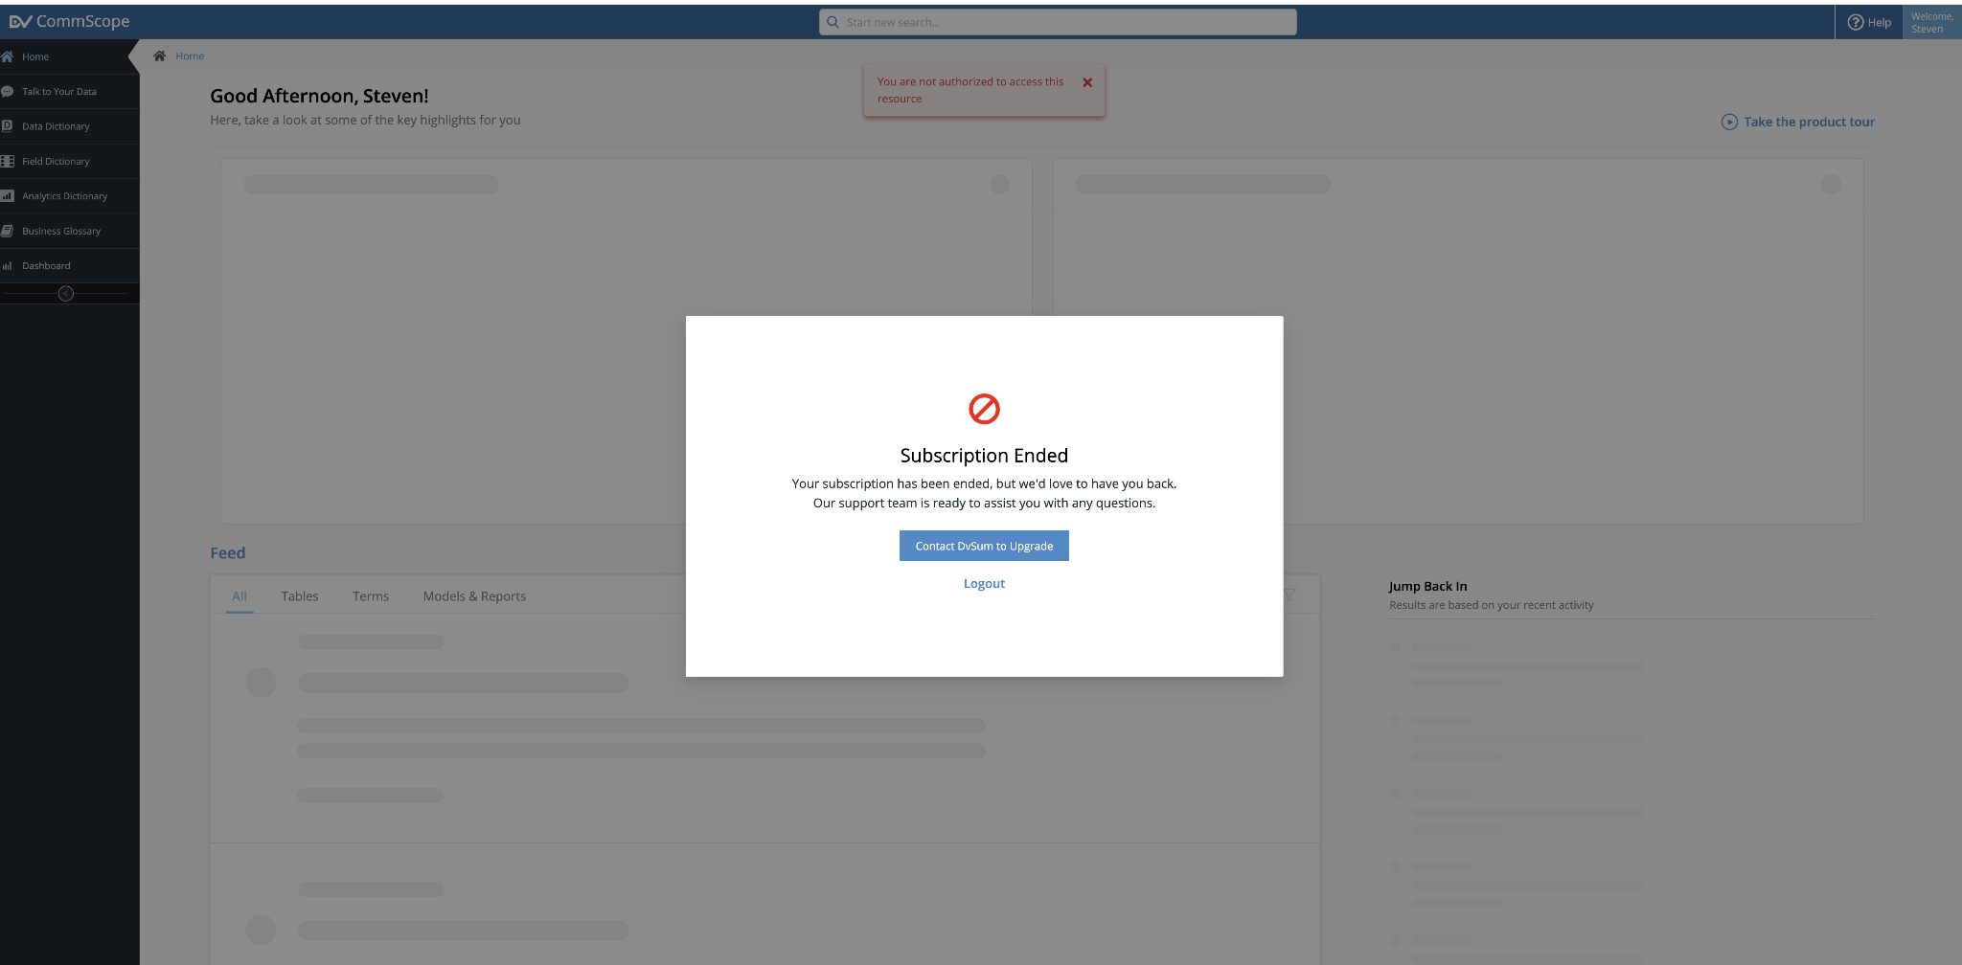

**Solution:** The subscription for the CommScope demo account was successfully renewed.

**125. Incident #27695**

**Sub: Removal of Sign-Up link**

**Question:** FDA has requested the removal of Sign-up link from the UI

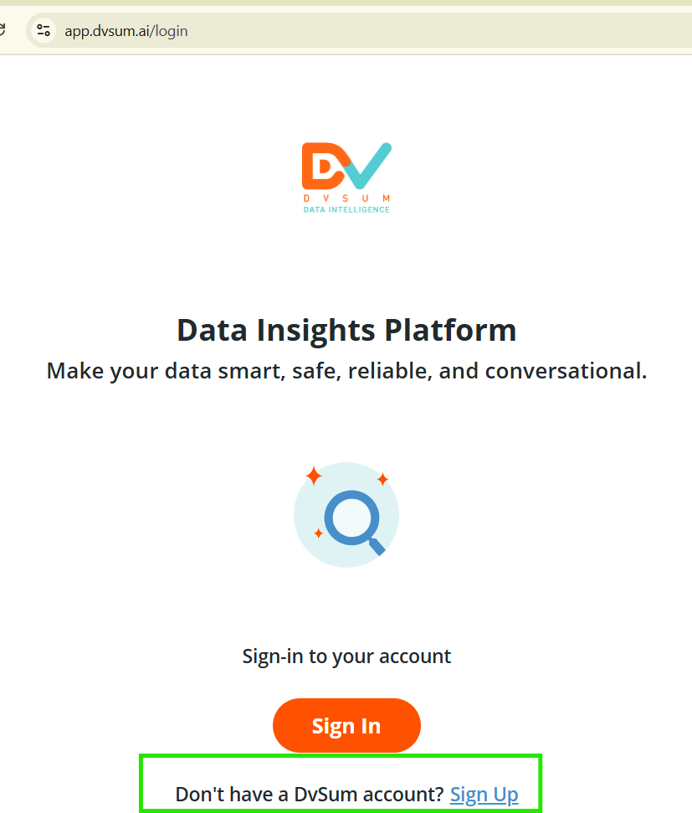

**Solution:** We connected with the FDA team and the new code was deployed into the environment. As requested, the sign-up button was removed from the UI.

**126. Incident #27689**

**Sub: Unable to connect to Data Sources - Databricks**

**Question:** Lakshmi - "Databricks: Not able to establish the connection."

**Solution:** We connected with the FDA team regarding the issues with the Databricks data source. And provided updates given below and solved the issue.

Issues:

Missing DvSum-ECSServiceRole stack (resolved).

SSL handshake needs to be disabled.

Update:

The DvSum team provided an updated installer to address the SSL handshake issue.

**127. Incident #27688**

**Sub: Unable to Connect to Oracle**

**Question:** "Oracle – Connection is successful but we are not able to see any Schemas/Data /Tables etc."

**Solution:** We connected with FDA team and guided them what permissions are needed and how they can achieve those by reaching out to Oracle DBA

**128. Incident #27354**

**Sub: Sigma error, but Sigma MAC available  
  
Question:**

Marcelo is asking for clarification about the "Sigma DPM" status showing as an "error,"

while a "Sigma DPM MAC address" is still being displayed. He wants to know where the MAC address is coming from and what the nature of the error is.

.  
  
**Solution:**

Matt confirmed that Vishal has applied a fix to all four of LLA’s bots.

**129. Incident #27354**

**Sub: Sigma error, but Sigma MAC available  
  
Question:**

Marcelo informed the team that two users, Ravi Grant and Christopher Lamia, were unable to interact with the TT UAT bot and were seeing an error message. They had already tried logging out and back in, as well as restarting their computers, but the issue persisted. Marcelo checked their accounts and confirmed they were active and not expired. He is asking for advice on how to resolve the issue.

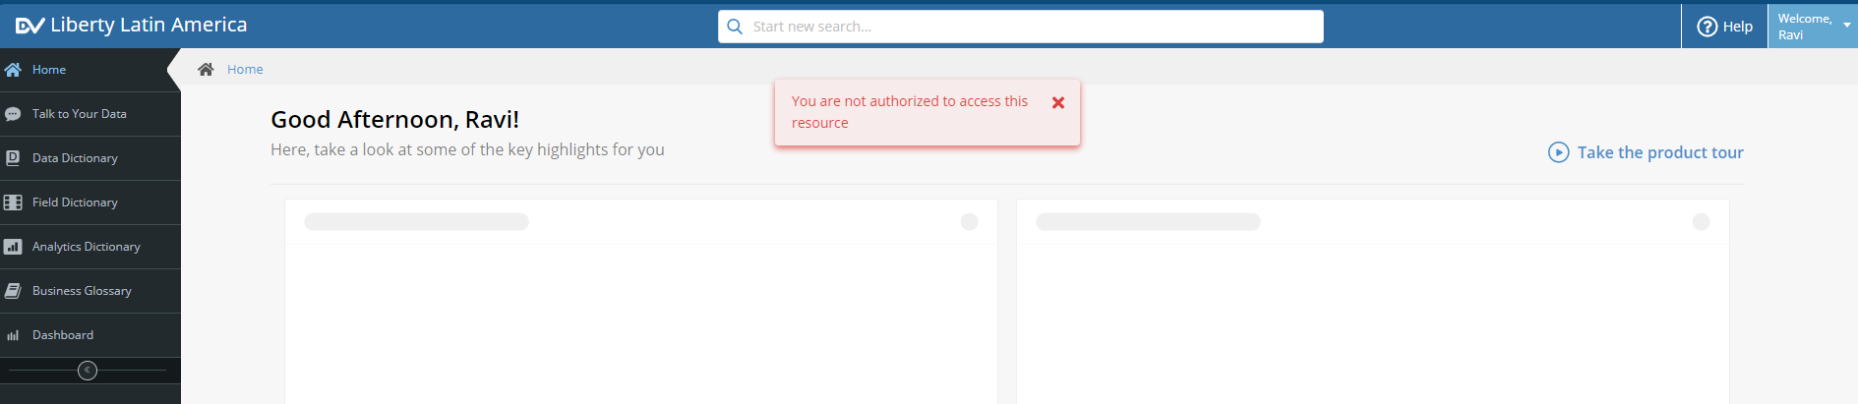

**Solution:**

We’ve advised the users to follow these steps:

Copy and paste the provided link into their browser (https://www.app.dvsum.ai/chat/new).

Logout by clicking the button at the bottom left of the page.

Log back in and check if the issue is resolved.

And the user replied issue got resolved.

**130. Incident #27348**

**Sub: RE: [EXT] RPA Bot availability**

**Question:**

Marcelo informed Richard and the DVSUM support team that he was seeing errors while testing the production Jamaica bots.

**Solution:**

Richard identified the issue as being related to a problem between the RPA bot and Sigma. So we closed this ticket.

**131.Incident #27347**

**Sub: Bug in the Comments field on Rule**

**Question:**

Aashish reported that when there was an error, the information overflowed and didn't display properly. Additionally, the comments or activity field didn't expand, making it impossible to view the full error message.

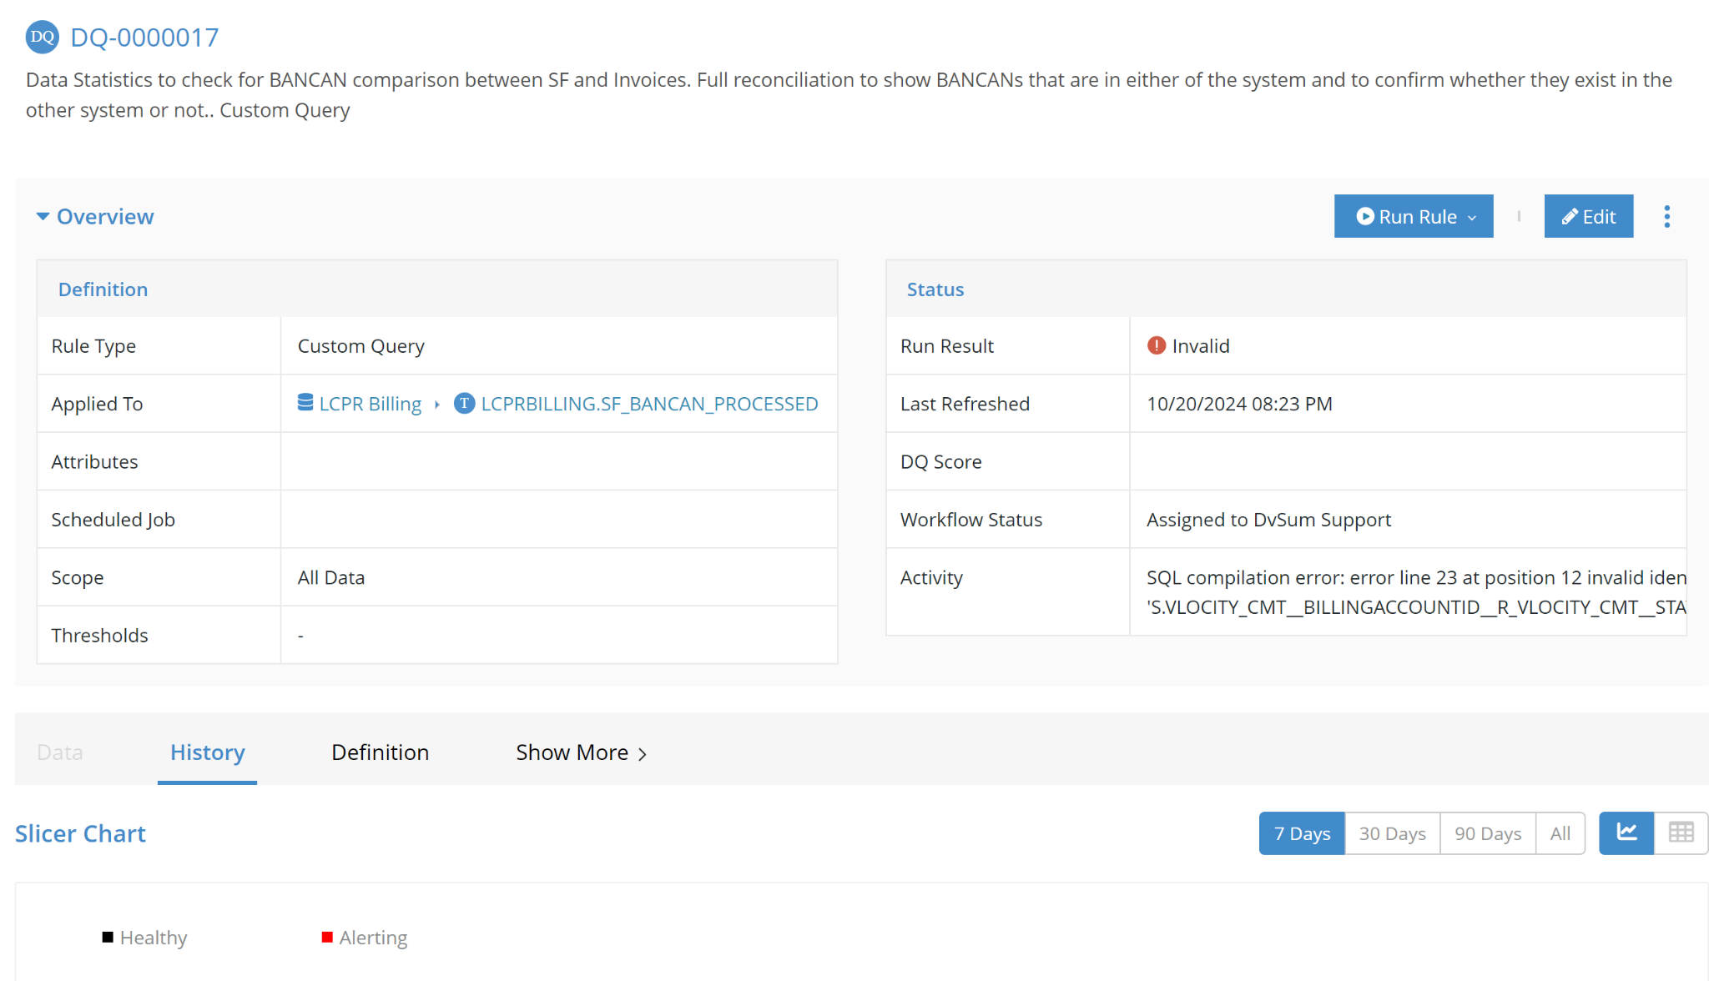

**Solution:**

We replied to Aashish letting him know that we’ve implemented the fix, and it’s now live in production. We explained that comments in the activity field will no longer be cut off and will display fully. If a comment is lengthy, it will appear in the left pane when clicking on the three dots.

**132. Incident #27340**

**Sub: Need this source to have updated scan**

**Question:**

Debra mentioned that this resource was updated to the newest service principle and connection to dbsql. It was the only one where the updated scan date had not been successful since then. She noted that two jobs appeared to be running and that she had tried to abort both. She requested a review and assistance. The last successful run for Databricks_Prod_ref_workday_rstr was on 10/3.

**Solution:**

We replied to Debra, letting her know that while investigating the issue she reported, we noticed that a catalog scan had been successfully completed yesterday at 7:31 PM. We suggested that she go ahead and schedule both a Catalog and Profile scan, as they should also complete successfully.



**133. Incident #27333**

**Sub: *IMPORTANT* 37 Rules Missing in Data Quality**

**Question:**

Lauren reported that she had been working on creating multiple rules in the Data Quality module and organizing them into new validation groups. At 4:30 PM CST on 10/16, she had confirmed that all the rules were created and placed in the correct groups. However, when she logged in today, 37 rules were missing, and the validation group 'TEST_FIN_REFINED_1' was also gone. She provided a list of missing rule IDs, which mostly included freshness checks and custom queries on the Anaplan_v2 schema in the UAT environment. Lauren had verified that there were no changes with the schema, and all data had been recataloged and was appearing as expected. She requested help investigating the issue.

Lauren mentioned that as soon as she submitted the ticket, all the missing rules and the validation group came back. She expressed uncertainty about how or why this happened but still requested to know the root cause if possible.

**Solution:**

We replied to Lauren, thanking her for her patience. Upon investigation, we mentioned that the disappearance of the rules could have occurred if the table was hidden by another user or if the Data Quality module was disabled in the module settings.

Since the rules have now returned, we explained that it’s likely one of these scenarios was the cause. We also let her know that if she experiences any further issues or has additional questions, she can feel free to reach out.

**134. Incident #27634**

**Sub: Job scheduled  
Question:** If I have a scheduled job is there anyway to run the job outside the job besides immediately. I was rerunning some profile jobs UAT Profile D365 and they profile a number so take a while. I am leaving and just ran one immediately. Was trying to figure out if I could run a 2nd one today but 1 hour later. I couldn't find a way without changing scheduled then I would need to change schedule tomorrow. Is there a way?

**Solution:**

By analyzing the query and have to perform the following steps to help to run jobs outside their regular schedule without altering the original one:

Step 1: Navigate to the Job Detail page, click on the three dots, and select Run Now to execute the job immediately

Step 2: For running multiple jobs simultaneously, go to the Job Listing page, select the desired jobs, and click the Run Now button at the top-right corner.

refer to the attached screenshot for reference.



Since there is no update from Debra, we're closing this ticket.

**135. Incident #27634**

**Sub: DvSUM.ai website down**

**Question:** DvSum website dvsum.ai is down

**Solution:**

The issue with the DVSum.ai website has been escalated to the Marketing team. They are investigating and will resolve the issue shortly

**136. Incident #27654**

**Sub: Distribution List Request - DvSum Alert. JobJB-001856 Commercial Rule 1433 weekly run (Commercial: Onhand Items with Zero Cost in Warehouse...) completed**

**Question:**

This weekly distributed file identifies zero cost items. Attached is a review that Lourdes (“Lulu”) did recently for the Climate items. I’ll be reviewing the most current zero cost file against hers to see if there’s any movement, sometime after close.

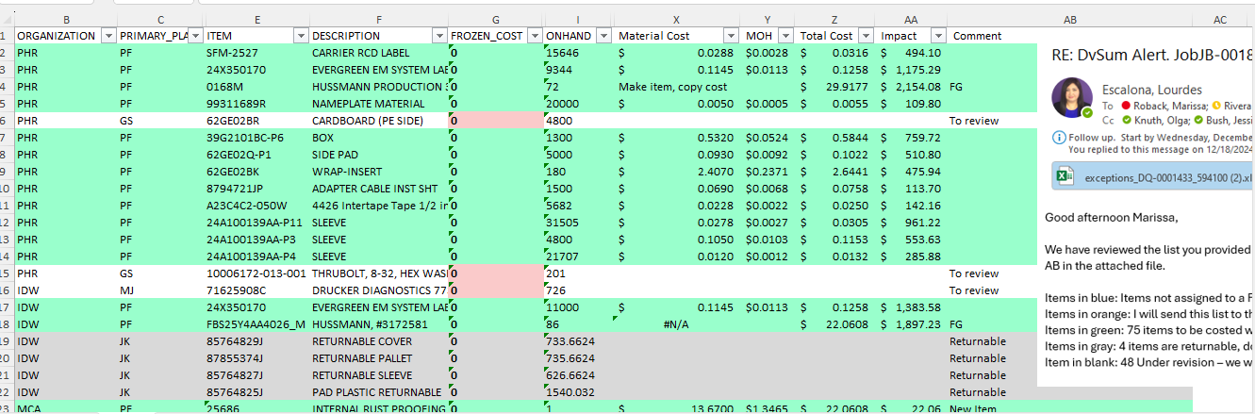

**Solution:**

I have checked the table "RBC_DVS_ITEMMASTER_DVSUM" and the rule DQ-0001433. Both were last refreshed on 01/07/2025 via the weekly scheduled job, and the next execution is also scheduled for 01/07/2025.

The table and rule were refreshed successfully during the scheduled job on January 7, 2025.

The job is now running as expected, and the DvSUM issue is resolved.

Joshua Mueller was added to the distribution list.

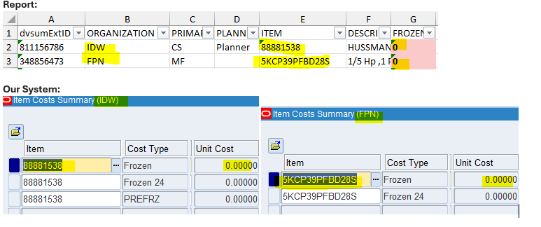

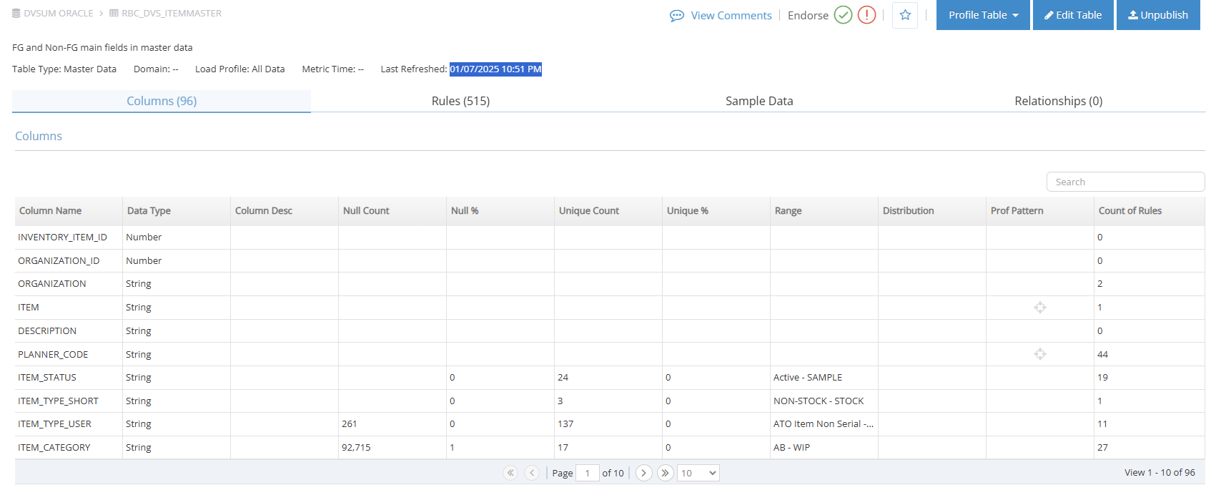

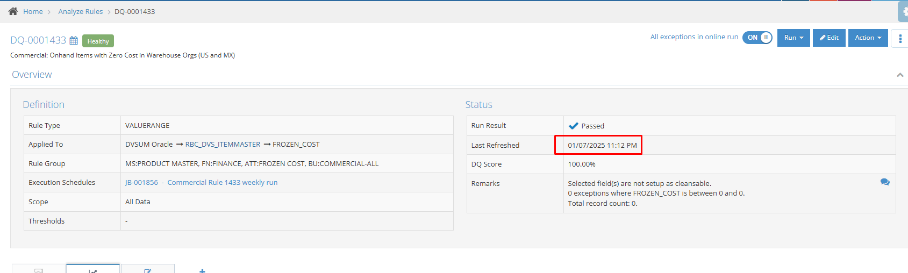

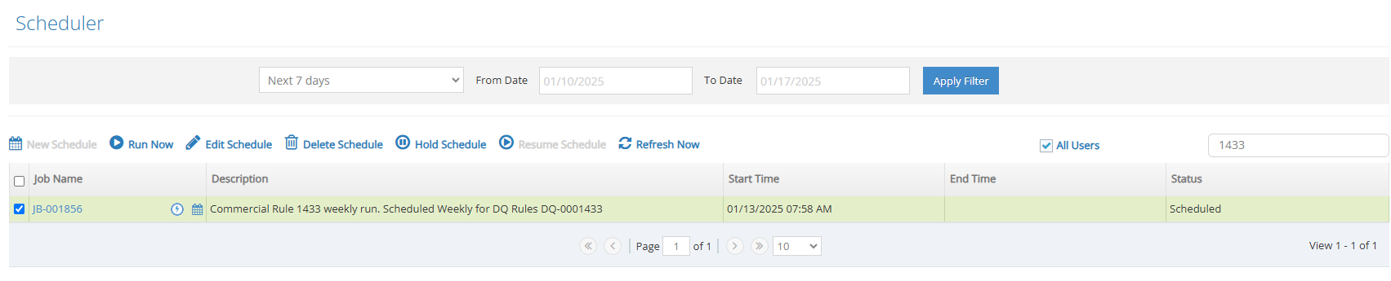

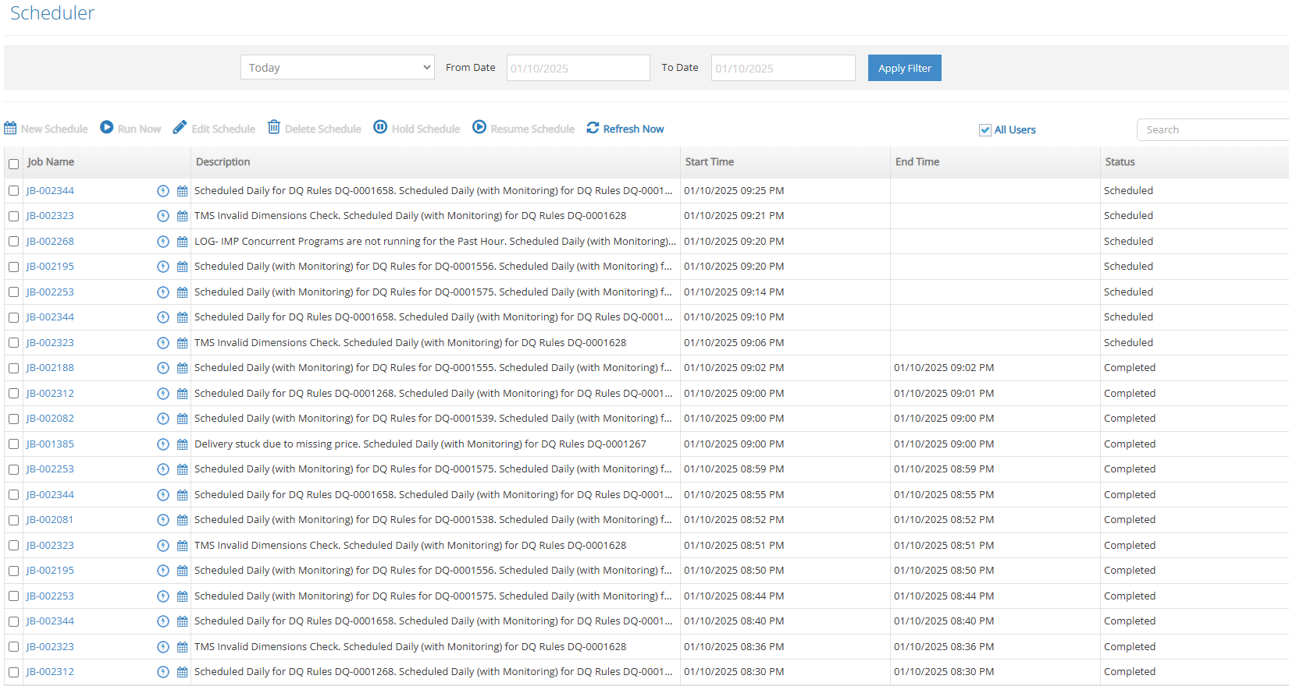



**137. Incident #27664**

**Sub: Request -- need the record id or url to direct rule from using the rest api**

**Question:**

We have not been able to replicate fully our use of setting a link in our dashboard to display the correct rule in dvsum. It is related to the url used in DI is using a record id where in DQ it was using the rule id (DQ-000082).

If the record id is coming over and we have missed please correct us.

If that record id is not coming over, please update the API to get it coming over ASAP.

We have less functionality due to the api changes and archictectual changes that in DI in terms of dashboards. Please help to rectify as soon as possible. We don't like our group seeing error or us directing them to an overall page where they then need to manually track and search for the rule.

Please advise as soon as possible when the expected change could be completed

**Solution:**

**138. Incident #27665**

**Sub: Issue with Min/Max Display in DI**

**Question:**

As I was working in DI I noticed that the Min/Max profiling information is not displaying correctly. I have attached a screen shot of an example. For Approval Code on the table Dimemployeeexpensereport in the source Databricks_Prod_Curated_Fin the min-max display is incorrect. It is showing a min-max of 100000-NA but in the distribution list you will see data that is only 5 digits long. Can you look into why this is displaying incorrectly?

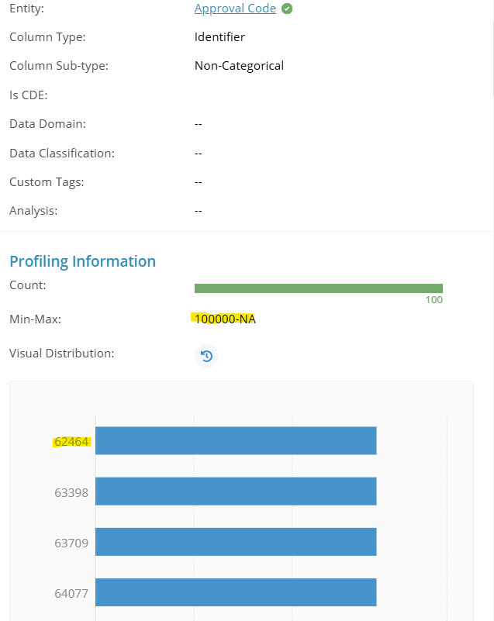

**Solution:**

The Min/Max values displayed in the profiling tool are calculated based on the entire dataset. However, the distribution shows the top 100 most occurring values in the dataset. If the distinct count is greater than 100 values, the Min/Max values may not necessarily appear within the sampled distribution.

This behaviour is expected and does not indicate an error.

**139. Incident #27668**

**Sub: Unable to upload file in Data dictionary**

**Question:**

I am trying to upload a file and getting the error "Something went wrong. Please contact DvSum support." consistently.

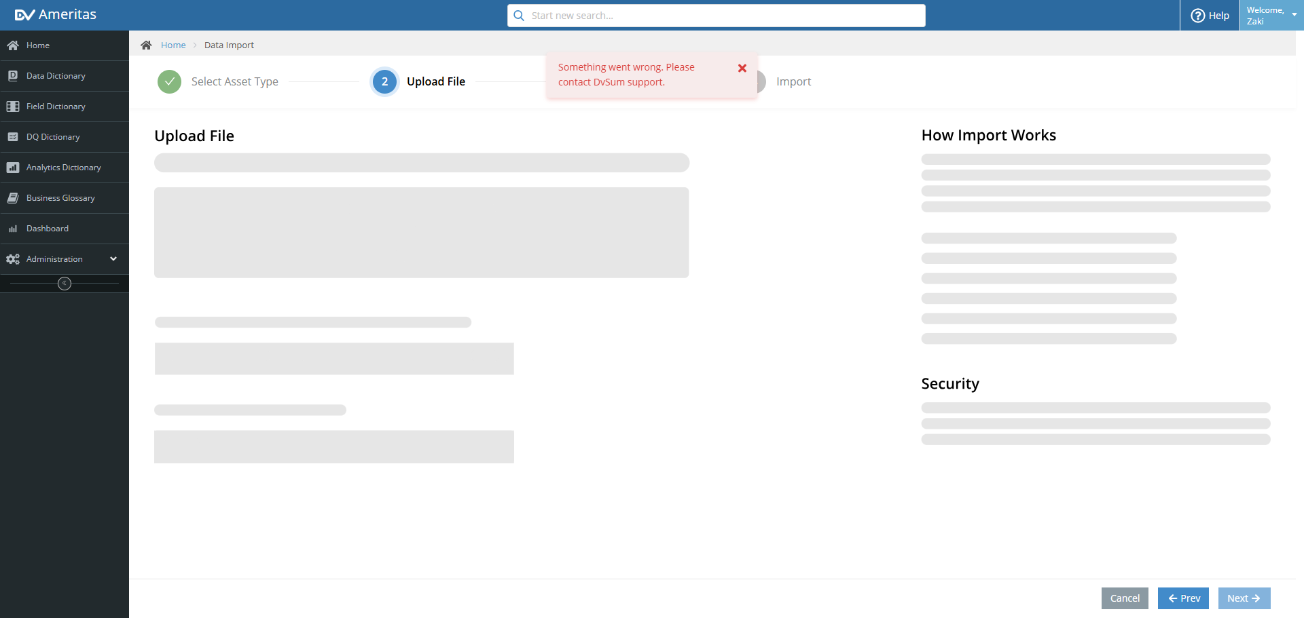

Using the file you shared, we were able to successfully import the data. Please find the attached screenshot for reference.

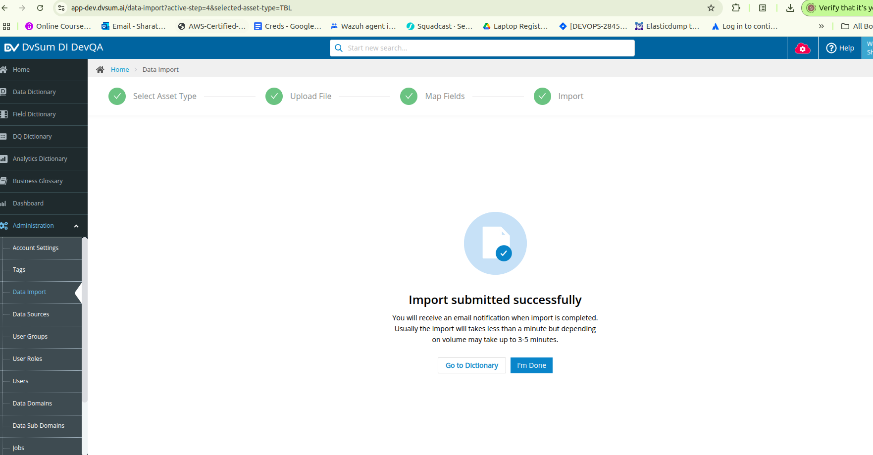

**Question 2:**

The issue seems to be with the file name.

When i upload the file Data_Dictionary.xlsx it allows me to upload but when i use the filename Data_Dictionary (1).xlsx it gives the error.





**Solution :**

Logged an FR-1005 for this to fix the issue. Will keep the update on any progress.

**140. Incident #27669**

**Sub: Segregation of CAM rules and related issues**

**Question:** I write this e-mail to share some issues our teams have encountered in the platform:

DVSUM does not update FGSUPMASTER information for the rules corresponding to CAM that use this table.

Changeovertime table does not reflect updates in the results of rules based on SKUs that have already been registered in Blueyonder

Information is not accurate.

DVSUM rules are missing segmentation.

Rule 6892 does not reflect data correctly.

Rule 7637 affects locations in Guatemala and Panama, it should take only CAM locations.

Rule 8178 does not update TM information in DVSUM.

The attached images include the non-separated rules that have to be segmented to only consider the locations on the attached file for CAM rules.

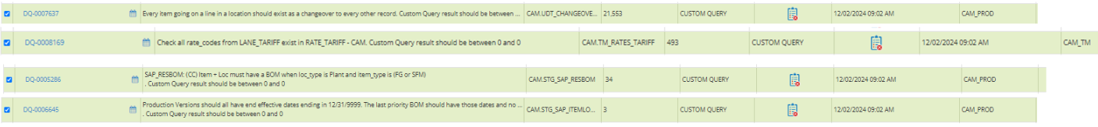

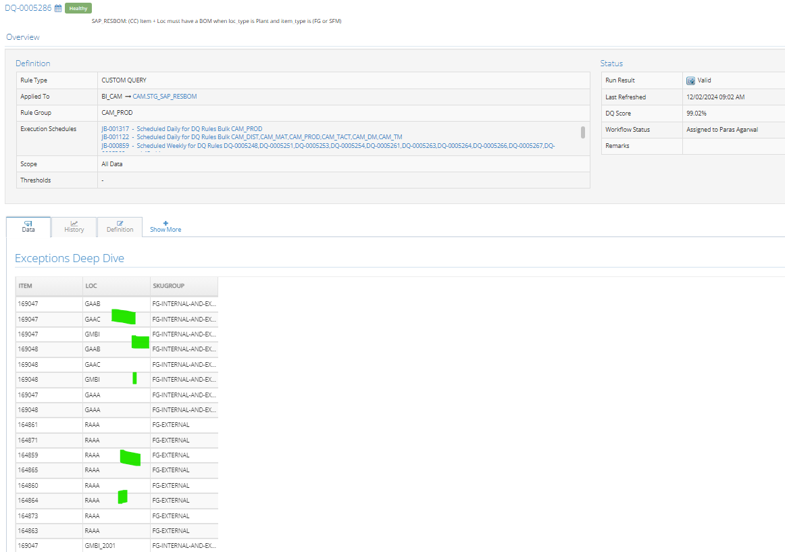

And also shared Excl sheet for reference: [Locaciones CAMSUR](https://docs.google.com/spreadsheets/d/1IMUVfNzEGbekZ4ejPQ2Q4R2HQ0S8CeruXxUeV2OmZZU/edit?gid=1204358428#gid=1204358428)

**Solution:** After investigating the issue related to FGSUPMASTER updates for CAM rules, we found that the jobs are encountering errors. Upon further analysis, it was determined that several hidden tables in the source database are preventing the custom query rule from functioning properly.

We requested confirmation from the clients to determine if the tables were hidden by the FEMSA team. If so, we advised them to unhide the necessary tables to ensure the successful completion of the rules. Additionally, we asked them to inform us if the FEMSA team was not responsible for hiding the tables.

For their reference, we also shared a knowledge base article outlining the steps to hide and unhide tables: <https://dvsum.zendesk.com/hc/en-us/articles/21781811462676-Data-Security-Admin>

Later a temporary fix was applied by rescheduling the jobs in production to ensure continuity. The permanent fix was implemented, deployed to production, and successfully validated to resolve the issue.

**141. Incident #27688**

**Sub: Unable to Connect to Oracle**

**Question:** "Oracle – Connection is successful but we are not able to see any Schemas/Data /Tables etc."

JC Note: Second database issue - with Oracle (most used DB for FDA). Solution will most likely be Muneeb or Shafaqat join Lakshmi Scheduled meeting, "DvSum Smoke Test Session" on Wednesday at 9 AM EST.

**Solution:** Shafaqat connected with the FDA team to resolve the data source issue. After engaging with the FDA team, we received the following update:

Issue: Permissions problem.  
Update: Ravi is coordinating with the team to address and resolve the permissions issue.

We then guided them on the required permissions and explained how they can obtain them by reaching out to the Oracle DBA.

**141. Incident #27689**

**Sub: Unable to connect to Data Sources - Databricks**

**Question:**

"Databricks: Not able to establish the connection."

**Solution:**

The Databricks issue reported by the FDA team has been resolved.

* Issue: Unable to connect/authenticate to Databricks.
* Update: Updated the configurations in the backend JAR file, provided the updated CloudSAWS JAR, and re-deployed CloudSAWS in their environment. This fixed the issue

**142. Incident #27695**

**Sub: Removal of Sign-Up link**

**Question:**

FDA has requested the removal of Sign-up link from the UI



Solution:

Connected with the FDA team and deployed the new code in their environment. As requested, the sign-up button is no longer visible. They have been informed about the steps to reinstate the button for new users if needed and how to access the old code.

**143. Incident #27701**

**Sub: Need access to DvSum demo again. See below**

**Question:** Please renew my CommScope demo membership



**Solution:**

Try logging out and then logging back into the DvSum account.

The subscription for the CommScope demo account was successfully renewed.

**144. Incident #27702**

**Sub: Issue with rule LLA Data Quality Rule #DQ-0000005.**

**Question:**

I ran this rule online and scheduled. I receive an error message when running in DvSum. However, I can run it successfully using dbeaver. This looks like another issue with the CDATA driver, maybe.

I can run this rule successfully in dbeaver directly against the database.

I will try to work around it. This query previously ran fine.

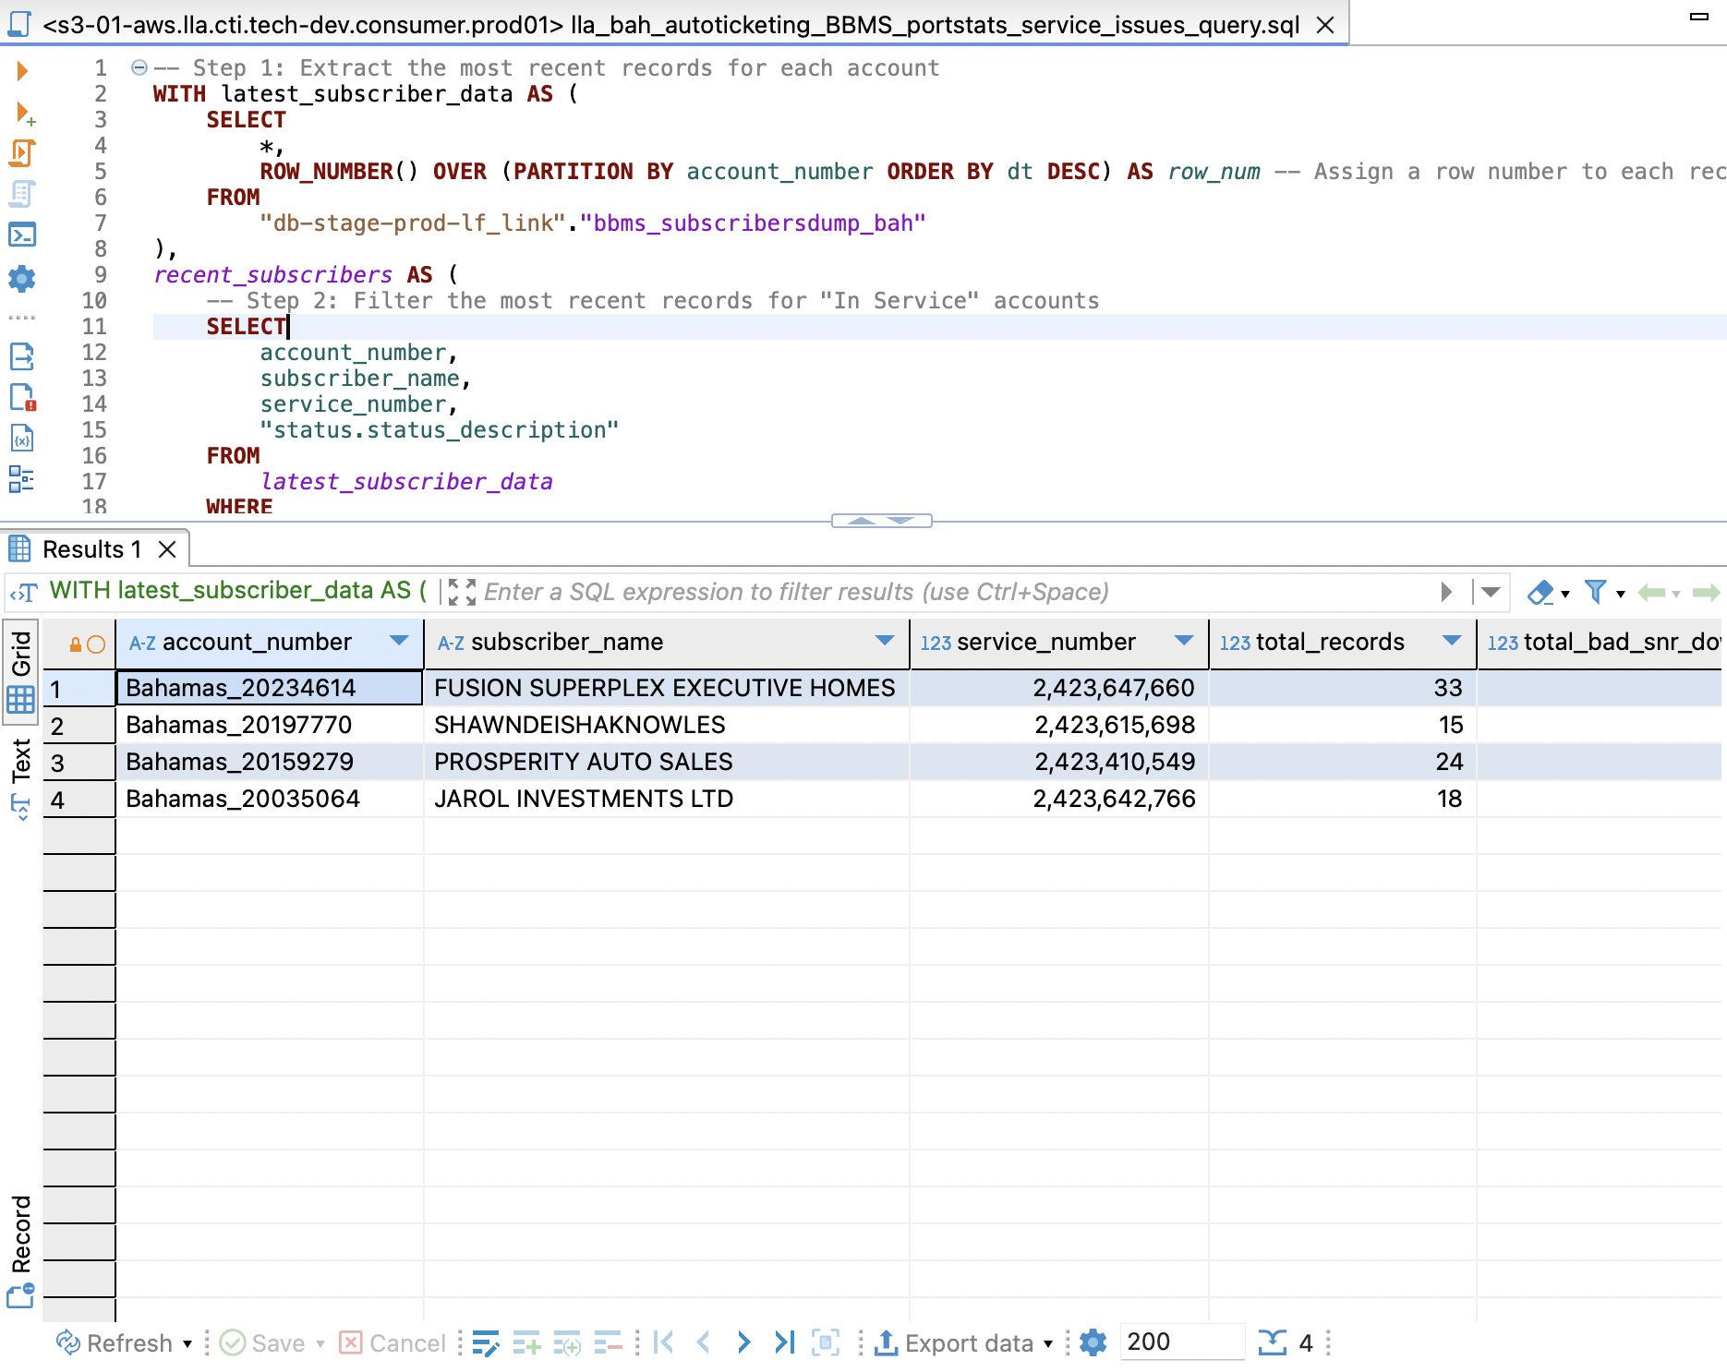

**Solution:**

Closing out this ticket and merging into another one as another same kind of ticket has been created and we will use the same for the follow-up

**New ticket** [**#27718**](https://dvsum.zendesk.com/agent/tickets/27718)**(this ticket is in open status).**

**145. Incident #27529**

**Sub: Different recommendation for the same account SLU. (Open)**

Pending at Marcelo's end for approval

**146. Incident #27565**

**Sub:** CADDI does not generate SQL

**Question :**

Why is CADDI not generating SQL. It is a simple 2 table, few columns design.

**Solution:**

Logged FR-901 for this issue. A follow-up ticket will be created once the fix is deployed to production.

**147. Incident #27583**

**Sub:** Null vs Blanks Issue

**Question:**

I am following up on a ticket I had submitted a while back regarding Nulls vs Blanks checks in Data Quality. I was informed that the issue would be resolved in a future enhancement that was on the road map. I believe the timing aligned with the go live of the one module. I am wondering when this will be resolved. I was creating new DQ rules in the Data Intelligence module and noticed the same issue. Nulls and Blanks are being considered one in the same in this module too. With the DQ checks we run we need to be able to differentiate Blanks vs Nulls. I am currently getting around the out of the box rules with custom queries.

Please reach out if you have any other questions regarding this issue.

Solution:

**148. Incident #27615**

**Sub:** CADDI LLA change request, customer name and last registration. **(Open)**

This work done by our side and waiting for Marcelo's reply

**149. Incident #27619**

**Sub:** Endpoint request timed out

**Question:**

I was able to make any edits to this domain. (I could edit other domains as usual.)

Are you able to see in the backend what's going wrong?

I removed its subdomain, "Data Sub". Now I can edit it.



**Solution:**

Logged FR-990 for the issue. A follow-up ticket will be created once the fix is deployed to production.

**150. Incident #**27641

**Sub:** Inconsistent Recommendation customer 60318089**(Open)**

No replay from Marcelo. Waiting for his reply.

**151. Incident #27684**

**Sub:** Glossary term status

**Question:**I made an edit to the glossary term and saved the draft. It still shows as Published on the term detail page and also the Publish button is clickable. However, in the glossary listing page the status shows as modified.

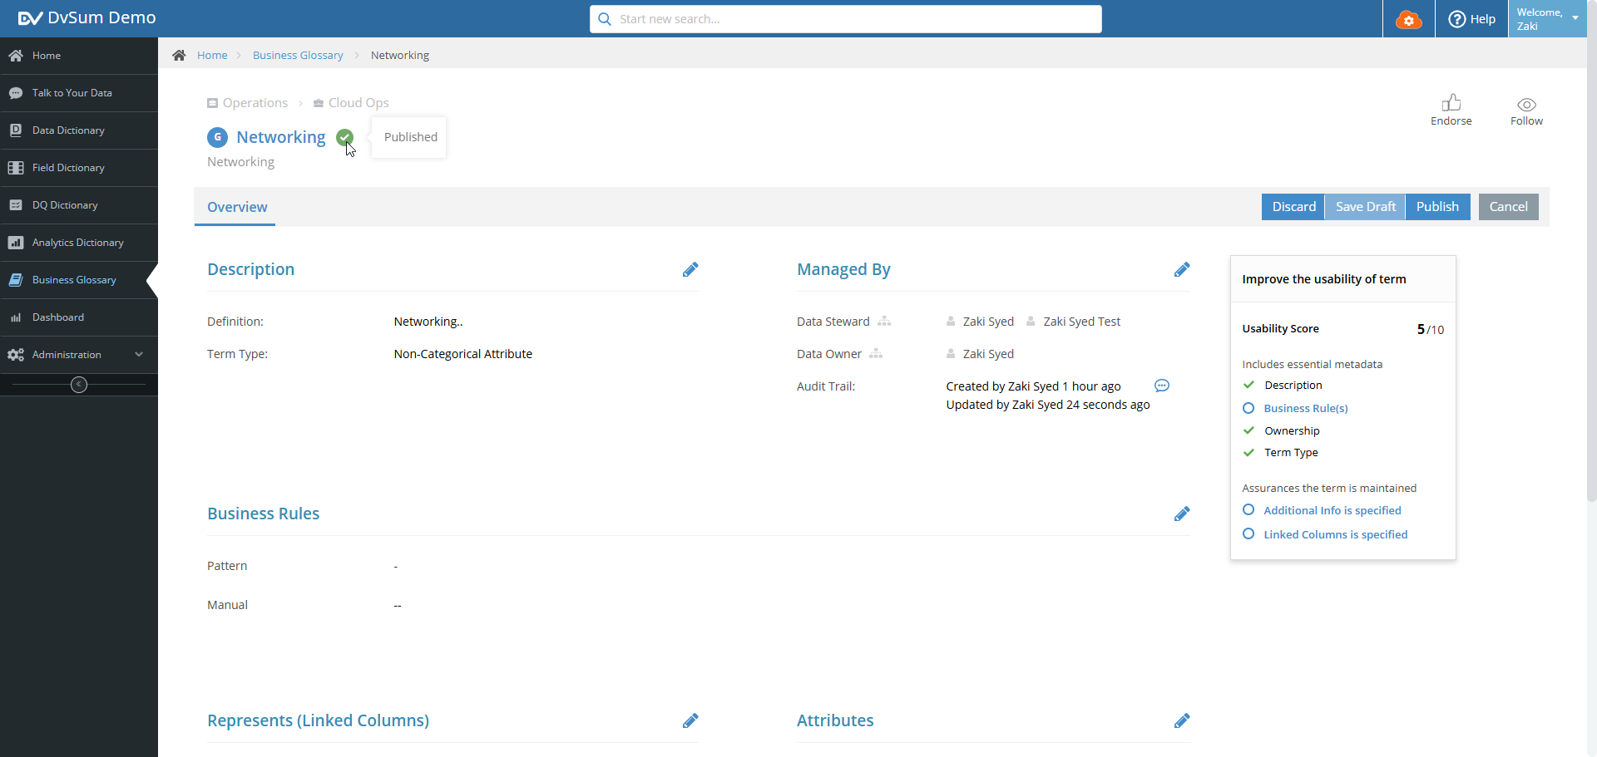

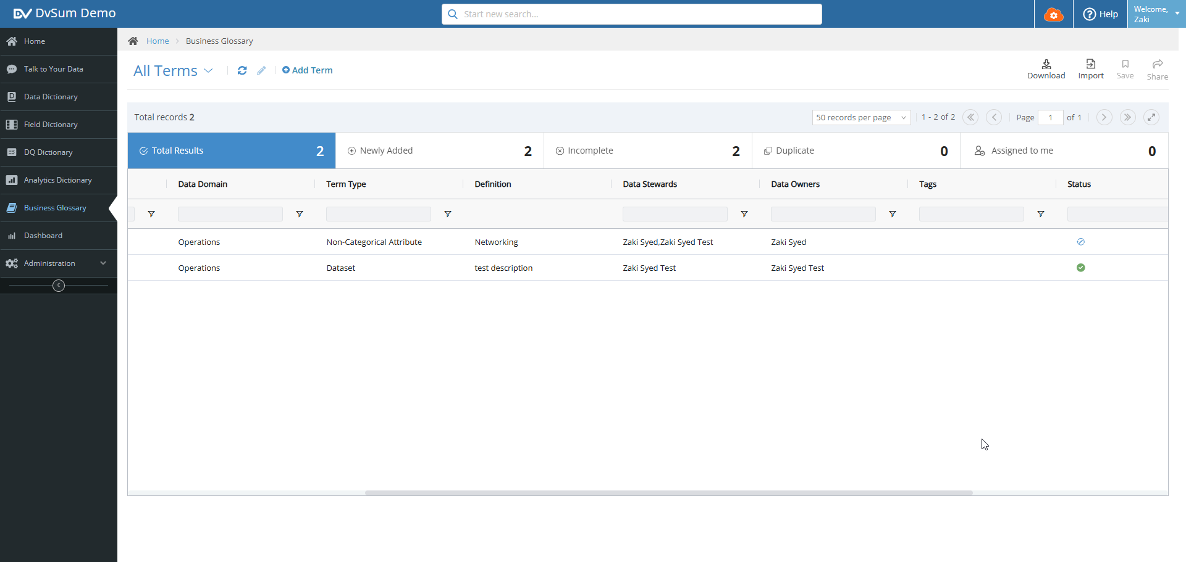

**Solution:**

* When a glossary term is edited and the changes are saved as a draft, the Term Detail Page will still show the status as "Published." However, upon clicking Edit, the status will correctly update to "Modified." To finalize the changes, the term must be published.
* The Term Detail Page now updates the status to "Modified" when clicking Edit.
* The term must be published for changes to take effect.

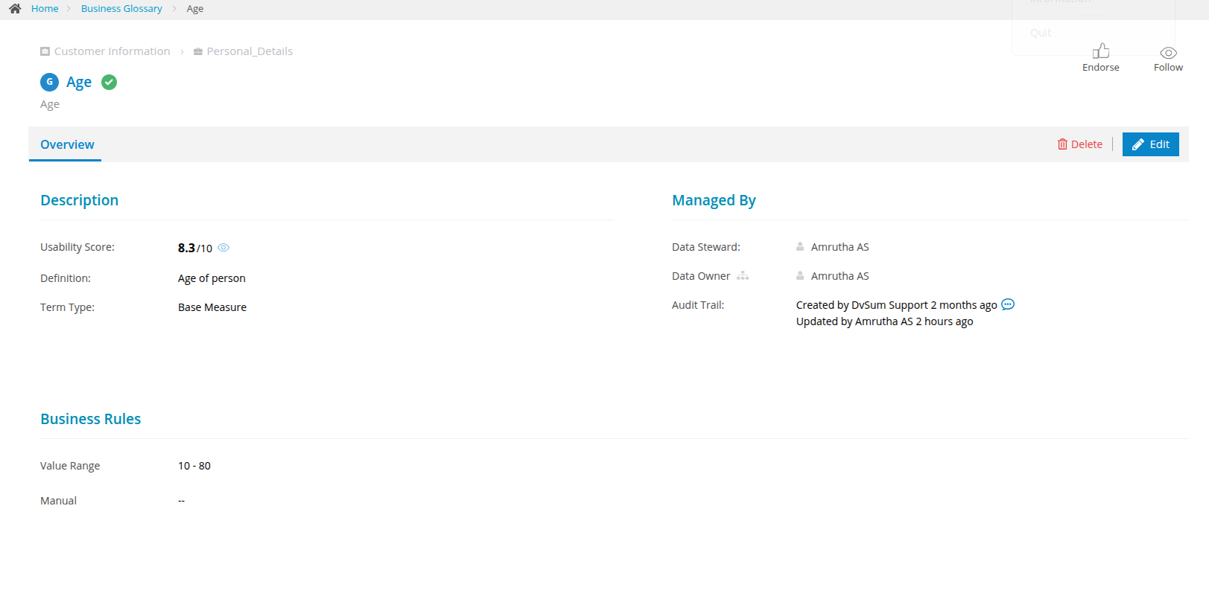

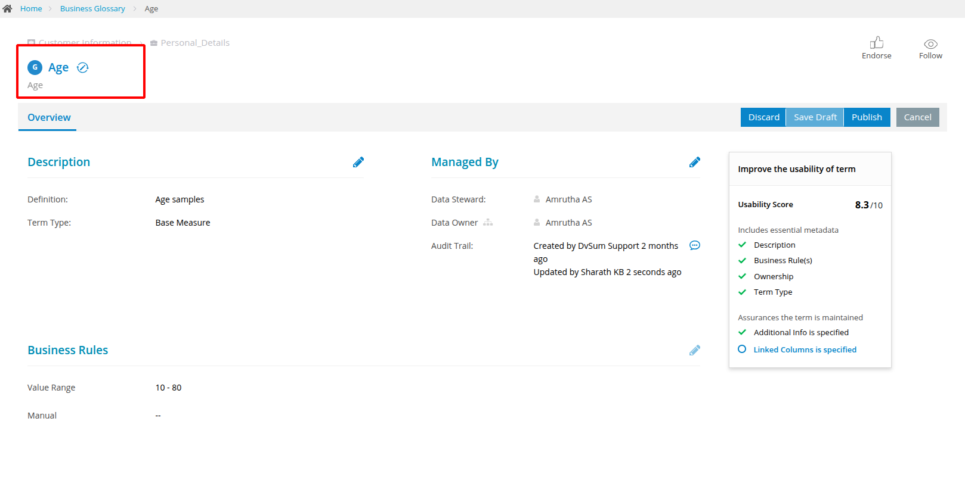

**152. Incident #**27685

**Sub:** Issue with Min/Max Display in DI - re-opened

**Question:**

John Cowan (JC) posting on behalf of Brian Ayers. Please move forward with responding to Lauren Sauter and Brian Ayers valid observation. Include next steps and timing to satisfy the USV need.

Brian: "If that is the case, then the min-max distribution is inaccurate and cannot be used as a mode of analysis, which in turn defeats the purpose of having it. Min-Max is not supposed to be sampled, but should consider the entire population of values. The purpose of min-max is to show the MINIMUM value and the MAXIMUM value in a range of values. The scholarl definition is: a data distribution where all values fall within a defined range, with a known minimum ("min") and maximum ("max") value. It should not be an “expected” outcome, because the logic behind it violates laws of statistics."

**Solution:**

* The metadata label currently displays values as "Min - Max."
* However, the actual values are shown as "Max - Min."
* It is recommended to align the display with the label for consistency.
* Should check if this can be corrected.
* This is the only recommendation for now, but further review may be needed.

As per the discussion, and a new ticket will be created for the change requested by Brian.

**153. Incident #**27700

**Sub:** 404 error on SAWS screen

**Question:** Team, users are reporting the bot is stuck in generating insights, when trying to accept the security exception on the saws page, I see this instead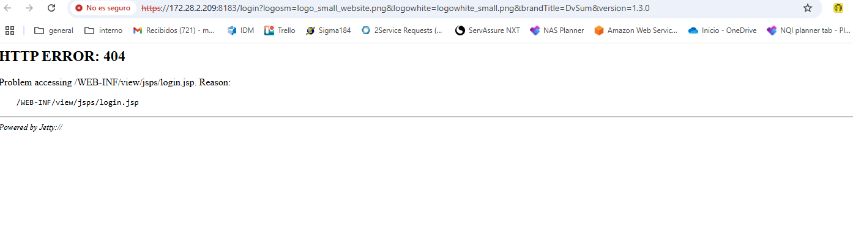And also Team we noticed the -ca services were down. We tried starting it seems to be running now. This one is also down, we will try restarting. @faiz.shaheen @Vishal Kasula any recent changes you are aware of?

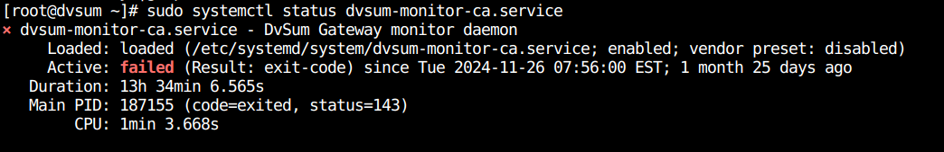

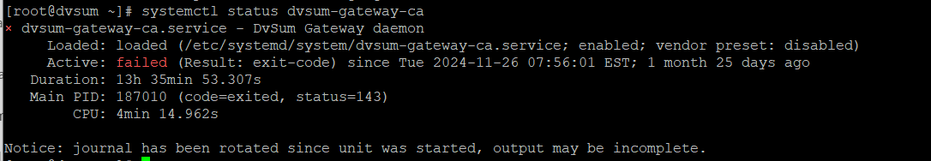

**Solution:**  The team collaborated with the internal team to stop the old gateway initiated by the LLA team. Backup files and outdated gateway archives were deleted to free up storage. The main gateway was successfully restarted, and Marcelo confirmed that the system is now operational, with bot results generating as expected.

To prevent similar issues in the future we provided the below steps:

* The LLA team will work on increasing the server’s storage capacity.
* Amilcar will schedule a meeting with Faiz, Matt, and Marcelo to establish policies for managing and deleting older data to avoid recurrence.

**154. Incident #**27703

**Sub:** New LLA Data Source for Auto Ticketing Project won't return table (bng_accountingdaily)**(Open)**

Determined that this issue may be in the CData connector so this issue has been escalated to the CData team for their analysis and resolution.

**155. Incident #**27706

**Sub:** Additional Information - Long Running Jobs**(Open)**

**156. Incident #**27718

**Sub:** DQ Rule takes forever to run and fails - does not complete in DvSum - takes 11 seconds in SQL client (dbeaver)**(Open)**

Taimor and Rafique are working on this issue.

**157. Incident #**27720

**Sub:** "Applied to" - Missing from the DQ rule definition

**Question:**

I created a Rule a while back and now the Applied to section under Definition is blank.

The rule is still running fine and returning results but Applied to is still empty.

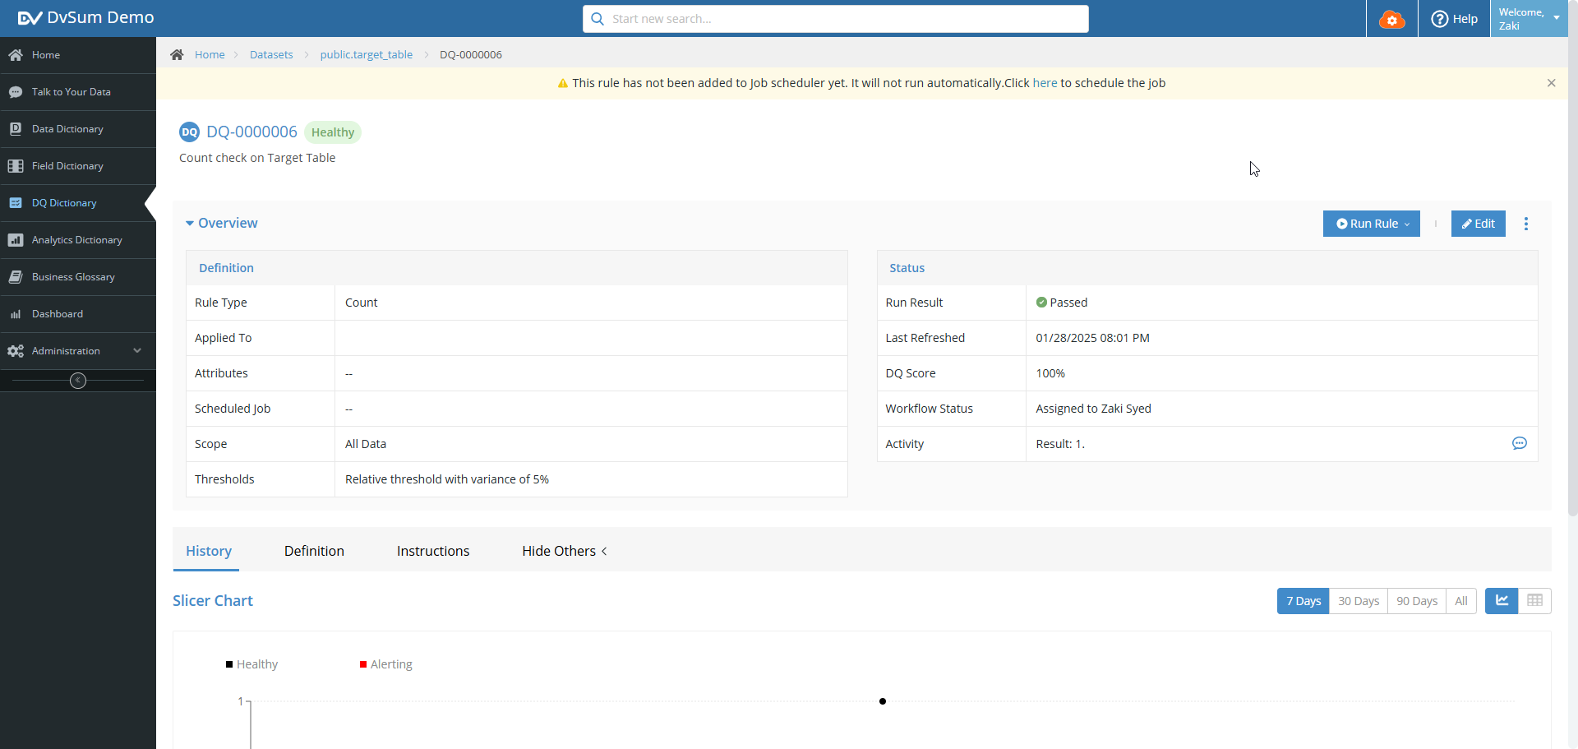

**Solution:**

FR-1073 has been logged but has not yet been prioritized. A follow-up ticket will be created once the fix is deployed to production.

**158. Incident #27731**

**Sub**: Unable to Authenticate Snowflake using cloud gateway.

**Question:** I just added snowflake creds and it is not authenticating, however the same user is working fine in dbeaver.

Similarly, in an already added snowflake source in another account with same creds is also not getting authenticated..

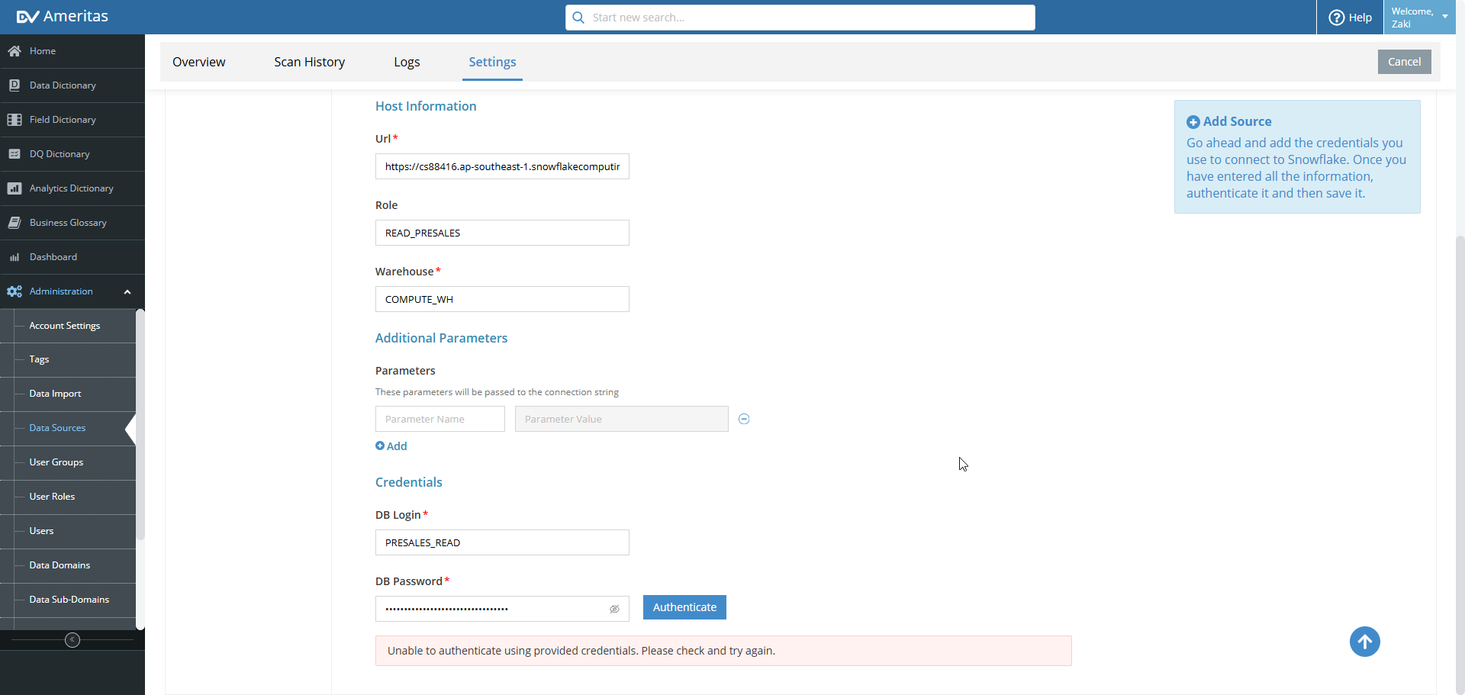

**Solution:** We verified on our end that the credentials were working correctly and successfully added and tested the Snowflake data source.

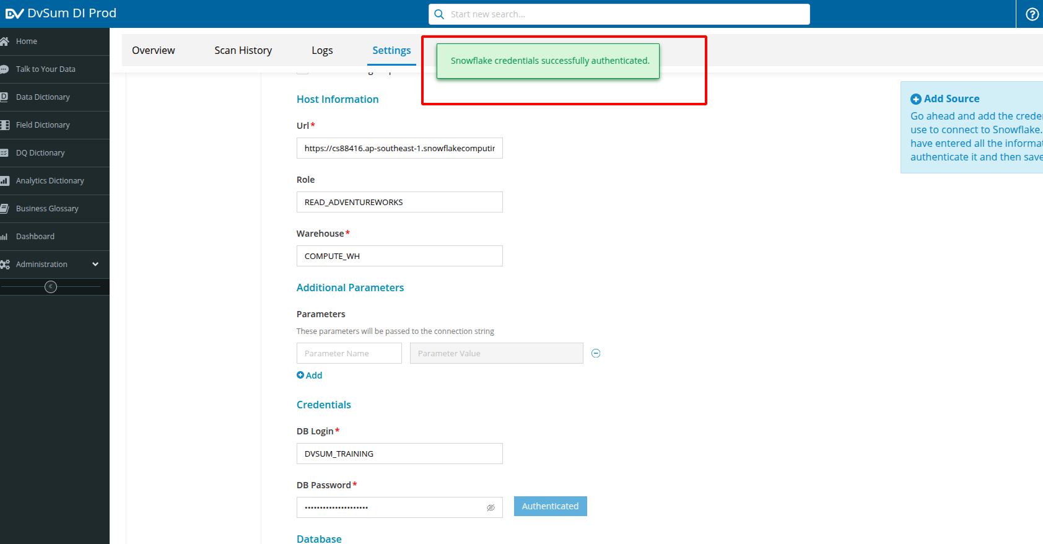

We then asked them to recheck on their side and confirm. They later responded that it was working fine after reconnecting, so we closed the ticket.

**159. Incident #27730**

**Sub: Table name overlaps the column name**

**Question:** The table name overlaps the column name, please fix this.

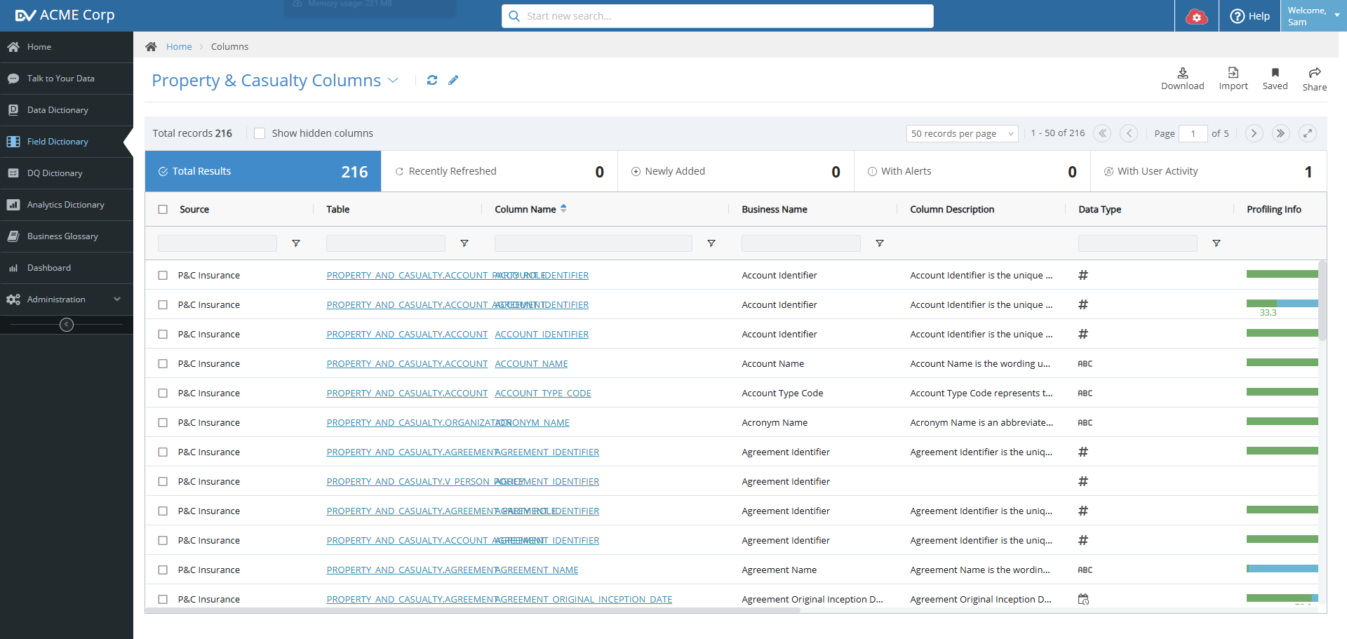

**Solution:**

The issue of table and column name overlap in the Field Dictionary has been resolved and is fixed.

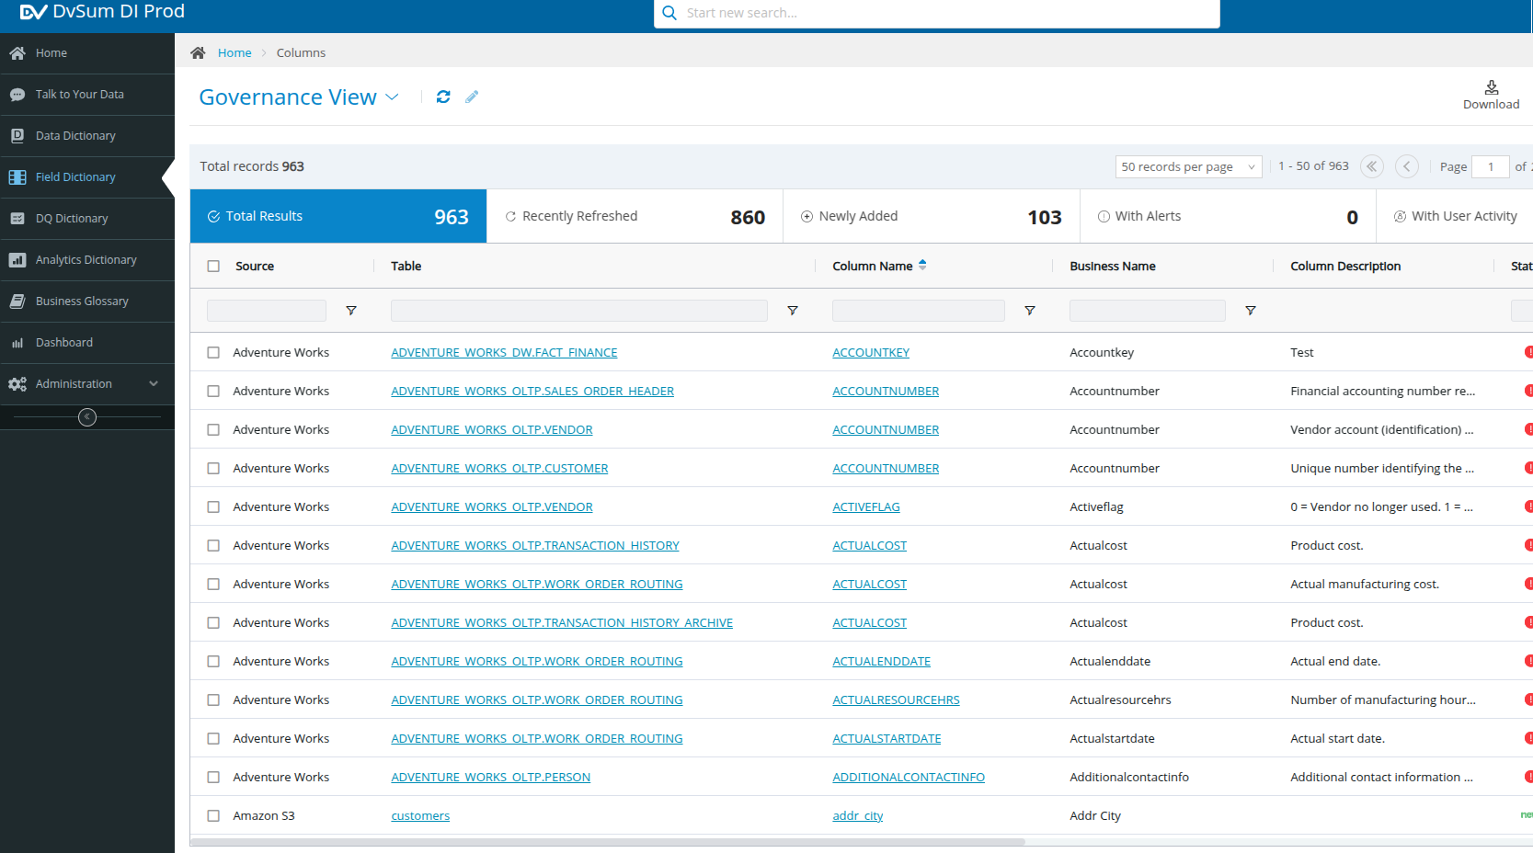

**160. Incident #27732**

**Sub:** Alix Partners Data Extraction

**Question:** Team,

I am hoping to get an extract of all the CADDI specific data from Alix Partners – questions and training information – so that I can better understand appropriately generate SQL vs incorrect outcomes. Is that something you all can help with? If not, can you please point me in the right direction?

**Solution:**

The response field appears cut off because it is designed to filter and show the most important content. However, you can resize the column to view the full content, as shown in the attached screenshot.

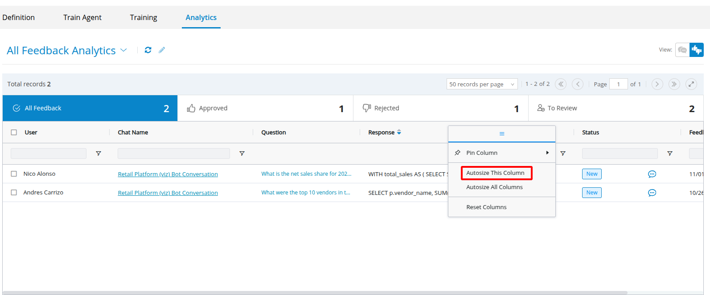 Logged a Feature Request (FR) for a visual cue to simplify downloading responses. In the meantime, you can select the desired feedback, right-click, and choose the copy or export option, as shown in the screenshot.

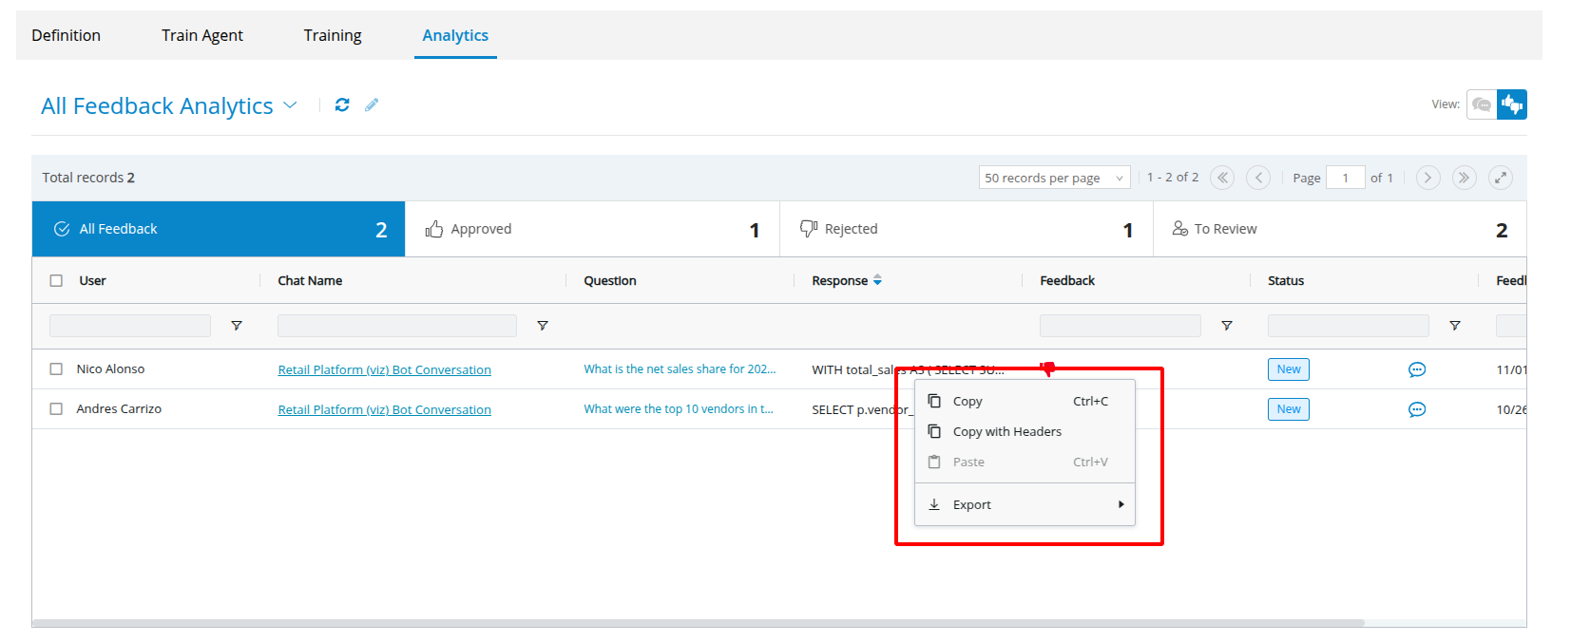

[**https://dvsum.zendesk.com/hc/en-us/articles/27034936667924-Agent-Analytics**](https://dvsum.zendesk.com/hc/en-us/articles/27034936667924-Agent-Analytics)

**161. Incident #27728 (Open)**

**Sub: CADDI test bots not getting cerillion response**

**Question:** Hello RPA team

We are getting “Error connecting to Cerillion” response from the RPA test bots.

This is not critical as the production environment is responding normally, but we need to understand why we get this response for the test environment.

Please note Sigma responds normally.

**Solution:** Srinath confirmed that the connectivity issue resolved itself over time without requiring any intervention. As of now, the Cerillion bot is functioning normally.

**162. Incident #27741 (Open)**

**Sub: language question**

**Question:**

As per Article,

[**https://dvsum.zendesk.com/hc/en-us/articles/15168396488852-How-to-talk-to-your-data**](https://dvsum.zendesk.com/hc/en-us/articles/15168396488852-How-to-talk-to-your-data)

I understand we can interact with CADDI in Spanish. But is the interface itself available Spanish? (IE: the button talk to your data can be shown in Spanish?)

**Solution:** We informed the client that a Feature Request has been logged, and the Product Development (PD) team is working on it. Updates will be shared once the enhancement is rolled out to production.

**162. Incident #27751 (Open)**

**Sub: Segregation of CAM rules and related issues**

**Question:**

I hope you are doing well, do you have any news about the exclusion of locations for the CAM rules? the operation is having problems because the rules are bringing data from Guatemala and Venezuela, can you help us to make the exclusion of the locations that were shared previously.

**Solution:**

It has been successfully rolled out. As a result, the table visibility change is no longer required. Now be able to see the updated rule status with the daily schedule run.

For your reference, I’ve attached a screenshot that illustrates the updates.

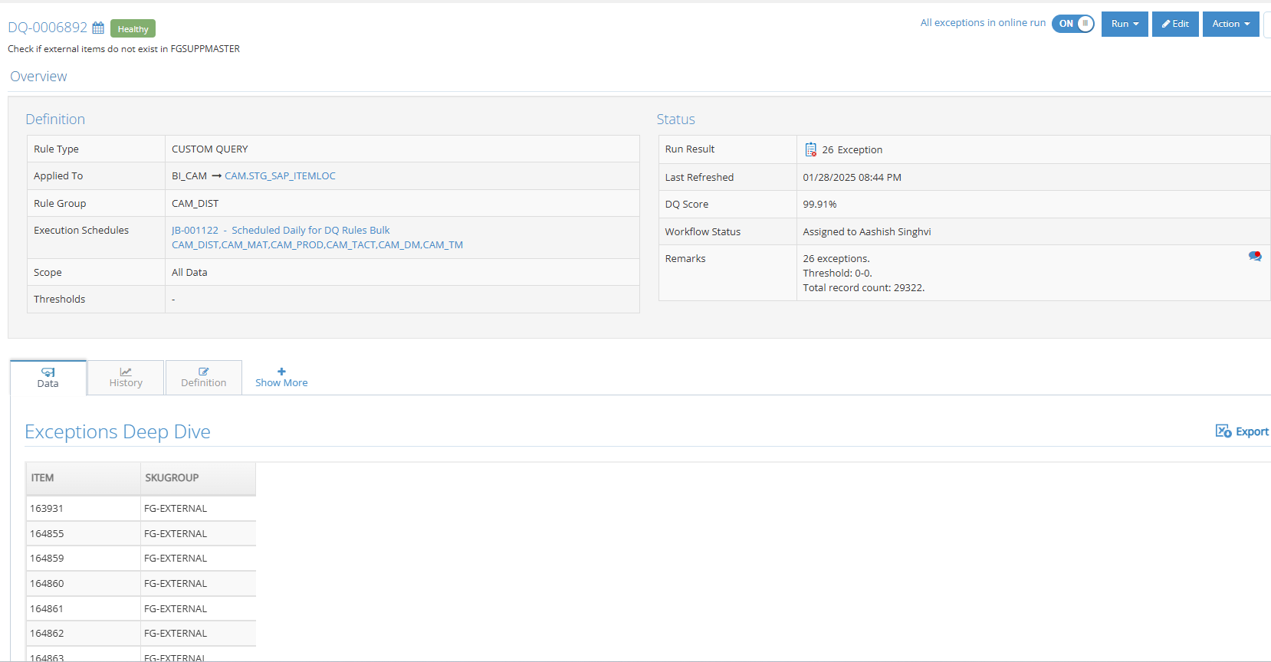

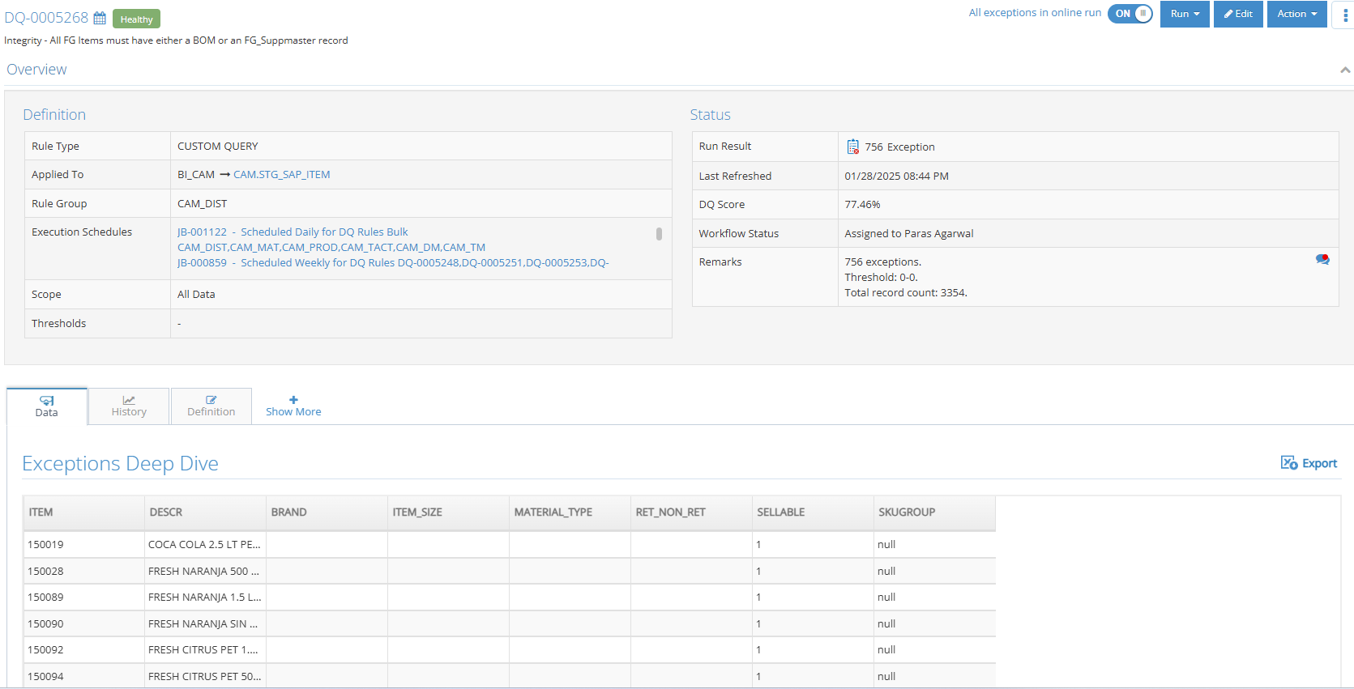

**163. Incident #27762**

**Sub: replace Sigma DPM with Resolve (Integration request for CADDI LLA LC)**

**Question:** We need to replace Sigma DPM as source of provisioning data in LC, with Resolve.

In the below email you will find an example of request and response format for the new Resolve API.

Queries will use port 7777. There will be a FQDN for these API calls, and the load balancer will automatically translate it to the resolve cluster via port 7777. FQDN are:

api.resolve.cwc.com

uatapi.resolve.cwc.com

We currently have connectivity to the IP where the endpoint is sitting, but we still need to test the FQDN access (the DNS server we are using is external only)

Reference document:

<https://dvsum.zendesk.com/attachments/token/tMXnxVAtVJxYu3dyVOLPo6fzV/?name=hfcmodemtests.yaml>

**Solution:**

The request has been assigned to the **DvSum team**, with **John Cowan** managing the response. The ticket is now closed, and the customer has been advised to reach out if further assistance is needed.

**164. Incident #27766**

**Sub: CADDI LC GW VM stopped responding**

**Question:** Today Faiz informed around 3:50 pm UTC, we lost connectivity to the VM in Curacao. I was not able to connect either for a couple of minutes.

When looking at performance in the VM Pablo found the below. Problem seem to have lasted around 10 minutes.

@faiz.shaheen were you executing anything new at the time it vm stopped responding? It returned to normal without any intervention but this is clearly an operational risk so we should further investigate.

**Solution:** The LLA team needs to optimize memory usage by monitoring Java and Python processes, ensuring proper memory management, and evaluating if 16GB RAM is sufficient. Vishal and JC are following up on this with the client.

**165. Incident #27771 (Open)**

**Sub: Tracking down detailed database error logs**

**Question:** As part of the process, you need to create the Feature Request (FR) in AirTable. Depending on the severity, we will discuss it with Aashish or Shree and prioritize accordingly. You may also send an email after logging the FR if it is critical and requires urgent attention.

In this specific case, please create the FR, and we will discuss it with Aashish/Shree. We will keep you posted on its progress.

**Solution:** The FR was logged, assigned to the SME, and the document will be updated and shared as requested.

**166. Incident #27772 (Open)**

**Sub: Tracking issues raised by FDA that will be addressed in a new update to FDA**

**Question:** I want to make sure we have a light tracking of FDA issues raised, that would be addressed in a new release. My suggestion is to simply use the current ticketing system. We have already had this happen once so far:

1. Problems with dictionary template downloads. Matt logged FR1043 and FR1044

2. Issue with the download template already fixed in SaaS version, but not updated for FDA On-Prem.

3. Next Step: Add a Zendesk ticket, tie to the two FRs, as per normal. Track next DvSum application update sent to FDA.

4. Notify CSM/Support

5. Verify the issue solved with client once application updated.

6. Close ticket.

If I am missing something, or another process is preferred, please let me know.

**167. Incident #27775**

**Sub: Unable to authenticate Snowflake using Cloud Gateway**

**Question:** I am unable to authenticate snowflake using cloud gateway in Production however the same credentials are working fine on dbeaver.

**Solution:** Team informed the client that as a temporary fix, the Cloud Gateway was restarted, which restored authentication functionality. The team is actively working on a permanent solution to address the driver-related issue and prevent recurrence.

**168. Incident #27777**

**Sub: Maintain the time of how long agent takes to respond to question**

**Question:** Feel free to delete this if this is already a Feature Request, but I've seen this request come up about saving/maintaining the time for any agent response, when a question is asked. Marcelo raised this again last week.

**Solution:** We informed that the request was already logged under FR-851 and is currently in P2 status, we informed JC and closed the duplicate ticket as per their confirmation.

**169. Incident #27780**

**Sub: Schedule Group in DI vs Custom Tags and other Schedule Question**

**Question:** I have a few questions we'd like answered to the team. I will be out of the office for a few weeks so am sending this way to ensure Lauren and Brian are included on all communications.

Attached I have a document that shows the Add Job screen:

Please explain what the schedule group functionality does. It does not match all the Custom Tags we were instructed and have been using to set up new jobs.

Another tab in the document shows two examples of jobs and how they appear in the system:

1.JB-45317999 indicates it has custom tag prod_global_curated_1, the description says DQ-0004354, DQ-0006760, and PROD_GLOBAL_CURATED_1 The rules shown are just the two new ones 4354 and 6760

1.A second job has JB-45318015 has PROD_GLOBAL_CURATED_2, the description has 3 rules plus PROD_GLOBAL_CURATED_2, and the rules only list 2 rules.

Questions / Concerns are:

*Second job has inconsistency between description and rule list.

*We would want need way to see all the rules in the job

*Why do the newly added rules show up separately instead of part of the group; Lauren may have experienced something else but when I add rule to group it seemed to work fine.

**Solution:**

1. Provided clarification on Schedule Groups vs. Custom Tags: Both Schedule Groups and Custom Tags serve as tag sets. However, Custom Tags apply across all modules, whereas Schedule Groups are specific to datasets only.

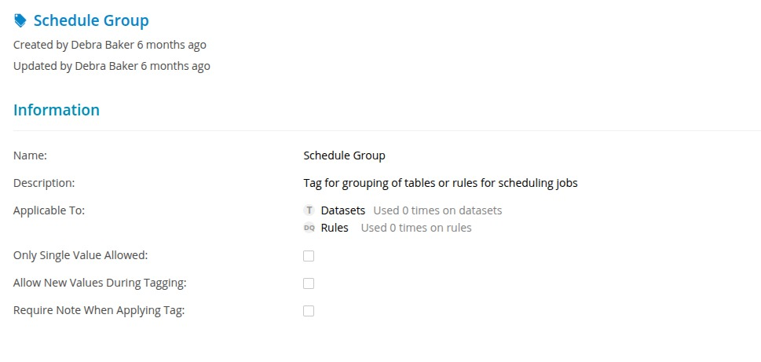

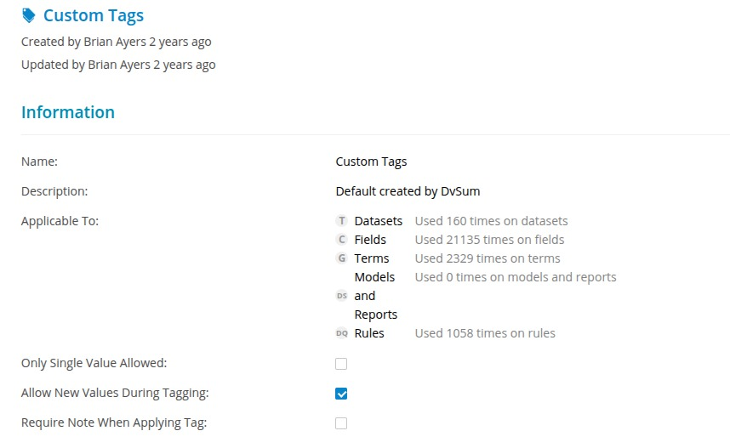

2. Logged an FR to ensure deleted rules do not remain in the Description field.

3. Confirm that all rules are visible in the Rules section and Attributes in the job details.

**169. Incident #27786**

**Sub: DVSUM VM in LLA not responding**

**Question:** This is to let you know that the DVSUM GW 172.28.2.209 un Curacao is not reachable, reported 10 minutes ago, I requested my team to investigate.

If any information on your side, please let me know,

**Solution:** This ticket has been merged with the Ticket#27788 and closed.

**170. Incident #27788 (Open)**

**Sub: RE: [EXT] Re: CADDI LC GW VM stopped responding**

**Qustion:** This is to let you know that the DVSUM GW 172.28.2.209 un Curacao is not reachable, reported 10 minutes ago, I requested my team to investigate.

If any information on your side, please let me know,

This is a follow-up to your previous request #27766 "CADDI LC GW VM stopped resp..."

Thanks Taimoor, GW is responding normally , it went back to normal automatically around the time I escalated the ticket.

So no immediate urgency as it is working, but we need to figure out why this is happening because it will happen again.

**172. Incident #27789**

**Sub:** Sub:Add to U.S. Venture procedure CC'ing 3 people.

**Question:**

Based on last conversation on U.S. Venture Thursday call, a small addition to any U.S. Venture

ticket. Please immediately add to CC's the missing two of the following three:

1. Brian Ayers

2.Deb Baker.

3.Lauren Sauter.

To close this ticket, please confirm:

1.This procedure added to Standard Operating Procedure for U.S. Venture.

2.This procedure viewed and SIGNED OFF by all Support Agents. (email is fine).

NOTE: Getting a digital sign off, for new competencies learned/procedures put in place, is

becoming a more frequent requirement, based on Aashish input. So I am adopting this more

formally now.

**173. Incident #27790**

**Sub:Setup of U.S. Venture portal**

**Question:**

Sometime next week, please pick a time where we setup with Deb and Lauren, to enable them to see their own tickets. Please see attached.

NOTE; If there are concerns on this, please let me know, we can discuss, if I'm missing something.

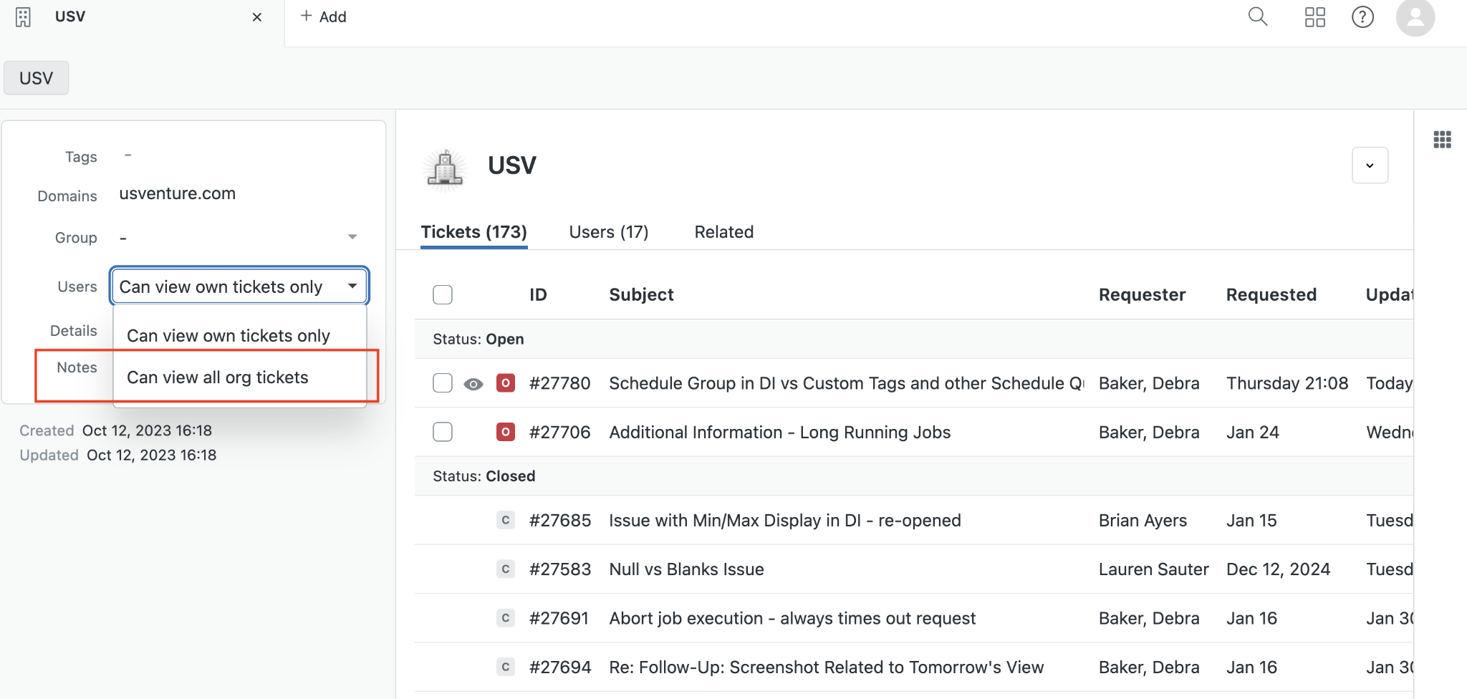

**Solution:**

An email was sent to the USV team to schedule the meeting this week. Since the scheduling request has been initiated, the ticket has been closed.

**172. Incident #27791**

**Sub: One last request from US Venture**

**Question:**

This is from the Thursday call. I was taking notes, but I was typing quickly. I got: "Field called ‘schedule group’. All the rules that are in a job, when we schedule them, using custom tags. Optimize the worklow. ".

**Solution:**

The issue in this ticket was already addressed under ticket #27780. It stemmed from a query Debra raised during the meeting, and no further action was needed.

**173. Incident #27799**

**Sub: SSO configured but not able to login using corporate email**

**Question:** We setup SSO for a customer "IAT Insurance" and they are using Azure AD as their SSO Provider.

Everything is setup and we are even seeing the SSO Login logs in Azure.

However, when the user tries to login using Corporate email the application tries to login and but the screen stays on the same login page and is a little greyed out.

**Solution:** A fresh SSO setup was performed, ensuring all configurations were correctly applied. After reconfiguring and testing, the authentication process worked successfully, resolving the issue.

**174. Incident #27806**

**Sub: Re: DVSum Login Issues**

**Question:** User requested to update their email address from “LokeshKishor.Shah@regalrexnord.com” to “LokeshShah@regalrexnord.com”.

**Solution:** The email address was updated as requested, and the user is able to log in successfully with an updated email.

**175. Incident #27810**

**Sub: Re: DVSum Login Issues**

**Question:** The same user was experiencing a login issue.

**Solution:** Upon acknowledging the ticket, we requested a call to assist in resolving the issue. However, since there was no response from the client, the ticket was closed.

**176. Incident #27813**

**Sub:** **For FDA Field Dictionary, column descriptions are blank. Can these be auto-populated?**

**Question:** How does DvSum Auto-populate and suggest column descriptions for Field Dictionary? We understand there is Inline editing, and also mass update, but that is not auto-populated.

Solution: We informed the client that, as of now, descriptions are auto-populated in two scenarios:

1. If business terms are associated with the columns in the Field Dictionary, the descriptions are auto-filled.
2. If column descriptions exist at the database level, DVSum automatically captures them during the catalog scan.

Additionally, we mentioned that if descriptions are updated at the database level, running a catalog scan afterward will update descriptions in DVSum.

**177. Incident #27814**

**Sub: Can a Data Quality rule be added at the Database level, not just the table level?**

**Question:** The client inquired about applying a data quality rule across the entire database, rather than at the individual table level.

**Solution:** We informed the client that, currently, there is no feature available to apply a rule across the entire database. However, we have logged a Feature Request (FR) to support this functionality in the future.

**178. Incident #27819**

**Sub: DQ Tab - Something went wrong. Please contact DvSum support.**

**Question:** The user encountered an error message when attempting to access the Data Quality section on the Table Detail page.

**Solution:** The issue occurred because the rule applied to the table did not return any records, which caused the error. A fix has been implemented, and the user can now access the Data Quality section even when the rule has no records.

**180. Incident #27828**

**Sub: Shutting down Mazda**

**Question:** A ticket was raised to track the shutdown process for Mazda, as they are exiting DVSum.

**Resolution:** The shutdown process is completed and the Mazda account was deleted permanently.

**182. Incident #27841**

**Sub:Unable to login**

**Question:** The user was unable to log in using their corporate email ID.

**Solution:** We first verified the user's status, which was showing as *Active*. We then attempted to log in using their email ID from our end and were able to do so successfully. To further troubleshoot, we requested a call with the user. Later, we received a similar ticket from another user within the same organization, so this ticket was merged into ticket #27858.

**183. Incident # 27846**

**Sub:Can not access business glossary**

**Question:** The client reported an issue where the Business Glossary page initially worked as expected. However, after switching the view to "0 Core Foundation Glossary", they encountered a problem where they were unable to switch back to the previous view. As a result, they requested the deletion of the problematic view and also suggested that the view dropdown should remain accessible even in the event of an error.

**Solution:** To address this, we first acknowledged the issue and recommended logging out and back in, which did not resolve the problem. After engaging with the PD team, the view was successfully reset, and we communicated this resolution to the client. Upon further request, we permanently deleted the problematic view. Additionally, we submitted a feature request on their behalf to ensure the view dropdown remains functional even when an error occurs within Governance views.

**184. Incident # 27851**

**Sub:Testing ticket and response**

**Question:** The client submitted the ticket as a test to verify if they would receive a response and to measure the response time.  
  
**Solution:** We acknowledged the ticket as requested by the client.  
  
**185.** **Incident # 27852**

**Sub: Testing submittal of ticket and email response to BAH when submitted by JC**

**Question:** John submitted a ticket on Lakshmi's behalf to test if she would receive the response.

**Solution:** The ticket was acknowledged as requested.

186. Incident #27853

Sub: Review of Linked Column Issue with new questions related to change

Question:

**1.Incident #28666**

**Sub:** DvSum Notification: Database Columns Import Successful

**Question:** It worked for me. Strange that we got different results.

**Solution:** To address this, we first acknowledged the issue and tested both scenarios by importing the file with the “Ignore Case when matching” option enabled and disabled, and the import completed successfully in both cases. Additionally, we submitted a feature request on their behalf to ensure that data imports proceed normally when “Ignore Case when matching” is enabled while matching by ID.

**2.Incident #28664**

**Sub:** Import rejects "Published" status

**Question:** imported the attached file as Database Columns. All records failed with the remark "Status has Invalid data.

**Solution:**  We acknowledged the issue and logged the FR to address the issue and recommended a work around by unmapping the ‘Status fields’ while importing the file to achieve the expected results.

**3. Incident #28663.**

**Sub:** CADDI PR ESB agent queries not finishing  
**Questions:** Requests sent to the Telco HFC Agent – ESB are not completing. The issue reappeared on Dec 29, The failure point and ESB response are unclear, and details are urgently needed from DVSUM to enable troubleshooting with the ESB ops team.

**Solution:** After acknowledging the reported issue, we logged the FR-1637. From the investigation - The issue was caused by a problem in the DvSum backend API related to the webhook flow. Product Engineering has fixed the issue, and queries are now completing successfully. Validation was completed by testing on the same bot with Vishal, and the behavior is working as expected.

**4. Incident #28662**

**Sub:** Testing out the expanded User Permissions functionality  
**Questions:Video was shared**

**Solution:** We acknowledged the ticket and reviewed the shared video, after which FR-1635 was logged to address the issue of disabling permission editing for default system roles.

**5. Incident #28659**

**Sub: Previous ticket on adding Heat Map chart**

**Questions:** Requesting guidance and feasibility confirmation to build a Heat Map–based widget (using API chat history for LLA) that includes a numbered/shaded heat map and separate daily volume charts segmented by Unknown, Jamaica, and remaining markets to account for scale differences.

**Solution:** Following up on the Heat Map enhancement. We requested JC,in addition to the details already shared, please feel free to add any further ideas or inputs as comments in the existing FR-1626, as this will help the Product Development team during their review and evaluation of the enhancement.

**6. Incident # 28658**

**Sub:** Proposed Article: Tips for Effective CADDI Prompting

**Questions:** Proposing the creation of a DvSum knowledge article on effective CADDI prompting, starting from an attached draft and enhanced with procedural steps and real-world implementation insights.

**Solution:** We reviewed the draft and coordinated with Hajra for further discussion. As this is not a support-related request, the ticket has been closed.

**7. Incident #28654**

**Sub:**Display Time Zone Information and Improve Timestamp Clarity Across DvSum UI

**Questions:**Requesting an enhancement to clearly indicate or manage time zones for all timestamps in the DvSum UI—either by standardizing on UTC, adding a local-time toggle, or displaying explicit time zone labels to avoid user confusion**.**

**Solution:** The request has been logged as FR-1633 for engineering review, and the ticket will be closed for now since this is an enhancement rather than a defect, with updates to follow as available.

**8. Incident #28649**

**Sub:** Quick Technical Review Requested – Derivative Asset Generator (10 min)

**Question:** Requesting a brief technical review of an AI tool that generates customer success and documentation derivative assets from Help Desk articles to identify any obvious issues.

**Solution:** The documentation aligns factually with the Help Centre article, but several elements (personas, use cases, capability level, and success metrics) are inferred for positioning and would require validation before external use.

**9. Incident #28647**

**Sub:** Dvsum application is loading for a while

**Question** Session was forcibly logged out, and I’m currently unable to log back in—the application remains stuck on the loading screen.

**Solution:** The login issue was due to expired LLA access, which has now been reset and extended until December 17, 2026, and access has been confirmed as working.

**10. Incident # 28646**

**Sub:**Ujjwals Data

**Question:** Matt reported multiple issues during data import in the Ameritas account: Some glossary references appeared to be imported, but the changes were not actually applied. He asked for confirmation about an existing feature request, as there was no clear message when a reference update failed. One XLSX file of about 9 MB failed to upload due to a timeout error. Additionally, Nicole reported that after a successful upload, some entities were not reflecting correctly in the Enterprise Search results.

**Solution:** Ramana connected directly with Matt to review the glossary reference issue. We confirmed that an existing feature request (FR-1484) will improve the import summary to clearly show failed reference updates. The XLSX upload issue was caused by heavy file formatting, not file size. Internal settings were updated to better support formatted XLSX files. The entity visibility issue reported by Nicole has been logged as a feature request and will be addressed in a future release.

**11.Incident #28647**

**Sub:** Dvsum application is loading for a while

**Question:** Dhilip reported that he was logged out of the application and could not log back in, as the page kept loading.

**Solution:**The issue was due to his user access being expired. The expiry date was updated, and he is now able to log in successfully.

12.Incident #28649

**Sub:** Quick Technical Review Requested – Derivative Asset Generator (10 min)

**Question:** John requested a quick technical review of an AI tool that generates derivative assets from Help Desk article, to validate accuracy and identify any obvious issues.

**Solution:** The team reviewed the AI-generated content against the Help Center article and found no issues. Some items were identified as assumptions needing validation if used externally. From the Support perspective, no further action is required, and the ticket is closed.

13..Incident #28654

**Sub:** Display Time Zone Information and Improve Timestamp Clarity Across DvSum UI

**Question:** Users reported confusion because the UI shows timestamps without the time zone, making it hard to understand timings across different regions.

**Solution:** A feature request (FR-1633) has been logged to improve time zone display in the UI. The ticket is closed, and the update will be tracked through the feature request.

14.Incident #28658

**Sub:** Proposed Article: Tips for Effective CADDI Prompting

**Question:** JC shared a draft document and asked for a review to explore creating a Help Center article on effective CADDI prompting tips.

**Solution:** We reviewed the document shared by JC and informed JC to coordinate with Hajra for further discussion. As this is not a support-related request, the ticket has been closed.

**15.**Incident #**28659  
Sub:** Previous ticket on adding Heat Map chart

**Question:** JC followed up on the Heat Map enhancement and shared ideas for additional dashboard charts, asking whether they could be supported with the current dashboard configuration.

**Solution:** Followed up with JC, and he asked whether charts other than the heat map shared in the document can be created using the existing dashboard configuration. We confirmed that separate dashboards for individual markets are not currently supported and requested him to add these as examples in the FR and asked JC to add the detailed requirements to the existing FR-1626. Since the next steps are tracked through the FR, the ticket is being closed.

**16.** Incident #28662

**Sub:** Testing out the expanded User Permissions functionality

**Question:** JC shared the video link which questioned Why do default system roles (Administrator, Editor, User) appear editable in the User Management UI when their permissions cannot actually be modified and revert to defaults after saving?

**Solution:** After reviewing the details, we logged FR-1635 to address the need to disable (gray out) all permission controls for default system roles in the User Management UI, ensuring users cannot edit or save permission changes and clearly indicating that these roles are fixed and not customizable.

**17.** Incident: #28663

**Sub:** CADDI PR ESB agent queries not finishing

**Question:** Why are requests sent to the “Telco HFC Agent – ESB” not completing, and what failure or response is being returned by ESB since traffic stopped after Dec 19th?

**Solution:** Identified and fixed a DvSum backend API issue affecting the webhook flow. After the fix, queries now complete successfully with correct analysis. Verified internally with the same bot; functionality is working as expected.

**18.** Incident # 28664

**SUB:** Import rejects "Published" status

**QUESTION:** Database Columns import failed with “Status has Invalid data” even though all records use the supported status “Published,” indicating a potential product bug.

**SOLUTION:** The issue has been identified as a product limitation and has been logged as a Feature Request. As a temporary workaround, removing or unmapping the Status field during import allows the process to complete successfully.

**19.** Incident: #28666

**SUB:** DvSum Notification: Database Columns Import Successful

**QUESTION:** The import worked successfully for me, but earlier we saw failures. Could there have been any differences in the file or import setup that explain the discrepancy?

**SOLUTION:** We reviewed the behavior with Matt and explained during the call that this occurs when importing by ID with this option enabled. This is the current system behavior. A feature request (FR-1639) has been logged to address and improve ID-based imports when “Ignore Case when matching” is enabled.

2026

**1. Ticket #28669 this is a follow up ticket for #28669** **Sub:** CADDI PR PROD queries not finishing

**Question:** Hello Taimoor

Thanks. However, today i saw the issue again (process never finishing) now on the prod agent, that is a real concern @John Cowan. Please note this happened for a specific question. I afterward run the same account and It came through correctly. But we shouldn’t have never-ending queries at all.

Chat name jan2-telco

Account number 8211080670148592

Exec id: 50513533_260102120101_444ab518-d74d-4538-aa01-46a5aa98405e

**Solution:** We acknowledged the issue and escalated it to the PD team to investigate the specific scenario highlighted by Marcelo. The PD team completed their investigation and confirmed that the issue was observed only once at the time it was reported by the customer, and no issues were identified from our side. As the issue did not recur for over a week, the ticket was closed.

**2. Ticket #28671**

**Sub:** Regression: expand all downstream nodes

**Question:** Hi team,

I was reviewing FR-1364, which was recently set to "Review".

While doing this, I noticed that "Expand all downstream nodes" is not working correctly.

Here's an example in ACME.

1.Browse to the Person table. https://www.app.dvsum.ai/tables/44580048/overview

2.Open Lineage.The initial view shows 4 nodes: Person has 2 downstream views and 2 downstream table.

3.In the Person node click "Expand all downstream nodes".

Expected: It expands all downstream nodes.

Actual: It expands some downstream nodes. Specifically, we see PERSON_S get displayed, but we do not see PERSON, which is downstream from PERSON_S, get displayed.

Workaround: you can still manually display nodes downstream from PERSON_S. But the whole point of "Expand all downstream nodes" is to get ALL downstream nodes. So this is a significant problem.

**Solution:** We first acknowledged the ticket and logged a new FR based on Matt’s suggestion. The PD team later confirmed that this behavior is a known limitation. Currently, the “Expand all downstream nodes” option expands only up to three levels in a single action due to a technical constraint. As a result, the PERSON_S node is displayed, but its downstream PERSON node is not expanded automatically.

To avoid confusion, the team plans to update the tooltip/label so it no longer refers to “All downstream” or “All upstream,” as this does not accurately reflect the current behavior. We closed the ticket after confirming the same with Matt.

**3. Ticket #28672**

**Sub: Claro - Project Extension**

**Question:** Hi Team,

As we are working with Claro with commscope request to extend the end date by 3 months

**Solution:** By checking with Raman from the PD team we extended the Claro commscope account by 3 months and informed Pavan.

**4. Ticket #28673**

**Sub:** Downloaded API from LLA - user group

**Question**: Quick quesiton. Take a look at the screenshot. This LOOKS like User Group is included in the file. (Did this through Postman). Am I missing something? Note: Setting to Pending, since no rush on answering.

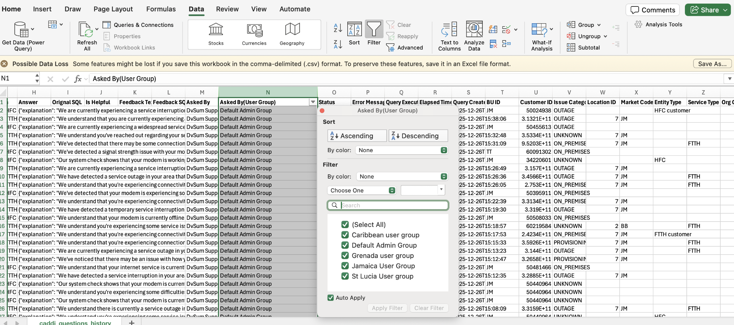

**Solution:** We informed him that this request has been logged under FR-1623, which is currently in the Review state. He then confirmed that he had discussed this with Adnan and asked us to test the functionality on both the LLA and LCPR sites.

We tested the functionality on both sites and confirmed that it is working as expected. Subsequently, he raised additional questions that were not related to his original concern. We informed him that any internal discussions regarding the application would be handled via Teams chat, and the ticket was then closed.

**5. Ticket #28682**

**Sub: CADDI**

**Question:** Buenas tardes

reporto que ya llevo algun tiempo que notifico que no tengo accseso a caddi, yalo habia reportado en el chat de teams y con supervisora leiddy farfan, me enviarion enalce pero como tal no e deja ingresar .

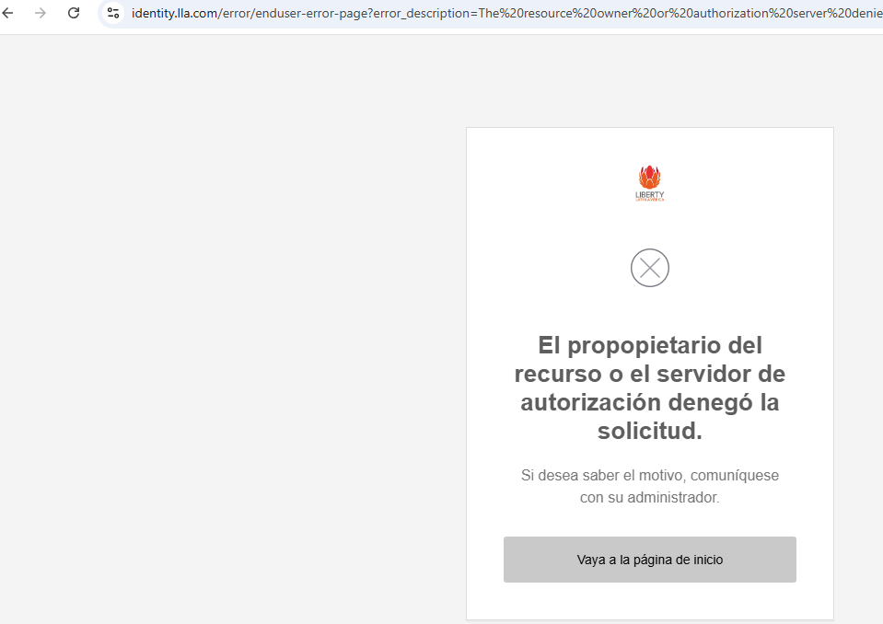

Note: This request was received in spanish so we should acknowledge or respond in spanish only

Solution: For this ticket, after checking the customer account, we observed that SSO was still in test mode. Since the requester was neither an owner nor an admin, they were unable to log in using Okta SSO.

We informed the customer of this and requested that they log in using their regular username and password. We also asked Marcelo to inform his team internally not to use SSO for login unless they are an owner or an admin, or until SSO is moved to Live mode.

**6. Ticket #28683**

**Sub:**[EXT] Question about blanks for Market Code

**Question:** Thanks, before getting JoseRaul, can we get an input example that’s coming to us without market code? With date/time and any other ID that can help us track it. As recent as possible.

This was a follow up question from Marcelo to JC for the information we provided to JC regarding the missing Market code.

**Solution:** We checked with Faiz and shared the payload for their reference where the market code and BU id was present.  
This was the shared payload for their reference:  
{

"analysis_id": 45412610,

"connection_id": "QyMrlc3lPHcCHnA=",

"audience_type": "CUSTOMER_FACING",

"response_type": "JSON",

"messages": [

{

"human_message": "analyze HFC customer 50471867"

}

],

"properties": {

"crm_data": {

"Sigma DPM": {

"service_details": {

"0": {

"package": "JM_TK_STRTR_LG_SIP ThreeInOne",

"mac_address": "e457406b3840",

"device_event_view": {

"0": {

"ip_address": "10.159.10.140",

"role": "dhcp",

"device_name": "JamaicaDHCP",

"mac_address": "-"

},

"1": {

"ip_address": "65.183.0.244",

"role": "DocsisCMTS",

"device_name": "H1-NMG2-CM1",

"mac_address": "-"

},

"2": {

"ip_address": "10.133.21.136",

"role": "CM",

"device_name": "-",

"mac_address": "e457406b3840"

},

"3": {

"ip_address": "72.252.183.235",

"role": "CPE",

"device_name": "-",

"mac_address": "e457406b3842"

}

}

}

},

"bu_id": "JM",

"timestamp": 1757643266.7420337,

"customer_id": "50471867",

"error": "",

"status": "Success"

},

"Cerillion": {

"due_amount": "0",

"sales_bar_note_uid": "0",

"fault_alarm": "None",

"mac_address": {

"0": "E457406B3840"

},

"tos_yn": "N",

"account_status": "Upgrade Hold",

"customer_id": "50471867",

"bu_id": "JM",

"error": "NA",

"account_alarm": "None",

"status": "success",

"timestamp": "20250912021428"

},

"customer_id": "50471867",

"bu_id": "JM"

}

}

}

**7. Ticket #28685**

**Sub:** Re: CADI billing cases

**Question**:Hello dvsum team, Happy holidays! Hey, I need your help. Could you please confirm with us the rules to consider a case as billing in CADDI? We have this conversationID as reference (Jamaica), but we are not completely sure why it was considered as billing: 3279aa68-4c8c-49a5-ae91-7df89a14fb26. Thank you!

**Solution:** For this ticket we checked with Vishal and provided the logic to consider a case as billing in CADDI for both FTTH and HFC separately and regarding conversationID they had shared was not found in the CADDI.  
**HFC Connection:**

An account is considered to have a billing issue if the value of Cerillion.account_status is any one of the following (account considered suspended):

"Suspend (Soft Disconnect)",

"Suspend",

"Suspended",

"Soft Disconnect",

"Comm - Suspend Service(Soft)",

"Suspend Service(Soft Disc)",

"Residential Soft Disconnect",

"COM - Suspend (Soft Disc.)",

"T-No service at all",

"B-Call Barred",

"Write Off",

"Inhouse Collections Agent",

"Field Collections",

"Comm - Write Off",

"Dummy action for MGWO",

"External Collections Agency",

"Disconnect Service",

"Retention Commence",

"Comm - Disconnect Service",

"Residential Disconnect Service",

"Residential Disc.",

"COM - Disconnect Service",

"S-No service at all",

"C-No service at all"

OR

If the Cerillion.TOS_YN flag is set to “Y” (Termination of Service), the account is also treated as a billing issue,

**FTTH Connection:**

For the account_status in Liberate. If the account status matches any of the following values, the customer is considered to have a billing issue:

"Suspend (Soft Disconnect)",

"Suspend",

"Suspended",

"Soft Disconnect",

"Comm - Suspend Service(Soft)",

"Suspend Service(Soft Disc)",

"Residential Soft Disconnect",

"COM - Suspend (Soft Disc.)",

"T-No service at all",

"B-Call Barred",

"Write Off",

"Inhouse Collections Agent",

"Field Collections",

"Comm - Write Off",

"Dummy action for MGWO",

"External Collections Agency",

"Disconnect Service",

"Retention Commence",

"Comm - Disconnect Service",

"Residential Disconnect Service",

"Residential Disc.",

"COM - Disconnect Service",

"S-No service at all",

"C-No service at all"

**8. Ticket #28687**

**Sub:** FDA unable to scan data sources without hanging

**Question:** Hey team,

FDA is unable to connect to a lot of sources, hangs for up to 24 hours. The September release was supposed to fix this, but Charlie reported it again. I need to troubleshoot this - and I want someone who will be on an audio call with me, to go through the steps, as I am on the FDA computer. I am scheduling this for 10:30 PKT/11 PM IST time. Please let me know who will join the call.

The Use Case:

You guys cannot access the FDA environment, so I need access to the procedural troubleshooting steps that you would go through, in order to successfully troubleshoot. Please send those to me, including any tracing of log files that I may need to ask Booz Allen for. This IS a high severity, as work can't be done, if data sources cannot be scanned.

**Solution:** For this ticket since we don’t have access to the FDA account we connected with JC and did some troubleshooting by running the couple of scans in the FDA account in which one scan was completed successfully. Sinc no further action was pending from support, this ticket was closed.

9. Ticket #28688

Sub: DATA Intelligence CADDI is down

Question: Customer was not able to login to DI.

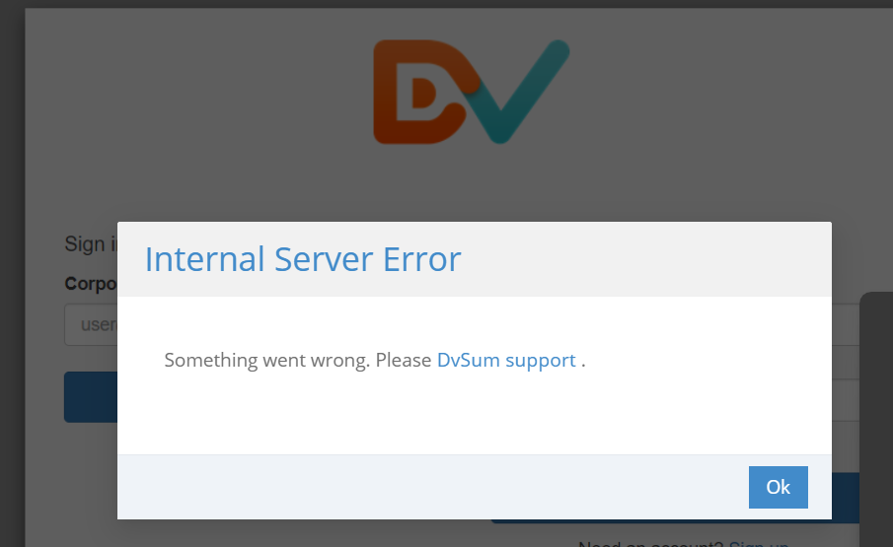

Solution: We investigated the issue and the application was confirmed to be up and running. The customer was advised to refresh the page and clear browser cache/cookies to restore access.

10. Ticket #28689

Sub: Cant create API credentials for Caribbean (LC) CADDI

Question: Team

I’m not able to create API keys for CADDi Caribbean, i tried m2m credentials and also role based with no success.

I tried yesterday using firefox, and today with chrome (i logged in to chrome today to do this)

When trying M2m, credentials are empty as seen below, and the entry gets rejected. If I download credentials, only column titles are present.

When enabling API access for the Admin user group, and trying to generate credentials, i click generate, button shows some progress icon, then stops, and nothing happens

Solution: We investigated the issue and found that it was failing when creating the API credentials the Enterprise search was included in, we informed this to the PD team and requested for the fix. The PD team fixed the issue and a confirmation response was sent to Marcelo after the fix.

**11. Ticket #28690**

**Sub:** CADDI caribbean prod bot not working

**Question:**Team

We just noticed we are getting timeout errores when queryis HFC accounts to the Tier-2 JAM agent.

We need evidence if this is an RPA issue, please review and revert back.

FTTH account are working normally on this bot. Issue seems to be limited top HFC.

**Solution:** This was an RPA issue which belongs to the customer not on our end.

**12. Ticket #28691**

**Sub:** RE: [DvSum] Re: [EXT] Question about blanks for Market Code

**Question:** Confirmed.

FTTH uses market_code

HFC uses BU_ID

Analysis done

After Dec17th, all questions using the “FTTH - Cognigy Integration – Tool” have a valid Market_code.

Also, all questions using the “HFC - Cognigy Integration - Tool” have a BLANK Market_code.

Except for this one, can we investigate? Maybe look at the input data from cognigy? By length seems to be HFC; however, its linked to BB, if this is Barbados, that’s an FTTH only market.

| **Question ID** | **Bot Name** | **Chat Name** | **Bot/Chat ID** | **Tool ID** | **Tool Name** | **Question** | **Answer** | **Orignal SQL** | **Is Helpful** | **Feedback Text** | **Feedback SQL** | **Asked By** | **Asked By(User Group)** | **Status** | **Error Message** | **Query Executed On** | **Elapsed Time** | **Query Created On** | **BU ID** | **Customer ID** | **Issue Category** | **Location ID** | **Market Code** | **Entity Type** | **Service Type** | **Org Cntry** | **Invoice ID** | **Customer Type** | **Port ID** | **Analysis Type** | **Entity ID** | **daymonth** | **Company Name** |
| --- | --- | --- | --- | --- | --- | --- | --- | --- | --- | --- | --- | --- | --- | --- | --- | --- | --- | --- | --- | --- | --- | --- | --- | --- | --- | --- | --- | --- | --- | --- | --- | --- | --- |
| 356557 | Unified - Cognigy Integration - Agent |  | 45412610 | 45412608 | HFC - Cognigy Integration - Tool | analyze FTTH customer 60618264 | {"explanation": "We've detected that your modem is experiencing some signal quality issues that may be affecting your service. While your modem is currently working, we've noticed some signal readings that could be improved to give you the best possible internet experience. This appears to be something we can help resolve at your location.", "recommended_actions": {"1": "Create a Ticket", "2": "Talk to a representative", "3": "Schedule a Technician", "4": "Reset the modem"}} |  |  |  |  | DvSum Support | Default Admin Group | PS |  | 23-12-2025 17:55 | 34 seconds | 23-12-2025 17:55 |  | 60618264 | ON_PREMISES | 2 | BB |  | FTTH |  |  |  |  |  |  | 23-12-2025 |  |

Likewise

all questions using the “FTTH - Cognigy Integration - Tool” have a BLANK BU_ID, and

After Dec17th, all questions using the “HFC - Cognigy Integration - Tool” have a valid BU_ID.

**Solution:** We reviewed the exception and confirmed it was due to mismatched data received from Cognigy. The findings were shared with the customer, and they were advised to standardize the data during analysis and review the Cognigy configuration to ensure the correct tool sends the appropriate identifier.

**13. Ticket #28693**

**Sub:** Import new glossary terms not working

**Question:** Hi team,

I'm trying to test a specific feature when importing glossary terms. But...

I'm not able to import a new glossary term in any account no matter what I try.

Can you please test this? Are you able to add new glossary terms via import?

Thanks,

Matt

P.S. In most cases I get an email indicating success. But the term is not in the glossary.

Depending on the columns I mapped, I sometimes get "Short Name has Invalid data." This makes no sense to me. But in all cases, I cannot import a new term.

**Solution:** We reviewed the import flow together with Matt and found that the file was missing the required Term-Id column. After adding this column and re-importing the file, the glossary terms were added successfully and the issue was resolved.

**14. Ticket #28694**

**Sub:** CADDI caribbean prod bot not working

**Question:**Hello DVSUM Support

Please help me collect the logs with the response from RPA in the Jamaica CADDI after showing a time out error:

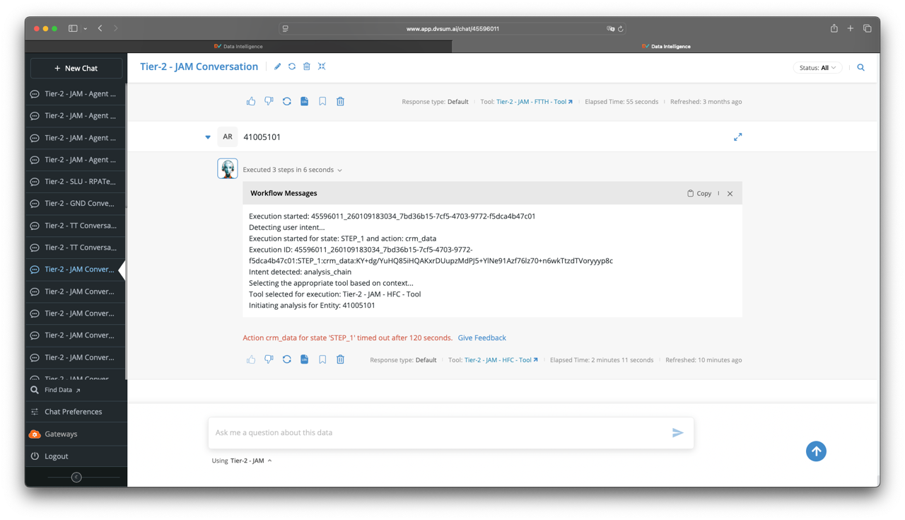

**Solution:** We reviewed this with our Engineering and found no errors on our side. The gateway timed out after 2 minutes with no RPA response, so no response details are available. The RPA issue is resolved, and executions should now work as expected.

**15. Ticket #28697, this is follow up ticket to #28669**

**Sub:** RE: CADDI PR PROD queries not finishing

**Question:** FYA, also happening on Liberty Caribbean instance, after the RPA fix. I run the same account again and it finished normally.

**Solution:** This was not reproduced in our side, so we checked with Faiz and Subhrajyothi das and they investigated the issue and confirmed like below:  
We use the boto3 client to stream LLM responses. In this case, the response was generated successfully, but the connection closed unexpectedly before the internal cleanup process in the boto3 service completed (due to their internal issue in boto3 and urlib3) which resulted in this error.

To address this, as suggested by Faiz, we have to add the following safeguards:

1. Pinned stable dependency versions:  
    boto3==1.36.14  
    urllib3>=1.26.18,<2.0.0
2. Also, a retry mechanism
3. A fallback that re-runs the request without streaming if an exception occurs

Since this is not fixed yet, this ticket is in pending state.

16. Ticket #28700

Sub: Profiling data source scans in FDA failing

Question: Profiling data sources in FDA is failing. Not all tables are getting scans, as the scans simply stop, partway through the process. Attached are examples. There are 10 Data Sources, that are not finishing scans. here are some of the errors. Please troubleshoot and provide next steps, as soon as possible.

Solution: to directly provide the troubleshooting steps to be performed on the FDA account. Muneeb shared the required steps, after which JC confirmed that the Booz Allen DSO team, who manage the logs, have reached out to Charlie to schedule a troubleshooting session.

We closed the ticket, and a new ticket will be opened if required based on the outcome of that session.

17. Ticket #28708

Sub: Share Flow agent with users

Question: Hello team,

I need help sharing the flow agent (“DEV: HFC Agent – FLOW”) with the following users

Michael Ramos Rivera michael.ramos@libertypr.com;

Jaime Garcia jaime.garcia@libertypr.com

Also if you can make sure that Amilcar and I are always able to shared them when needed, would be appreciated.

Solution: After reviewing, the agent was shared with the users, and the steps to manage access for other users were explained to Marcelo and Amilcar.

18. Ticket #28709

Sub: JIRA Ticket IDs not displaying on DQ Rules Dictionary

Question: Good morning team –

We seem to be experiencing an issue around DvSum’s JIRA integration and are hoping you can assist.

Issue:

We created a customized DQ view called “Active Data Quality Alerts” to help streamline operations. A column containing the Ticket ID was added to show whether a JIRA ticket for the alert was submitted. We were expecting Jira ticket IDs originally submitted via DvSum to be visible (open tickets with status <> Done) however the column seems to be showing blank, leading us to believe no tickets are associated with the alert. This prompts our developers to submit tickets again, when an already open ticket exists resulting in duplicate tickets.

Expected Behavior

Display last open Jira ticket Ids associated with the alert.

Artifacts

Customized DQ View with Ticket Id showing Blank

DQ Rule Activity showing ticket creation via DvSum

Jira ticket showing current status – “In Progress”

Solution: We reviewed the behavior and confirmed this happens when Manual Ticket Creation is used. In this mode, ticket details are cleared after a rule re-run. We advised using Automatic Ticket Creation to retain ticket IDs across runs and we logged FR-1651 to retain the ticket if its status is not done.

19. Ticket #28710

Sub: CADDI PR intraway error in Flow, working fine in prod agent - 8211080890073299

Question: Team,

Account 8211080890073299 is giving INTRAWAY error every time in flow agent, but working fine through ESB and production agents. Can you please review why is that?

Exec id through “Telco HFC Agent - ESB Conversation”: 50622342_260115151950_c6bcb0f9-40d6-4dc4-9a56-58cc308969cb

Exec id through “DEV: HFC Agent – FLOW”: 50622331_260115151955_5557f1a1-a8f7-465c-b436-cbf819a3c698

Exec id through “Telco HFC Agent “ 50622373_260115155708_71cb66ae-d2df-4c09-ad36-790c49c082c2

Solution: We checked this with Vishal, and he reviewed the Exec id’s Marcelo has shared and shared his below findings:

Telco HFC Agent - ESB Conversation

The issue category provided by the agent is correct as per the data received.

DEV: HFC Agent – FLOW

The question was run four times and every time Intraway API threw the below error, and no data was returned hence the issue category provided by the agent is correct.

"errors": [

{

"code": 400,

"message": "Intraway: Error while fetching provisioned characteristics for a given Id.",

"description": "El dispositivo no fue encontrado."

}

]

}

Telco HFC Agent

In this case also Intraway threw an error, but the issue category provided by the agent was incorrect. This case happens to be an hallucination, the correct issue category should have been PROBLEMA_LEYENDO_LOS_DATOS_DE_INTRAWAY. For this Vishal has added some checks to help prevent this issue from recurring.

20. Ticket #28717

Sub: Looking for specific fields for exceptions

Question: JC has shared the video recording to review and address the question reported by Dhilip

Solution: We verified all execution paths (API, online, and offline) and confirmed that these metadata fields are present within DvSum. It was clarified that the S3 files are Athena-generated execution outputs and do not store DvSum application-level exception metadata. This behavior was explained to the customer

21. Ticket #28718

Sub: Re: [EXT] Re: CADI billing cases

Question: Hello Nischay,

I'm sorry I've missed your email, my bad! We might need to join in a meeting because I see some discrepancies in the list you have. In the meantime, here are the logs for the interactionId I shared (genesys conversationID). Please let me know if with this info you can locate the response in CADDI, thanks:

},

"lengthOfArray": 3,

"networkResponse": {

"length": 1,

"result": {

"ID": "352481750000",

"message_content": {

"answer": {

"explanation": "We noticed there is a billing-related matter that needs attention on your account. While your internet service is still working, there are some payment items we need to address to ensure you continue receiving uninterrupted service. This is a common situation that can be easily resolved.",

"recommended_actions": {

"1": "Create a Ticket",

"2": "Talk to a representative",

"3": "Schedule a Technician",

"4": "Reset the modem"

}

},

"detailed_answer": "### Recommendations:\n1. **Issue Category**: :red-background[BILLING]\n2. **Explanation**: Account has active billing restrictions that are affecting service delivery, though port is not suspended.\n3. Customer needs to resolve outstanding billing issues to restore full service functionality.\n\n### Key Facts:\n- **Account Name**: MITTY CLARKE\n- **Account ID**: 352481750000\n- **Service VLAN (SVLAN)**: 3847\n- **Customer VLAN (CVLAN)**: 104\n- **Account Status**: :red-background[B-Call Barred]\n- **Customer Type**: Residence\n- **Service Type**: BO+VO\n- **Broadband Speed**: 75/75\n- **Installation Date**: 15-10-2025\n- **BNG Online Status**: :green-background[true]\n- **Liberate Outage Flag**: N\n- **Total Lost-Carrier Disconnections (Last 2 Days)**: 1\n- **Hourly Peak Disconnections (Last 2 Days)**: 1\n- **Average Session Time (Last 2 Days)**: 2m 25s\n- **Intermittent Internet**: :green-background[false]\n- **Outage Analytics Total Ports**: 25\n- **Outage Analytics Offline Ports**: 0\n- **Outage Analytics Unknown Ports**: 25\n- **Outage Analytics Is Outage**: :red-background[true]\n\n### Observations:\n- Account has :red-background[billing restrictions] but port remains active\n- :blue-background[Billing issue] detected in account status details\n- Service remains technically operational despite billing restrictions",

"issue_category": "BILLING",

"timestamp": 1766363253716,

"token_usage": {

"completion_tokens": 629,

"prompt_tokens": 9393,

"total_tokens": 10022

}

},

"statusCode": "200"

},

"statusCode": 200

},

"networkScan": {

"length": 1,

"result": {

"ID": "352481750000",

"SESSIONID": "1db456c1-affd-4bb2-96bd-dae1e8f06c97",

"statusCode": 200

},

"statusCode": 200

},

Solution: For this ticket Vishal had connected with customer directly and addressed his concerns

22. Ticket #28719

Sub: What version of TLS 1.2 is used?

Question: Can you provide an official reply for the ESB team's question on the TLS protocol we use. They want to know if we use TLS 1.2 or better.

If we do not use TLS 1.2 or better, this could be a problem for our integration with the LLA ESB hub after an upcoming upgrade. Our intraway intergation will no longer work which will create a production issue for the LCPR Tier 1 agents.

The ESB support team is represented by Nagaraj Nangunoori <nagaraj.nangunoori@libertycaribbean.com>.

Please confirm receipt and action

Solution: We confirmed with the Product Development team that DvSum uses TLS 1.2. The confirmation was sent directly to the ESB representative.

23. Ticket #28720

Sub: CADDI PR markdown format in issue type field within API logs

Question: Team,

For logs exported via API, I’m seeing markdown coloring format within the issue category field, can please fix this.

:green-background[DESCONOCIDO]

:green-background[En Residencia]

:green-background[En Residencia]

:green-background[En Residencia]

:green-background[En Residencia]

:green-background[En Residencia]

:green-background[En Residencia]

:green-background[En Residencia]

:green-background[MAINTENANCE]

:green-background[MAINTENANCE]

:red-background[DESCONOCIDO]

:red-background[DESCONOCIDO]

:red-background[DESCONOCIDO]

:red-background[DESCONOCIDO]

:red-background[En Residencia]

:red-background[En Residencia]

:red-background[OUTAGE]

:red-background[PROBLEMA_LEYENDO_LOS_DATOS_DE_INTRAWAY]

:red-background[PROBLEMA_LEYENDO_LOS_DATOS_DE_INTRAWAY]

Solution: We’ve logged FR-1644 to address the reported issue and will notify customer once the fix is implemented.

24. Ticket #28740

Sub: internal server error

Question: Internal Server Error

Something went wrong. PleaseDvSum support<mailto:support@dvsum.com> .

Solution: After sending a couple of responses, there has been no update from the customer side. It seems like it was some glitch or one-time issue, so we'll mark this as closed for now until we receive it again.

25. Ticket #28741

Sub: Update suscription CommScope/VISTANSE 2026

Question: Hi, good afternoon.

Is possible update the subscription to CommScope now Vistance/AURORA please?

Solution: The ask is not clear in this request so it is still pending from customer side.

26. Ticket #28743

Sub: Low accuracy, fixes needed in CADDI LC (CWC)

Question: Hello DVSUM support, Aashish

We performed a small accuracy test for 10 cases in LC with Sibeko E., and the results show a 60% accuracy (6 over 10. But 2 cases marked as * are "half pass", see comments in each entry comments)

From the discussion with Sibeko, problems are affecting not specific cases, but logic to identify certain issue types, so improvement are needed specifically for HFC -BILLING and HFC-PROVISIONING cases and FTTH-ON PREM.

With these results, we need to quickly come up with a plan to improve.

@Aashish Singhvi<mailto:aashish@dvsum.com> can you please comment who can be assigned to execute any fixed needed, and let us know if we need sessions with the SME to fix.

Solution: This request was discussed with Aashish and has moved to an official project, Vivek & Vishal will be leading the implementation.

27. Ticket #28746

Sub: Enhance CADDI Webhook payload to Cognigy

Question: Just to formalize, as discussed on Jan 21st, we are requesting for CADDI webhook to respond with all available data.

Can you provide updates on this request?

Currently the response is very limited, we want to include all data available, meaning, all data collected from the source systems, which we see for the Copilot in the grids below the bot response.

Current response example (shared by Faiz on Aug 2025, may have changed)

{

"query_id": "39105371_241025165200_1656d151-0dab-4da5-a5e3-4fabe5ac2cgz",

"tool_id": "45722152",

"tool_name": "FTTH Tool - DvSum Test",

"message_content": {

"issue_category": "ON_PREMISES",

"answer": {

"explanation": "It seems that your ONT (Optical Network Terminal) is not working. This might be because it is either turned off or not properly connected.",

"recommended_actions": {

"1": "Please check if the ONT is powered on and all connections are secure. Also, verify the LED status on the device.",

"2": "If the issue persists after checking, we may need to send a technician to assist you."

}

},

"detailed_answer": "### Recommendations:\n1. **Issue Category**: :red-background[ON_PREMISES]\n2. **Explanation**: The ONT is not operational, indicating it may be powered off or disconnected.\n3. **Recommended next step**: Advise the customer to check ONT power, connections, and LED status. If these do not resolve the issue, dispatching a technician may be needed.\n\n### Key Facts:\n- **Account Name**: PHILMORE GIVANS\n- **Account ID**: 318915090000\n- **Port ID**: 1000201019\n- **Service VLAN (SVLAN)**: 1680\n- **Customer VLAN (CVLAN)**: 1365\n- **Card Info**: 999901098/shelf:0/slot:3/port:15\n- **Account/Service Status**: :green-background[W-Working]\n- **BBMS Port Status**: :green-background[In Service]\n- **Customer Type**: Residence\n- **Service Type**: BO+VO\n- **Broadband Speed**: 150/150\n- **Installation Date**: 30-12-2021\n- **SNMP Operational Status**: :red-background[Down]\n- **BNG Online Status**: :red-background[False]\n- **Liberate Outage Flag**: Y\n- **Total Lost-Carrier Disconnections (Last 2 Days)**: 0\n- **Hourly Peak Disconnections (Last 2 Days)**: 0\n- **Average Session Time (Last 2 Days)**: 0s\n- **Intermittent Internet**: False\n- **Outage Analytics Total Ports**: 15\n- **Outage Analytics Offline Ports**: 2\n- **Outage Analytics Unknown Ports**: 0\n- **Outage Analytics Is Outage**: False\n\n### Observations:\n- ONT is not operational (ONT powered off or disconnected).",

"token_usage": {

"prompt_tokens": 9722,

"completion_tokens": 1427,

"total_tokens": 11149

},

"timestamp": 1755265156529

},

"responses": {

},

"is_last_msg": true,

"qry_status": "PS"

}

We need to add all data available in the grids (below is just a sample as reference)

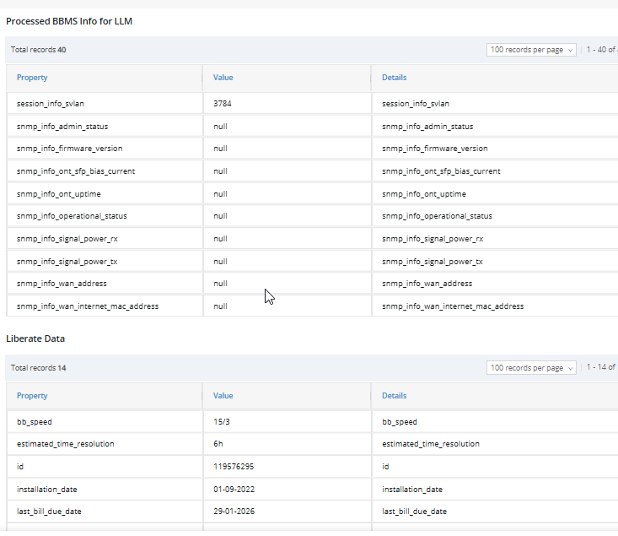

Solution: Feature Request FR-1662 has been logged with all details and marked as high priority. Marcelo will be notified once the enhancement is completed and deployed to production.

28. Ticket #28747

Sub: Issue?? Sample Data Restrictions where File Upload is Source Type

Question: Hi there -

I just wanted to bring up a potential issue with the way sample data restrictions work. When the Source Type is FILE UPLOAD, Sources do not show up in the sample data restrictions INLCUDES picker list. A wildcard will not always work for this so I need to be able to select specific folders even when the source type is a file upload. Please advise.

Solution: When using FILE UPLOAD as the source type, the source does not appear in the Sample Data Restrictions Include list until at least one file is uploaded, preventing users from applying restrictions before importing actual data.

The issue was reviewed with engineering and a feature request FR-1663 has been logged to address this behavior; in the meantime, uploading a dummy file first works as a temporary workaround.

29. Ticket #28748

Sub/Question: Please re-active aashish+lla@dvsum.com account on production /eom

Solution: The account has expired and has now been reactivated by extending its expiry date.

Dec-2025

1. **Ticket #28575**

**Sub:** Missing User Group in API Feed Export

**Question:** Add the corresponding User Group to both the API response and the Excel export in the API feed export functionality. This enhancement should ensure that, along with the existing fields, the exported data includes the User Group information, similar to how the “Asked By” column currently displays the username of the user who executed or created the query.

**Solution:**We have logged FR-1604 for this request. Since it is an enhancement we have closed the ticket and a mail will be sent to the customer once the enhancement is deployed to production.

2. **Ticket #28576**  
**Sub:** Exclude “About” Entries from Question History Logs and Exports

**Question:** Log entries labelled as “about questions” are not real interactions but still appear in the Question History API export without an Issue Type, requiring manual removal and resulting in misleading insights. These entries should be excluded or suppressed in the exported logs to maintain accuracy in Issue Type–based reporting.

**Solution**: The “About” questions appear in the chat logs because they are linked to the About section of each agent. On the agent’s detail page, the Agent Name and Description fields can be edited. This description is shown whenever a user selects an agent from the Talk to Agent – Data Screen, so users can quickly understand which agent they are interacting with and what the agent is intended to do. For this reason, the “About” information currently appears in the chat logs.

We understand that the concern is specifically about the “About” entries appearing in the exported Excel file. We have already logged a FR-1605 to remove these entries from the Question column in the export. Since it is an enhancement we have closed the ticket and a mail will be sent to the customer once the enhancement is deployed to production.

3. **Ticket #28577**

**Sub:** Add Numeric Elapsed Time to API Output and Excel Export

**Question:** The Elapsed Time field in both the API output and Excel export is currently provided only in a text format (e.g., “1 minute 30 seconds”), making it difficult to use for calculations. Requesting a numeric duration field (e.g., total seconds).

**Solution**: After acknowledging the ticket We’ve noted the request to update the Elapsed Time field format in both the API output and the Excel export and logged it as an enhancement request.

4. **Ticket #28578**

**Sub:** Enhance APIs to Include Additional User Management Module.

**Question:** Requesting User Management attributes such as Created Date, Modified Date, User Role, and User Group exposed through the DvSum API endpoints.

**Solution:** After acknowledging the ticket we have noted the requirement to expose additional User Management attributes such as Created Date, Modified Date, User Role, and User Group through the DvSum API endpoints. We have logged this as an enhancement request.

5. **Ticket #28580**

**Sub:**how to revoke api key - marcelo maruri

**Question:** Marcelo receives these alerts daily, he cannot find where he can revoke this key.

Since he is receiving this email directed to marcelo.maruri+lcprmain he logged into the PR instance.

There is a Demo user role, assigned to a demo user group api. But his user is not assigned to this group. He also cannot see this key at the account level. So he has requested us to understand where he can find and delete this key?

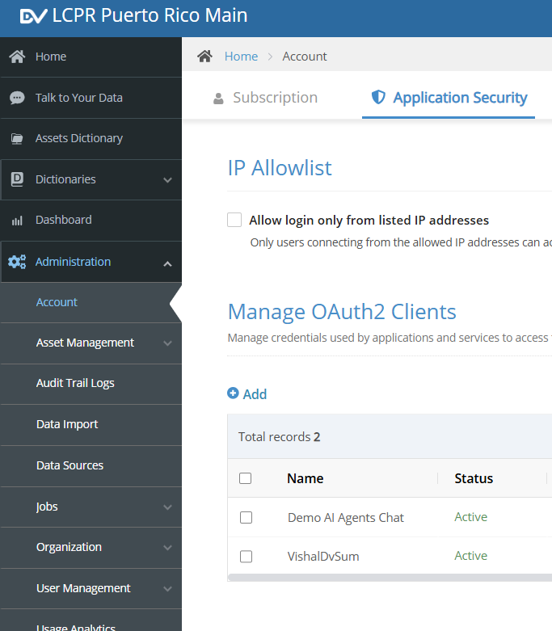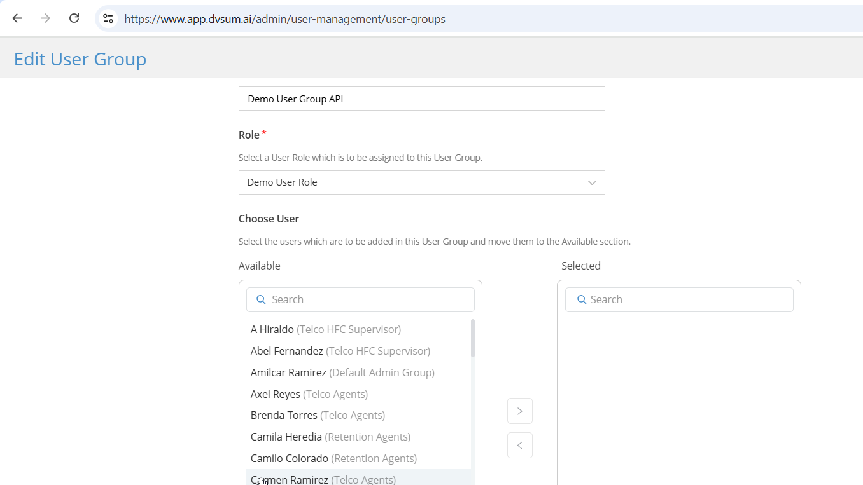

**Solution:** The alerts you are receiving are related to a demo session you had with Taimoor and the team on the 26th, where the new API capabilities in DvSum were showcased. For that session, your user was temporarily added to the Demo User Group API so that you could see the API Credentials tab in My Settings, since only that role had API access enabled. During this time you may have navigated to My Settings → API Credentials and generated credentials.

After the demo, your user was moved back to the Default Admin Group, which revoked those previous configurations. This is why you are unable to locate or manage the key with your current permissions.

Regarding the notifications, the Client ID was configured with a 7 days expiry. Since December 3rd is the expiration date, the system began sending reminders 3 days prior, as designed.

Please choose one of the following options:

Option 1:

Allow the key to expire naturally. Notifications will cease after the expiration date and no further action is required.

Option 2:

If you prefer the key removed immediately, we can temporarily move you back to the Demo User Group API so you can access My Settings → API Credentials and delete the key. Once you confirm the key has been removed, we will restore your user to the Default Admin Group.

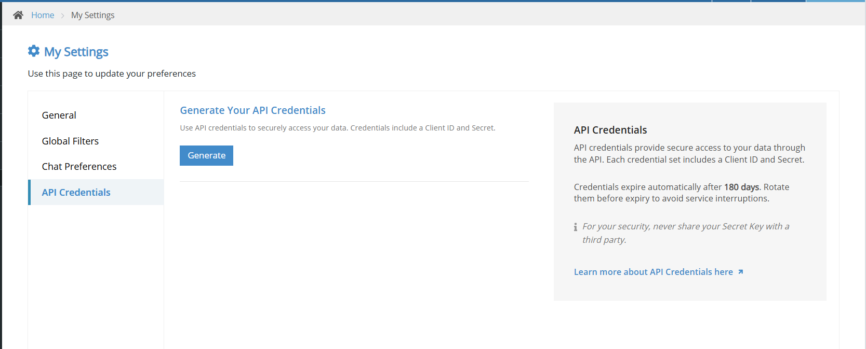

6. **Ticket #28584**

**Sub:** Lineage missing for Ameritas

**Question:** The lineage section was not appearing in the table detail page.

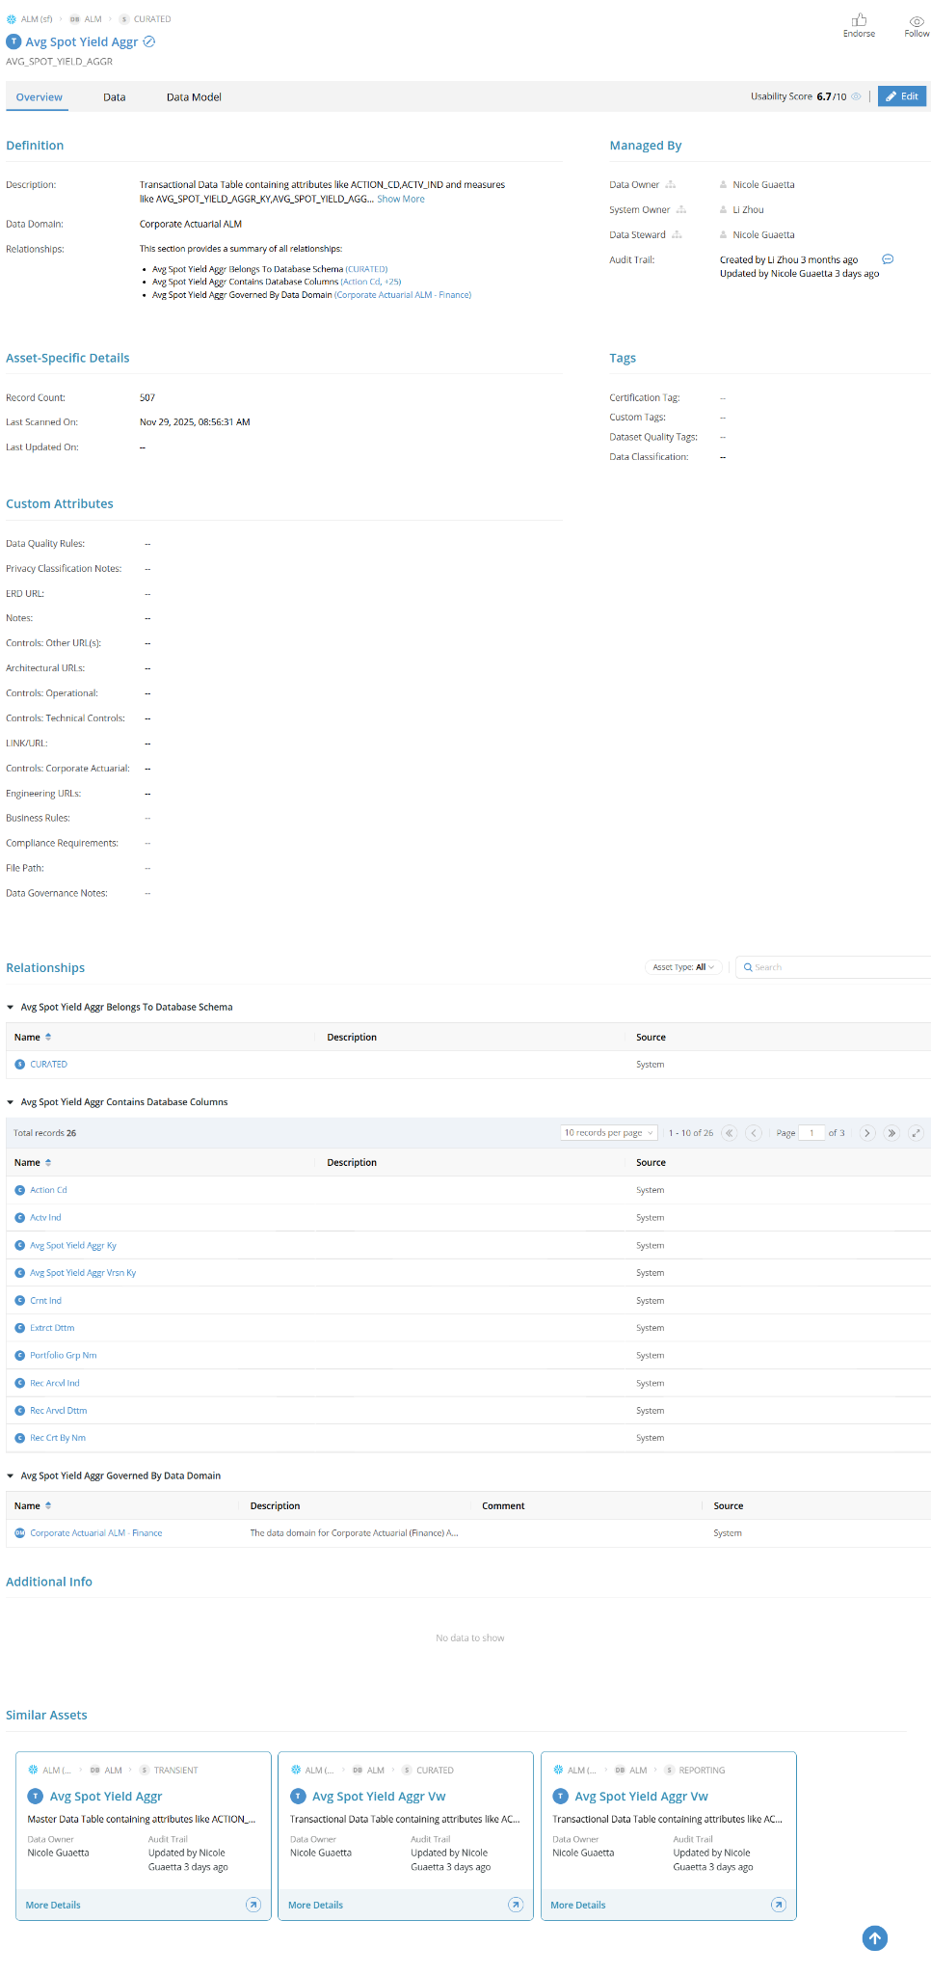

**Solution:** After acknowledging the ticket it is treated as S1 ticket then s1 escalation protocol was followed but in the meantime we informed them to try disabling Lineage once and then re-enabling it from the Module Settings? This may help restore access temporarily. And they confirmed that Lineage is working well after turning it off and then back on again.  
After this we escalated this to the Engineering team for further investigation into the root cause. After checking with the engineering team, we found that, due to production release, a logout and login were required. Unfortunately, this step was not included in the post-release communication, which caused the Lineage section not to appear.

The PD team will be investigating this further and will ensure that such gaps do not occur in future releases. Additionally, FR-1609 has been logged and shared with the engineering team for follow-up on this incident.

7. **Ticket #28585**

**Sub**: CADDI PR log extraction over API issue category problem

**Question:** The customer reported an inconsistency where the Issue Category field was present in one API extract but missing for the same records in a later extract.

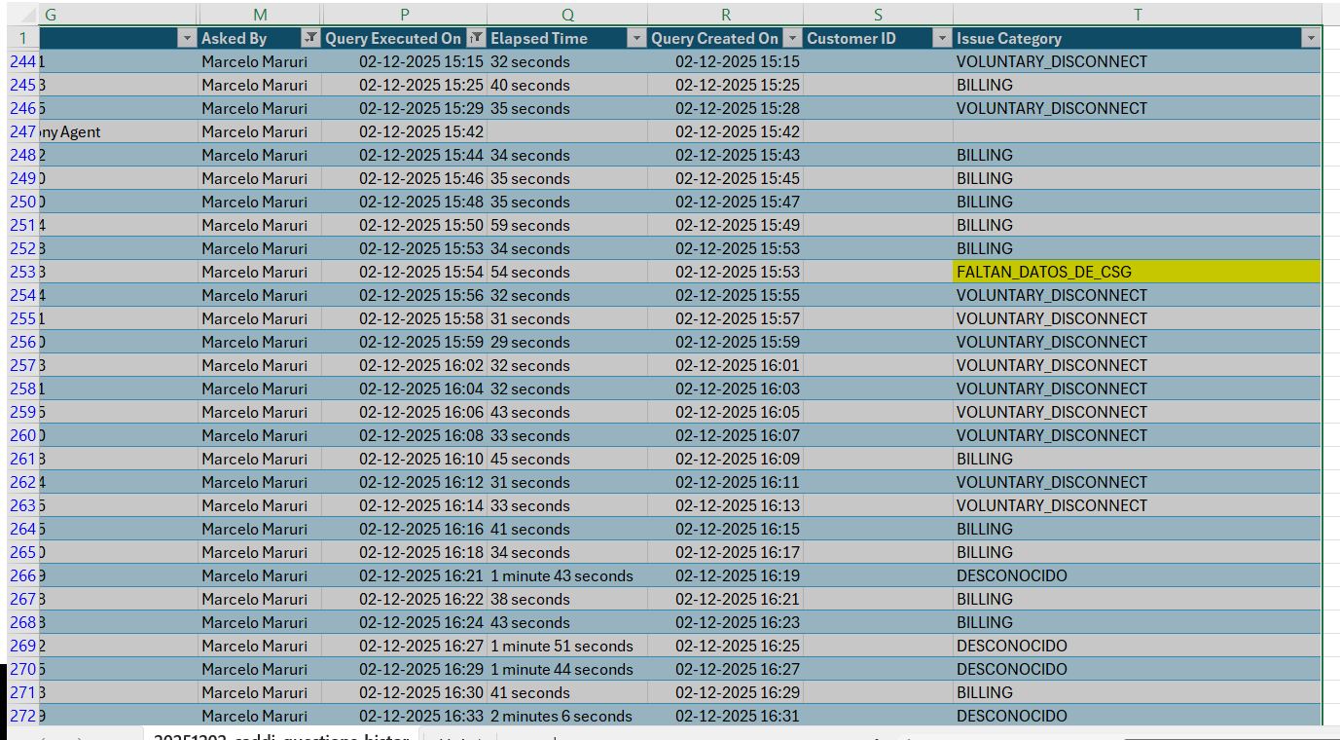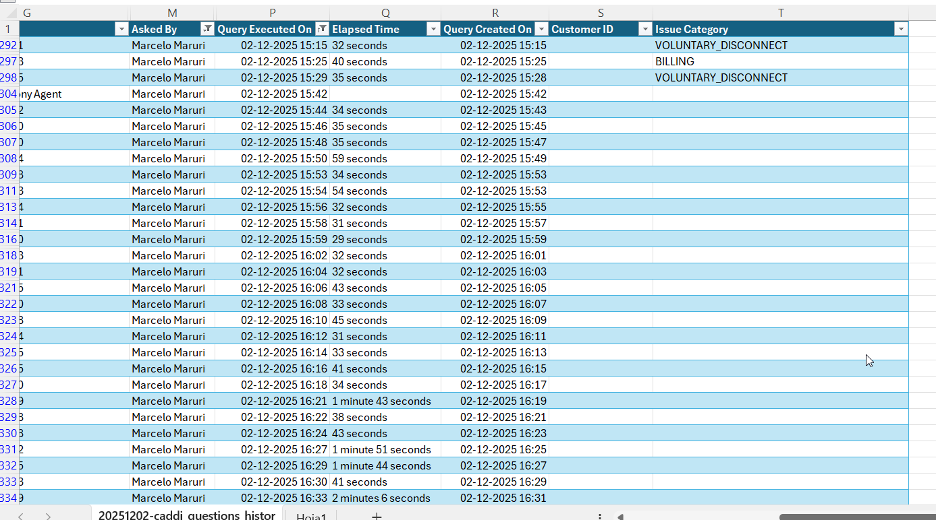

**Solution:** After acknowledging the ticket, we connected with Muiz and investigated the issue. Since the issue could not be reproduced on our side, the team believes it was likely caused by a temporary glitch. The ticket has been closed, and we will continue to monitor the situation. If the issue occurs again, we will attempt to reproduce it and coordinate with the PD team for a fix.

8. **Ticket #28590**

**Sub**: FDA CodeBase and notifying FDA of 3 months of features

**Question:** JC raised this ticket for tracking: FDA needs a clear view of FDA-specific FRs in the new release, relevant new features from the past 3 months, and the use cases or optimizations these features enable.

**Solution:** After preparing the sheet and discussing it with Hajra, we shared the summary sheet with JC, covering the last three months of FDA-relevant updates.  
[Link](https://dvsum2-my.sharepoint.com/:x:/r/personal/amulya_as_dvsum_com/_layouts/15/doc2.aspx?sourcedoc=%7BBE54D749-E699-4457-A740-50F1B72ACA26%7D&file=FR%27s%20list%20for%20last%203%20months%20release%20mail%20(2)%20(2).xlsx&action=default&mobileredirect=true&wdOrigin=MAIL.SHELL%2CAPPHOME-WEB.BANNER.UPLOAD&wdPreviousSession=3d9706fa-d267-4f43-857d-4177ef81e2b4&wdPreviousSessionSrc=AppHomeWeb&ct=1769632120905)

8. **Ticket #28591**

**Sub**: Cannot display DQ rules consistently

**Question:** Matt reported that the DQ Rules list was reloading repeatedly, sorting was not working, and the page was crashing.

**Solution:** We logged FR-1611 for this issue and discussed it with Khushbakhat to investigate the root cause. After that the team has fixed the sorting and display issues, and sorting on both the rule listing page and the table details page is now working correctly.

9. **Ticket #28593**

**Sub**: CWC User Nigel Blake not able to login after domain change

**Question:** Marcelo reported that Nigel was unable to log in after the domain change.

**Solution**: Taimoor shared the sheet provided by Marcelo. We reached out to Ramana regarding this, and Ramana completed the email domain updates for all users listed in DvSum, including Nigel and the other users. The users are now able to log in successfully using their **@libertycaribbean.com** email addresses.

10. **Ticket #28599**

**Sub**: Exceptions not showing correctly in the Data tab

**Question:** In the Data tab, the exceptions are not loading properly. Instead of the actual details, some invalid text/URL is showing. But in the Jira ticket, the exception file looks correct. So the problem seems to be with how the Data tab is displaying the information.

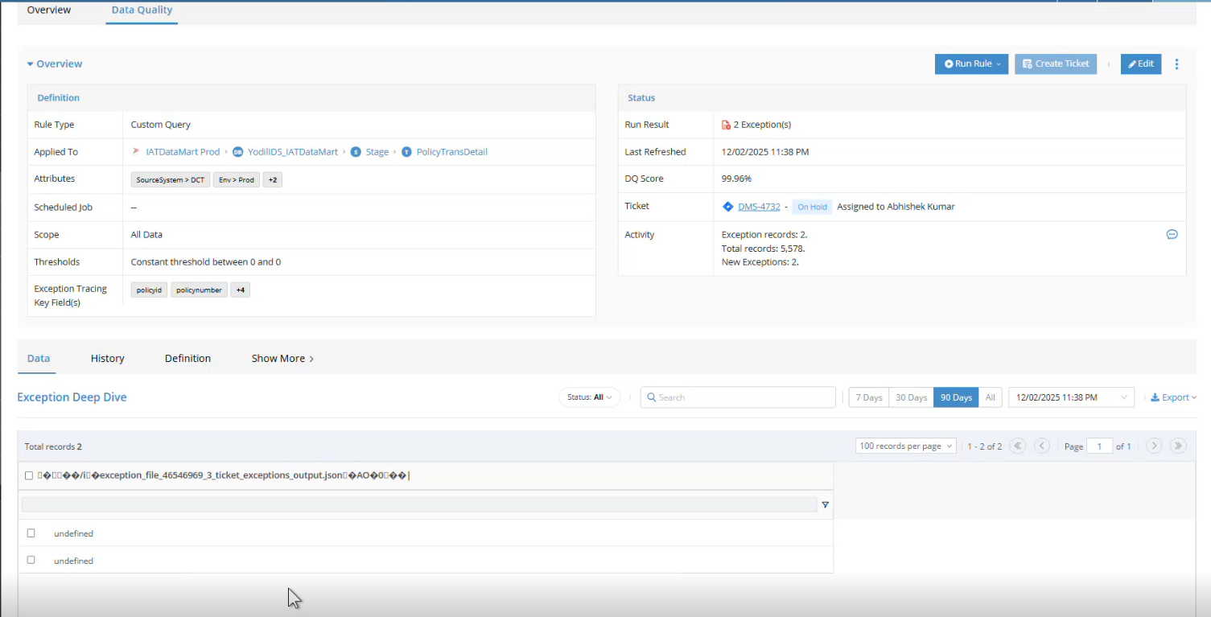

**Solution:** We have provided an update on the issue reported in the Data tab. The development team has resolved the problem where exceptions were not displaying correctly for every run. To reflect this fix on the platform, the gateway needs to be updated to the latest version, 2.1.6.

We have provided the link to the article with instructions to update the gateway to the latest version: [*Gateway Installer Download Document*](https://dvsum.zendesk.com/hc/en-us/articles/29756078237460-DvSum-Gateway-Installer-Links)*.*

Once the update is completed, we requested the customer to review the rule again to confirm that exceptions are now displayed correctly and that the issue no longer occurs.

11. **Ticket #28600**

**Sub**:Support Task - short term

**Question:** JC requested the support team to take over sending the daily file to the LLA team, as Vishal needs to focus on optimizing the CADDI project for PR.  
 **Solution:** Taimoor scheduled a call with Vishal, and Vishal provided us with the KT on the process for generating and sending the daily file. The team member on the day shift will be sending the file to LLA as part of the interim process.

12. **Ticket #28603**

**Sub**:Jira Integration Issue

**Question 1:** When testing the Jira integration connection, the application keeps spinning for a while and then stops responding.  
  
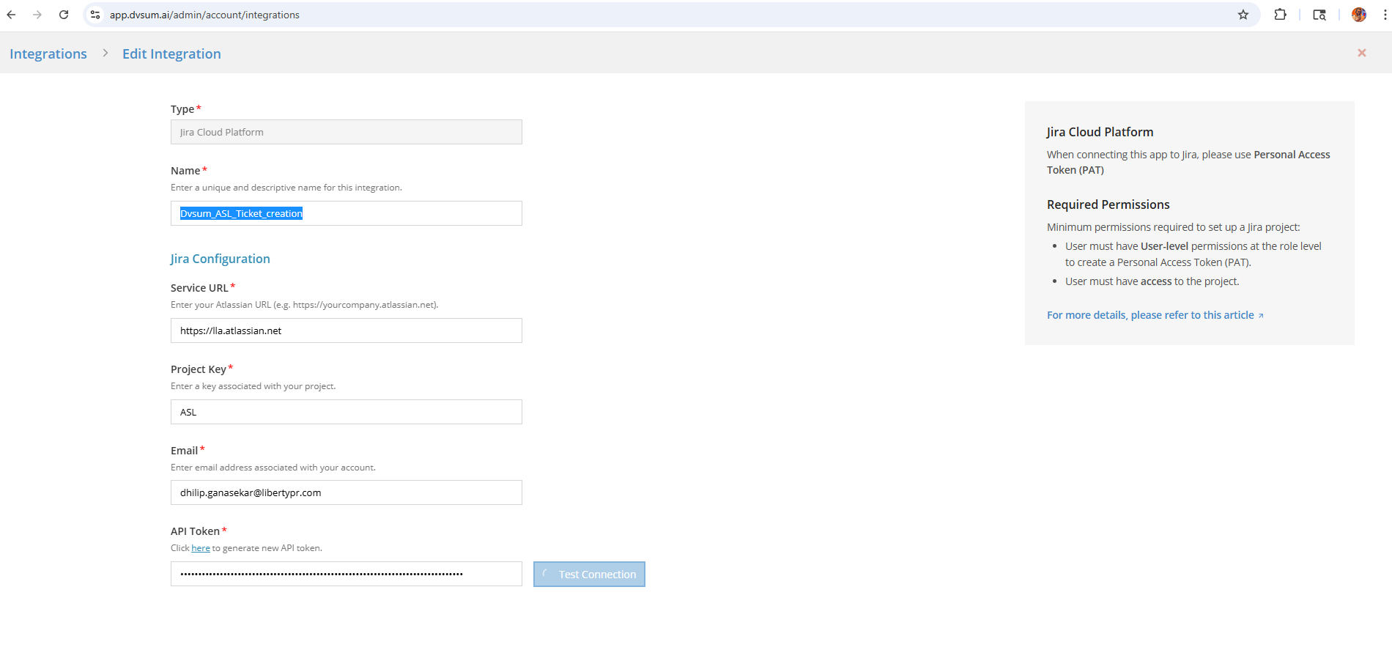

**Solution 1**: We have reviewed and verified the issue on our end, and the test connection is working fine for us. So requested the customer to try the test connection again from their side

For more details, please refer to the Jira Integration for DQ Rules article.

**Question 2:** Still not able to make a successful connection.

Can you confirm if the Service URL should be the base URL?  
 **Solution 2:** We updated the Service URL from <https://lla.atlassian.net/rest/api/2/project/> to [https://lla.atlassian.net](https://lla.atlassian.net/). After making this change, the test connection request is being triggered successfully from the application. However, Jira is not returning any response, which is why the test continues to run without completing. This behaviour typically indicates a security or network-level restriction on the Jira side rather than a configuration issue within DvSum.

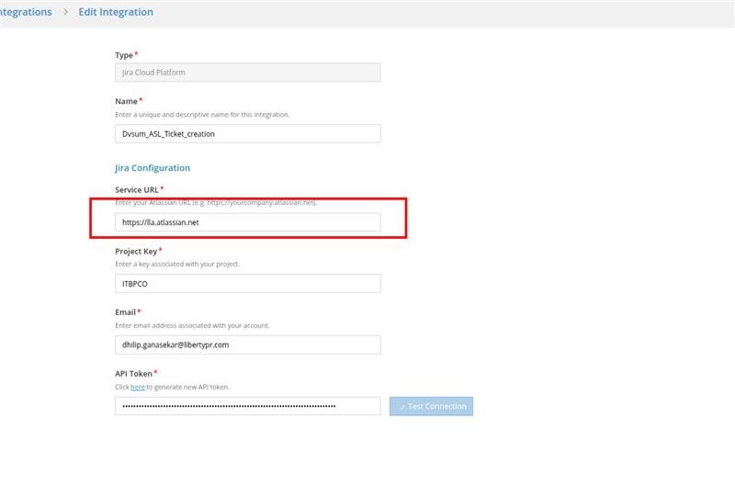

We recommend checking the following with your IT/Jira team:

* Whether any security or network policy is blocking external system access to Jira
* If there are any organisation-level restrictions on Jira API access
* If a corporate proxy or security gateway is controlling external API traffic

Once this is validated, please test the connection again from your side and share the outcome with us so we can proceed further.

**Question 3:** Customer requested for more details. If this could be a firewall blocking issue. What is the source IP we need to be whitelisted?

**Solution 3:** There is no specific IP that needs to be whitelisted from our side. Since the test request is reaching Jira, but no response is coming back, the issue is likely related to user permissions or an internal network restriction within your Jira environment.

It would be helpful if your IT/Jira team could review:

* Whether the Jira user being used has the required project/API access.
* Whether any firewall, proxy, or security rule is blocking the response from Jira

Once they confirm this, please try the test connection again and let us know the result.

13.

Nov - 2025

1. **Ticket # 28516**

**Sub:**Incorrect workflow status - DvSum UI

**Question:** Pavan Ramakrishna requested to make the correction in the UI of the workflow status - In Progressd.

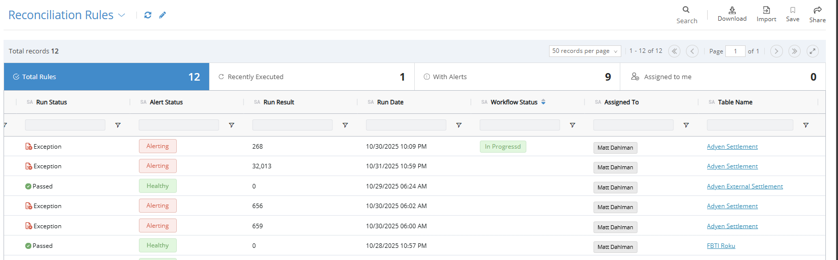

**Solution:**  We logged an FR-1586 and It was reverted back to Pavan once the correction was completed.

1. **Ticket #28517**

**Sub:** Issues in DvSum UI

**Question:** Vaidehi Mhatre reported on the currently facing two issues in DvSum.

1. Unable to delete rules - The Delete option is disabled when attempting to remove the rule from Data quality tab and for Mass delete. It is working from Overview tab.

1. Unable to clone the jobs – the process shows as completed, but the cloned job is not actually created.

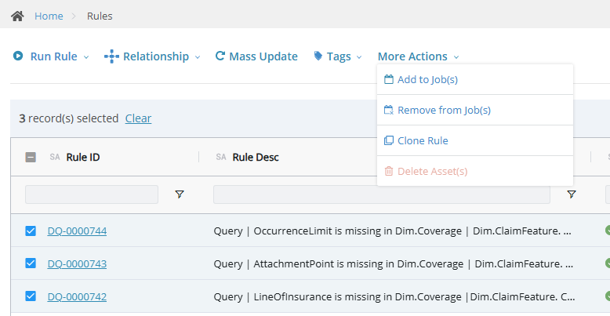

**Question 2:** Mike added his assumptions regarding the Rule Deletion and clone Job creation

**Solution:**

Thank you for the update. I wanted to confirm that the issue is not related to the Gateway status , the red icon and invalid certificate date will not impact the rule deletion or job cloning functionalities.

And Vaidehi,

Regarding the first issue of deleting rules , you’re unable to delete them because you are neither the creator of the rule nor assigned the Data Security Admin role. To delete a rule, you must either be the creator of the rule or have Data Security Admin privileges.

For the second issue, we have verified that the Clone Job functionality is working as expected. We also tested this in the IAT environment by cloning a test job, and it was successfully created. Please try cloning the job again and let us know if you still face any issues.

1. **Ticket #28523**

**Sub:** PR csg missing data for 8211990050676881

**Question:** Agent Miguel Palomino reports account 8211990050676881 with CSG data missing, run at least twice. Can you validate if this is a hallucination o was effectively data missing?

**Solution:** After reviewing the chat logs and AWS logs, support confirmed that Miguel received the same CSG error twice with status code 400 indicating an unexpected response from the billing system, while Marcelo’s run did not return any errors; therefore, both results were correct, there was no hallucination, the CADDI bot functioned as expected, the error was observed 14 times across CADDI queries on November 4–5, and no further action was required from Support as the broader issue would be addressed separately through the Symphony migration

1. **Ticket # 28524.**

**Sub:**

**Question:**

**Solution:**

1. **Ticket #28527.**

**Sub:**CADDI PR – Difference in daily question counts between dashboard and logs.

**Question:**Marcelo asked why there are consistent mismatches between the number of daily questions shown on the UI dashboard and the CSV logs shared by Vishal, even after aligning fields (QUERY_CREATED_ON vs QUERY_EXECUTED_ON), adjusting for timezone differences, and confirming that no API traffic or explicit filters were applied, with discrepancies varying day by day and missing data observed around Oct 31 and Nov 1.

**Solution:** After investigation with Engineering, it was confirmed that the mismatch is caused by multiple factors, including a timezone difference where the dashboard reflects the user’s local timezone while logs and API data are recorded in UTC, dashboard widget filters that exclude admin users, DvSum internal users, and test agents from the counts, and the fact that deleted chats are removed from the dashboard in real time but remain in the static exported logs; additionally, some missing records were due to an incorrect export parameter that was later corrected, and a separate ticket.

Feature Request were logged to address the broader gaps, after which this ticket was closed.

1. **Ticket # 28529.**

**Sub:** Unable to modify user group for Nicole at Ameritas.

**Question:** Matt reported that he was unable to modify Nicole’s user group at Ameritas despite attempting the change and shared a screenshot, requesting a call to investigate the issue further together.

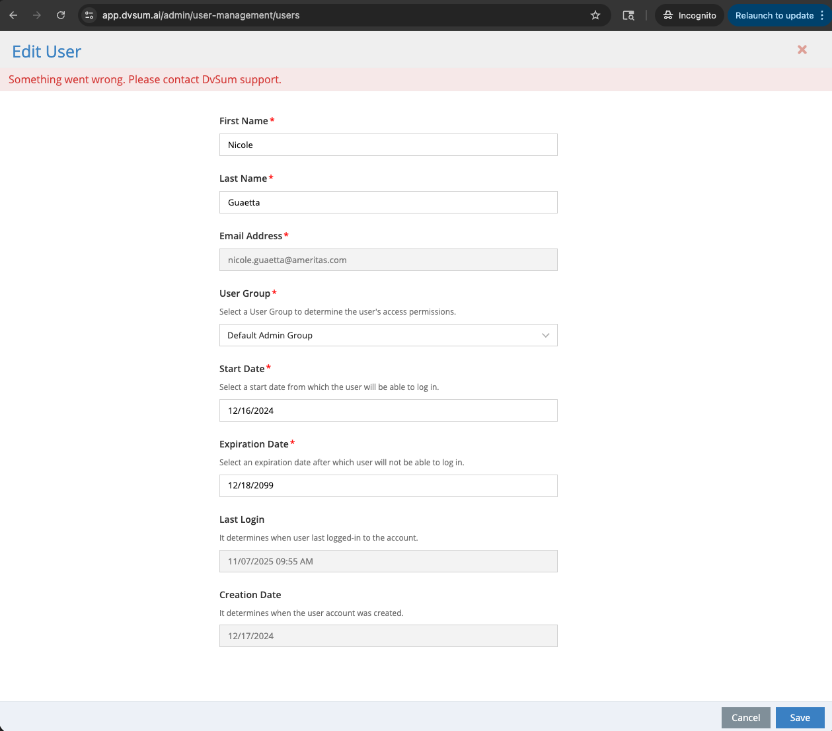

**Solution:** Reviewed the issue on a call with Matt and confirmed that after updating the role of the user group, the changes worked as expected; it was agreed to separately review the behavior of the “No Permission” role with the internal team as a low-priority item, and the ticket was closed.

1. **Ticket #28533**

**Sub:**API job clone does not create a new job on save.

**Question:** Vaidehi reported that when attempting to clone an API job, the clone window opens with all details prefilled, but after clicking Save, no new job is created and no success or error message is shown.

**Solution:** Reviewed the behavior with the internal team and confirmed it as a product gap, logged Feature Request FR-1591 to address the issue, planned the fix for an upcoming release, and informed that the customer will be notified once the fix is deployed; the ticket was closed due to no further response from the customer.

1. **Ticket # 28537.**

**Sub:** Request to retain usage data when users delete chats.

**Question:** Marcelo raised a concern that when users delete their old chats, visibility into their usage activity is lost, and asked whether chat deletion could be disabled or deleted chat history retained for accurate reporting and tracking.

**Solution:** Support acknowledged the request, logged it as an enhancement under Feature Request FR-1592 to either disable chat deletion or retain deleted chat history for reporting purposes, confirmed that updates will be shared once there is progress, and closed the ticket while the FR is tracked separately.

1. **Ticket #28539**

**Sub:**Scan History UI does not clearly indicate failed or partial scan outcomes.

**Question:** On behalf of Charlie Haggard, it was reported that the Scan History UI always shows a scan as “Complete” as long as it starts and ends, even when the scan fails to retrieve all data, requiring users to rely on email notifications or logs to identify failures, which can mislead Data Stewards or Data Owners into thinking the scan was fully successful.

**Solution:** Support reviewed the request and logged it as an enhancement under Feature Request FR-1594 to improve the Scan History UI by clearly displaying scan outcomes with explicit result statuses (such as Passed, Failed, Partial, or other applicable outcomes), updated the FR to ensure all possible scan result states are covered, confirmed alignment with the requester, and closed the ticket while tracking the enhancement separately.

**10 Ticket #28540.**

**Sub:**Status filter limitations and lifecycle behavior across Asset, Dictionary, and Glossary views.

**Question:** On behalf of Charlie, John reported that when creating views on Asset, Data, or Field dictionaries, the Status filter does not include certain values such as “Deleted,” and in the Business Glossary only “Valid” is available, despite records existing with other statuses; the request also questioned why some statuses appear abbreviated (for example, “Dep”), asked for clarification on the intended lifecycle of Status fields across Assets and Glossary, and requested a way to create views based on any possible status value, including those not currently applied, with suggestions such as using tags or other alternatives.

**Solution:** Reviewed the multiple concerns with the relevant teams and determined they should be handled separately, resulting in the creation of individual tickets and feature requests to address missing and abbreviated status values, limited glossary status filters, clarification of status lifecycle behavior, and the ability to filter on all possible status values; the original ticket was closed after creating tickets 28545 (FR-1545), 28546, 28547 (FR-1595), 28548, and 28549, with updates to be shared as each item progresses independently.

**11. #28542**

**Subject:** Field Dictionary label missing and replaced with “Database Column”.

**Question:** Aashish reported that the categorical value set should display “Field Dictionary”, noting that this behavior was working previously, but the label is no longer shown and needs to be fixed.

**Solution Provided:** After reviewing the issue, it was confirmed that the label change occurred because “Field Dictionary” was renamed to “Database Column” across the platform for consistency; an internal ticket was logged to change this specific label back to “Field Dictionary”, it was added to the current development bucket, and the ticket was closed with a commitment to inform Aashish once the fix is deployed to production.

**12. #28545**

**Subject:** “Deleted” status not available in Status filter when creating views.

**Question:** Charles reported that while creating views in the Asset, Data, or Field Dictionary, the Status filter does not show “Deleted” as an option even though records with Deleted status exist, preventing the ability to filter specifically for deleted items.

**Solution Provided:** After reviewing the issue, it was confirmed that the missing “Deleted” status in the filter options is already tracked under Feature Request FR-1545; as a workaround, steps were provided to manually create a view by adding a condition group and setting Status = Deleted for Assets, Data Dictionary tables, Fields, and Database Columns, with a note that some Deleted records may no longer appear due to automated cleanup, and the ticket was closed while the FR continues to be tracked separately.

**13.#28546**

**Subject:** “Deleted” status displayed as “Dep” in the Data Dictionary.

**Question:** Charles reported that in the Data Dictionary the status value appears as “Dep” instead of “Deleted,” which is unclear and causes confusion for users expecting the full status value.

**Solution Provided:** After reviewing the issue, it was confirmed that although the “Deleted” filter option is now working correctly across governance views, the abbreviated “Dep” status display remains and is planned to be corrected in the December codebase release; the customer was advised to recheck after the release is deployed, and the ticket was closed with the fix tracked as part of the upcoming FDA release.

**14.#28547.**

**Subject:** Business Glossary status filter shows only “Valid” when creating views.

**Question:** Charles reported that when creating a View in the Business Glossary, the Status filter only displays “Valid,” even though the Glossary supports multiple lifecycle statuses, preventing users from creating views based on the full set of supported statuses.

**Solution Provided:** After reviewing the behavior, it was identified that there is an inconsistency in how Business Glossary status values are exposed between the listing page and the view-creation flow, and a Feature Request FR-1595 was logged to ensure all lifecycle status values are consistently available for filtering; the ticket was closed while the enhancement is tracked separately.

**15. #28548.**

**Subject:** Clarification of status lifecycle for Assets and Business Glossary.

**Question:** Charles requested a clear explanation of the status lifecycle used in Assets and the Business Glossary, including what each status means, how statuses transition, visibility rules, and how terms move between states, with additional clarification requested around differences such as New vs Default, handling of Deleted and Modified statuses, publishing expectations, and the meaning of “Incomplete” in the Business Glossary.

**Solution Provided:** After reviewing the request, a detailed article explaining the complete status lifecycle for Assets and Glossary terms was published and then updated to address all follow-up questions, including automatic transitions, visibility rules, publishing behavior, and removal of outdated terminology; additional clarification was provided that Glossary terms move from Incomplete to Complete based on usability score behavior, for which Feature Request FR-1600 was logged to refine the transition, and once Charles confirmed the explanation resolved his confusion, the ticket was closed with Ellen’s concern tracked separately.

**16.#28549**

**Subject:** Request to display all possible status values in the Status filter for views.

**Question:** Charles conveyed that the customer wants the Status filter to show all possible status values, even if no current records use them, so they can create Views in advance for statuses such as “Deleted” or other future lifecycle states.

**Solution Provided:** After reviewing the requirement, a workaround was provided using a custom Status Tag Set, allowing users to define and apply their own status values (such as In Progress, Review, or Deleted) and then build Views based on those tags; this approach was confirmed to meet the customer’s needs, after which the ticket was closed.

**17. # 28550**

**Subject:** CADDI query execution hangs and does not complete.

**Question:** Marcelo reported that a CADDI query for account **8211080500008560** ran for more than 10 minutes without completing and eventually failed, and requested an investigation to understand why the execution was stuck for an unusually long time despite subsequent runs completing successfully.

**Solution Provided:** After reviewing the logs and execution details, it was identified that the issue was caused by a **parsing error in the LangChain library on the LLM side**, which led to the query hanging instead of returning a proper error; the team refined the prompt, completed regression testing, improved the error-handling flow, and logged **Feature Request FR-1601**, with the fix already implemented by Engineering and planned for deployment in the next release, after which the ticket was closed and the customer will be notified once the fix reaches production.

**18.28554.**

**Subject:** Dashboard widget sorting reset and incorrect current date filtering.

**Question:** It was reported that dashboard widgets for rules, jobs, and job executions have two issues: the selected default sorting is lost after refreshing the page or URL, and the “current date” filter does not work as expected, as relative date values (such as Equals 0 or Greater Than or Equal To 0) fail to return results for the current calendar day and instead behave like a rolling 24-hour window.

**Solution Provided:** After reviewing the issues, both were logged as separate feature requests, with the sorting problem tracked under FR-1598 and planned for a fix in the current release, and the current date filtering behavior tracked under FR-1599 and scheduled for a future release; the ticket was closed with a commitment to notify the customer once the fixes are deployed to production

**19. #28555.**

**Subject:** Business Glossary terms remain marked as “Incomplete” after publish.

**Question:** Ellen asked why imported Business Glossary terms continue to appear as **“Incomplete”** even after being submitted for approval, approved, and published, and requested clarification on what “Incomplete” means and how to transition terms to **“Complete.”**

**Solution Provided:** After reviewing the behavior with Engineering, it was confirmed that the existing completeness logic was inconsistent and caused some terms to remain Incomplete despite being published; the logic was updated so that a term is marked **Complete** once **Description, Ownership, and Data Domain** are populated and published (with workflow approval still required if enabled), removing unnecessary dependencies, and the fix was scheduled for deployment in the next codebase, after which customers were advised to verify and report any discrepancies.

**20. #28557.**

**Subject:** Duplicate and orphaned database/schema assets in FDA pre-prod environment.

**Question:** Charlie reported that multiple database and schema assets appear duplicated in the FDA pre-prod environment, with some databases and schemas orphaned and linked to Data Sources that no longer exist, and requested an investigation into the root cause and resolution.

**Solution Provided:** After reviewing the issue with Engineering, it was confirmed that the duplication and orphaned records occur when a Data Source is deleted but its associated Database and Schema assets are not cleaned up; a fix addressing this behavior was already completed in a prior support release and is included in the upcoming FDA release, which will also provide a UI option to delete orphaned assets, and since FDA testing did not reproduce the issue after applying the fix, the ticket was closed.

**21. #28558.**

**Subject:** Line chart in dashboard widget does not follow stacked bar grouping logic.

**Question:** LLA reported that when using the same slicers (Created On Daily and Market Code), the stacked bar chart correctly groups data by date and splits it by market, but switching to a line chart changes the X-axis to market codes instead of dates and fails to render continuous lines per market, resulting in inconsistent and confusing behavior across chart types.

**Solution Provided:** After reviewing the requirement, a feature request was logged to enhance the line chart so it supports the same grouping logic as the stacked bar chart—grouping by date on the X-axis, displaying one continuous line per market, and maintaining consistent slicer behavior—and the ticket was closed with the request tracked internally and the customer to be notified once the enhancement is implemented

**22. #28559.**

**Subject:** Ability to select and move multiple schemas at once when configuring a data source.

**Question:** John, on behalf of Charlie, reported that when limiting schemas during data source configuration, users must individually select and move each schema one by one, and requested an improved user experience that supports bulk selection (for example, using SHIFT + click) and moving multiple schemas at once, similar to multi-select behavior needed in other parts of the UI.

**Solution Provided:** After reviewing the request, an enhancement was logged under **Feature Request FR-1602** to improve the interface and support bulk selection and movement of schemas, the request was added to the FDA tracker, and the ticket was closed while the enhancement is tracked separately.

**23. # 28563**

**Subject:** Error shown in the “Ticket” field during Jira ticket fetch.

**Question:** Matt asked what the error shown in the “Ticket” field means when attempting to fetch or create a Jira ticket.

**Solution Provided:** After reviewing the behavior, it was explained that the error occurs when the system attempts to fetch ticket details from Jira but Jira temporarily does not respond as expected, which can be caused by cache issues, brief Jira API outages, network or routing glitches, or rate limiting on Jira’s side; since the rule worked correctly on retry, the issue was confirmed to be transient and not related to the rule or Jira integration configuration, and the ticket was closed due to no further response.

**24. #28565.**

**Subject:** Follow-up on API feed functionality questions from LLA demo.

**Question:** Following Taimoor’s API functionality demonstration to Marcelo, John raised four support questions regarding API and feed behavior: whether the user group field should be included in feed output, how to handle and filter frequent “about” questions in chat logs, whether elapsed time should be returned in a numeric seconds format instead of human-readable text, and whether additional user details (create/modify/role/group) can be included in the feed for better reporting.

**Solution Provided:** After reviewing the meeting notes and recording, the team kept the ticket in pending as advised, analyzed each concern, and created **four separate tickets** for Marcelo covering each item individually, with corresponding feature requests logged (**FR-1604, FR-1605, FR-1606, FR-1607**); once all four tickets were created and tracked separately, this parent ticket was closed.

**25. #28568.**

**Subject:** Follow-up on recurring CADDI PR queries running indefinitely.

**Question:** Marcelo followed up on the earlier CADDI PR issue where queries run for more than 10 minutes without completing, reporting that the same behavior occurred again for another execution and requesting an update on the fix status.

**Solution Provided:** After reviewing the repeated occurrences, it was confirmed that the root cause was a parsing error that could cause executions to remain stuck; Engineering completed the fix and improved the error-handling flow so queries now return a proper error instead of hanging, the fix was tested and deployed to production, Marcelo confirmed successful testing, and the ticket was closed with the understanding that he would report back only if the issue reoccurs.

**26. # 28572.**

**Subject:** Temporary password expired error for user login.

**Question:** Marcelo reported that the user **santiago.montoya@libertypr.com** receives the message *“temp password expired, must be reset by admin”* and requested guidance on how to reset the password.

**Solution Provided:** After reviewing the user’s status, it was confirmed that the temporary password had expired, as such passwords are valid for only 24 hours; instructions were provided to regenerate a new temporary password by deactivating and reactivating the user from the **Manage Users** page, which triggers an automatic email with a new temporary password, and it was also noted that the user can alternatively use the **Forgot Password** option on the login screen, after which the ticket was closed once successful login activity was confirmed.